ITALY  -It is in central of  Naples  -Built in 1279 | ITALY  -Famous in the world for his architecture (leaning)  -In the North of Italy | ITALY  -It's in Rome  -Was built in10 years  -It's for the Gladiator's fights
GREECE  -The site of the old Olympic games  -Located in the valley in Ellis  -It's a sanctuary | GREECE  -They are monuments in the garden  -It's located inside the city wall | FRANCE  -He his inspired a counter  -he his in edges of the Loire  -It is a castle
GREECE  -The architect is Polyclète  -Built in the 3rd century before Christ  -It's in the Argolide district | FRANCE  -It is in Paris  -It's a Tower  -It's very famous | FRANCE  -It was a jail  -It was a famous tv show in France  -It's the home of the « the Fourras's father »
SPAIN  -in the west of the Spain  -it's in the UNESCO  -it's a mediaval city | SLOVAKIA  -it's a cave  -it's a good site for the geological history | HOLLAND  -It's a shop  -with a lot of shoes

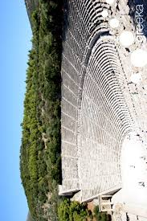  EPIDAURUS | 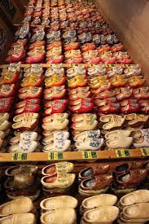  WOODEN SHOE WORKSHOP | 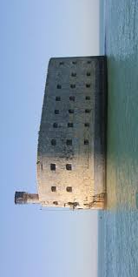  FORD BOYARD
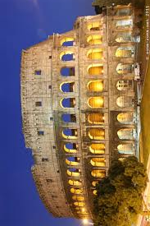  THE COLLOSEUM | 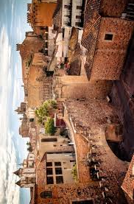  CACERES | 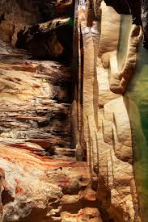  CAVES OF AGGTELEK KARST AND SLOVAK KARS
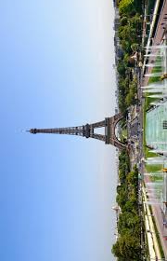  EIFFEL TOWER | 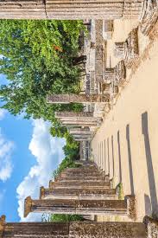  OLYMPIA | 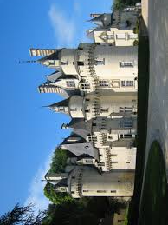  USSE CASTLE
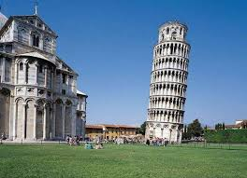  LEANING TOWER | 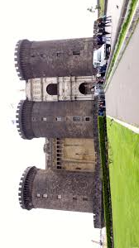  CASTLE NUOVO | 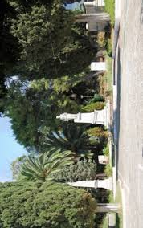  GARDEN OF HEROES MESSOLONGHI

Games's ruler

It's a memory but instead of matching two pictures you must match one picture and its description . If you want play ,you can print and cut the card of the game.

