CHRISTMAS HOLIDAYS

This year (like the others) I’m going to celebrate Christmas with my family. On 24th December I’m going to have dinner with my parents, grandparents, my brother and his girlfriend at home.
Then, on Christmas Day we open our presents and have lunch in my uncle’s chalet in Cambrils. On this day we usually eat traditional Christmas food like soup with pasta.
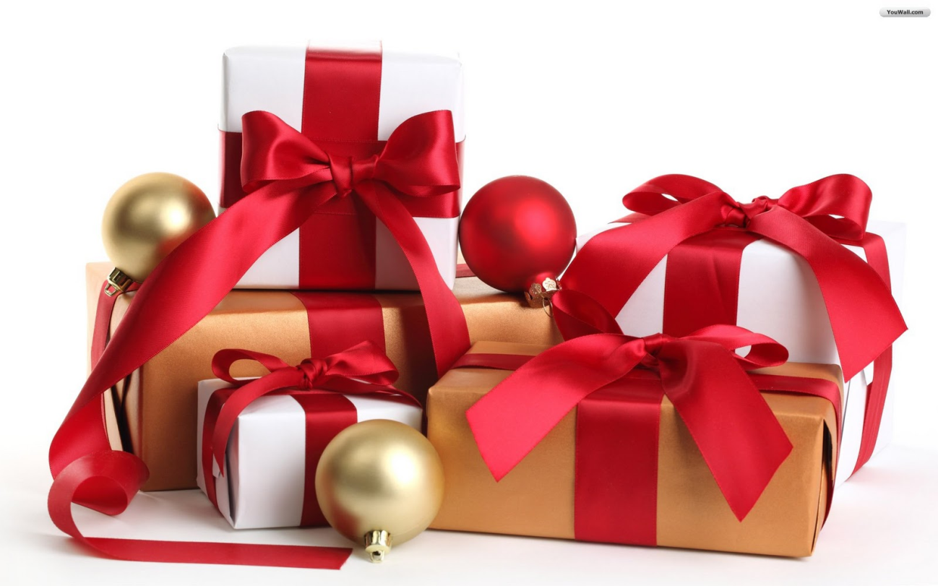
On 31st December we all meet again and celebrate New Year’s Day eating the twelve traditional grapes. We usually go to my grandparents’ house to celebrate it. Finally, on 6th January we meet in a cosy restaurant near Valls and have lunch there.

