ACTIVITY LEAFLET
Twinspace tools: Blog, image gallery, video gallery.
Tools to create it: Microsoft Publisher.
GRADE: SIXTH GRADE

Phase 1: We worked leaflets in our classrooms . The process was recorded and it appears on-etwinning. (Materiasl-videos)

Phase 2: Pupils knew Microsoft publisher (ICT class )

Phase 3: We wrote a leaflet using the information about every participant with a Publisher template.

Phase 4: We vote our favorite.

Phase 5: We send it to our Erasmus friends and made corrections.

Phase 6: We finish and publish it in our school communities (Erasmus corners, copy for our families in two languages, e-twinning etc) We read it in the classrooms etc

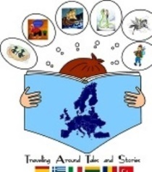 “TRAVELLING AROUND TALES AND STORIES”

