ACTIVITY TRAVELLING BOOK
Twinspaces tools: Blog, Image gallery
Other tools: Word, e-mail, Calameo publisher
The idea of this activity was to write a story between five countries. This story had to reflect European aspects related to the culture, history, gastronomy and traditions in every country, in other words we wanted to create an European Travelling Book. Spain will started the story inventing the main characters and their characteristics, then Greece continued an so on. In our meeting in Spain we decided to write three stories.
Phase 1: We chose the pupils level for our stories.
Phase 2: We formed groups in our classrooms.
Phase 3: We wrote two pages with two pictures
Phase 4: We wrote the best story as a part of the travelling book.
Phase 5: We added our part to a word document and passed it to the following country via e-mail. The last country (Turkey finished every story and invented the title)
Phase 6: Stories were reviewed and corrected in our visit to Romania.
Phase 7: Three e-books were created by Spain using the tool called Calameo.
Turkey gave a printed copy to every participant in Romania.
Phase 8: E-books and materials were uploaded on e-twinning as a digital products and published in our schools social networks, staff meetings etc
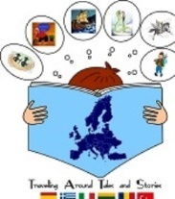 PROJECT KA 219. “TRAVELLING AROUND TALES AND STORIES”

