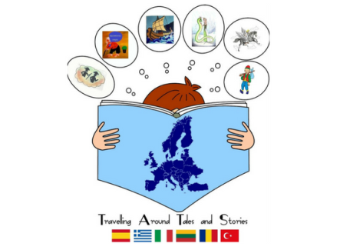
TRIVIAL GOOSE GAME

- DEFINITION
This trivial game was planned as an activity in relation to our project aimed to achieve the following objectives:
- To review the knowledge that our children had about the different stories
- To work on stories in a funny way
- To develop oral skills and reading comprehension
- To develop multiple intelligences (linguistic, artistic, interpersonal etc)
- To attend students with different capacities
- To integrate pupils from different nationalities
- To promote traditional stories from different countries
- To enjoy learning English

- WORKING PROCESS
This game is based in our traditional stories and was created the following working process
- Every country chose a traditional story and made a 8 slides presentation
- Every country wrote three eight questions about their story divided in three categories: Story questions, drama questions and National Culture questions. Moreover, they had to invent an instruction for the game that will be for extra boxes.
- All the stories and questions were posted on e-twinning and sent to all our project participants
- All participants worked on all our stories to learn about them
- Spain as a coordinator country designed the board game using Corel Draw and the cards for the game.
- Both cards and boardgame were sent to all the countries by google docs and published on e-twinning.
- The game was printed to play in Greece where children from different countries played.

3. PRODUCTS
- A written document explaining the activity
- A boardgame composed of 54 squares
- 56 cards to play with different types of questions

- DISSEMINATION
- Meeting in our schools
- International meeting in Greece
- E-twinning
https://twinspace.etwinning.net/26088/home

- GAME INSTRUCTIONS
- The aim of this game to finish the game before than the other teams solving different types of questions in relation to different traditional stories from different countries
- There are 54 questions divided into four categories ( questions about traditional stories, drama challenges about traditional stories, National Culture questions about six different countries (Spain, Greece, Italy, Lithuania, Romania and Turkey) and six intructions boxes
- This game can be played individually or in pairs
- Players start the game rolling the dice from the first square and count as many boxes as the dice indicates.
- If you land on a white box you have to do what it is written
- If a team answers properly stays in the same box
- If a team doesn´t answer properly, it goes backwards two steps.
- The winner team is the team that complete all the game and finishes it before
- These instruction could be modified according to different ways of playing, number of players etc.

- VARIATIONS
- If a team doesn´t answer a question has to go backwards more steps
- We could play with a digital dice on the smartboard or with a big dice made of cardboard
- The winner team can have a challenge at the end

- MATERIALS TO PLAY
- Game board
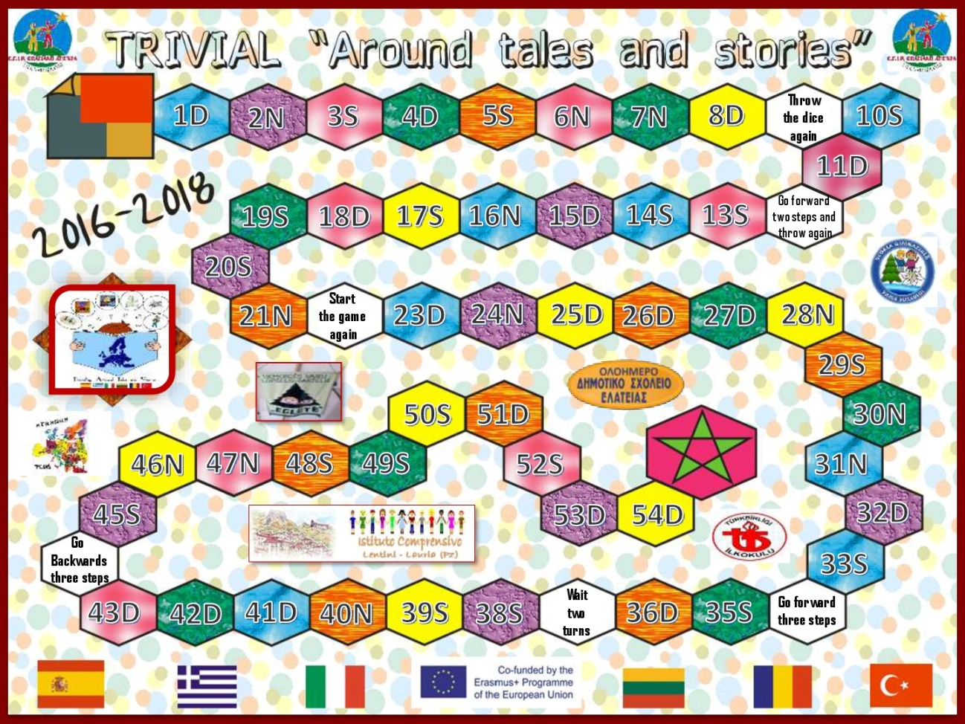

- 56 cards questions .

Every card has the flag country and the question at the back and our logo and type of question at the front.
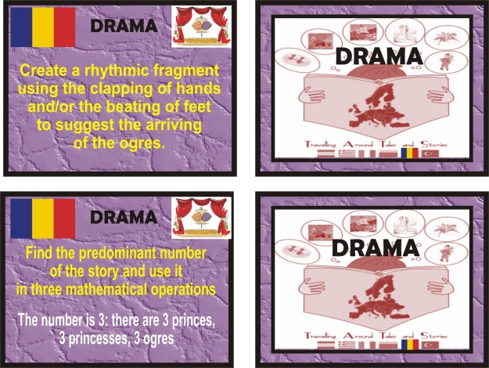

- Dice
- Counters

