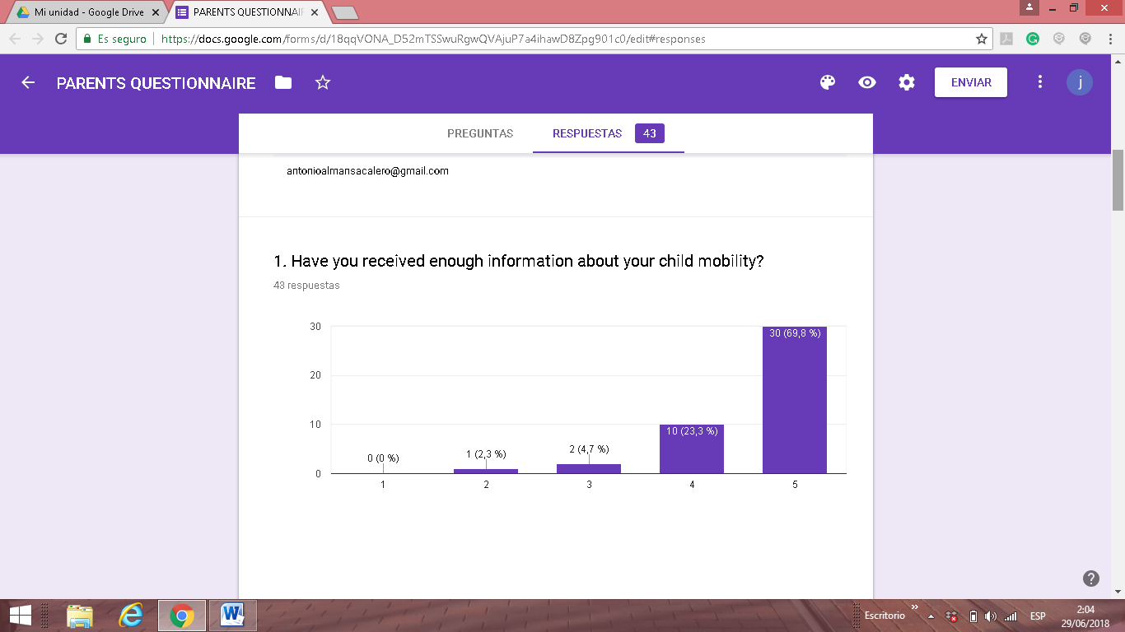
The majority of parents whose kids traveled to Romania, Turkey and Greece (almost 95%) answered that they have received enough information before their child mobility ( dates, documents, host families, activities etc)
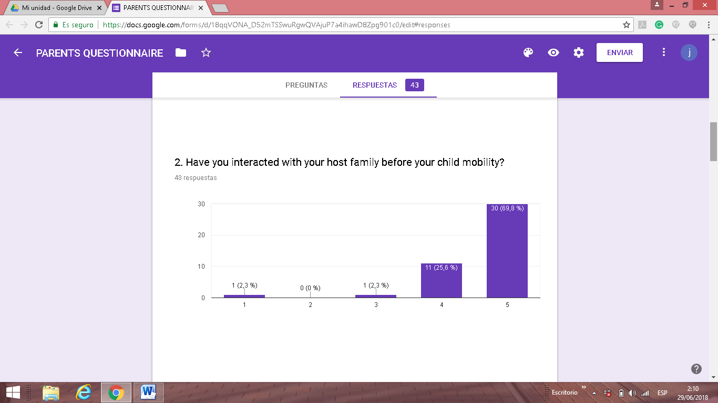
41 out of 43 families (almost 96%) have interacted with their host family before their child mobility through e-mails, Whats apps or video conferencing tools. Only one family hasn´t (2,3%)

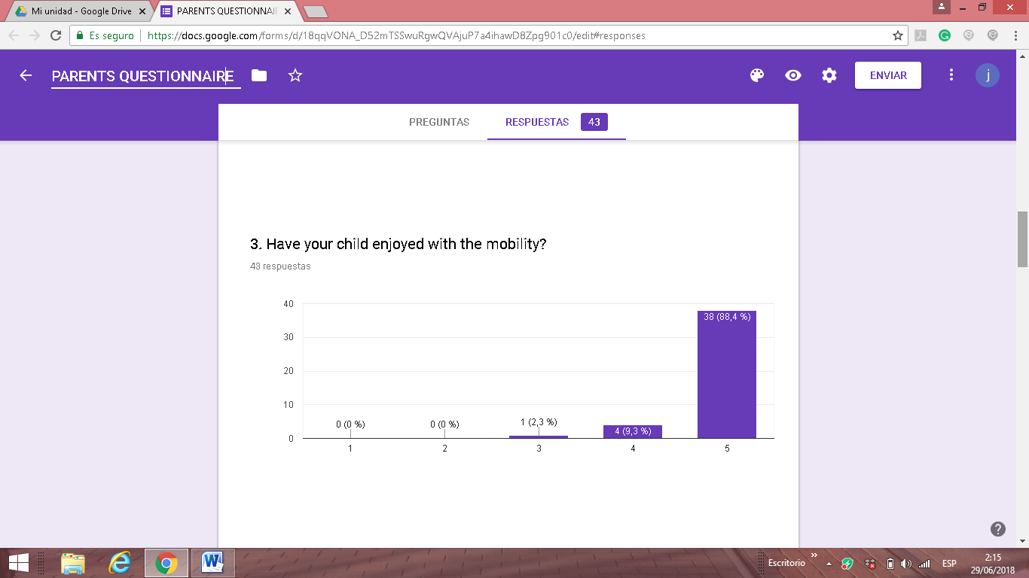
Almost 100% of those parents whose kids that travelled to other countries think that their children enjoyed with the mobility. It means that all the activities were successful, they had nice host families and they spent their time in a funny way.

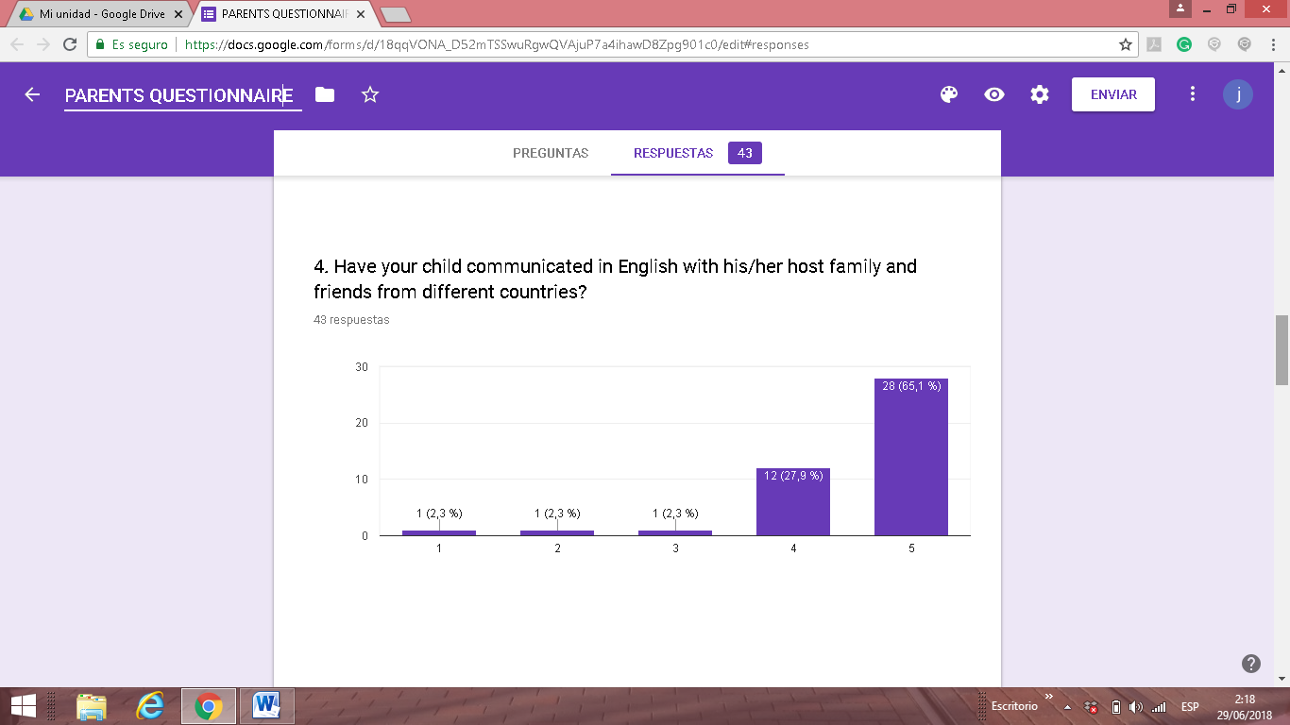
In general, our parents think that our students have communicated in English developing their oral skills because they face to real life situations. Only 5% of families stated that they use the language a few to communicate with other children.
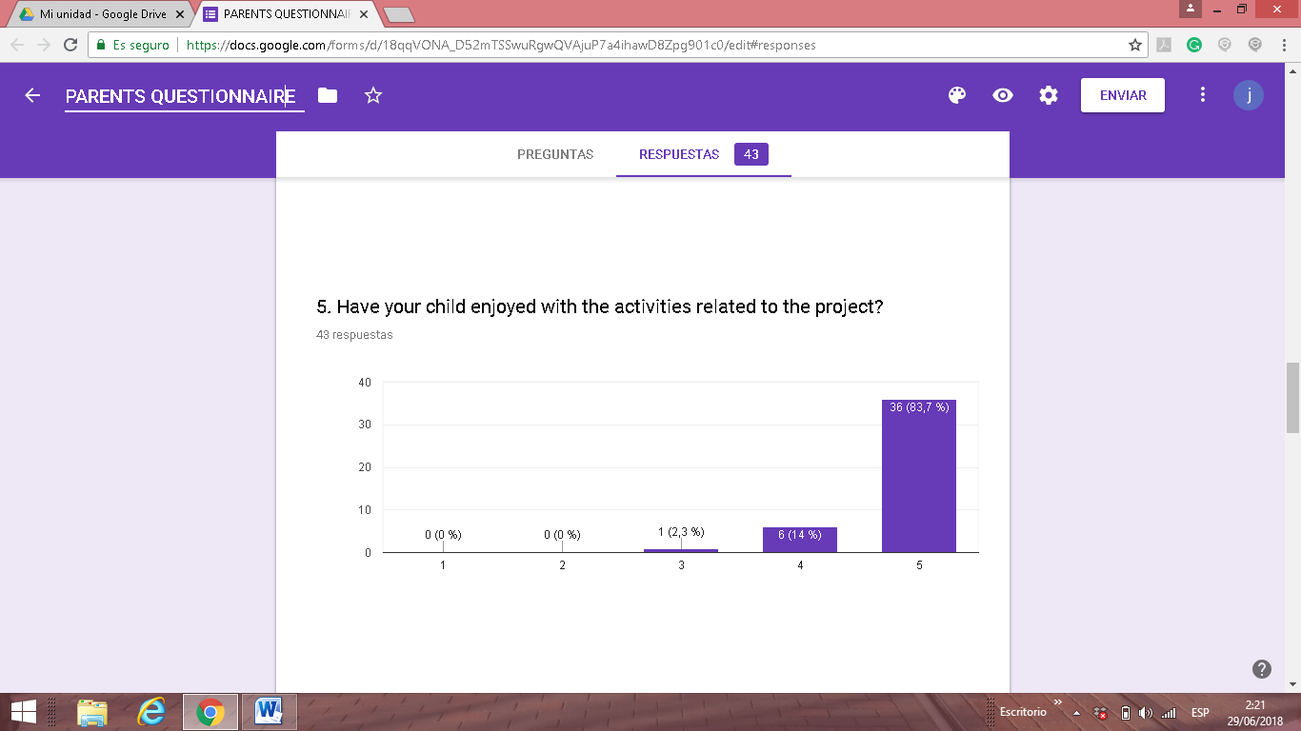
Almost 98 % of those families that filled this survey answered that their children enjoyed with the activities we carried out so it increased the motivation to learn English.

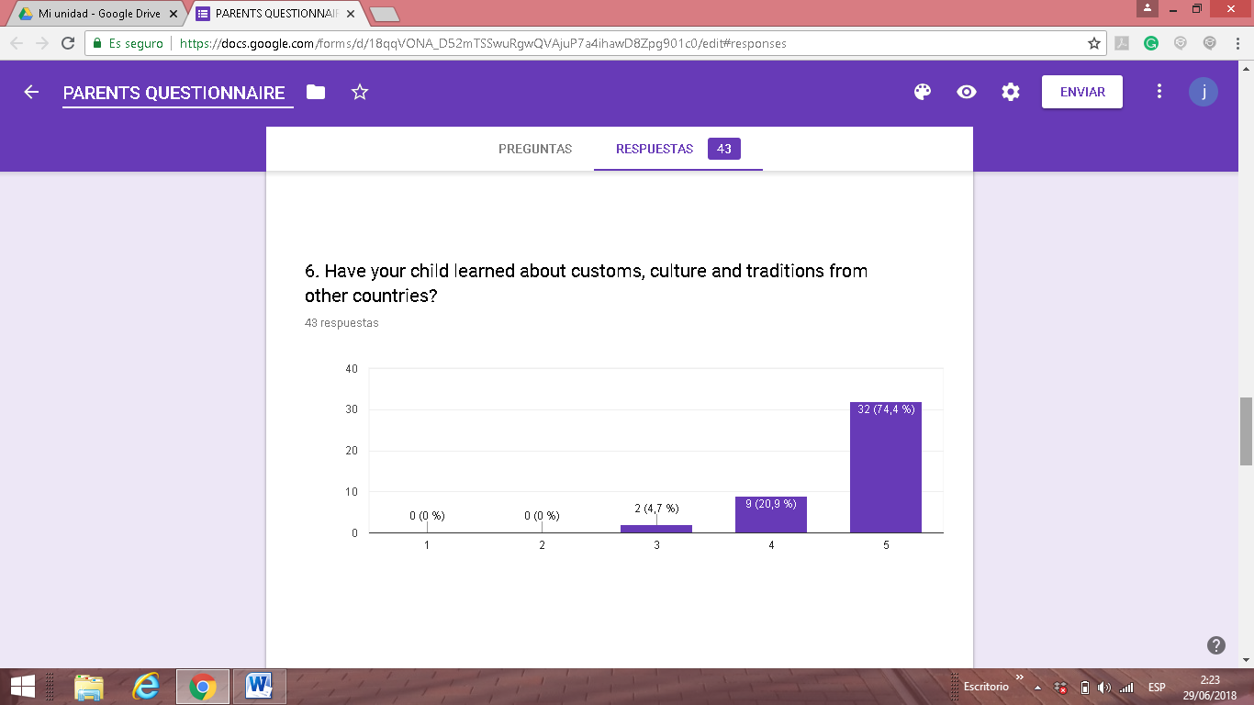
More than 95% of the families answered that their children had learned a lot about customs, culture and traditions from other countries.

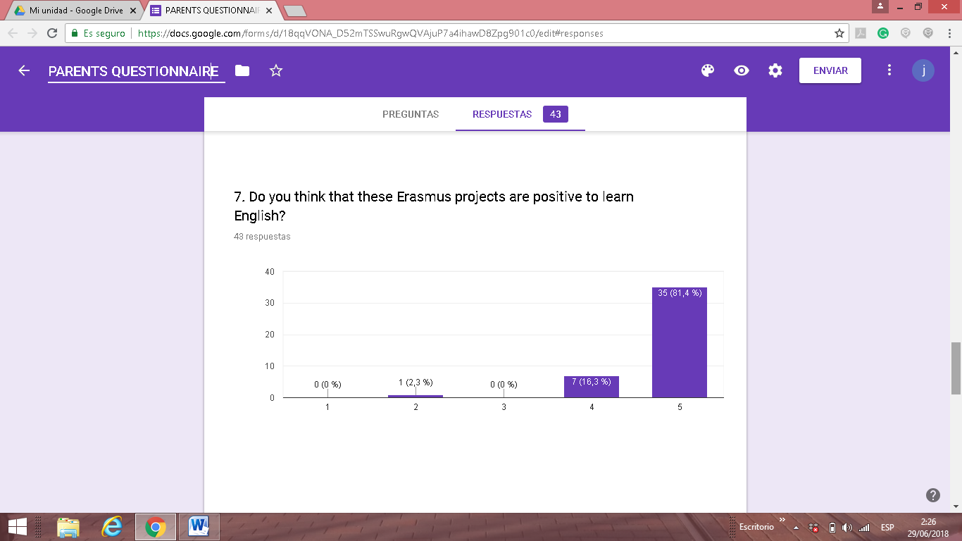
Almost 98 % of the families think that these kind of projects are very useful to learn English and only one family answered that are not to much useful for this purpose.
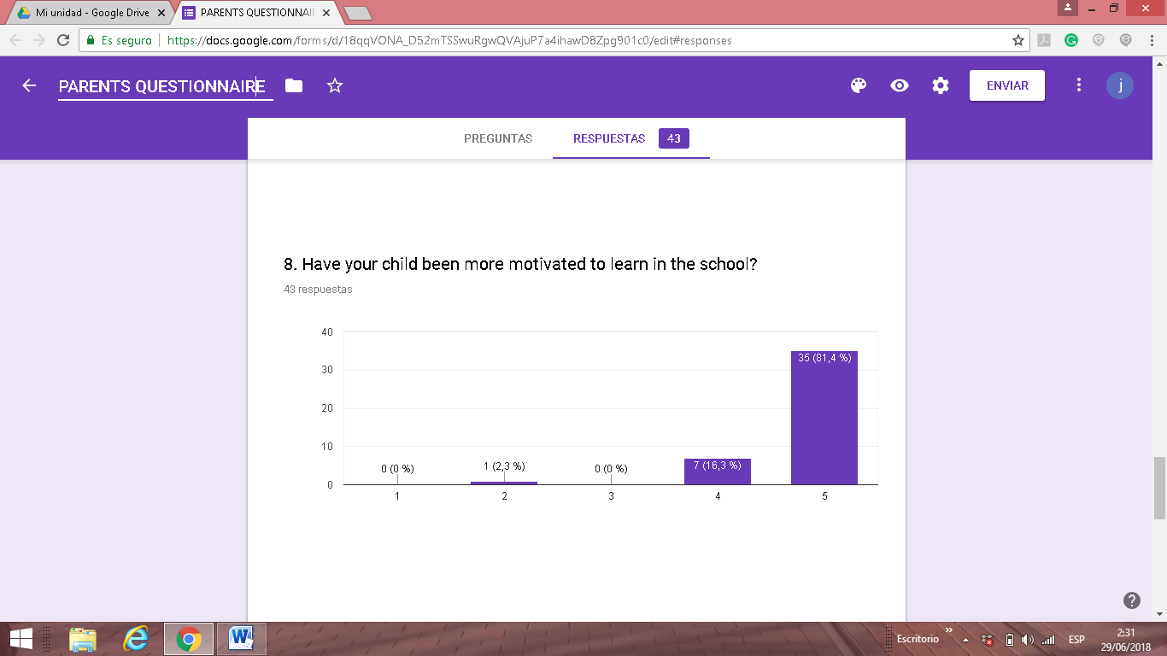
42 out of 43 families think that their children had have more motivation to learn with the project activities (98%). Only one family doesn´t think that our project increased their child´s motivation.

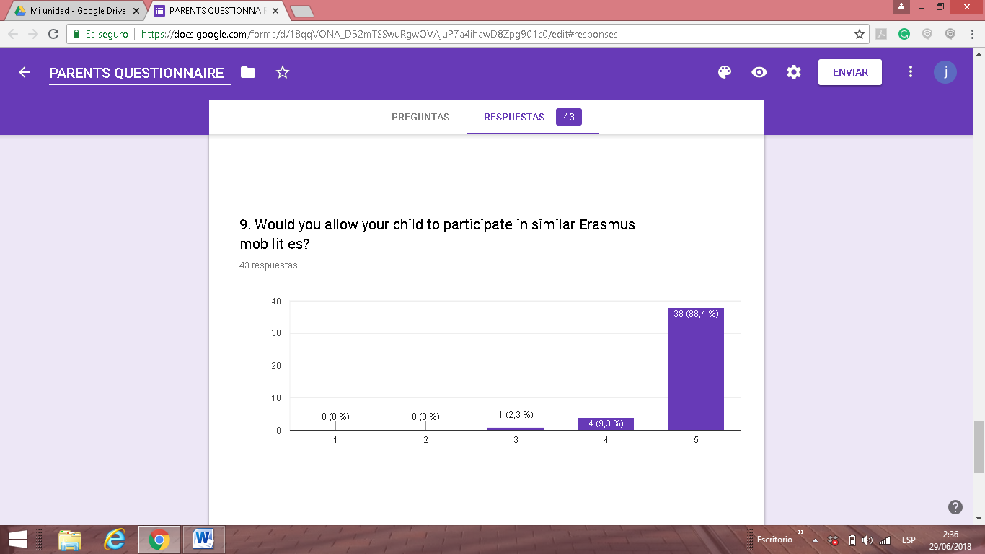
98% of our families will allow to take part in similar mobilities to their children . After coming back from our trips our families have changed their minds about our mobilities in a very positive way.
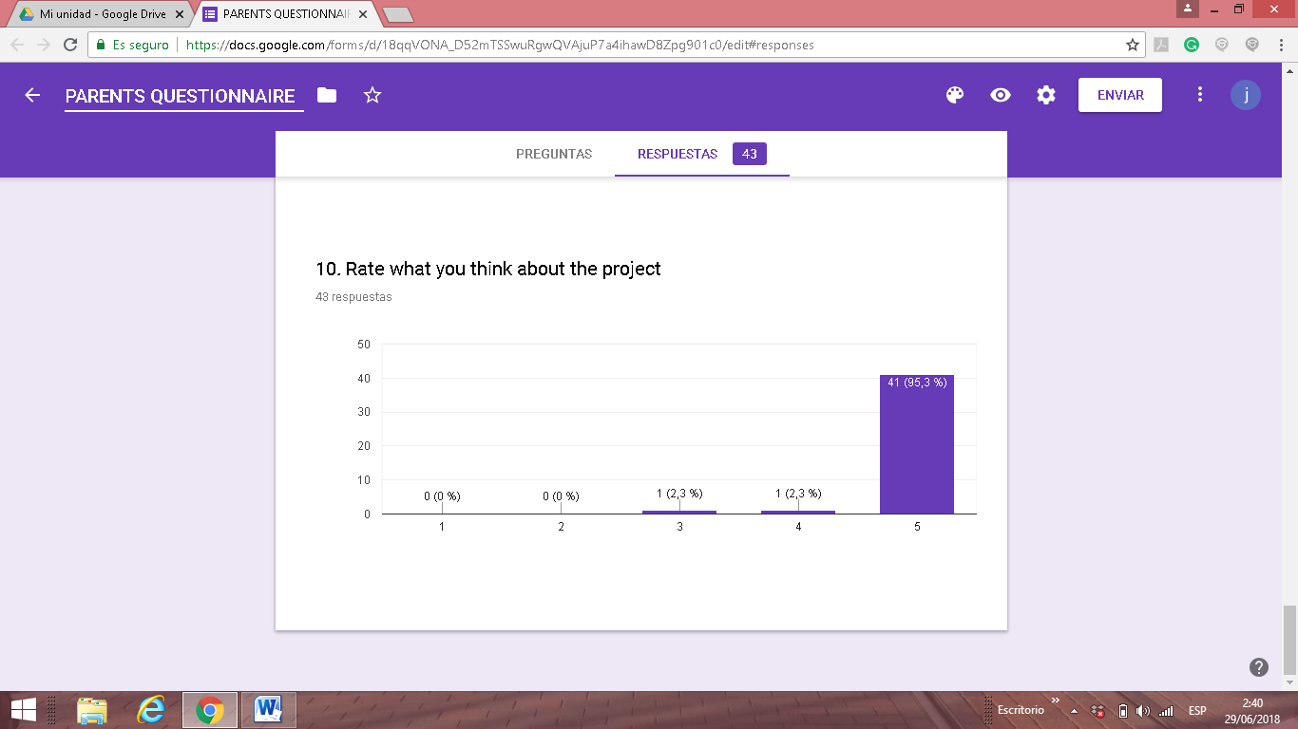
41 families out of 43 rated this project with the highest scoring
One family rated this project with 4 in a scale from 1 to 5
One family rated this project with 3 in a scale from 1 to 5.

