PROJECT TRAVELLING AROUND TALES AND STORIES:
SURVEY RESULTS
STUDENTS QUESTIONNAIRE TO ASSESS MOTIVATION TO LEARN
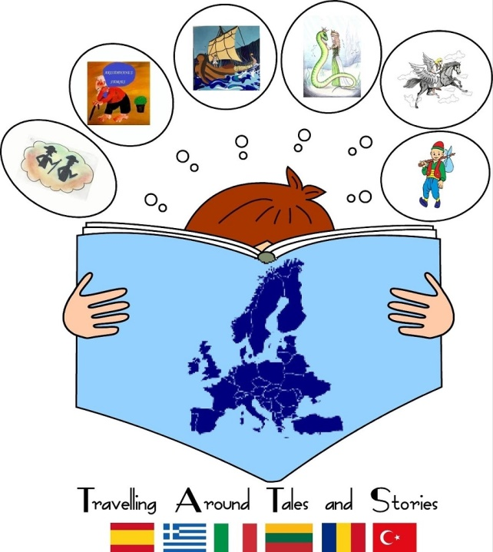

SAMPLE: 137 STUDENTS
TOOL: GOOGLE FORMS
NUMBER OF QUESTIONS: 10

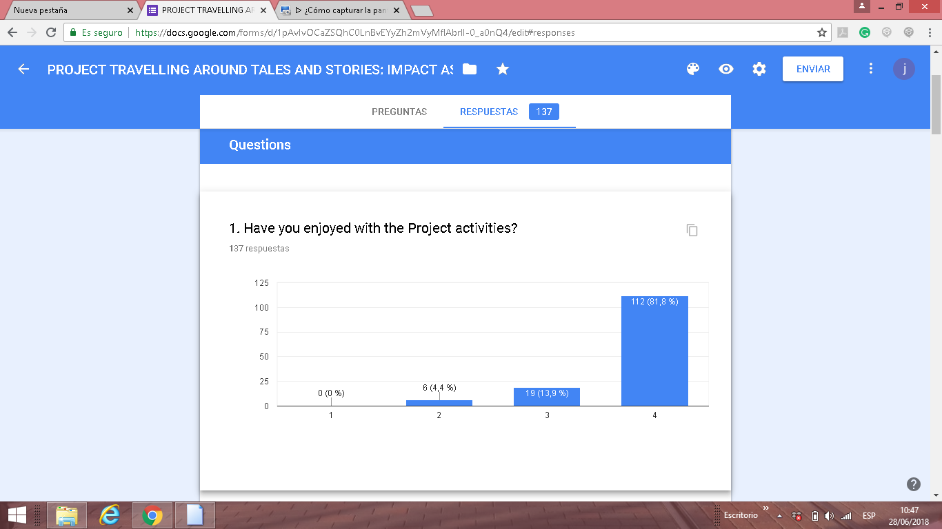

81´8 % of students have enjoyed a lot with the Project activities according with the first question and 0% of the students have no enjoyed.

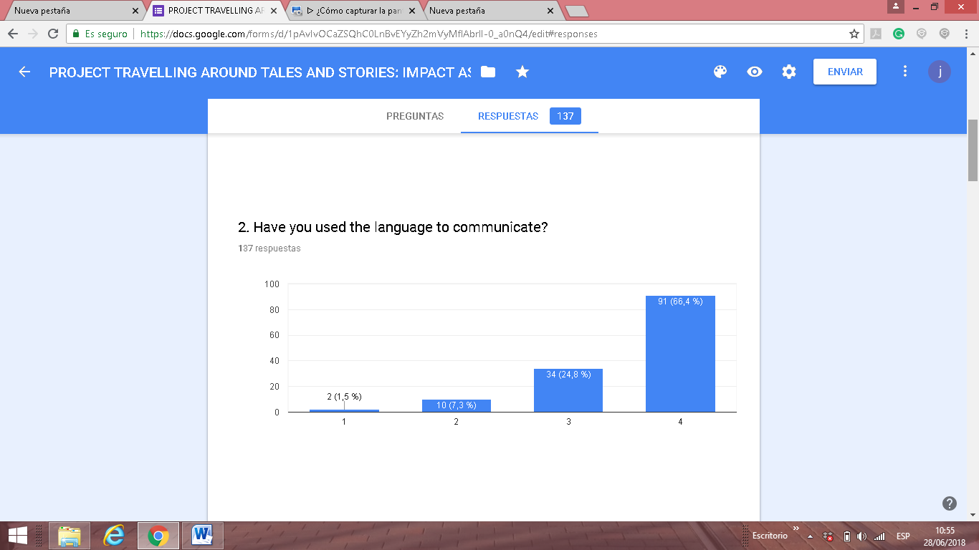
According with the second question, the majority of pupils have used the language to communicate in our project activities 66´4% of pupils answered
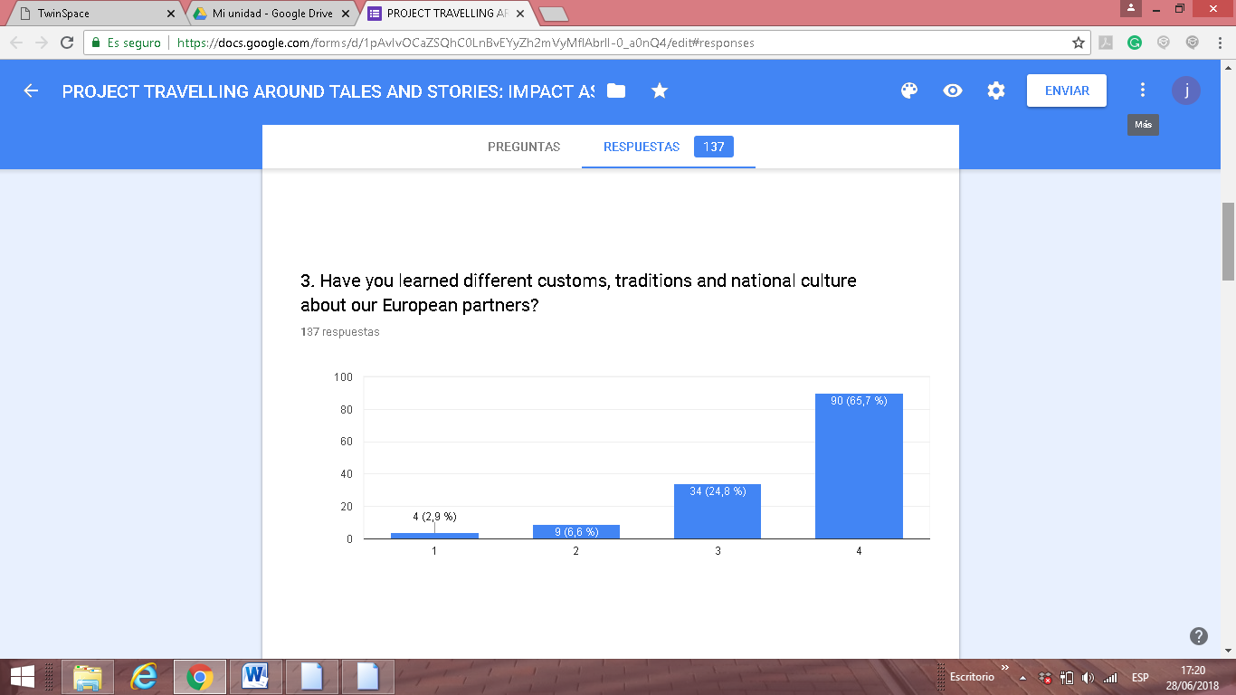
90 pupils have answered that they have learned a lot about customs, traditions etc from other European countries. (65,7%). Only 4 pupils (2,9%) have answered they have learned a little.

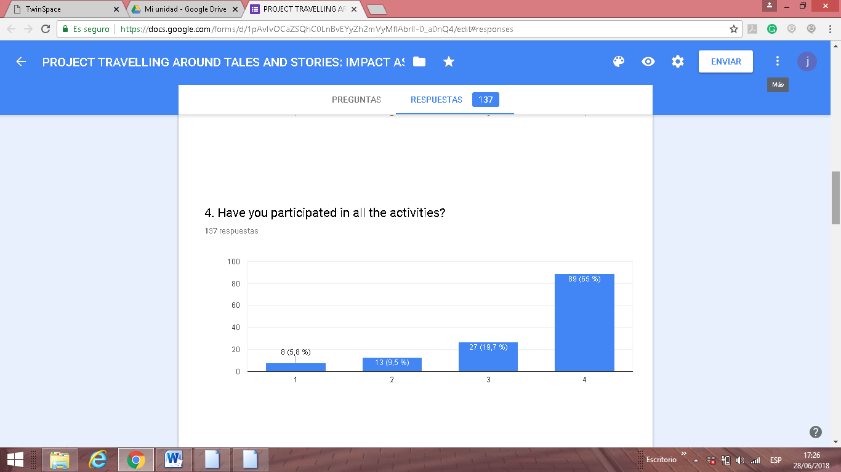
The majority of pupils have participated in all the activities to some degree but only a small percentage 5,8 % have not participated in all of them.

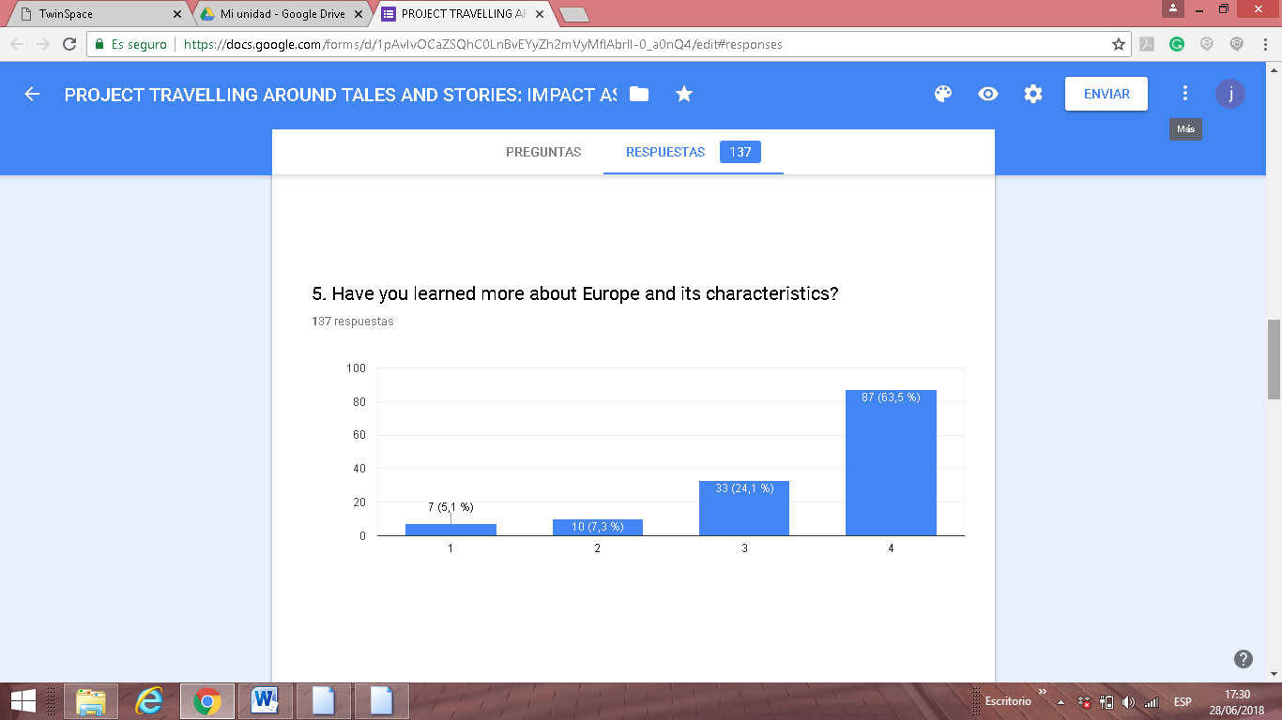

The majority of pupils have learned a lot about Europe, this project has been very useful to learn geography about our different countries, history etc. Moreover, we have integrated important European values like diversity, integration etc

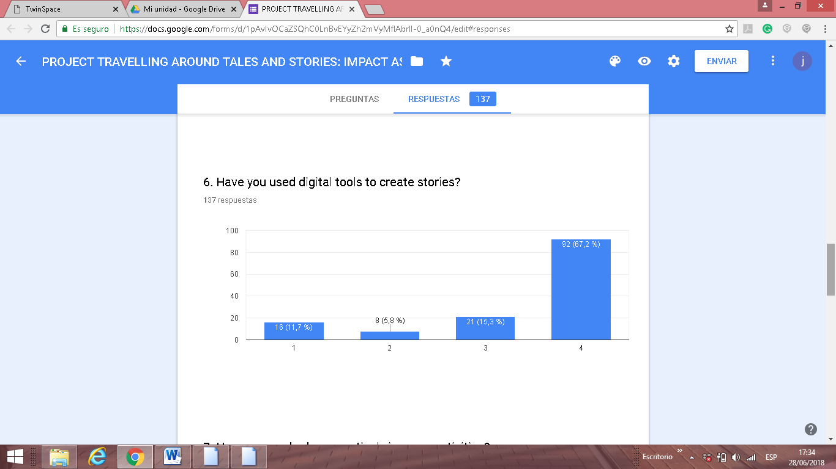
This project has been very useful to use digital tools in our daily teaching.
92 out of 137 students answered 4. However, 11 % of students have
used them because they are kindergarden students and they work with
their teachers help.
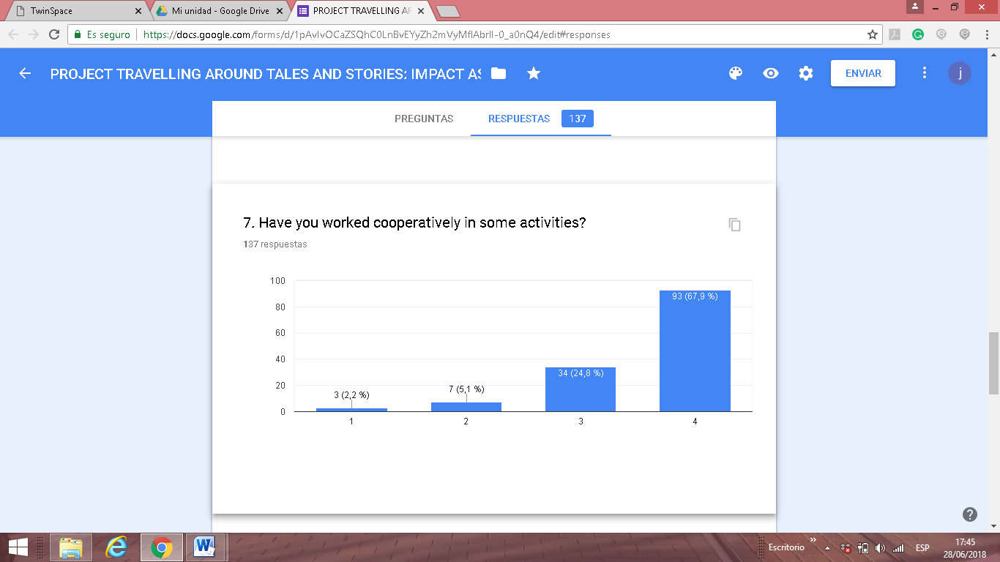
The majority of students have worked cooperatively in our activities.
As we can see 93 students have answered the best rating due to the fact
We have developed a lot of cooperative techniques in our project.

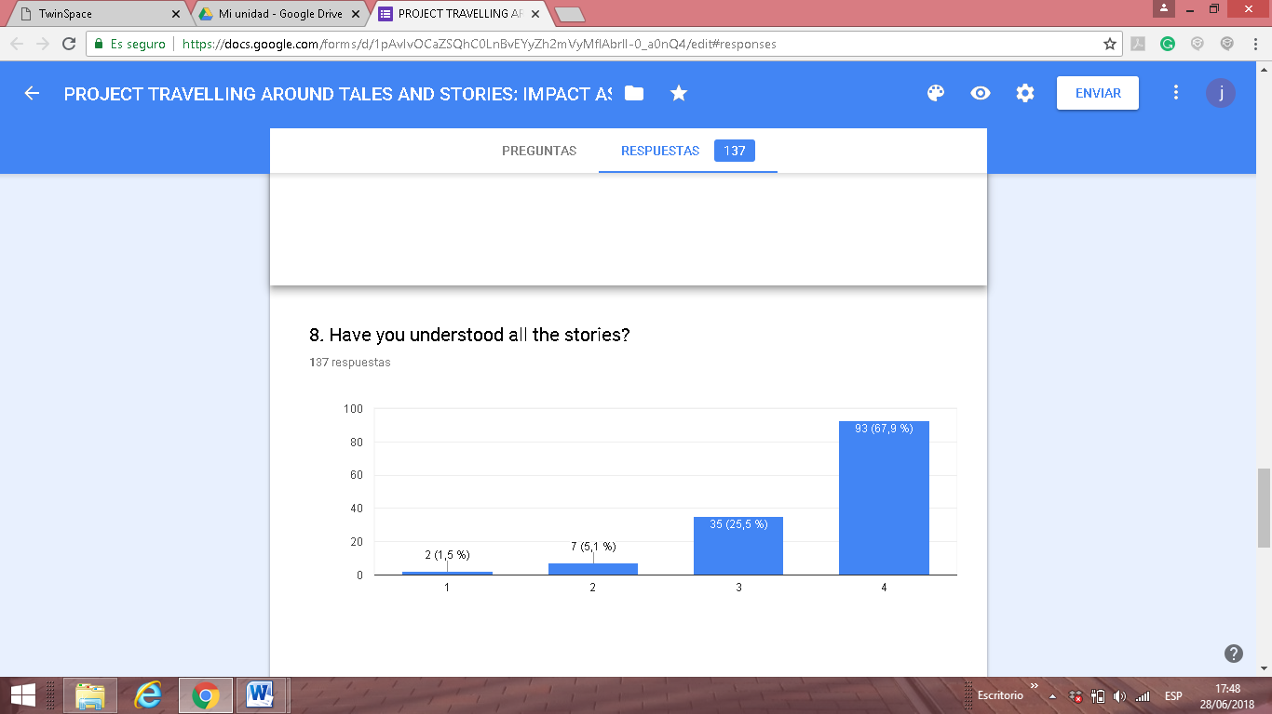
127 out of 137 students have understood our six traditional stories.
These stories were worked applying different methodologies.
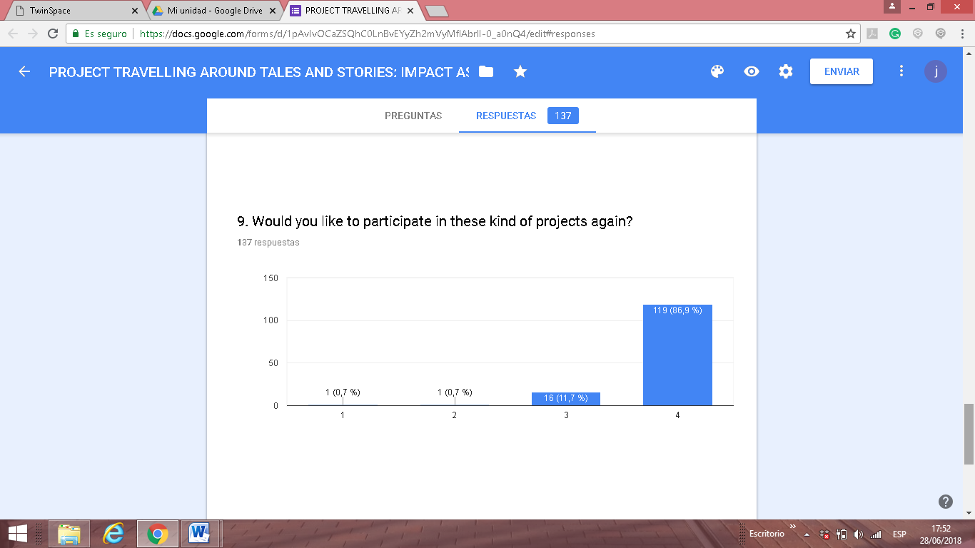
The majority of students have answered that they want to participate in a
project like this one. It has been motivating for our pupils and very impor-
tant inside our institutions.

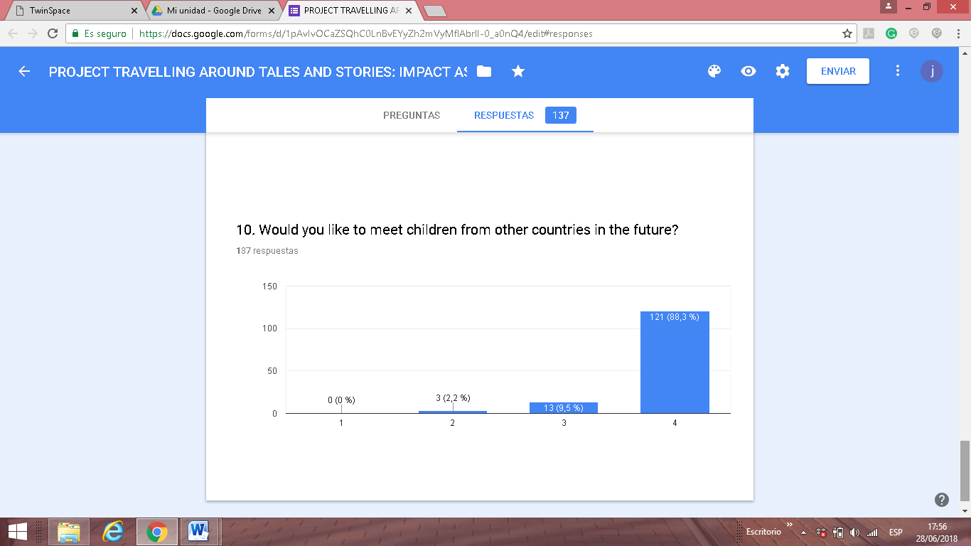
The majority of students want to meet students from other countries in
the future, Our activities have allowed them to interact with them in
different ways: skype meetings, visits, etc

