HOLIDAYS AND FESTIVALS IN BULGARIA
BULGARIA is a country with long history and culture. Its geographical location, namely the crossroads between 2 Continents define the role and place of contact and cultural exchange between different peoples and nationalities.
Christmas- Koleduvane
Christmas - Christmas is among the most revered holidays in Bulgaria. Celebrated from 24 December-Christmas Eve when preparing an odd number of meatless dishes. Carollers is one of the traditional Bulgarian customs. Koleduvane time is strictly determined by tradition - from midnight to sunrise on Christmas Eve. Waits with their songs have the power to expel evil spirits. Carols are performed in carolling tradition - Christmas Eve battalions of young men "carol" led by an older man called "stanenik" walk a predetermined neighborhood and sing songs on the road, the house and the house as it was in those songs They are dedicated and host (master), the shepherd, hunter, priest, bride, maid bachelor little boy or girl. Waits are traditionally festive clothing and special decoration of hats. Generally they are ritually wishes for happiness in the family.
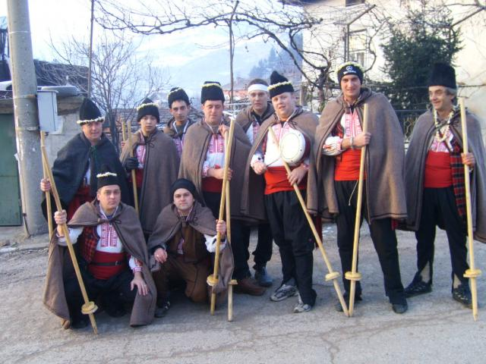
Grandmother Marta
Grandmother Marta is a mythical character in Bulgarian folklore. There is no similar festival anywhere in the world. With Baba Marta and March connect many customs and festivals dedicated to the coming spring. The most famous custom associated with Baba Marta is zakichvaneto people and young animals Martenitza (twisted white and red thread) on March 1 - the day of the arrival of Baba Marta. Throughout the month of ceremonies to banish snakes and lizards, and divination associated with some migratory birds. Most children enjoy. Red grandmother tie each child martenitsa for health and luck.
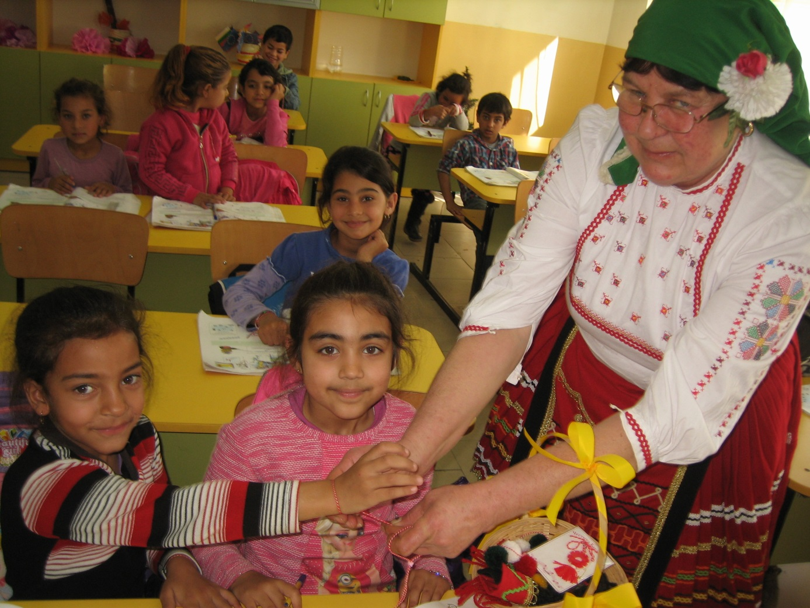

3rd of March
Third of March is one of the brightest and sacred dates in Bulgarian history -NATsIONALEN holiday in Bulgaria. . This is the day of liberation of Bulgaria from Ottoman rule, the restored Bulgarian statehood .On this day tribute to the heroism of the thousands of warriors who gave their lives in the name of Bulgaria. We express our tribute to all known and unknown Bulgarian patriots who contributed to the liberation. Bulgarians celebrated with military parades and processions, with ceremonies, songs and poetry. Students made posters and boards in honor of the holiday, recite poems and sing songs. Bulgaria celebrates.
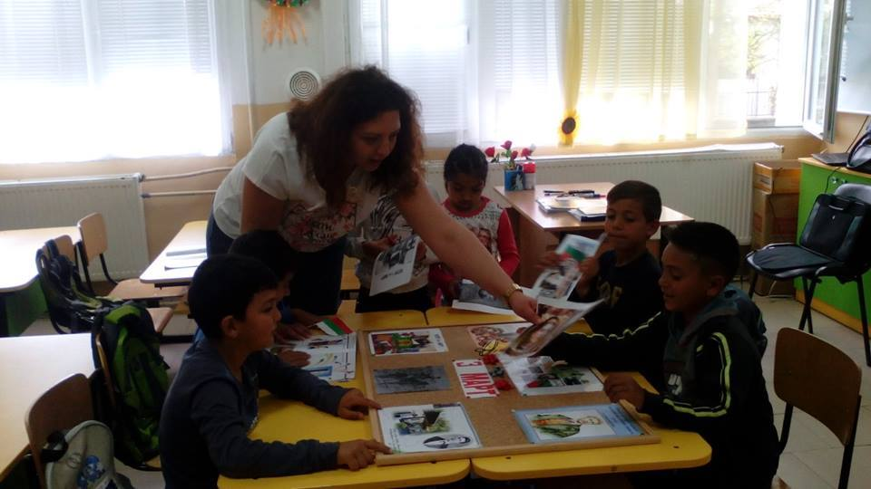
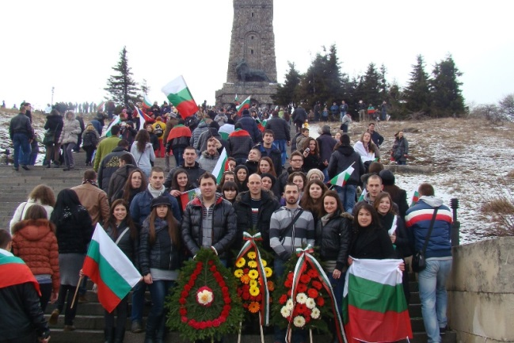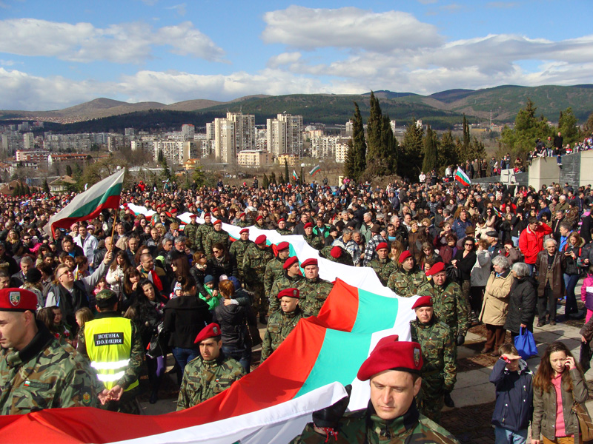
Easter
Easter (Easter, Passover) is the day on which Christians celebrate the Resurrection of the Son of God, Jesus Christ. In the Christian religion Easter (Easter) celebrates the resurrection of Jesus Christ on the third day after being crucified and buried. In Bulgaria traditionally painted eggs on Maundy Thursday or Holy Saturday, their number depends on family members. The first is always colored in red of the older woman. While it is still warm and fresh paint, she painted sign of the cross on the foreheads of children to be healthy. Children draw pictures, Easter eggs made of paper and other materials.
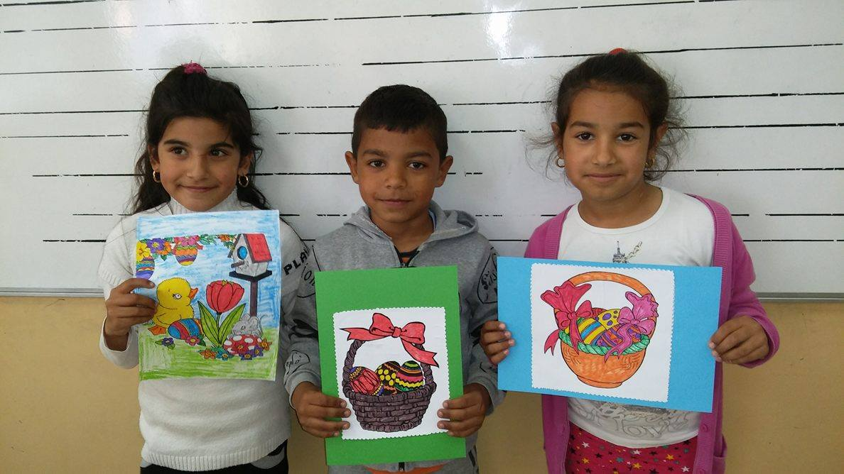
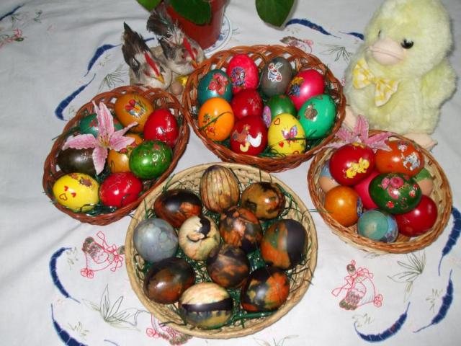

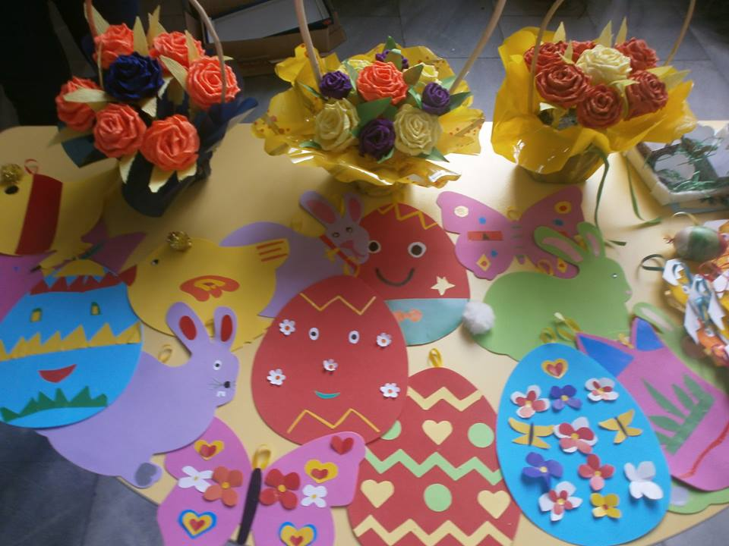
St. George
St. George's Day in Bulgaria is called the day which celebrates St. George, May 6th. It was declared a public holiday in the Republic of Bulgaria and the Day of the Bulgarian Army. It is celebrated as a holiday of a shepherd. Festive table is made somewhere outside the village of greenery - usually in consecrated ground, a chapel and monastery (if there is one nearby). After sanctify it carry baked lamb, ritual breads, fresh milk and the curd cheese from him.
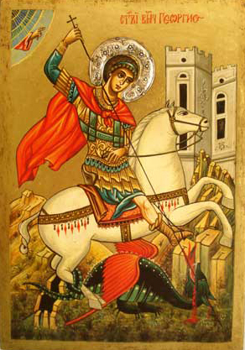
Day of Bulgarian Education and Culture and Slavonic Literature
St. St. Cyril and Methodius
Day of Bulgarian Education and Culture, and Slavonic Literature is Bulgarian public holiday, celebrated on to May 24th. On this day in Bulgaria celebrates Bulgarian Education and Culture and the creation of the Glagolitic alphabet of Cyril and Methodius, also known as Thessalonica brothers. On this day celebrate Bulgarian teachers and cultural workers. Ministry of Education and district centers reward teachers with merit and excellence in education. The whole country manifestira- parade of culture, streets filled with students and teachers, young and old, bouquets and flags.
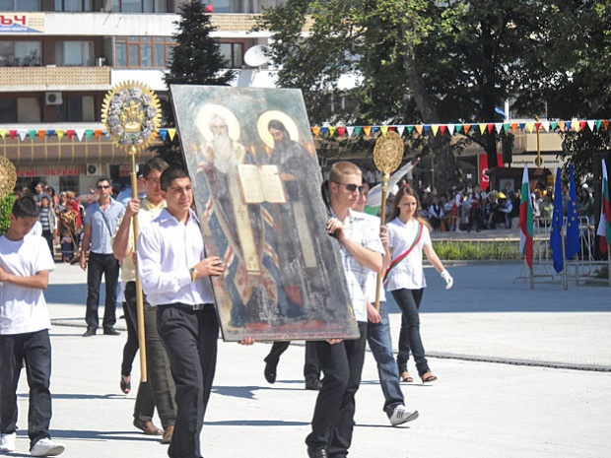
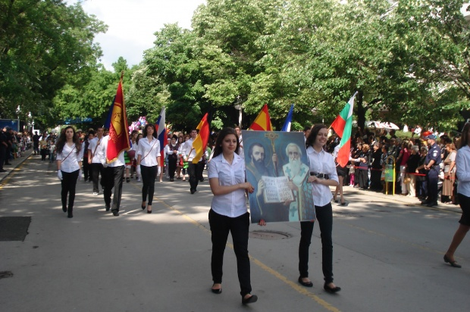

Rose Festival and Festival of Roses
Rose Festival in Kazanlak is the first in Bulgaria and has over 110 years of tradition. First Kazanlak in 1903 organized a celebration in honor of rose flowers and fertility, beauty and appreciation for the livelihood of the Rose Valley. Rose Festival takes place the first week of June, when the newly crowned Rose Queen and begin the climactic three-day celebrations. Saturday and Sunday are filled with festive events such as the highlights are the official rituals Picking and rose Sunday morning and colorful carnival procession of Kazanlak on Sunday at noon, which is the largest street carnival in Bulgaria.
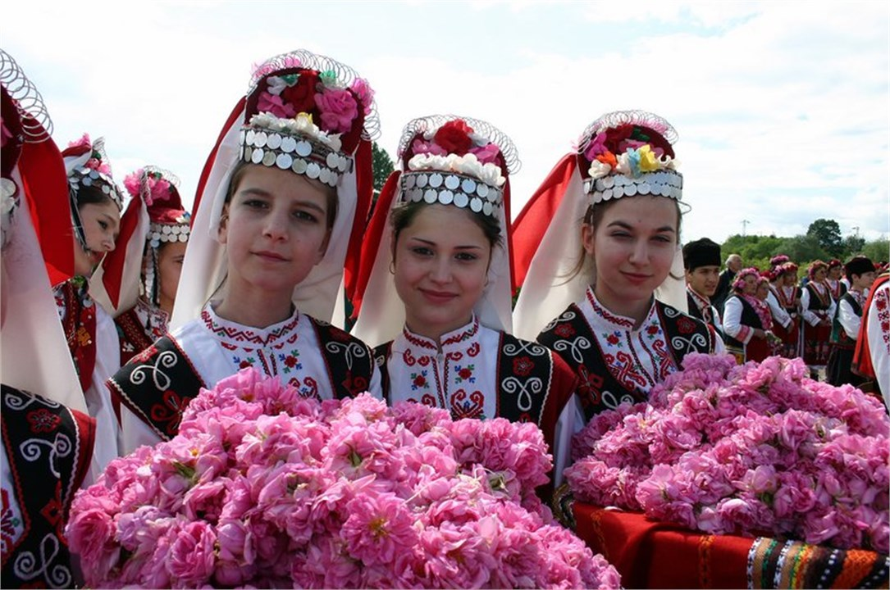
Made by students 1-4 grades from Primary school “Inj. G.Valkov” in Lukovit

