CHRISTMAS’EVE
Some days before Christmas’ Eve my sister and I decorate our house, we put the tree and the nativity scene, we also decórate our grandparents’ house.
I have chosen to talk about Christmas Eve since it is the most important day for me and my family, this night the so called Santa Claus comes, when we were small, my father dressed up as Santa Claus to give us gifts and he still continues doing that for my little cousins. At night the family gathers, eats seafood and lamb, then takes sweets and at the end sings a few carols and dances. In my house there is very much Christmas spirit and for us it is important our Christmas Eve tradition. 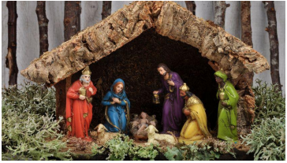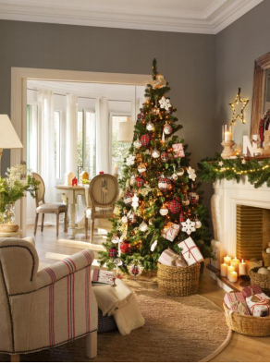Alejandra Sánchez Ferrer.1ºBach

