What is in the Picture?
What you see in the Picture is none other than one of our most characteristic festivals in El Campello: the Correfocs, but what is it exactly?
The meaning of the word Correfocs is “fire-run”. It’s a type of open-air performance during which people dressed as devils and other creatures dance to the sound of a rhythmic drum group and spew out sparks from fireworks attached to forks among the crowd. Those spectators who form part of the spectacle wear protective clothes, which prevent them from getting small burns and other kinds of injuries. They also have the opportunity to get as close as possible to the devils, so they can run through the fire. The rest of the spectators watch this from a “safe” zone retreating if necessary. During this event, in all of the streets it takes place, all lights are turned off. It is celebrated the 9th of October at 00:00 hours. Additionally, the shops and buildings are protected to avoid any damage due to fireworks.
In this picture it is visible a representation of a dragon, which has a lot of fireworks attached to it and as you can see at the end of the street, there’s a firework curtain where the people can cross through it. The people dressed in red are the ones that take care of it and run or dance between the fire curtains. This tradition comes in all shapes and sizes, and it can be held differently in every town.
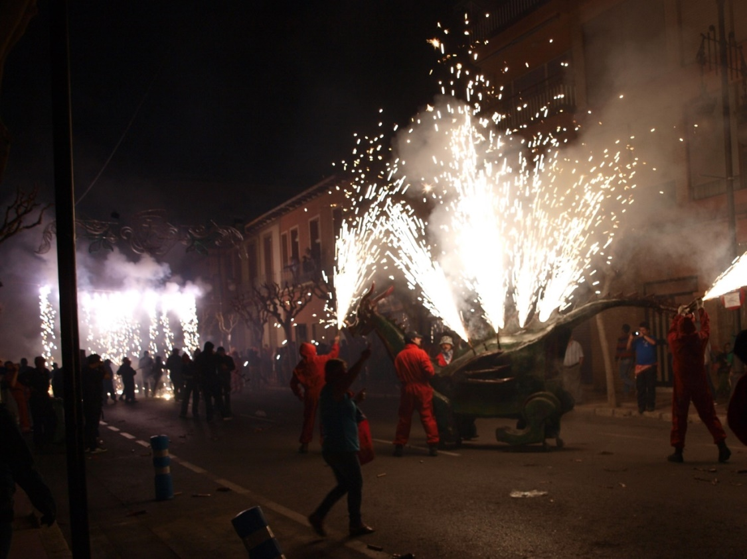
It is fantastic to start Moors and Christians!!!

