CHRISTMAS DAY

For me Christmas is one of the most beautiful times of the year

because the whole family are together.

I think my favorite days at Christmas are Christmas' Eve which is on

December 24th and New Year's Eve.

Christmas' Eve. I like this daybecause we are together as a familyand also for the gifts.

As a child the tradition was to meet for dinner and my

parents left the gifts at the door, somebody knocked on the door and the same night we opened the gifts although the next day we went to myrelatives' houses and they came to ours to exchange Santa's gifts.

We currently have dinner and we give the gifts because we can not

wait until the next day.

Normally we celebrate Christmas Day at home and the preparations are made by all of us even though my father usuallycooks.

What we normally eat is a snack including seafood cocktail, there are always two types of dishes to choose :meat or fish. For dessert we have profiteroles or something similar and also mantecados and

nougat.

A few days before the dinners we decorate the house, my family is a believer and therefore we always set up the nativity scene, we also assemble the Christmas tree with balls, tinsel and Christmas

lights and finally at the door we put a Christmas wreath.

I usually ask for clothes or shoes as a gift but sometimes I ask for a video or a game.

Another day that I like about Christmas is New Year's Eve, which is

the night on which the end of the year is celebrated, I like it because

many emotions come together remembering all the good and bad

that we have lived throughout the year and it is very nice, I usually

get together with my cousins, we dance, we play table games, we

tell anecdotes and then accompanied by the bells broadcast on

television we take the grapes and toast when they have given the

12 bells.

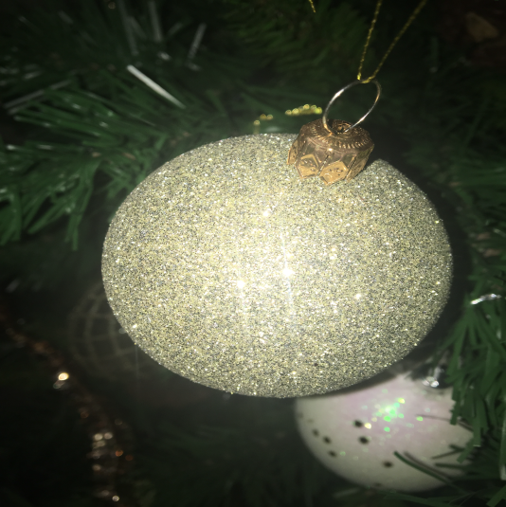

**By: Susana Morales 1 BACH**