MAKE-UP

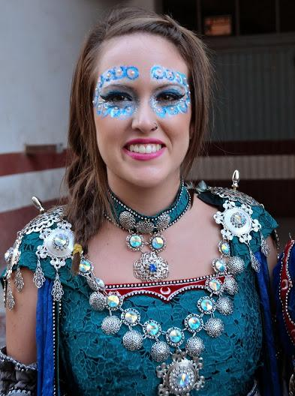

Here we’ve got one of the most beautiful things of this party and also one of the most difficult ones to make, the makeup. People who participate in the parades need to have a makeup inspired in moors or christians, so that makeups and dresses are really beautiful ones.

As you can see at the picture, this girl belongs to a Moorish comparsa, we can know that by paying attention to the colours of the dress and makeup, they are in different tones of blue and green and also white not as Christian ones that are usually red, grey black or yellow. Also in her dress, right at the middle of her chest under the necklace the dress has got a moon, that represents the moorish side. We can also appreciate a lot of jewelry such as precious stones in the necklace or silver things all around the dress
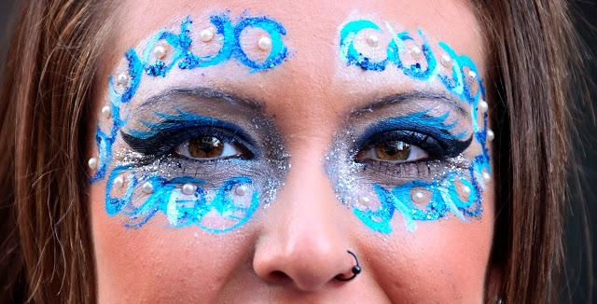

Here we’ve got a detailed picture of the makeup, as you can see it is all made in different tones of blue and represents some kind of moons or waves drawn all around the eyes in light blue, dark blue and white all mixed up and decorated with blue sparkles and white pearls. In the middle of the eyes we can appreciate grey and silver tones, but also, as we said before some dark blue tones too. The main eyeliner is made in dark blue and then there is other kind of eyeliner made with a lighter blue, under and above the eyes we can see some grey shadows, decorated with little silver sparkles.

COSTUMES

Next, we will talk about the dresses that make this party so entertaining to watch, starting with the Christians ones.

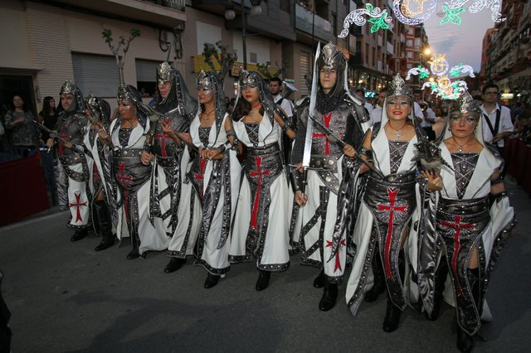

As we can appreciate, Christians dresses are usually white, red, yellow or black. In this picture we can see a comparsa whose dress is white and grey, with a Christian cross in the middle of it. They also use a typical sword that they carry on their shoulders.
It is also important to mention that Cristians comparsas often use shields, flat objects made of metal or leather that soldiers held in front of their bodies to protect themselves in the battlefield.

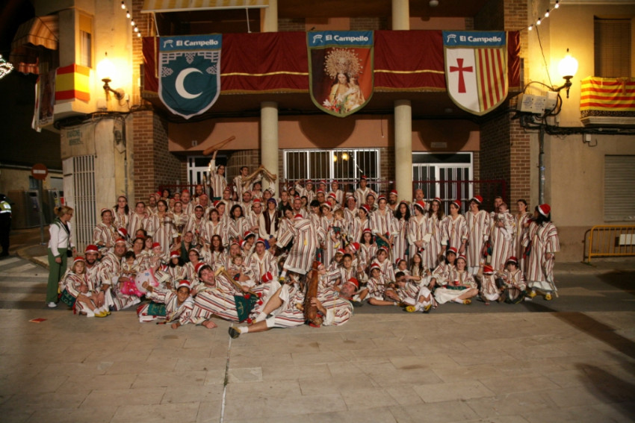

This one, is a moorish comparsa, we can say that by looking at the dresses that they use.They use like white kind of coat with vertical red lines that covers all of the dress.
They also use a red hat and yellow shoes with the tip up, that makes this kind of shoes so characteristic of the moorish comparsa.
Some other comparsas wear green with the waning moon in their dresses as we can see on the top of the picture, but not this one.
(Vera Mauri Ricarte and Javier Gutierrez Marco.1ºBachillerato)

