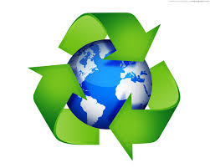

**REUSE – REDUCE – RECYCLE. . .**

**Protect**

**the earth,it’s**

**the greatest sourse**

**for everything…**

**Never forget recycle your rubbish**

**At the four different recycle bins!**

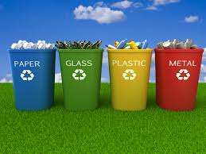

**Don’t throw rubbish in the oceans because the animals which live there are dying every day!!!**

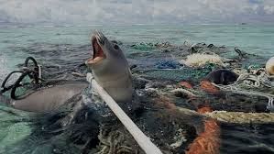**…For a better tommorow**