“BRIAM”

DESSERTS
Biscuits Mother’s Day
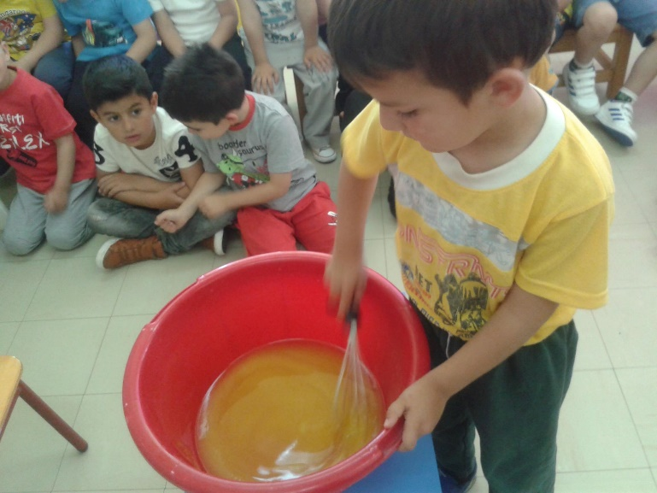
Ingredients:
- 1 cup of olive oil
- 1 cup of sugar
- 1 teaspoon baking powder
- 1 teaspoon baking soda
- 1 teaspoon cinnamon
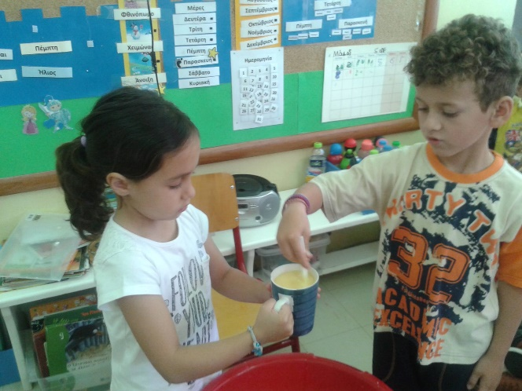
- Juice of 3 oranges
- Orange peel (3 oranges)
- Flour
Preparation:
At first, mix in a large bowl: flour, olive oil, sugar,
baking powder and stir until it becomes a solid mass.
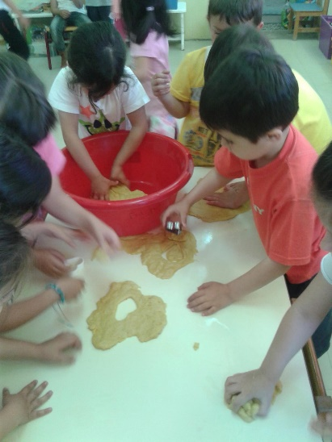
Afterwards, put into the dough the orange peel and
the cinnamon. Then, add in the orange juice, the
baking soda. Stir the mixture and let it rest for a while.
Finally, roll dough and use the stencils to create
handmade heart biscuits. Place them on ungreased
baking paper and let the biscuits about 12 minutes in
a preheated oven.

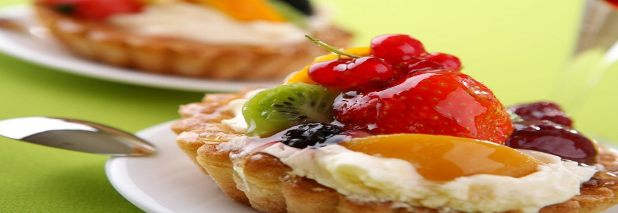

ENJOY!!!

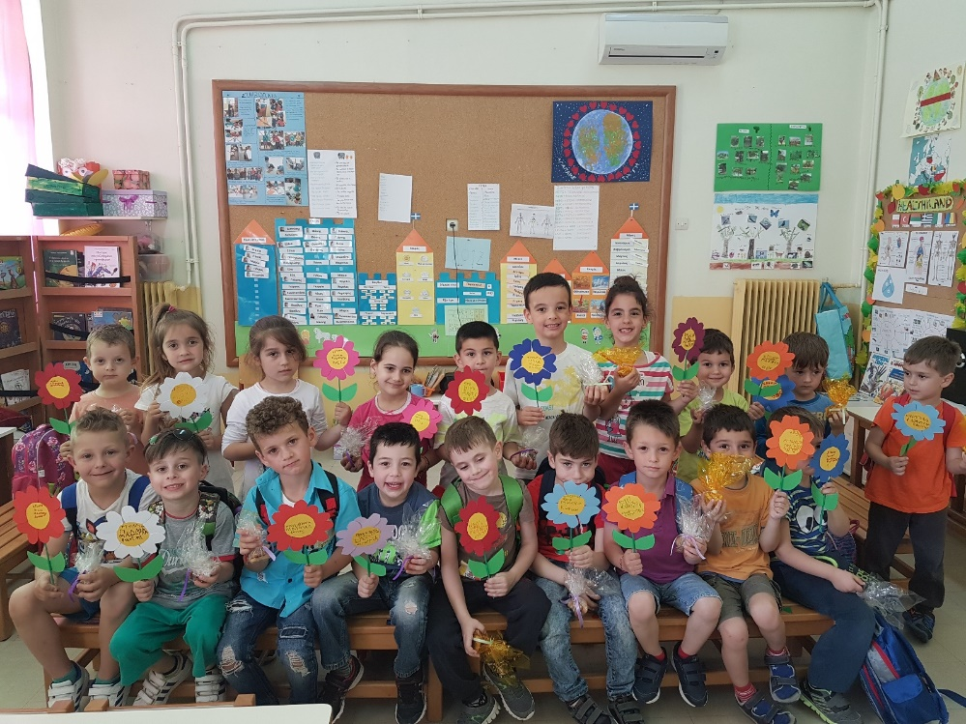
Kindergarten of Avlonari, Evia
2016-1-PL01-KA219-026474_4
Teachers:
Samoutian Margarita
Tsirgioti Eleni
Tatsiou Styliani

