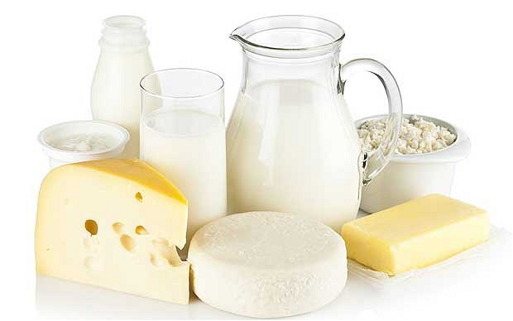
DAIRY PRODUCTS
Cheese Balls
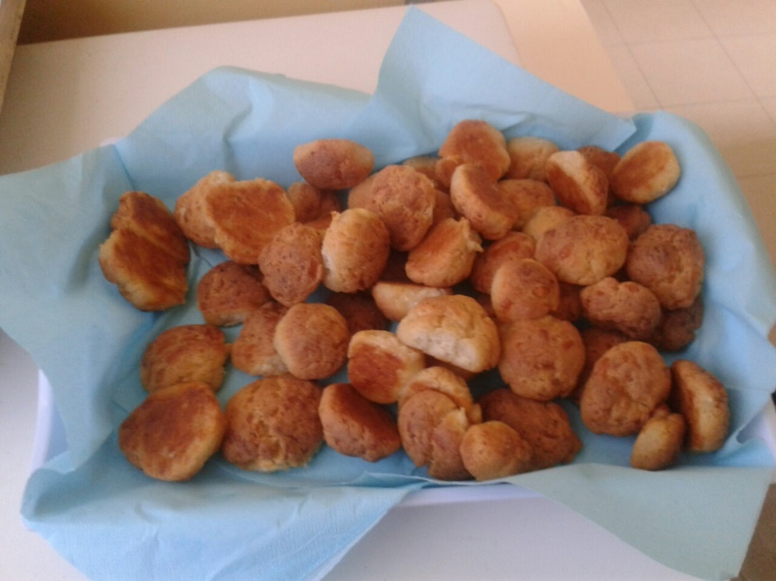
Ingredients:
- 2 cups of sunflower oil
- 2 cups of yogurt
- 2 eggs
- 300 gr cheese
- 300 gr butter
- 2 packs of flour (for cakes)

Preparation:
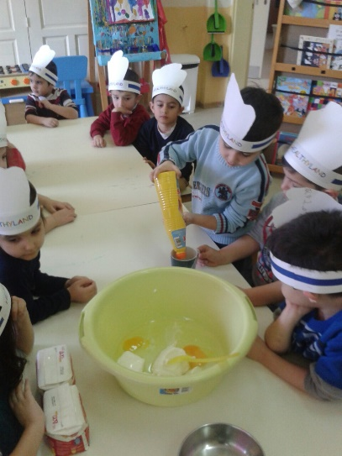
At first, mix all the ingredients
except flour, which is added at the
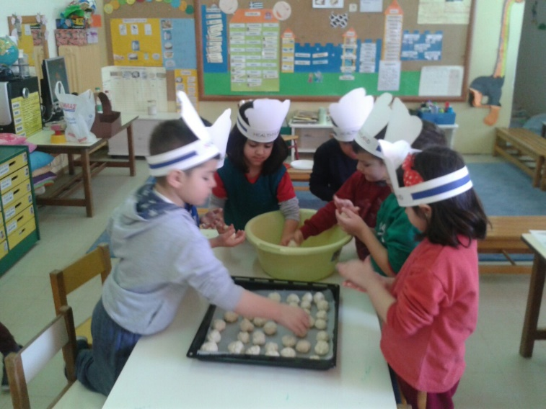
end. The dough should be soft.
Afterwards, make small balls and
put them in the oven at 180 º C until
they have a soft brown color.

ENJOY!!!

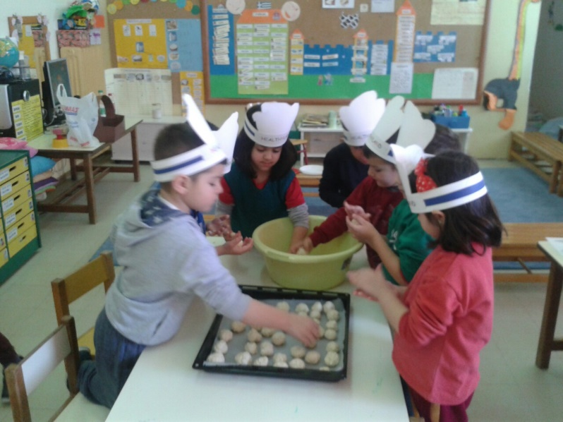

Kindergarten of Avlonari, Evia
2016-1-PL01-KA219-026474_4
Teachers:
Samoutian Margarita
Tsirgioti Eleni
Tatsiou Styliani

