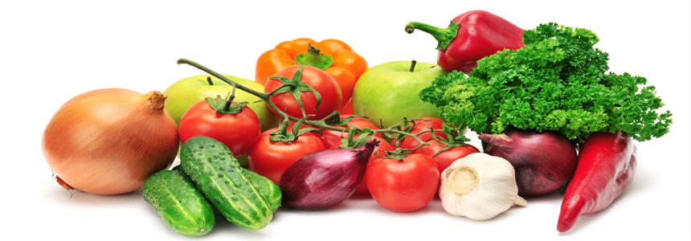

VEGETABLES
Greek Salad
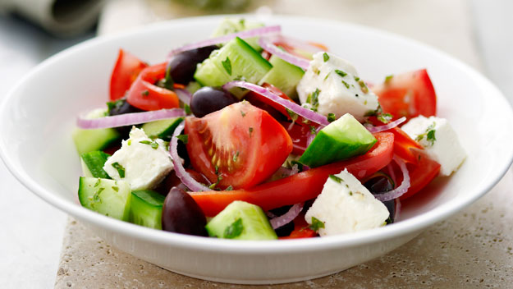
Ingredients:
- 4 tomatoes
- 2 cucumbers
- 2 green pepper
- 1 onion
- Some olive oils
- “Feta” cheese
- Olive oil, oregano & salt
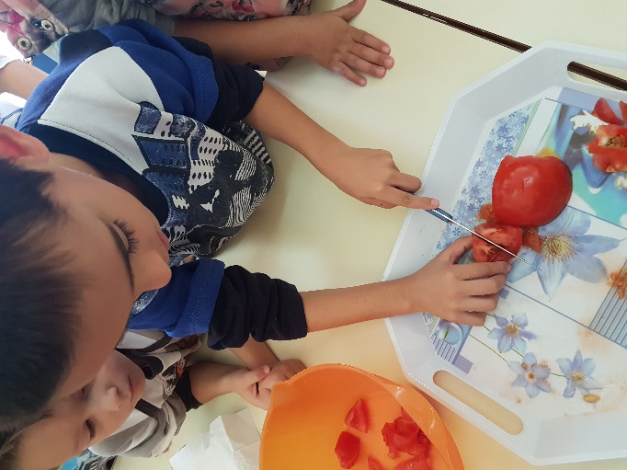
Preparation:
At first, wash and cut the vegetables into small
pieces. Place the tomatoes and the cucumbers at
the bottom of a large bowl. Then, put above
the slices of the onion and the green pepper.
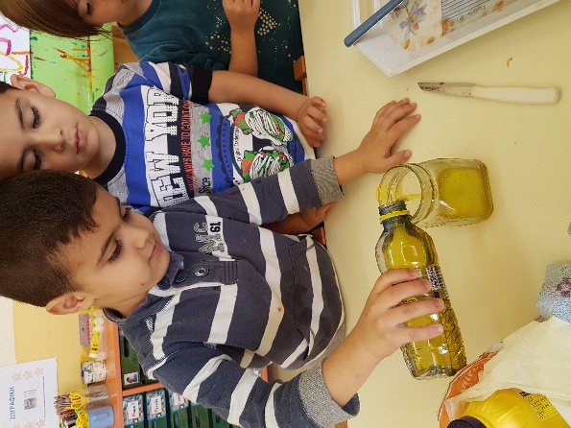
Afterwards, put some olive oils. Finally, place the
“Feta” cheese at the top. Add some
olive oil, some salt and some oregano.

ENJOY!!!

Kindergarten of Avlonari, Evia
2016-1-PL01-KA219-026474_4
Teachers:
Samoutian Margarita
Tsirgioti Eleni
Tatsiou Styliani

