How to create math task in postcards:
Step
1. | Create presentation, video or other about your school, participants.
2. | Share it by link | 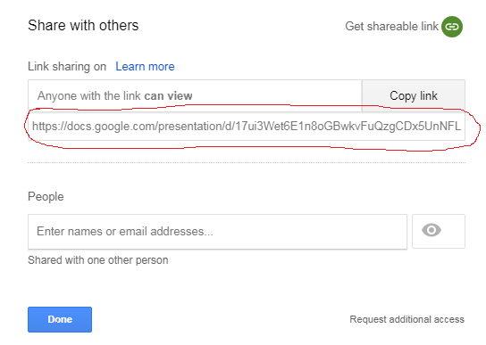
3. | Create linear equalion and solve it. The answer could be natural number. | 7(x-6)=2x+3  x=9
4. | Use http://bit.do/ , copy there presentation link | 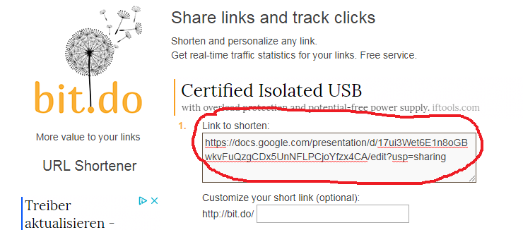
5. | make shorten link using linear equation answer. | 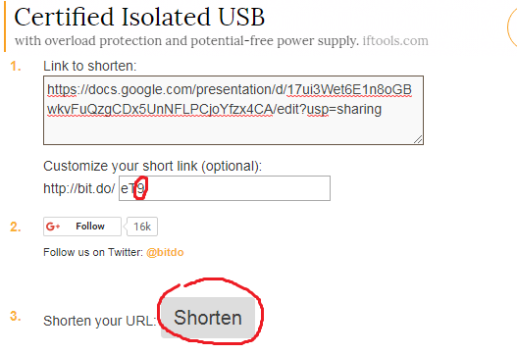
6. | You get short URL
7. | Create discription how the link is formed using the answer of the equation. | 1.Solve this linear equalion 7(x-6)=2x+3  2.Replace x with the linear equalion answer in the link http://bit.do/eTx .
8. | When students solve linear equalion and use it in link http://bit.do/eTx they will get presentation abaut schoool.
9. | Write discription to postcard and send to Project partner

