We come from Greece, Romania and Spain and here you can see what we know about Erasmus+ and what we expect about this project. Below you can see the results:

[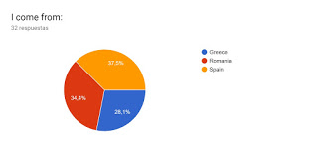](https://1.bp.blogspot.com/-PvZlRxN3pSs/Xa3zyjQc-zI/AAAAAAAAW0s/cYyGisqNI8wYMHQwtVjVRCKC66mLDBohACLcBGAsYHQ/s1600/encuesta1.jpg)

[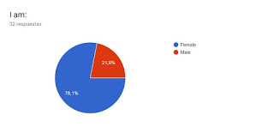](https://1.bp.blogspot.com/-vqLEIDXRfp8/Xa30I_Y81VI/AAAAAAAAW00/yVRYkqVwM288zjg3jjkDOG-E6bDs8MKLACLcBGAsYHQ/s1600/encuesta2.jpg)

[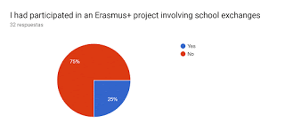](https://1.bp.blogspot.com/-V1y1yIHGupE/Xa30K5QtmVI/AAAAAAAAW04/yurI6WDF2yAY7J_c8532nXRNTZs75DxYwCLcBGAsYHQ/s1600/encuesta3.gif)

[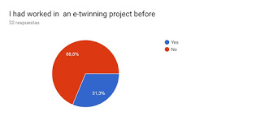](https://1.bp.blogspot.com/-0Ww4G4aPi4w/Xa30Nro1NlI/AAAAAAAAW08/SBtSpIV40hYld7cPdStq0HEdklGOMGS0gCLcBGAsYHQ/s1600/encuesta4.jpg)

[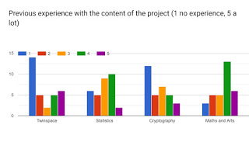](https://1.bp.blogspot.com/-mIKB_lH1RnA/Xa30jRkdY0I/AAAAAAAAW1I/_n_OFqxhTrIHW_166PnDpviQrkVGmhT5wCLcBGAsYHQ/s1600/encuesta5.jpg)

[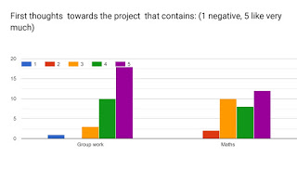](https://1.bp.blogspot.com/-OYHyB3v6SBI/Xa30l0_klBI/AAAAAAAAW1M/I-m9NGqlFtoVLIUYmRBPrqKml1_bWYDBQCLcBGAsYHQ/s1600/encuesta6.jpg)

[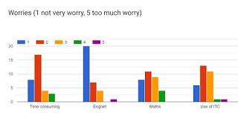](https://1.bp.blogspot.com/-Piwo8Ans4Dc/Xa30nyqgQII/AAAAAAAAW1Q/mLR14Tj3hNQNUsYsIGflw5u1lu3APX3vACLcBGAsYHQ/s1600/encuesta7.jpg)