Caesar’s cipher
In cryptography, a Caesar cipher, also known as Caesar's cipher, the shift cipher, Caesar's code or Caesar shift, is one of the simplest and most widely known encryption techniques. It is a type of substitution cipher in which each letter in the plaintext is replaced by a letter some fixed number of positions down the alphabet. For example, with a left shift of 3, D would be replaced by A, E would become B, and so on. The method is named after Julius Caesar, who used it in his private correspondence.
The transformation can be represented by aligning two alphabets; the cipher alphabet is the plain alphabet rotated left or right by some number of positions. For instance, here is a Caesar cipher using a left rotation of three places, equivalent to a right shift of 23 (the shift parameter is used as the key):
Plain: ABCDEFGHIJKLMNOPQRSTUVWXYZ
Cipher: XYZABCDEFGHIJKLMNOPQRSTUVW
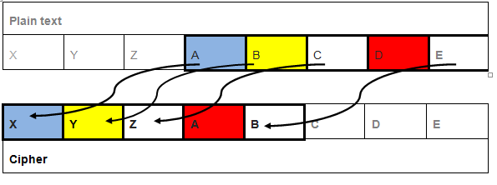
Picture 1. left rotation 3 places

When encrypting, a person looks up each letter of the message in the "plain" line and writes down the corresponding letter in the "cipher" line. Deciphering is done in reverse, with a right shift of 3.
Ciphertext: QEB NRFZH YOLTK CLU GRJMP LSBO QEB IXWV ALD
Plaintext: THE QUICK BROWN FOX JUMPS OVER THE LAZY DOG

Think a famous personality from your country, describe her/him in 5 sentences and cipher these sentences using Caesar Code

