1. Christianity

Determine the area (in m²) of the roof section of this tourist attraction, knowing that the height of the roof is 0.8 m.

2. The First Romanian School
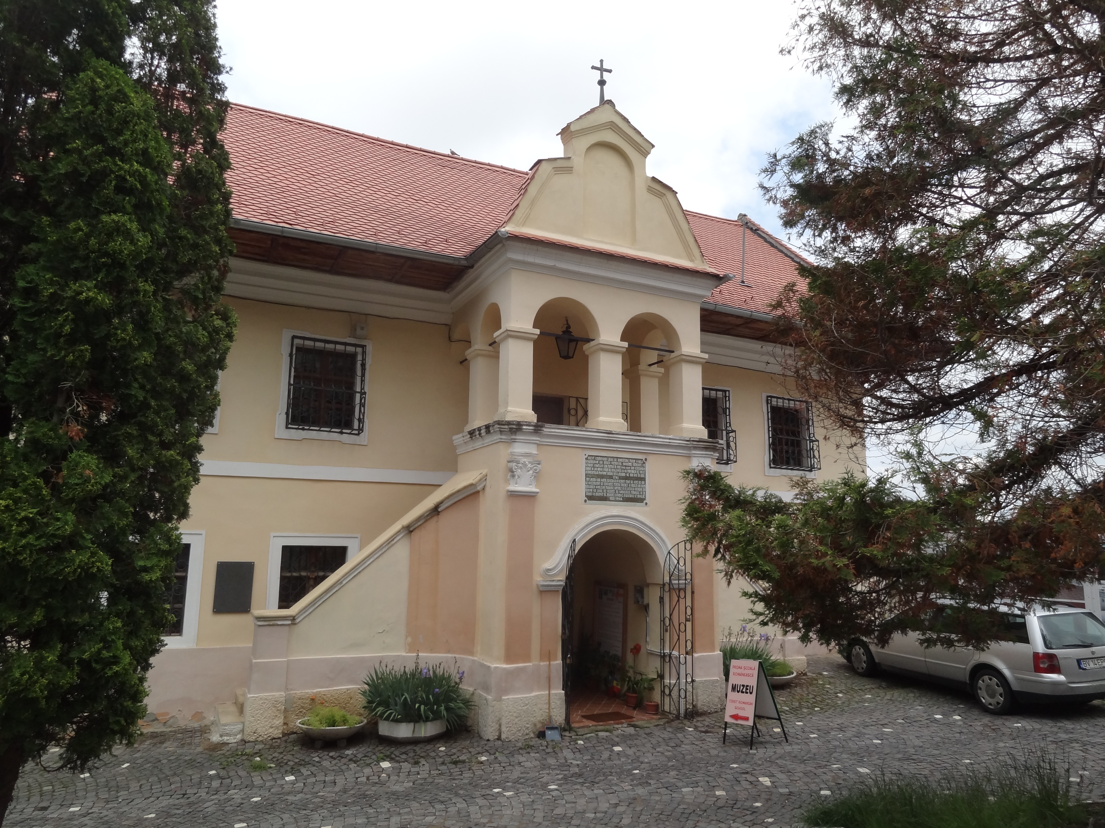
The principal of the first Romanian school wants to cover the teachers' staircase with a carpet. Determine the dimensions (in m²) of the carpet.

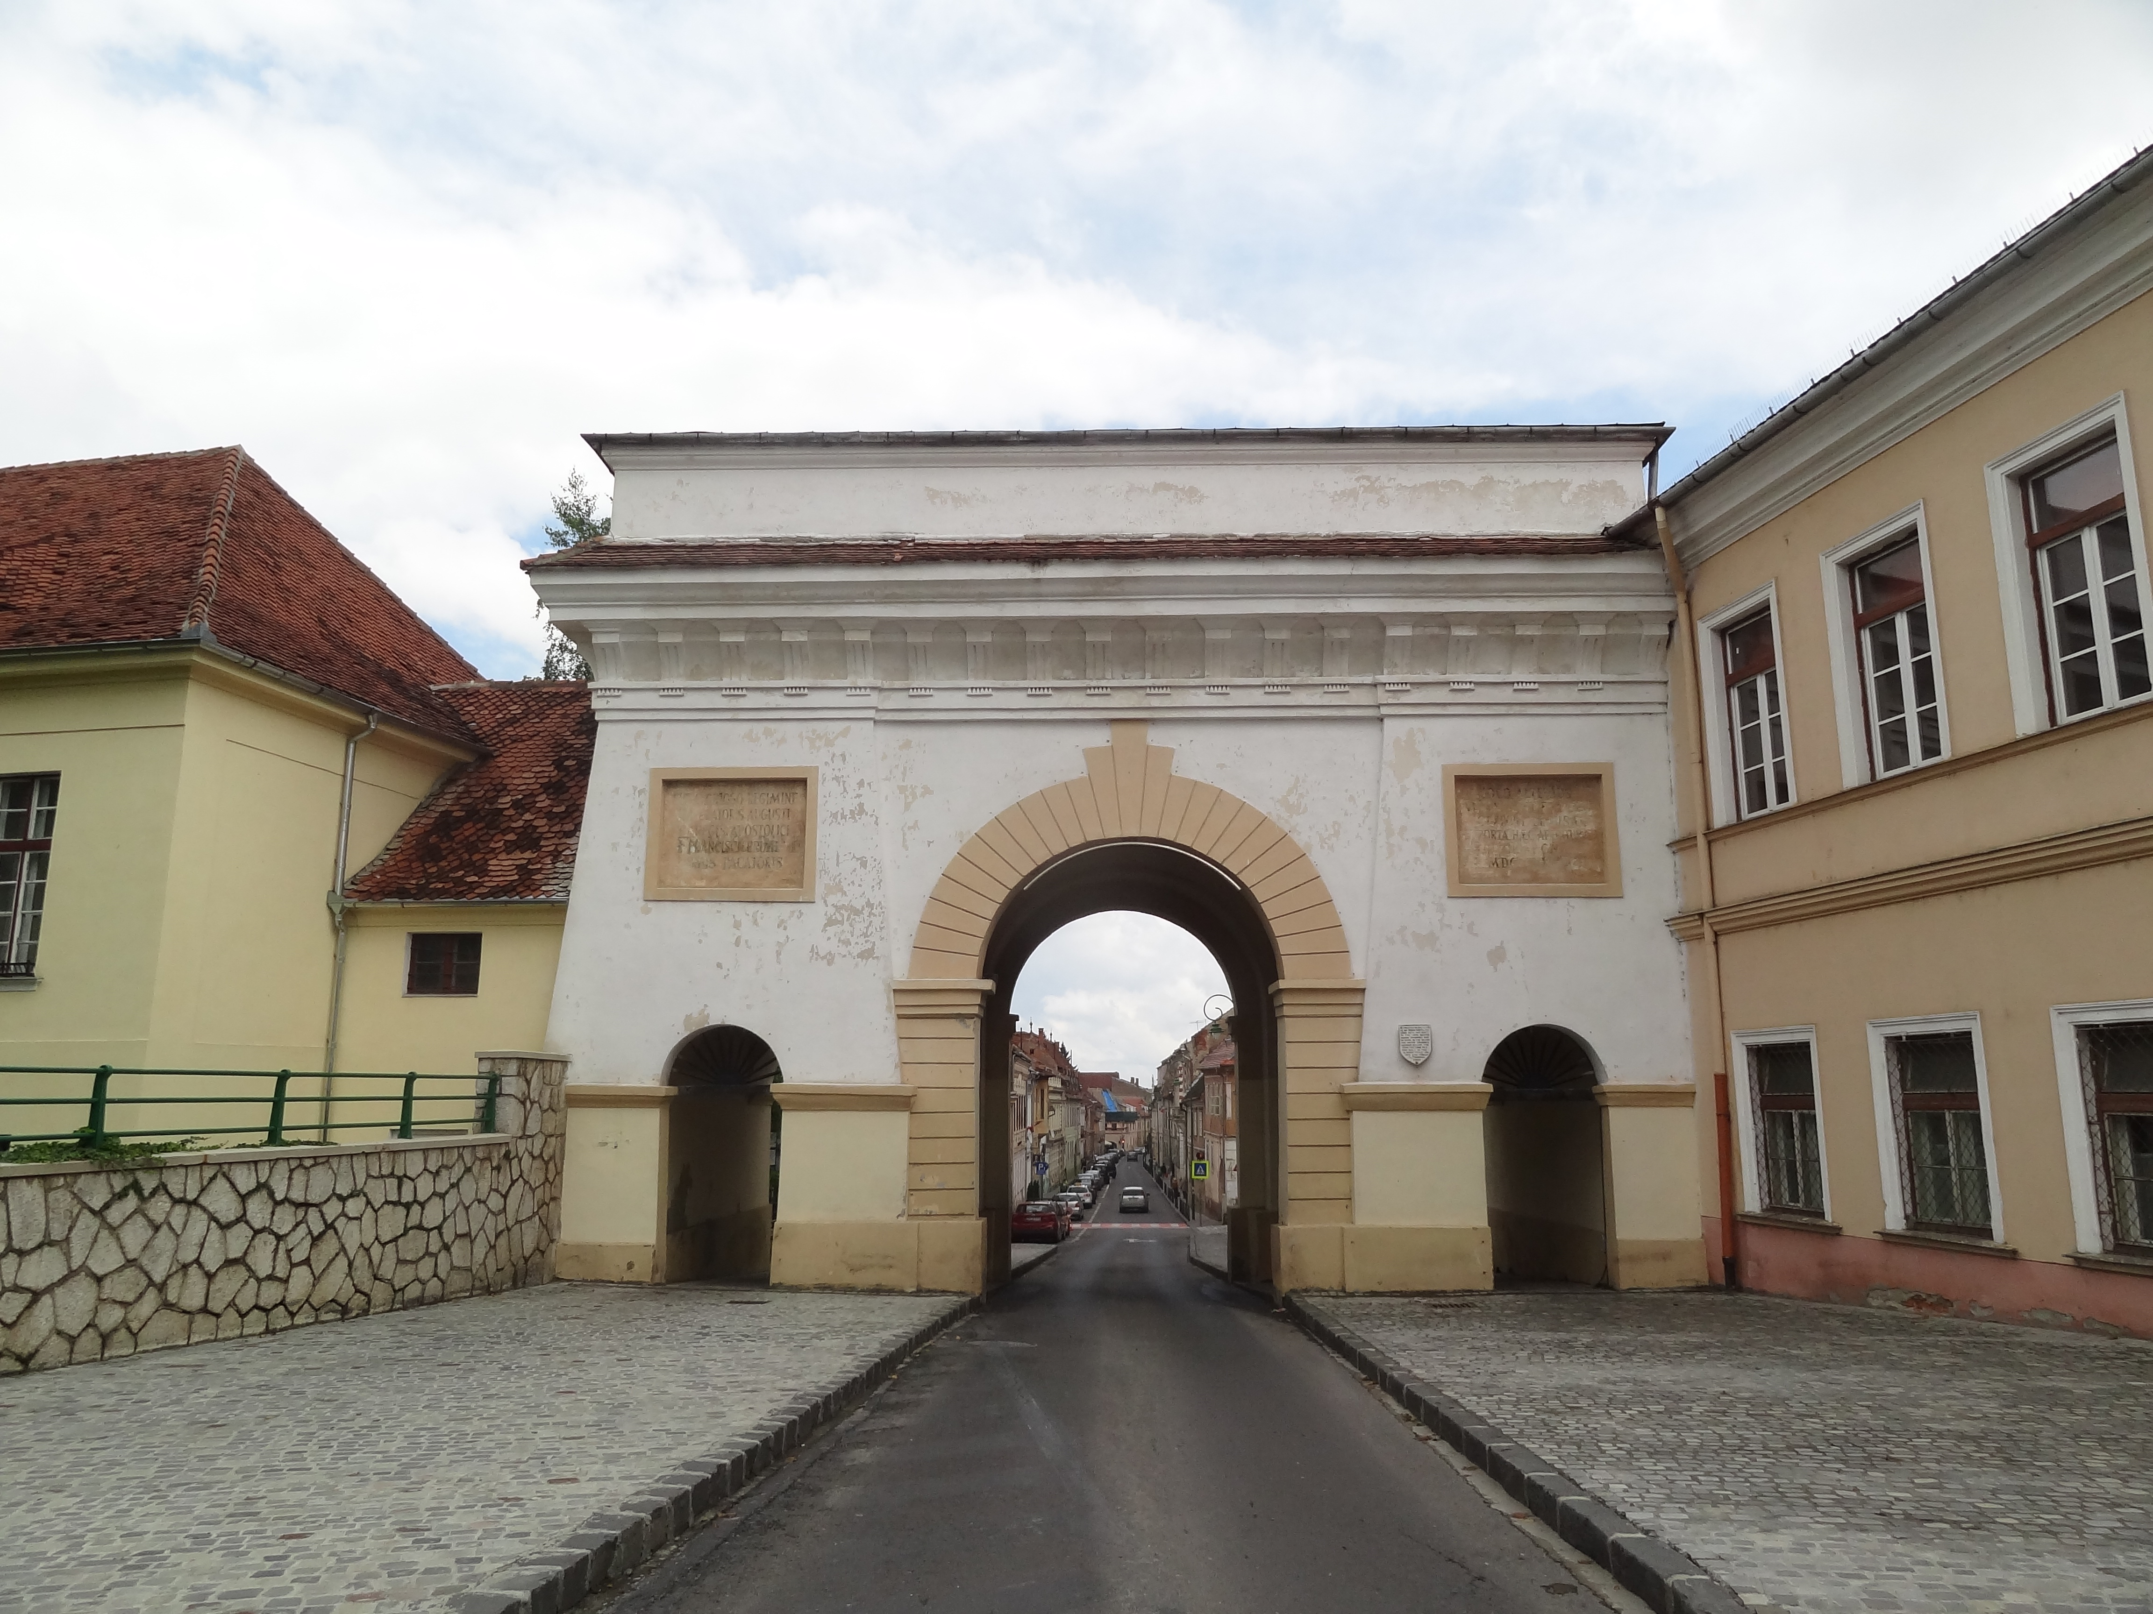
3. Schei Gate
Calculate the width (in cm) of the main gate using your step.

4. Catherine's Gate
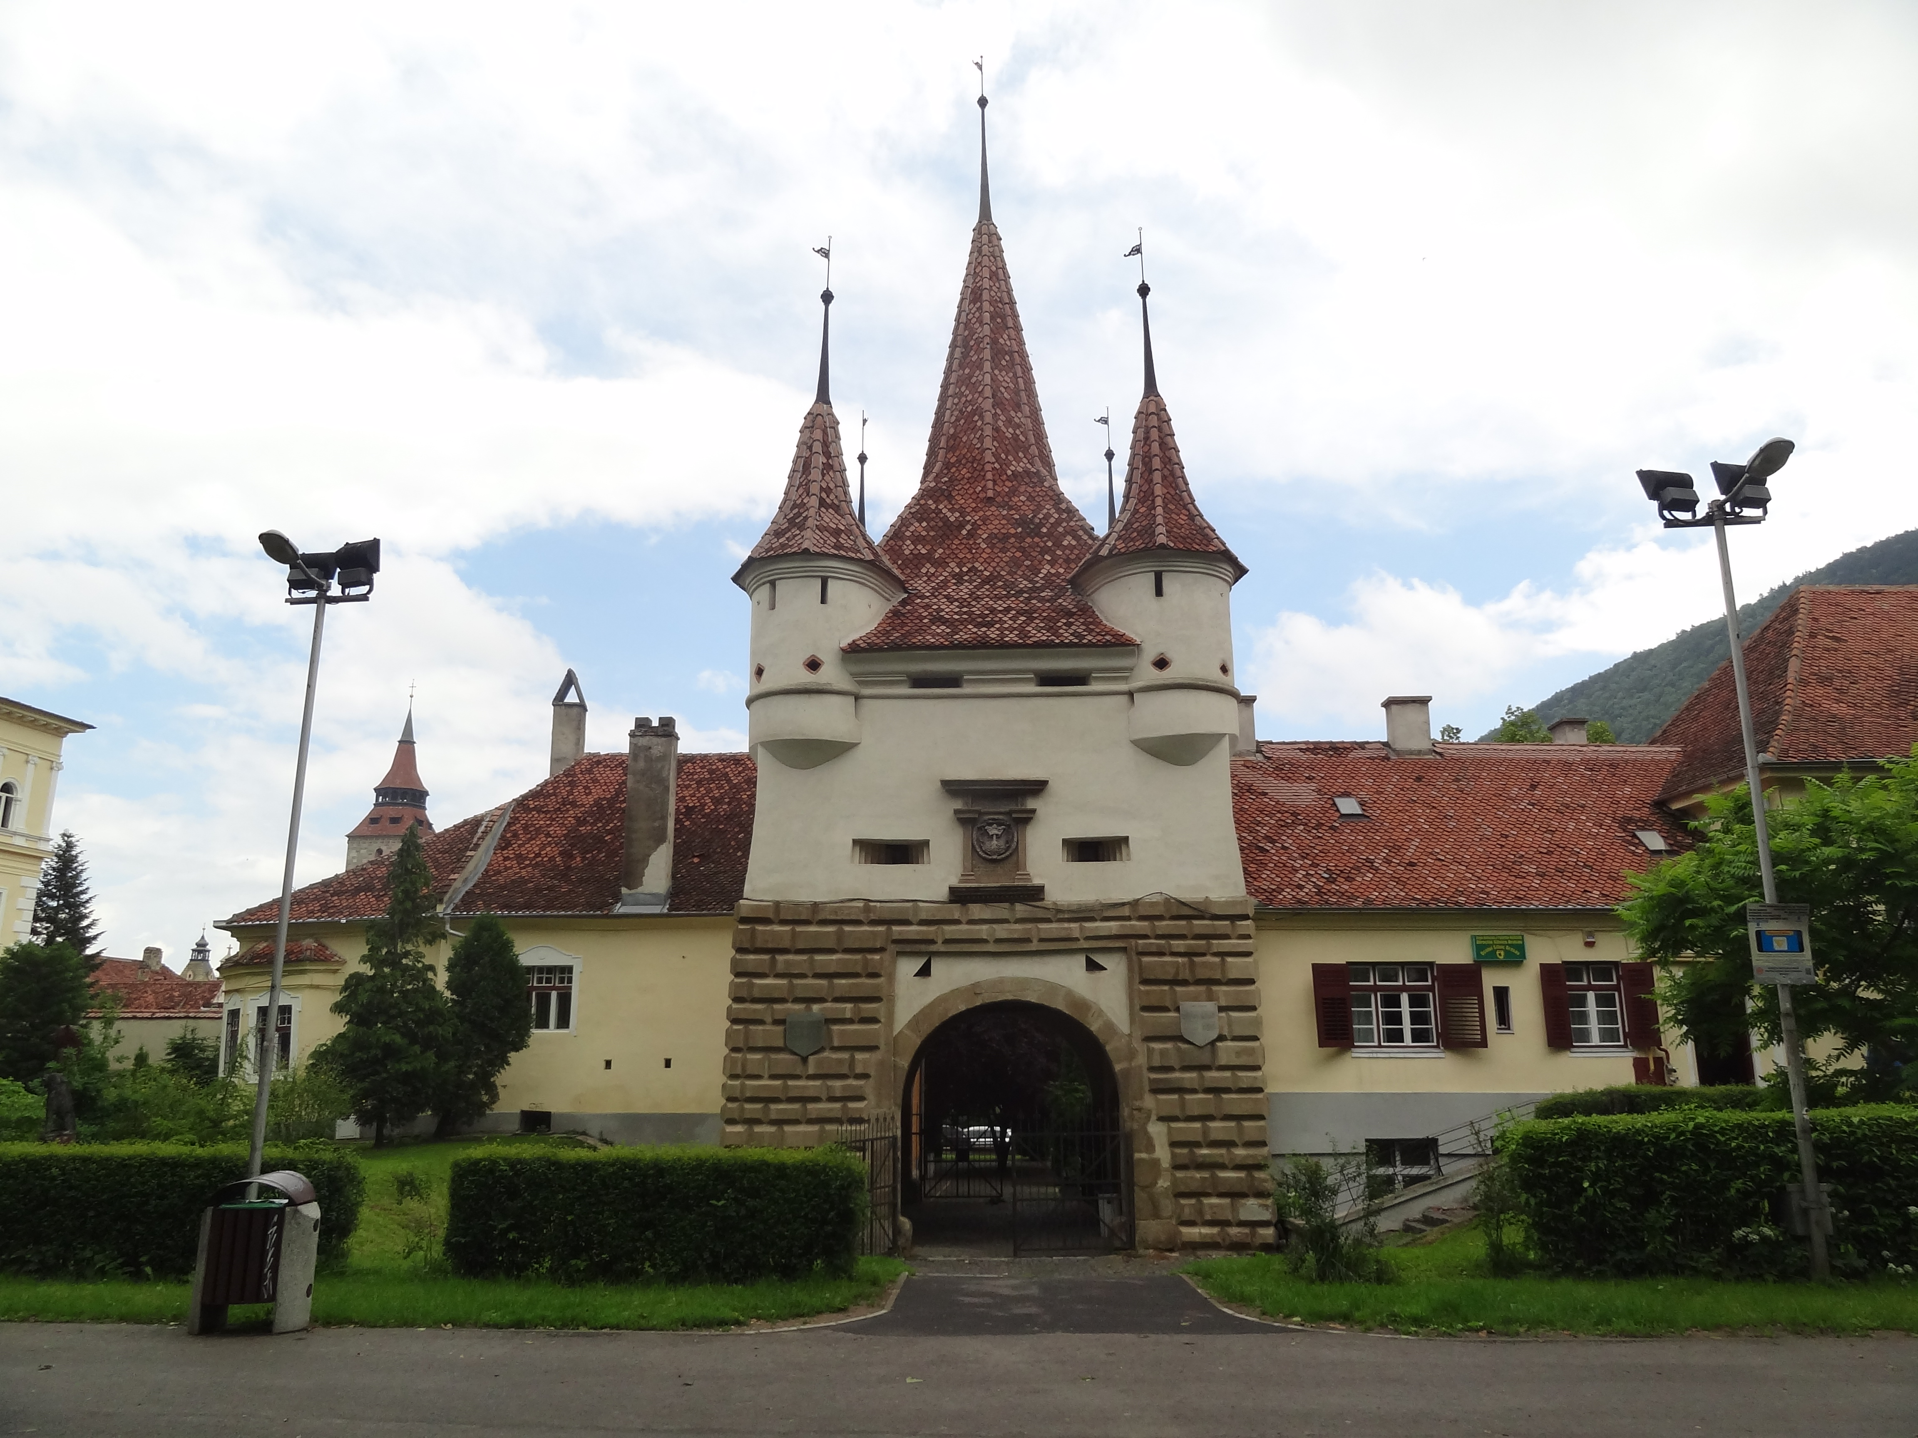
The shape of the first floor of Catherine's Gate is a square-based prism. Your task is to determine the volume of the body of the first floor (m³), considering that all the bricks of the first floor have the same height.

5. Black Church
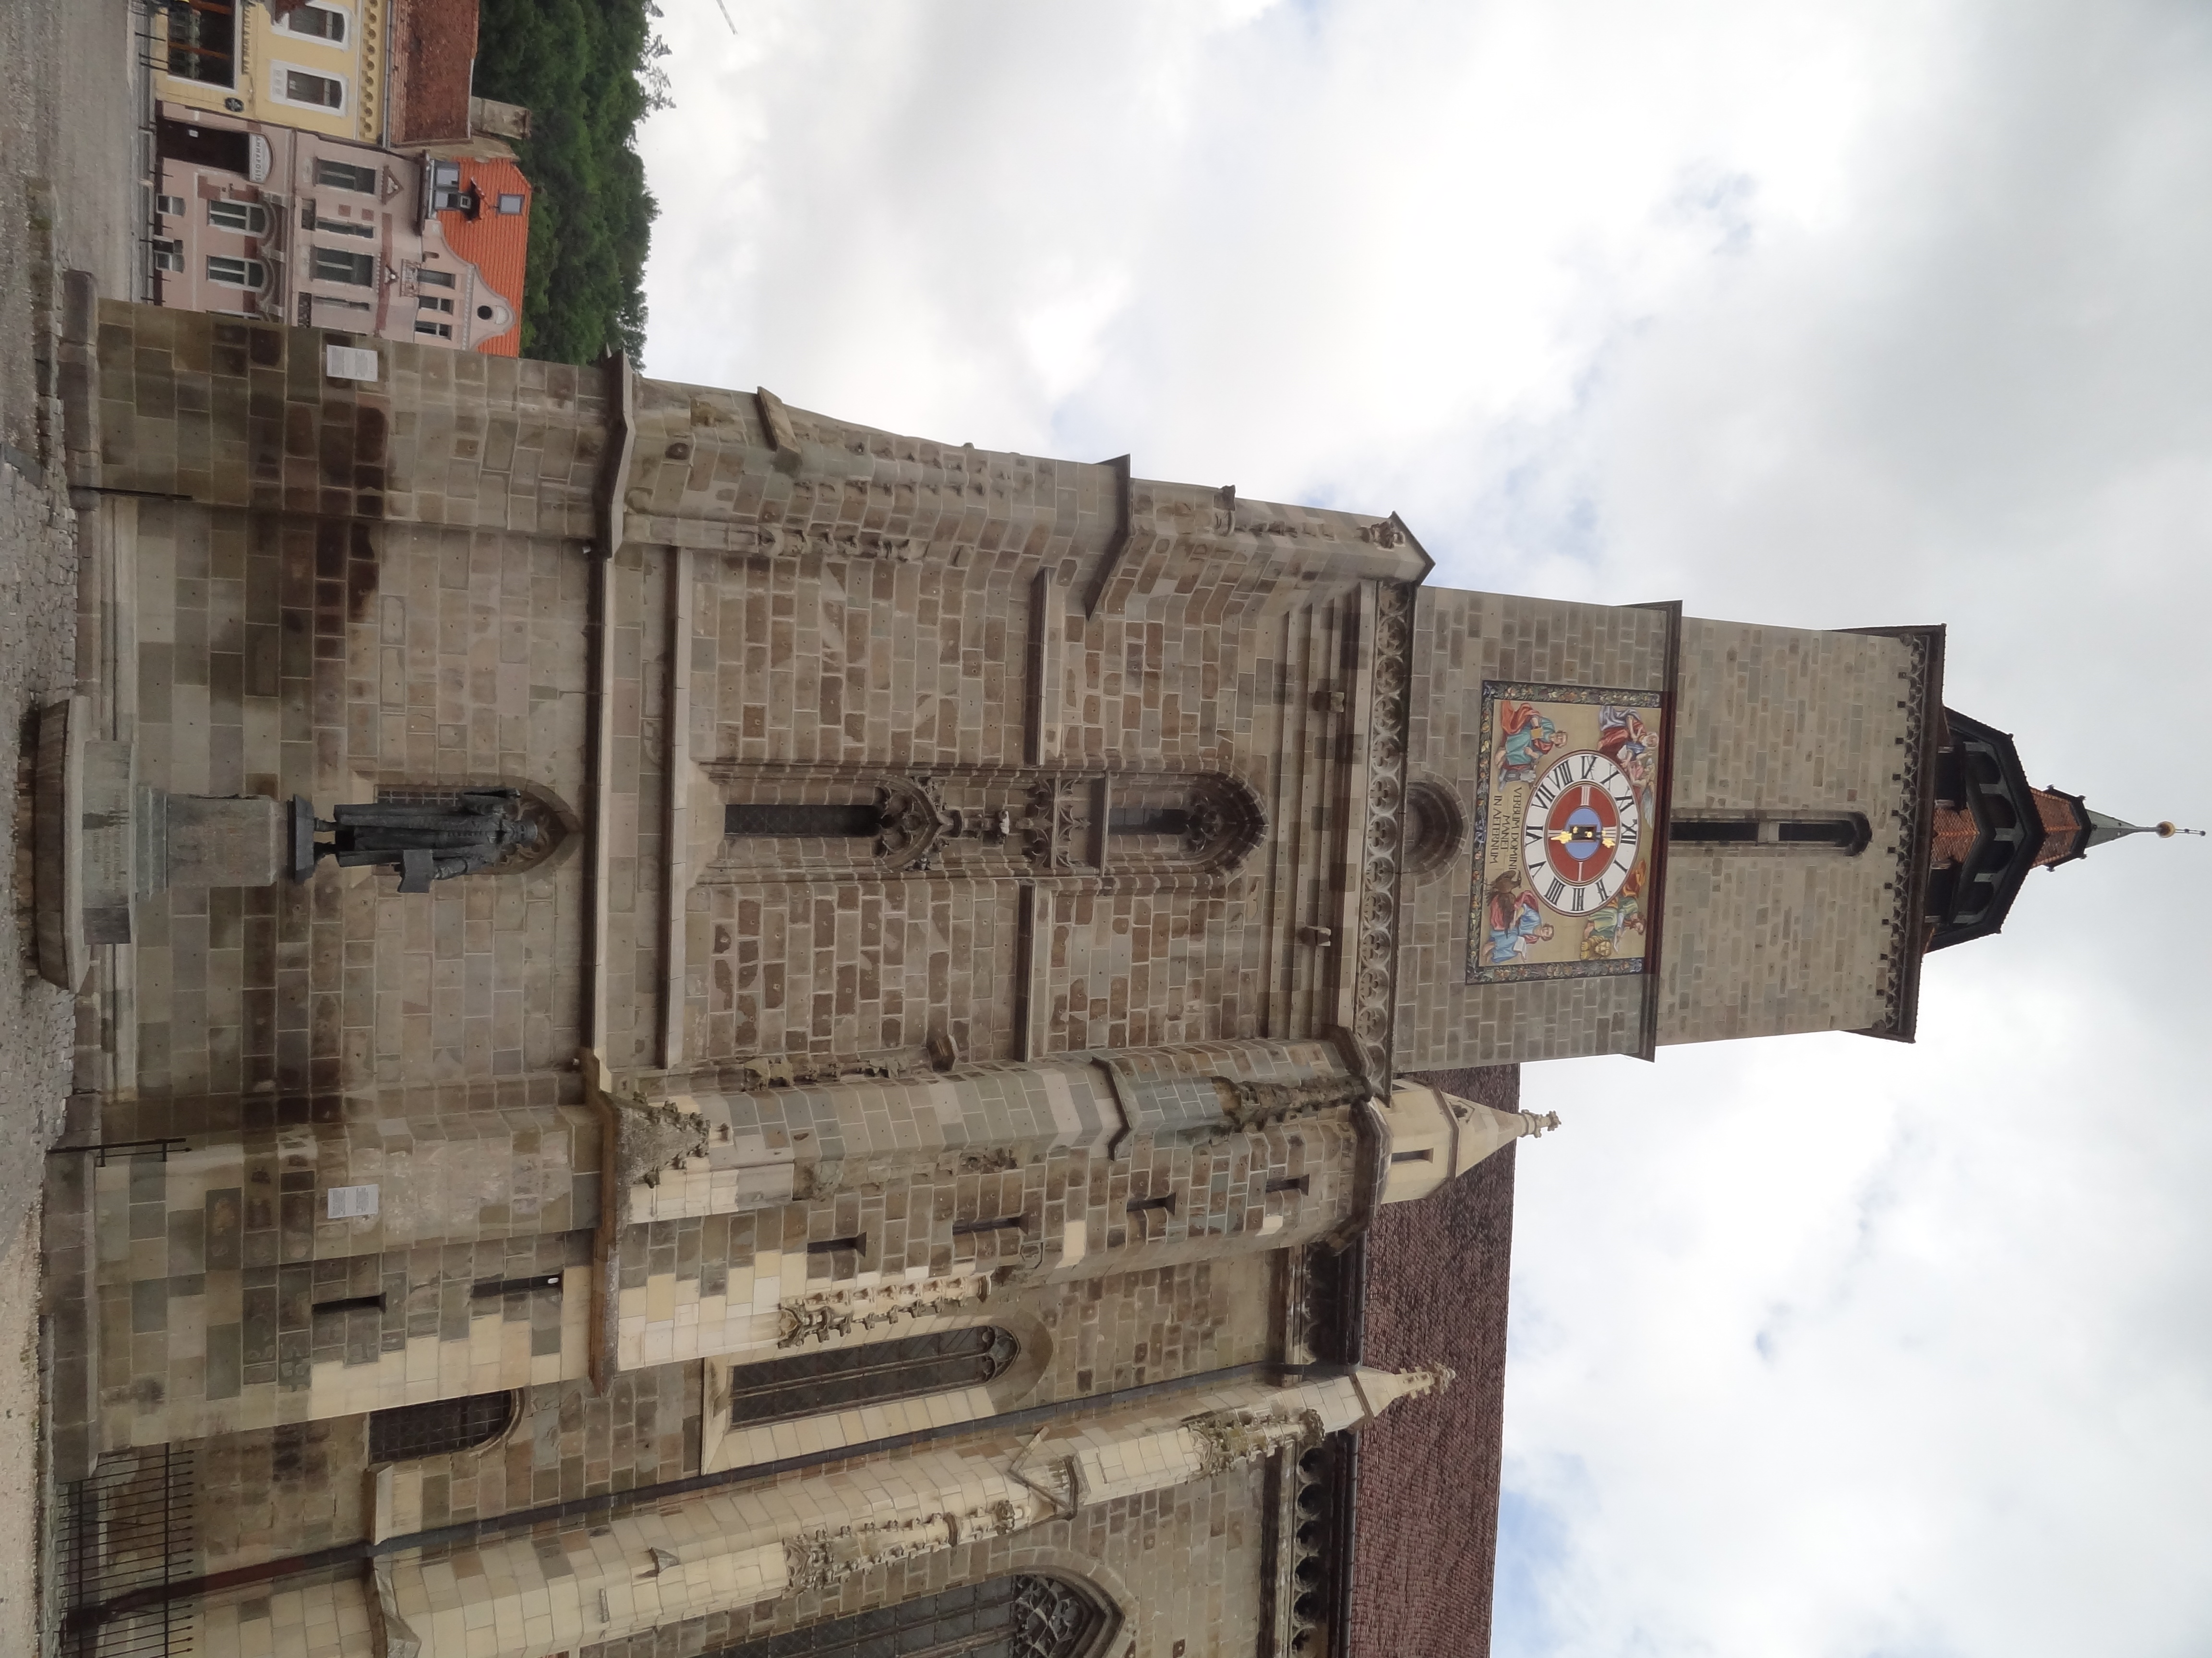
On the right side of the Black Church is the statue of Johannes Honterus . Your task is to determine the lateral surface area of the the pedestal of the statue (m²) on which is engraved the inscription with the year of construction.

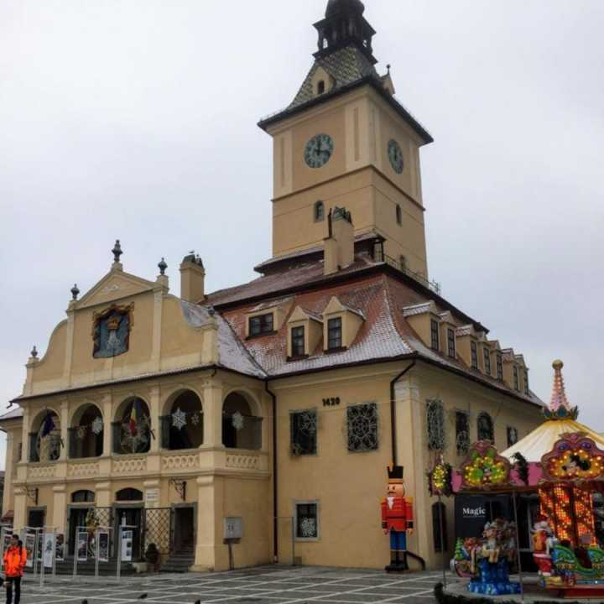
6. The Old Town Hall
You are a restorer and you have to paint the entrance doors from the Old Town Hall Museum. Determine the amount of paint (l) needed for painting the doors, knowing that 0.2 l of paint are needed for 1 m²

