Students thoughts about maths

- I am

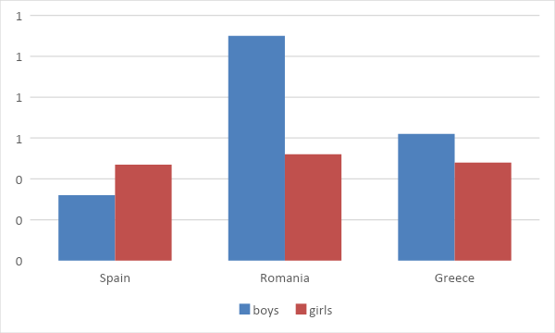

- I live in

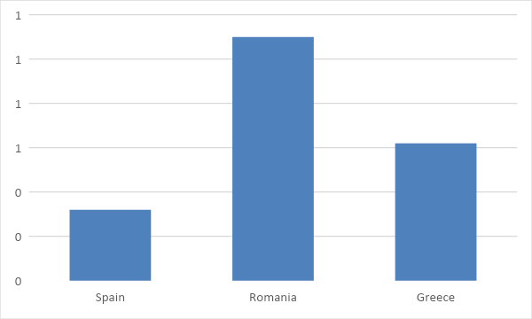

- I'm
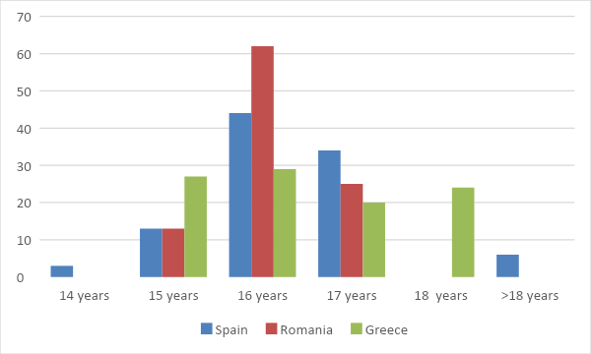

- I get good math grades

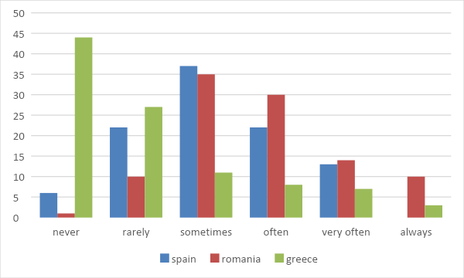
Topic:
Attitudes towards maths

5. Are you afraid of maths?

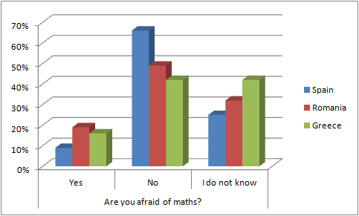

Conclusion
The Spanish people are not afraid of math because they think that it’s only a subject to pass.
The Greek people are not afraid of math because they study and they are prepared for the exams.
Romanians are not scared of math because it is theoretical and there is a lot of information but we have good teachers which help us.

6. If the lesson was optional would you choose it?

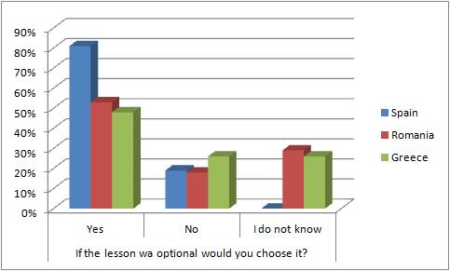

Conclusion
The Spanish people think that you have to know the basics of maths to applicate them in your life.
The Greek people would choose maths because they like the subject.
The Romanian would choose to learn math because it’s an useful skill in day to day life.

7. During math tests, do you feel panicked?

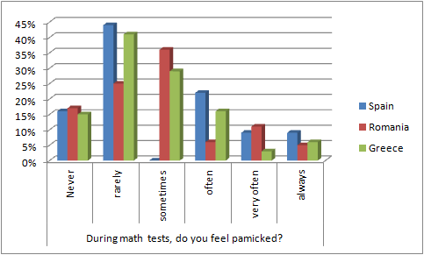

Conclusion
The Spanish people rarely feel panicked during their math tests when they haven’t studied.
The Greek people rarely feel panicked because they like maths and they study a lot for tests thus feeling prepared.
The Romanians feel panicked if they haven’t studied but if they do they don’t feel panicked.

8. Do you feel anxiety (worried, concerned) during math tests, because you think that you will forget things you may know well?

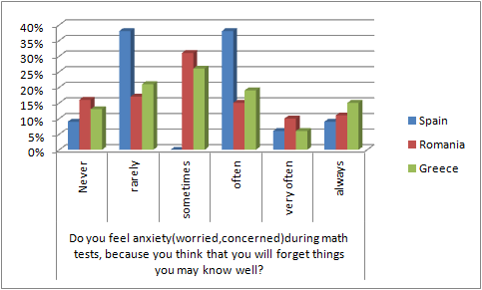

Conclusion
The Spanish people often feel anxious in math tests because they haven’t studied before.
The Greek people sometimes feel anxious because they don’t always study for the exams.
The Romanians sometimes feel anxious because their parents and professors put pressure on them.

9. When you cannot solve a mathematical problem, how much time will you still keep trying?

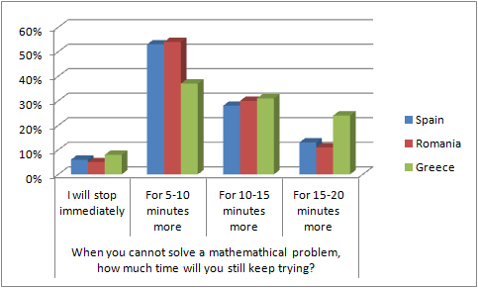

Conclusion
Most students give up after 5-10 minutes because they want to continue solving the other problems and if they have time they will come back and check it again to see if there is something they can do about it.

10. When you cannot solve a mathematical problem, what do you do?

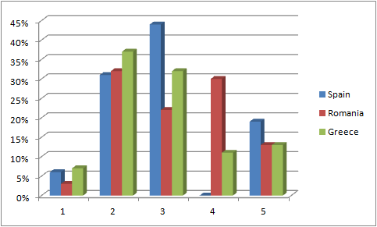

Conclusion
Students in Spain will not ask for help from a classmate because they believe they can do it themselves.
Students from Romania choose to ask for help from their teacher than get disappointed and quit.
Students from Greece prefer to take a break before continuing than looking for the answer at the solution book.

11. When you have to answer a math question in the class, how often do you feel like you do not have enough time to answer?

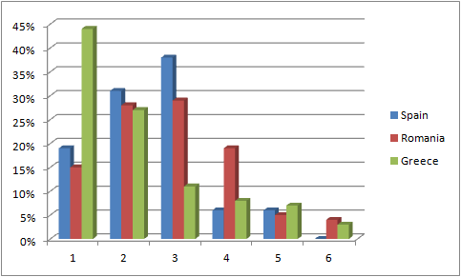

Conclusion
Students from Spain do not usually feel stressed about the time because they are sure and comfortable.
Students from Romania are sometimes and rarely stressed.
Students from Greece barely ever get nervous about timing because they prefer these kind of lessons.

12. When you have to answer a mathematical question in front of your classmate, how often do you feel stressed?

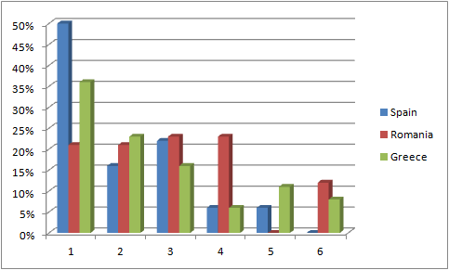

Conclusion
Half of the students from Spain never feel stressed when answering a mathematical question, Romanian students also do not feel stressed but in smaller quantities, and same thing happens with the students from Greece.

13. The math lesson at school is interesting.

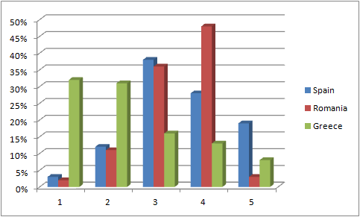

Conclusion
Greek students are more interested in math lessons than Spanish and Romanian students, even though they do not dislike them.

14. The ability of understanding maths is innate (we are born with that, it is natural)

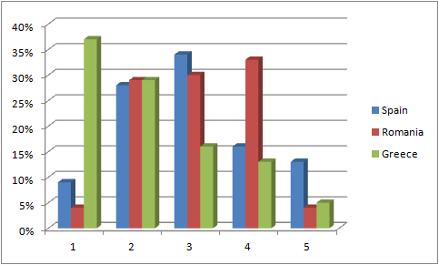

Conclusion
Greek students think that the ability of understanding maths is innate and so do Spanish students, meanwhile Romanian students do not agree as much as the others do.

Topic:
Perspectives

15. Maths is useful only for the students who want to study this kind of sciences.

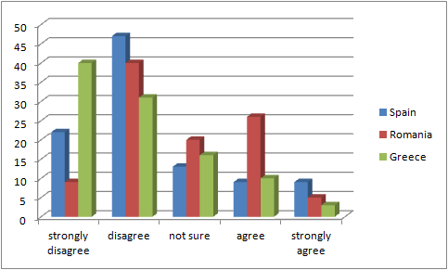

Conclusion
Because in Rethimno (Greece) and Hellin (Spain) are not many universities based on mathematics, so their students focus on another subject,

16. The math lesson is useful for our daily life

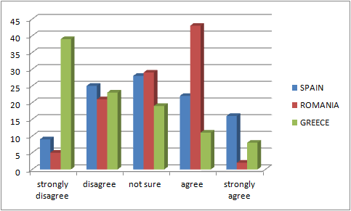

Conclusion
Because, for example, when you go to buy bread, you need to know math, mathematics is used also in architecture and you can find it anywhere.
The schools from Spain and Romania are more focused in developing mathematical skills of students. All the students from this countries understand the importance of maths and learning maths in the context of the current development of modern technology and computing.

17. Only the clever students can learn mathematics.

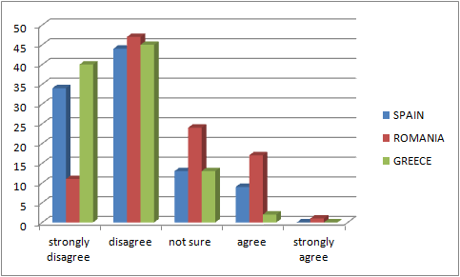

Conclusion
Students from Greece, Spain and Romania believe that anyone can learn mathematics, not just the clever ones if it is teached using modern methods. The teenagers study maths for pleasure, but especially to pass the final exam.

18. The boys are more effective in solving mathematical problems than girls.

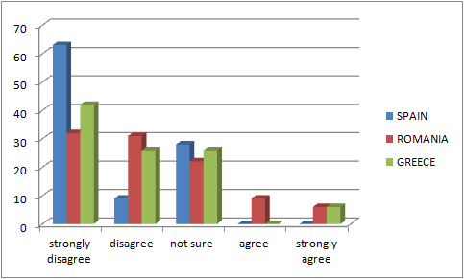

Conclusion
Because in Spain more girls than boys have answered this quiz.

Topic:
Influencing factors

19. The attitude you have towards maths was influenced by the teachers you had in junior high school (gymnasium)

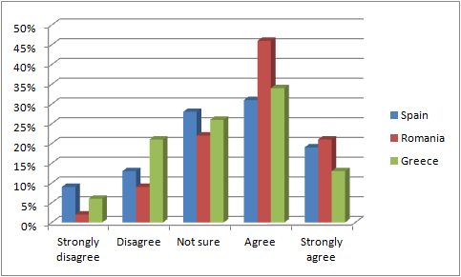

Conclusion
In Greece teachers don’t always influence the students about maths because many times students don’t pay attention to the lesson. Also many times they can’t understand the lesson and most of them they are shy to ask them.
In Romania the teachers have an aggressive attitude toward students in junior high school and the same attitude the children will have towards the subject.
In Spain the classes are smaller witch causes the teachers pay more attention if the students understood the lesson.

20. The attitude you have now towards maths was influenced by your parents.

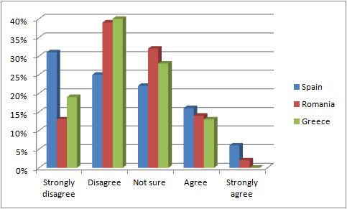

Conclusion
In Spain and Greece, parents give their children more freedom to choose what they want to study.
In Romania every parent want their child to have a high paying job as doctor, engineer and lawyer and won’t let their children develop their skills.

21. Does your mother believe that she is good at maths?

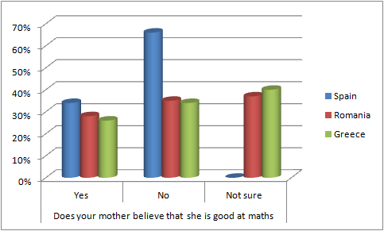

Conclusion
In Spain, mothers don’t know about maths because they could not finish their studies to work and earn money.
In Greece and Romania most people don’t care if their parents are good at maths.

22. Does your dad believe that he is good at maths?

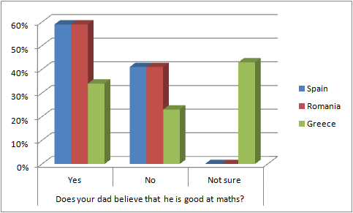

Conclusion
In Spain, mothers don’t know about maths because they could not finish their studies to work and earn money.
In Greece and Romania most people don’t care if their parents are good at maths.

Topic:
Proposals for the lesson

23. The Math lesson would be more interesting with mathematical games included.

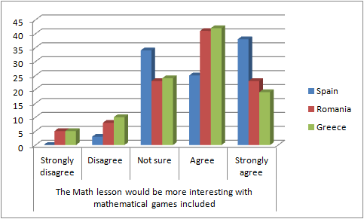

Conclusion
Spanish people think that using games, it is easier to understand maths.
Greek students believe that with the use of games, the lesson will become more attractive to them. Romanians consider that with the use of the games mathematics would become funnier and more interesting.

24. The Math lesson would be more interesting with the use of technology (computers, mobile devices, etc.)

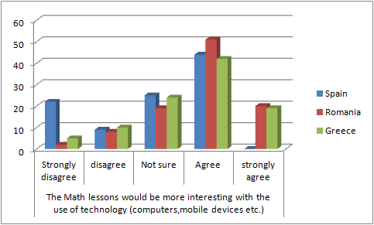

Conclusion
Romanian people think that with the using of those devices math lessons would become easier to understand. Greek students claim that with the use of technology devices, the lesson will become more interesting. Spanish people are mostly agree with the use of technology because it is more simple to see mathematical forms.

25. I would feel less anxiety if we had more lessons in class for revision.

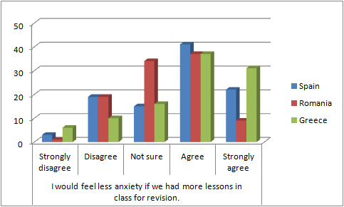

Conclusion
Greek students believe that with the revision, many of the questions they may have will be solved. Spanish people think that with more time to ask their teachers their questions, they will have better marks. Romanian people don’t think that their anxiety will decrease with the revision because they have many math hours and they feel confident when solving a problem.

