Etwinning project "Gender equality: a reality or a myth?" School year 2018/19

Getting into the project: some important concepts
and ideas related to gender equality.

1. In pairs. Answer the following questions. Write your thoughts in the spidergrams below. Use the dictionary if needed.
- What does it mean to “Act Like a Man”? What words or expectations do you think of?
- What does it mean “Act Like a Lady?” What words or expectations do you think of?

Act like a lady
Act like a man

Let's share our views.
• Where do we learn these gender roles?
• What people teach us these stereotypes?
• Where else in society do we find these messages?
2. Watch the video and say if the following statements are TRUE or FALSE. Correct the false ones.
https://www.youtube.com/watch?v=nrZ21nD9I-0
- Children are born with preconceptions about their future choices and roles in society
- Gender stereotypes influence children's identity formation and their future choice.
- Gender stereotypes are always recognizable.
- The repetition of the same stereotypes make people believe they are true and right.
- "Breaking the mould" means accepting gender stereotypes as natural.
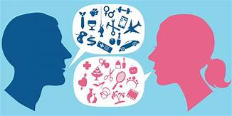
4. What is the difference between sex and gender?
Sex. This refers to the biological differences between men and women.
Gender. This refers to roles assigned to men and women in a given society, and the relations and representations that arise from these roles.

5. What are gender characteristics?
Unlike sex characteristics, which are biological, gender roles have the following dynamic characteristics.
Match the following headings with the right paragraph.
- Change over time
- Differ between cultures
- Differ within cultures
- Learned behaviour
1. From infancy we learn what it means to be male or female through stereotyping, such as when a boy receives a car or sports equipment and a girl receives a doll or a sewing kit as gifts. However, as awareness increases these practices are undergoing change in many societies resulting in more equal and equitable development opportunities for both sexes.
2. Historically, in many countries women have not always had the right to vote, but over time the situation has changed in these countries. Globally, the number of economically active women has also changed rapidly over time and this is influencing the roles of women and men within families and communities.
3. In many cultures, roles (farming, cattle grazing, doctors, drivers, pilots, and so on) are reserved for a specific sex.
4. Role definitions within cultures may also differ as a result of social, economic, ethnic, religious, political or other factors, including social class. For example, cultural groups may share agricultural tasks differently within the same society, and it may be the woman’s role to take care of livestock, while in another culture it is the man’s role.

6. Think and write.
Recall an incident in your childhood when you were treated differently because you were a boy or a girl. Looking back, how did it make you feel at the time? Would you feel differently today now that you have an understanding of gender?
NOT EVERBODY IS MAKING PROGRESS TO FIT GENDER STEROTYPES. QUITE THE REVERSE.....
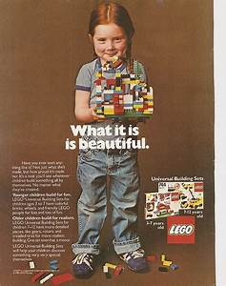
1981
A seven-year-old girl named Charlotte has complained against LEGO not only for making more "boy people" than "lego girls," but sending the former on adventures while the latter "sit at home."
"All the girls did was sit at home, go to the beach, and shop, and they had no jobs," writes Charlotte, "but the boys went on adventures, worked, saved people, and had jobs, even swam with sharks."
Her request is simple: "I want you to make more lego girl people and let them go on adventures and have fun ok!?! from Charlotte. Thank you."
LEGO has been criticized before for failing to bridge the gender gap in its line of minifigs. To its credit, they've made moves in recent years to do so, but the company still has a ways to go.

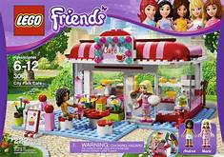
2012

