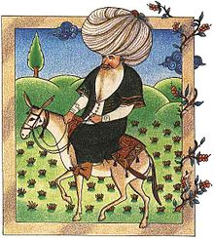
Nasreddin Hodja

Nasreddin or Nasreddin Hodja was a Seljuq satirical Sufi, born in Hortu Village in Sivrihisar, Eskişehir Province,in Turkiye and lived in 13th century.
There is the joke, followed by a moral and usually the little extra which brings the consciousness of the potential mystic a little further on the way to realization. Another important element in Nasreddin Hoca stories is the donkey, a reflection of the feelings of the people. It is impossible to imagine Nasreddin Hoca without his donkey, which is itself a vehicle of satire.

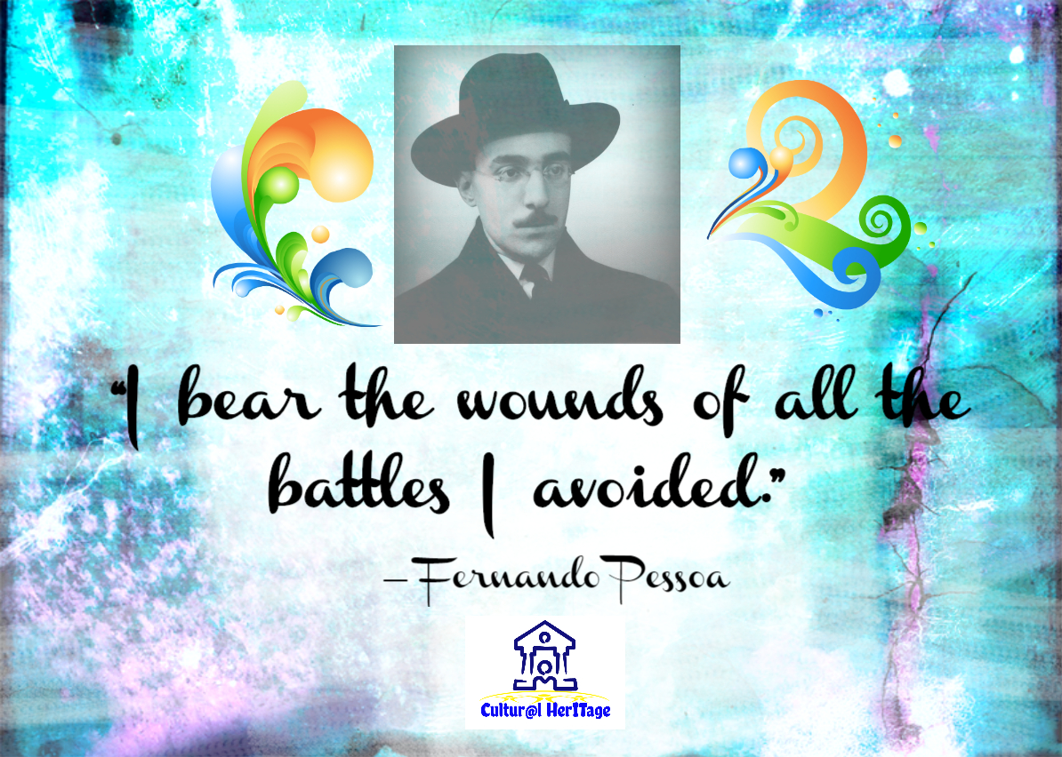
FERNANDO PESSOA
Fernando Pessoa, in full Fernando António Nogueira Pessoa, (
born June 13, 1888, Lisbon, Port.—died Nov. 30, 1935, Lisbon),
one of the greatest Portuguese writers.
