Tourist guide

Mielec and surroundings

Mielec

Mielec is a city founded in 1470 under Magdeburg law. It is a small industrial city. In Mielec there are also many interesting monuments.:

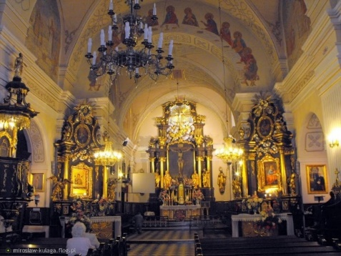
There you can find a Baroque parish church of Saint Matthew, from the 17th and 18th centuries, being the smaller basilica since 2006.

The Jaderny House, now a regional museum. Museum exhibitions are entirely dedicated to photography
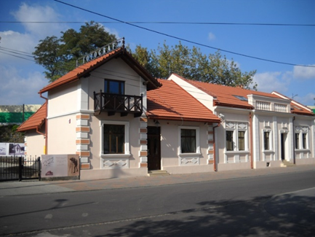

Mansion of Oborski family- a mansion situated on the banks of the Wisłoka river. In the past it belonged to the noble Oborski family. Today it is a regional museum popular with tourists.
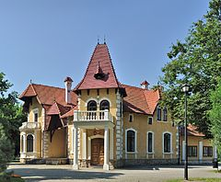

Polish Aircraft Corporation in Mielec – here Black Hawk aircraft is produced.
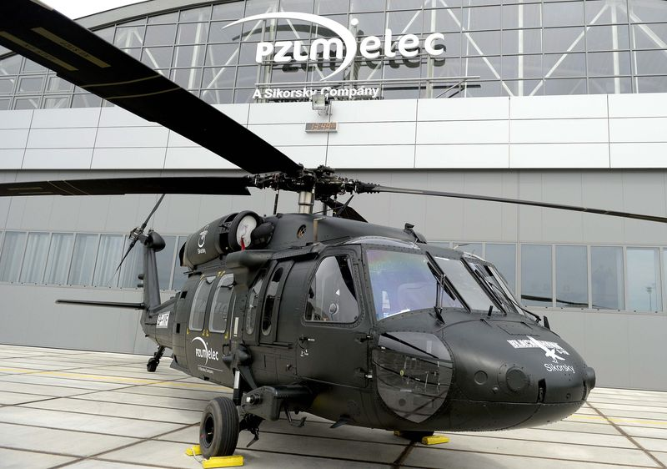
Agnieszka Godek, III Tb
Radomyśl Wielki

Radomyśl Wielki – the city in the Podkarpacie province in the District of Mielec, is the seat of the Radomyśl Wielki urban-rural community..

The only city in the world, which has the only existing PZL M-2 aircraft. This is the first Polish aircraft built after the war with a completely metal structure. It was constructed at WSK "PZL-Mielec" and despite excellent reviews, it was not put into production.

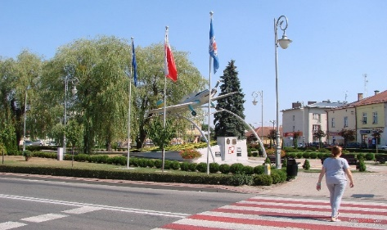

There is a parish church in the town. The Transfiguration of the Lord in the 18th century and the historic statue of Our Lady of Lourdes from the 19th century are its ornaments

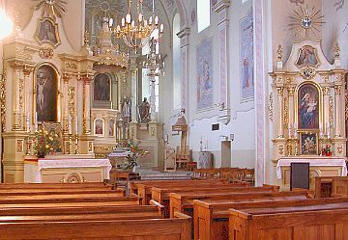

There were two Jewish cemeteries in the city. Only the newer one exists nowadays.

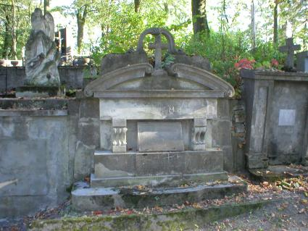
Agata Wolak, II Tb

Gawłuszowice

Church of Saint Wojciech . It was built In 1677 by a carpenter Stanisław Karkutowicz. This church is made of larch wood. It is the third church in the history of this parish. The first was built in 1215. It is situated in the centre of the village. In front of the church there is a monument of St Adalbert. The church is the second largest wooden church in Poland.

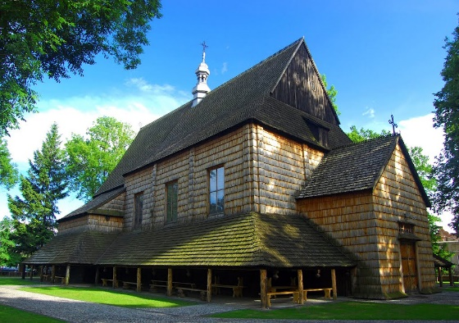
Maria Załudzka, II Ta

Kolbuszowa

A town in the Podkarpackie Voivodeship, in Kolbuszow County, located on the Nile River, on the Kolbuszow plateau in the Sandomierz Basin on the edge of the Sandomierz Forest. The seat of the urban-rural district of Kolbuszowa.

The main tourist attraction of this city is Skansen - Museum of Folk Culture.

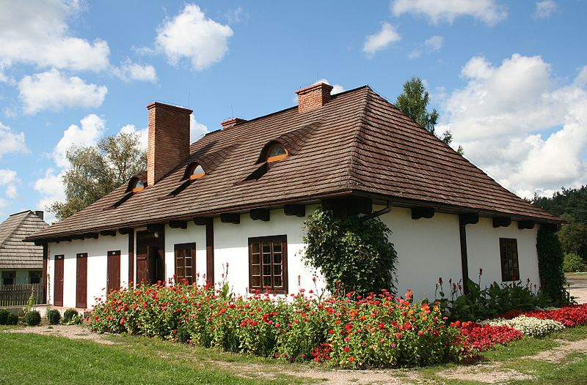

Sandomierz

Tourists willingly visit Sandomierz Castle. Kazimierz Wielki built it in the 14h century in gothic style. In the castle we will also see baroque and classicist style. Since 1986, in the renovated premises of the castle is the Regional Museum of Sandomierz.
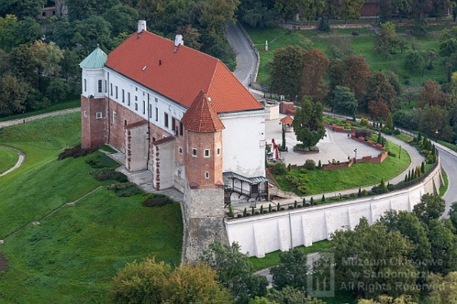

The Cathedral Basilica of the Nativity of the Virgin Mary in Sandomierz is a Gothic church built around 1360. In years 1708-1776 its interior was changed to Baroque. By the end of the 19th century, the cathedral was renovated by Father Karsznicki. The interior is Baroque and Rococo. There are numerous gravestones in the cathedral.
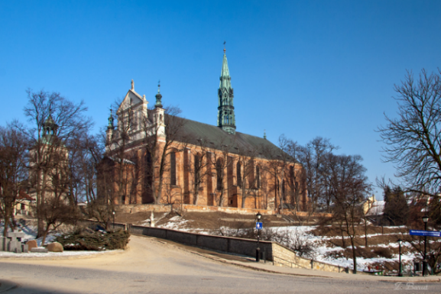

The Cathedral Basilica
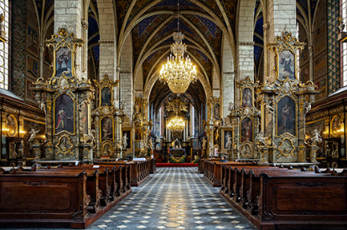

Anna Gawryś, III Ta

Rzeszów

Market Square in Rzeszow – is situated in the centre of the old town. There are many cafés and shops and also many cultural events.
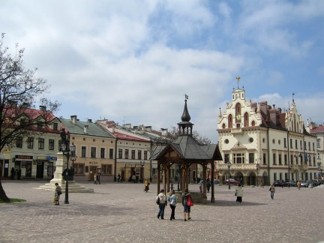

Castle in Rzeszow – the main monument of the city which was built in 1902-1906 at the same place as Ludomirski’s castle.
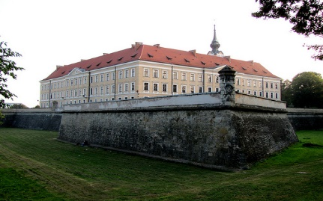

Underground Tourist Route – about 400 meters route which is under the Rzeszow’s Market Square.
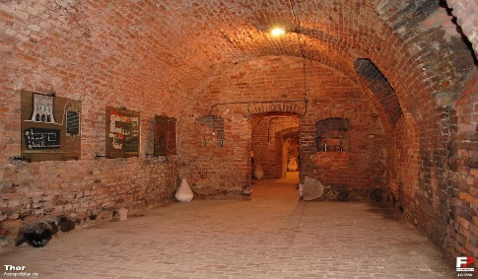

Alicja Wałek, I Tc

Tarnów

Tarnów is a city with a long history, the city was created in 1330. Tarnów is also called the Polish Heat Pole because it is the warmest city in Poland

Tarnów has a very beautiful market square where we can find a lot of interesting places, like a cafe located in a tramcar.
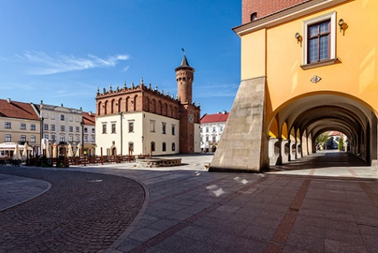

In Tarnow there is the Shooting Park with the Shooting Palace, the seat of the Polish Shooting companionship. In the lower part of the park there is the tomb of Józef Bem a famous person who was born in Tarnów and who fought in the Spring of Nations in Hungary in 1848. His grave is in a pond above the surface of the water.
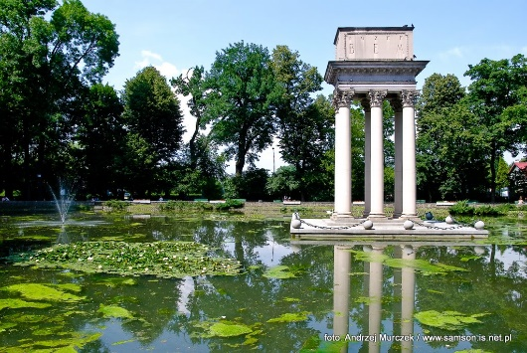

In Saint Martin’s Peak there are remains of the ruins of the castle that belonged to Leliwite Family.
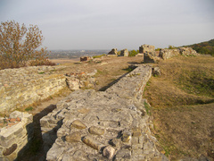

In Tarnow there is a museum dedicated to Gypsies people in Poland. Every year, in spring, the symbolic group of Gypsies celebrates their holidays.
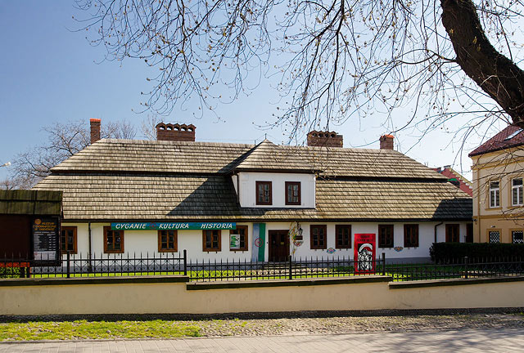

Jakub Moskalewicz, III Ta

Baranów Sandomierski

The Castle in Baranów Sandomierski is a late Renaissance Castle and because of similarities, called Little Wawel. This castle was designed by Santi Gucci from 1591 to 1606
The fortress in Baranów Sandomierski which is the Pearl of Renaissance architecture is located in the lower Vistula. The original Knight's Courtyard belonged to the Baranowski family . Over the years and centuries the Castle in Baranów belonged to many families, for example to the family of: Laszczyński, Wiśniowiecki, Sanguszko, Lubomirski, Małachowski, Potocki, Krasicki. The last owners of the Castle, family of Dolański, in the years 1900-1907 renovated the building. The effects of these works are visible today.

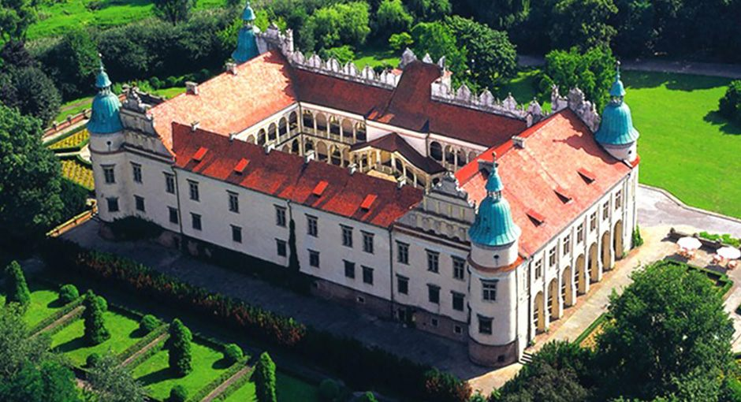

Krzysztof Łącz, III Ta

Przemyśl

Fortress in Przemyśl is one of the biggest and the most important in Poland..

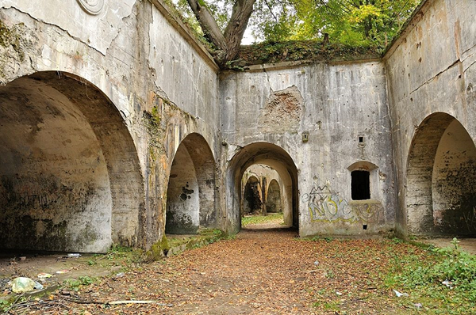

Market Square in Przemyśl is unusual as it’s not formed in a flat area so it looks amazing. There is also a nice fountain with a bear cub.

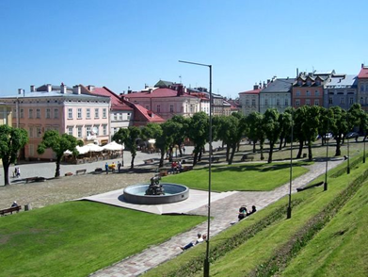

Tatar mound - A great recreation area, recently revitalized. There you can find an amphitheater and bike paths.

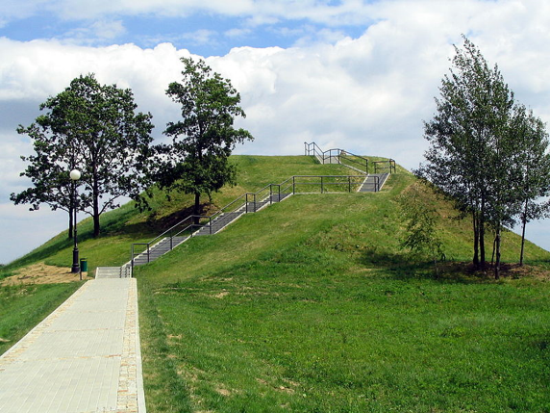

There is also Franciscan church situated between the market square and the town council. Built in rococo style is devoted to Saint Magdalena..

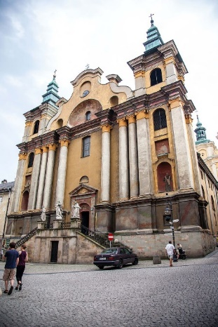
Sylwia Pietrzycka, III Tb

Połaniec

Połaniec is a town situated on the left side of Vistula river. There are many places worth seeing in Połaniec for example:

The 18th century church dedicated to St. Martin.

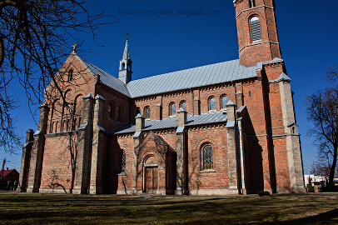

Market Square where you can see local artists and singers especially in the summer or spring. You can also try delicious ice creams - their tradition goes back to 1950.

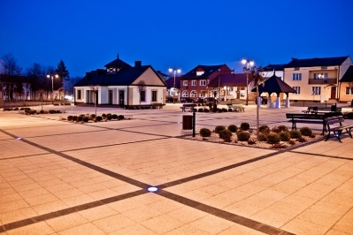

The Tadeusz Kosciuszko Mound – to remember the anniversary of signing Połaniecki Proclamation as it played an important role in Polish history.

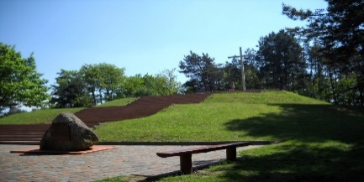

You can go canoeing in Czarna river, a really interesting form of entertainment.

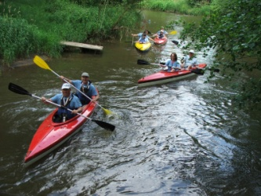

Agnieszka Banik, I Tc

Kraków

Kraków is one of the biggest cities,full of Polish history. Kraków is located in the east of Poland.
The most famous landmark in Kraków is the
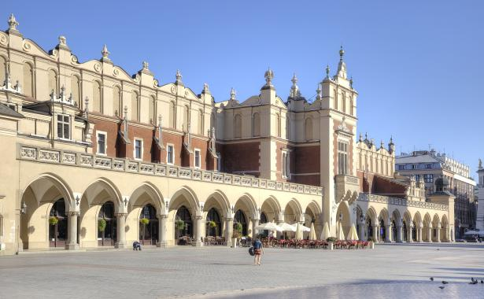

Townhall - Sukiennice, this is old place of the City, where people traded cloth. Old legend tells us the story about dragon which was killing local people and local animals, at the end he exploded because he drank too much water. In Kraków we have the beautifull royal castle "Wawel" and there is cementary of the most important people from Polish history. There are a lot of monuments and architecture is very intersting.

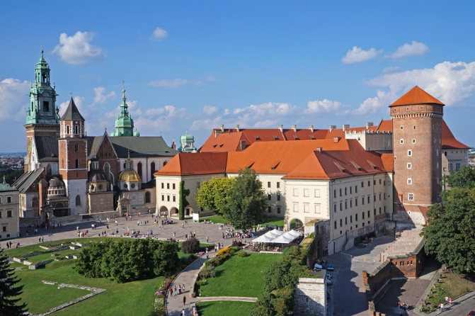

Fabian Pietryka, III Ta

Łańcut

Castle in Łańcut was built probably in the second half of 16th century. This is an old magnate's residence. Now there is a museum in the castle. It is famous for excellent interiors and a very interesting horse cart collection. Castle interiors are among the most beautiful in Poland. The palace complex is surrounded with an old, picturesque park in English style. There are numerous pavilions and business buildings, closely linked once with the daily life of the the residence. These are: a hothouse, a romantic castle, stables, a coach house, a music school, an orchid house and a tennis court.

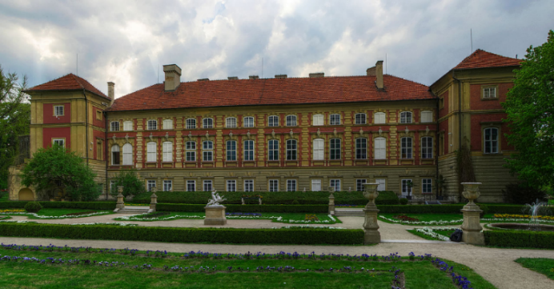

Katarzyna Kapinos, II Ta

