Polish Weekly

- Coronation of Barbara Radziwiłłówna
- Interview with Nicolaus Copernicus
- Famous for all Europe
- The fashion news
- Zygmunt bell
- Contemporary family
- A clock with music box in Wrocław
- Concert of Mikołaj Gomółka
- First texts in national language
- Advertisements

A.D. 1650
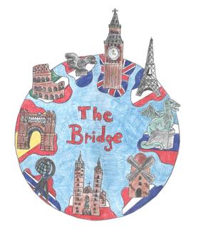 Intarnational Erasmus+ Project Building Resources and Innovation for Global Education „The Bridge”
ZSB Mielec, Poland, 2015-2018

1900-01-01

Interdyscyplinarny Międzynarodowy Projekt Building Resources and Innovation for Global Education „Bridge” prowadzony w ZSB Mielec w latach 2015-2018
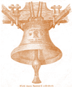
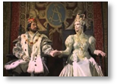
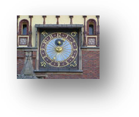
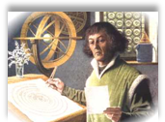
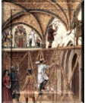
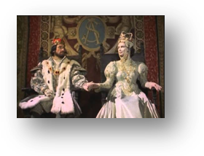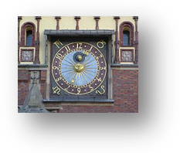

Coronation of Barbara Radziwiłłówna

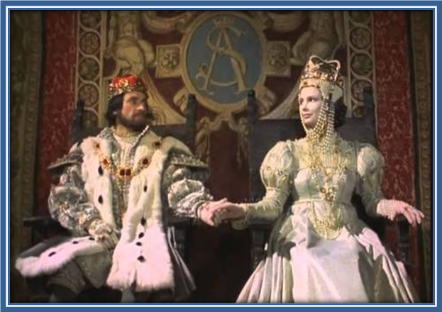
Barbara stepped forward to the altar. She knelt down, kissed the archbishop’s ring ,
whereupon she lay her body in the shape of a cross. Meanwhile all gathered began to recite lyrics of a prayer.
Hundreds of people resounded :” Kyrie elejson, Chryste elejson… “Celebrants solemnly called the most important women names from the Old Testament : Sara, Rebbeca , Judith and
Esthera. Thereafter Barbara was compared to sage wives and daughters instead the slave
married to Alexander the Great . Next, there were unction and coronation.
Barbara with the crown on her head, the royal apple and the scepter in hands, turned to the
crowd.
It was 7th of December 1550
That day she looked more attractive than ever. There wasn’t any trace of disease on her
face. She was young , proud and delicate: just a queen .Everyone could see her
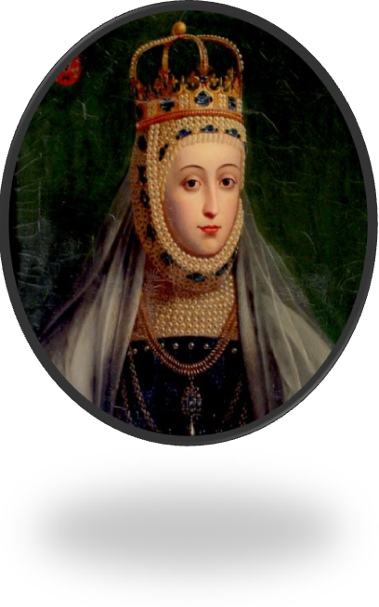
expensive crown. Her clothes were decorated with hundreds of pearls, but the most could be
seen from her eyes and lips. Barbara smiled to the dignitaries who took part in the coronation.
Many people could say that this smile showed pride of the great aristocrat. Some believed that,
Barbara, alike her family, was absorbed by political lust. It’s hard to accept such a conception
because Barbara’s face was rather expressing a relief.
Despite her critical health condition, she survived a lot of processions and celebrations. Several
witnesses heard Barbara saying : “ God will give me another crown…”.

Damian Żuraw

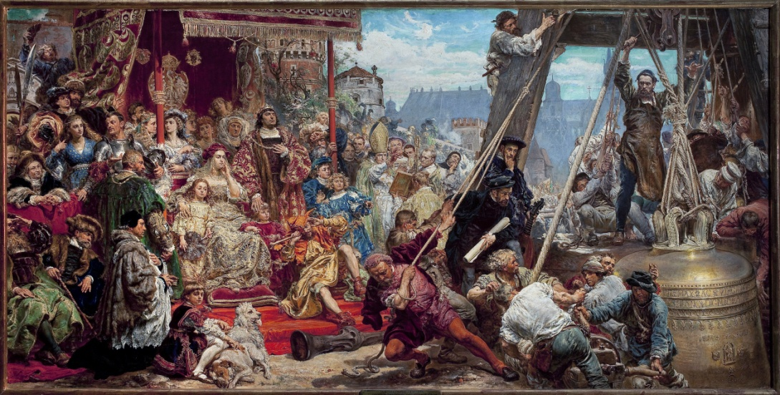
From history cards…….

35 years ago performed Zygmunt’s bell

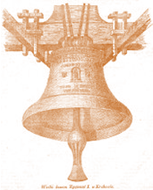

This colossal bell was moulded in 1520 in Cracow, by Hans Behem, who lived in Norymverg. The bell was hanged up 9 July 1521 on old defensive tower in royal castle situated on Wawel's hill. The tower became rebuildted and lifted. The Citizens of Kraków heard the Zygmunt Bell's sound for the first time on 13th of July 1521. The bell was founded by Zygmunt the First calles old who dedicated it " not only to God, but to glory of the Jagiellonian's family and Polish Kingdom. Captivity at time, the ball became one of the most important national symbol. At the top, you can see a latin inscription: " Dedicated to the Great and Holy God as well as to the vergin mother of God and the Holy Patrons, this Bell reflects thr greatness of its founder- Zygmunt the King of Polandin 1520. Below there some im ages of Stanislaw and Saint Zygmunt, and the ablazon of the Both United Nations of Polish Country. Nice heart hanging gothic's inside the cup's. | Sizes:  Diametr-242cm  Height-460cm  Lengnth heart's - 220 cm  Weights  From bronze 9,650 kg  Heart with waistband 365kg  All weight bell 12600kg.

According to legend , bursting hearts bell heralds bad times for Polish , and according to popular superstition, touching the heart brings good luck . Legend has it that as long as the bell hanging on the tower, nothing bad will meet in Krakow.

Aleksandra Wrzesień

He stopped the Sun and moved the Earth
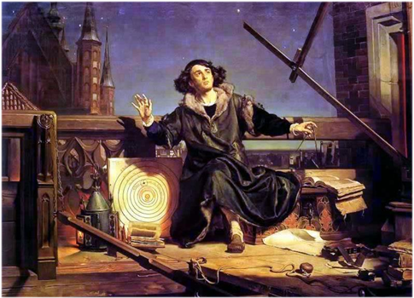
An interview with the distinguished astronomer -Nicolaus Copernicus, carried out by the Academy of Krakow student- Babuśka from Krapkowice.

Student Babuśka: Greetings Mr. Nicolaus Copernicus! Great thanks for agreeing to this interview.
MK: Good Morning! I am pleased to see that one of the best students of the Academy of Krakow is going to hold a conversation with me.
St B: Today you are a world-renowned astronomer. How did your early education look like? Rumour says that you were taught by the famous Nicolaus Włodka from Kwidzyn- Warsaw capitular.
MK: Unfortunately I was never educated my Mr. Nicolaus. But I have to admit I very much regret this fact- he was indeed a great man. After my father’s death in the 80’s my mother moved from Toruń, so I didn’t have the chance to meet him. However I truly admire his achievements, mostly his remarkable clock hanged on the Wrocław Cathedral.
SB: Please do forgive me but I have to ask- is it true that your mother Bożena‘s father..
Mk: Barbara’s… (smile).
SB: I am so sorry! Please, forgive my mistake! That was an unforgivable oversight!
MK: These things happen, don’t worry… What were you about to ask me?
SB: Oh yes, yes. Is it true that your mother Barbara’s father is the famous Bartłomiej Watzenrode, the supressor of…
MK: I don’t know about any Bartłomiej, I am only familiar with Łukasz Watzenrode. Please don’t be so stressed- you are not in an exam. (smile)
SB: Please accept my apology! What a shame! I am a useless human being.
MK: Everything is ok, really… Do continue.
SB: Oh yes, yes. Is it true that your mother Barbara’s father is the famous Łukasz Watzenrode, the vanquisher of the Knights of the Cross?
MK: Łukasz Watzenrode, the vanquisher of those filthy rats, you meant to say. Yes, he fought against them, he even got wounded during the battle of Łasinem in 1453 or 1453- I can’t remember-unfortunately my memory is slowly fading. Anyway he was a noble and honorable man. Out of the goodness of his heart he lent his vernacular town- Toruń, almost 269 florins for mililtary purposes. Regrettably, he was summoned to God before the Peace of Thorn, so he wasn’t able to see our motherland’s glory.
SB: Currently you are a well-known astronomer. However, was your education always directed towards this profession?
MK: No, it wasn’t- despite the fact that I was always fascinated by the stars and what is beyond them. Thanks to my uncle’s efforts I got into the University of Bologna, known perhaps for its gradutes- Dante Alighieri and Coluccio Salutati. My astronomy lecturer was Dominik Novara- for sure you have heard of him. He was the person who made me discover my love for the moon and planets once again after years of oblivion. However in 1501, after being granted permission by the Warmian chapter, I started attending medical school.
SB: Have you ever tought of, if you may call this, the career of a priest?
MK: No, never. But my uncle, who was a bishop, wanted me to become one, after my cousin came down with leprosy. To his, to say the least, great discontent I chose a scientific carrier. A big hmm…. dispute ensued between us. I have to say that I didn’t expect such bad temper from a man of the cloth. Honestly I wouldn’t even expect that kind of behaviour from my not so polite brother- and that is saying something.
SB: Let’s go forward to the essence of this interview. How did you feel after the heavy critiscm of your heliocentric theory? It is said that even Martin Luther dispised it, sayig that “The fool wants to turn the whole art of astronomy upside-down”.
MK: I am aware that my discovery ruined the foregoing world order and many beliefs became irrelevant. People want to feel safe, they hate such drastic upheavals. I have to admit that in spite of the irrefutable evidence, everyone, exept for my old teacher Jerzy Rytyk, questions my theory. The only thing that comforts me is the fact that maybe the next generations of humanity will accept this knowledge.
SB: You have definetely convinced me. Great thanks for your time, it was a pleasure.
MK: I am glad to have met such a bright student. The pleasure is mine.

Agata Wolak
Renessaince Fashion came to Poland!!!
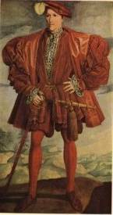
Men’s fashion
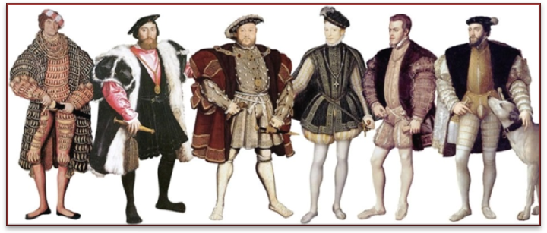
Wide necklines jackets, clothing with puffed sleeves, flat berets, and even shoes, with broad, blunt noses called “beaks of ducking”. Appeared in fashion trendy clothes are extensive, heavy and flowing. On the market there are new materials: cotton and silk, linen and cotton batiste for underwear. Very nice are also materials with large patterns for example velvet on a gold background. Most images are embroidered with black or gold thread. The most representative outfit topsheet is szuba: robe made of precious material with large, collar falling into the shoulders and often with slit sleeves. It has got fur as a lining. Sleeves of “szuba” can also hang freely from the elbow. Fur of beavers sable, kun, foxes, squirrels and dormouse way used for lining.
Female fashion.
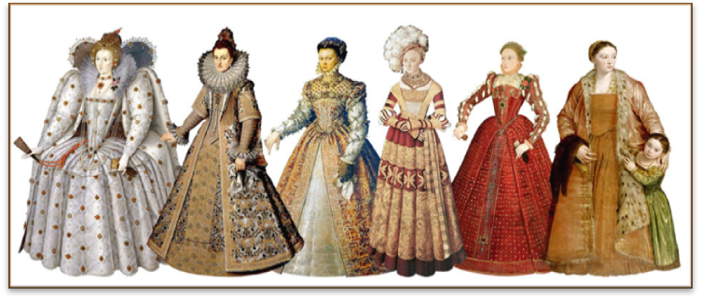
In the wardrobe of contemporary women there are dress pants (consisting of corset on the top and skirt stuck to it) and dress with cone-shaped skirt with a long train. Corset should have square necklines finished with lace and jewels. These sleeves of dress should be wide, trimmed with fur. Dresses should be sewn with wool linen silk or velvet. Woman wears a linen petticoat under the of two dresses. It may seem that this outfit has too many layers but remember that in the castle there was usually chilly and there were drafts. Lately more and more women began to wear the same dress pants. They wear them with decorative corsets resembling more lanes worn around the waist. Most often they were adorned with gold chains and precious stones. It is worth noting that these belts are fastened by a key!
.
Alicja Godek
Attention women!!!
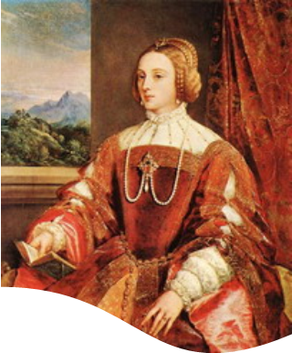
A fashion for New hairstyles is coming!!!
A new ideal of feminine beauty appeared. A Renaissance beauty has golden hair arranged in elaborate however free and natural hairstyle. About 1525 a master of the art of hairdressing created the hairstyle surrounding the face with two rollers of hair formed in the shape of a heart and supplemented with a toque or snood with pearls.
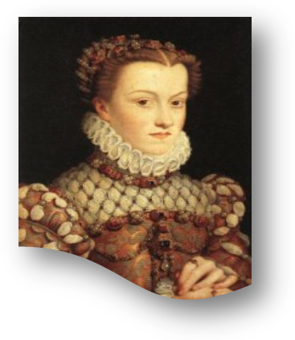
The best forehead should be preferably high and prominent, so to enhance it you can shave the hair on the temples. As not all women have a natural golden hair color, there is a solution!!! You can receive the color using herbal lotions and paints as well as the brightening sunlight.
Agata Wilk
Advertisement
Private cardiological surgery.

Medical doctor Józef Struś – a doctor of philosophy and medicine.
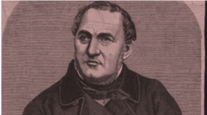
As one of the first discussed at length the issue of the pulse in the life of a healthy and sick person. Professional measurements of heart rate and pulse.
Poznań, Marketplace 15
Medical examnations: Monday, Wednesday, Friday from noon.
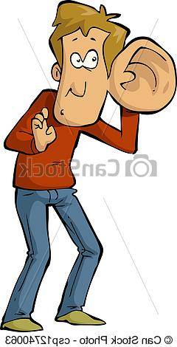
Contemporary family…
Family has always been an important part of the society. Children have been raised in many different ways. How does the situation look in today's family, in the times of development?

In
the Polish society small families were always the most frequent. People get married when the woman was 24-25 years old and the man was one or two years older. It happened like that because people wanted to start work first and to sustain the new-started family. Children were born approximately after a year of marriage. Children were born every 1,5 to 3 years. When thinking about the late marriage and early infertility of women, the number of children in the family was no more than 4 to 5 children. A huge death rate appeared, so 25% to 30% of new - born children died and little less of them died during childhood and teenage years. As a result of that less than half of the children born ever turned adult. A huge death rate also touched the women giving birth.
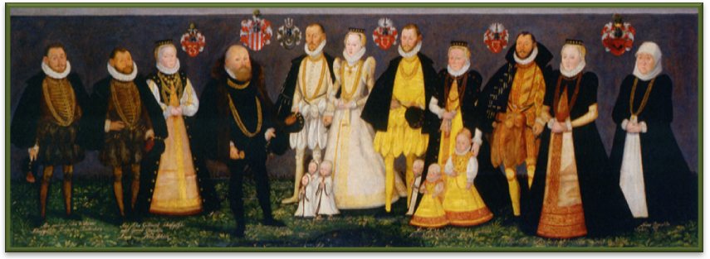

"Families in middle - class nobility"
To get married, the groom had to be educated in school or court and be experienced in army, have office skills or inherit some wealth or have something on lease. The bride did not have to do such things. Her father would give dowry to her. Different conditions caused a big age gap between the man and the woman. Children of the nobility middle - class were taken care of by servants. They were considered to be close to the children. They were called babysitters and were supposed to take care of the children but also breast - feed them instead of their mothers.

Dul Marzena
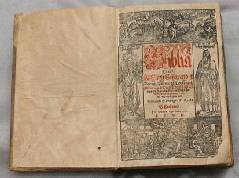
ATTENTION!!!

The first edition of The Bible are availavle in Polish language!

Meeting with history……
Poland at the time of the Jagiellonian dynasty is experiencing his golden age in the history. The founder of the dynasty was Wladyslaw Jagiello III who, in 1385 by the Act of Union in Krewo, married queen Jadwiga. Grand Duchy of Lithuania joined to the Crown of the Polish Kingdom. The last king of this dynasty was Zygmunt I Stary. The next king wass Zygmunt II August.
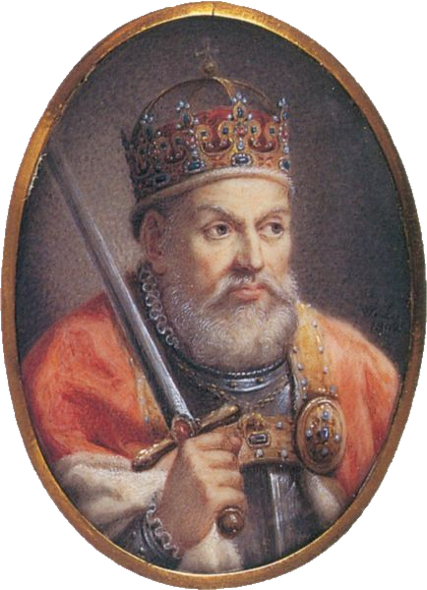
Zygmunt I Stary lived from 1476 to 1548, the Grand Duke of Lithuania and the Polish king was in 1506 as the Polish king relied on the Senate recognizing the nobility for immature which led to the war hen in 1537. In foreign and domestic policy , which sought to drive with caution and circumspection cared primarily about the interests of the State. The wife of Zymunt I Stary was Bona Sforza. The Queen had quite considerable influence over the king and especially in his last years of life. Turkish sultan forbade his pirates attacking castles in Bari or Ostini, Not because that he asked him about some Italian princess , but because fortresses belonged to the Polish Queen - State of which they counted. What is the proof that Poland experienced its golden period and was in power at that time in Europe, to which everyone had to be with reckoned. In 1525 in Krakow Grand Master of the Teutonic Order Albert Hohenzollern paid homage to King Zygmunt Stary, who gave lenny relationship to Poland and Prussia. The King in 1526 included Mazovia to Poland. He avoided a conflict with Turkey in 1533. Thanks to his political and economic abilities, he got a regular army called ‘Political Defense” He was a prominent patron of the arts, particularly architecture, that his reign was rebuilt in the Renaissance Wawel and during his reign in Poland art and culture flourished .
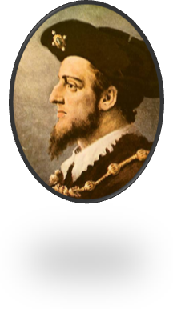
Zygmunt II August was born in 1520. Grand Duke of Lithuania was from 1529 years and the Polish king from 1548 (formally in 1530 ). Through his mother Bona Sforza crowned his lifetime father Zygmunt Stary in 1530. In 1547 , taking secretly married to Barbara Radziwill began his reign in conflict with the nobility. At first, he continued the policy of his father and reigned with the nobles gradually based , however, on average the nobility. During the coronation of the youngest Polish king when he was nine years and seven months. Adopted resolutions the Council of Trent , which was considered the beginning of the Counter-Reformation , but maintained religious tolerance. Zygmunt August , as the ruler of the state of the Commonwealth had to measure up to a great variety of religious. He was a Catholic. His reign fall on time powerful movements Reformation of Catholicism in Europe. Which required moderation in decisions regarding faith. King was tolerant of other faiths. The King often spoke to the deputies , " I am not king of your consciences ". Poland was called " a country without stakes " and many people banished from their countries settled in Commonwealth for example Czech Protestants Scots Dutch

Krystian Warias

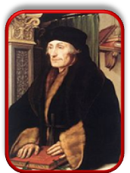
Breaking news!!! Revelation!!!

- Mikołaj Rej is the propagator of the national language, he’s writing in Polish. Finally, we can understand what we read.
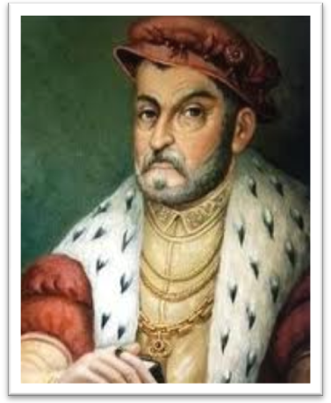

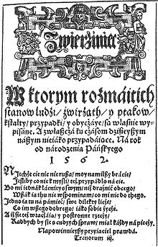

*Mirror

„Congratulations
for this country”

In 1523 the famous philosopher Erasm from Rotterdam, impressed by the Polish successes, wrote the following words: “ Congratulations to this nation… which now in science, law morality, religion and everything that separates us from barbasim, is in such a bloom that can compete with the first and highest of all the countries.”

Agata Wilk , Trembecka Weronika

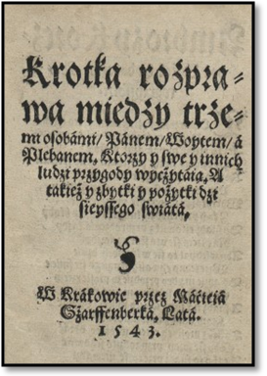
* A short dissertation between three people: Lord, Mayor and Pastor.

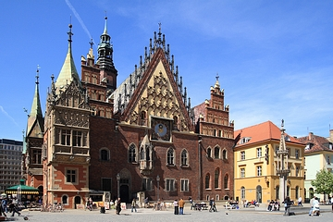
Breaking news!!!

On 9th October 1550 a clock with music, sounding at every hour and every half an hour was placed in the tower of Wrocław city hall. | 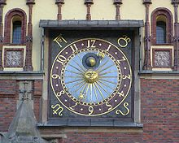

.

Poets travels - following Jan Kochanowski
In June 1549 Jan Kochanowski graduated from the Jagiellonian University and moved to Wrocław. Then he went to Królewiec and after a short period of time he started education at the University in Padua, Italy. The question is - does our Kochanowski in the era od great geographical discoveries discover new cities and tries to get to know different universities? For sure!!!
The Earth turned out to turn around the Sun! |  | 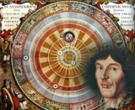
In a very wealthy family there was a young girl, who was interested in meteorology. She loved to watch stars in the evenings and she was wondering about secrets of the sky. The teenager was fascinated so much that she decided to study astronomy.  She searched for some information about the functioning of the cosmos. Her friend helped her. The sky was his hobby. He knew all issues about this topic. He told her about the important advantages of study in this field. The young girl was more and more sure that she wanted to learn about secrets of cosmos. She was very happy, and she went to her mother to tell her that she decided to study the stars, planets and other objects in the universe.  -Hi mum! I'm sure, I want to study astronomy.  -You are crazy.- Mum told her.- You are too wealthy to study. We give you all you need. You don't have to waste time to study and work. I think that it is more probable that the Earth will be spinning around the Sun than that you will manage to start University. You are too lazy. | -Mum, do you know that the Earth always spins around the Sun? You have never heard about Copernicus, have you?- Ann was very surprised.  -It's not true. The Earth is flat like a pancake.  -Rubbish! I'll prove to you that I'm right.-She screamed and slammed the door.  It took the girl a lot of time to show her mother that her theory was true. She conducted a lot of research, talked to many scientists. Finally, after many years of hard work, thanks to her curiosity she discovered what nobody else had noticed.  Turczyn Dominika
Congratulations!!!
Monika Dąbrowska

Concert of Mikołaj Gomółka  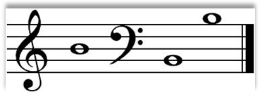  “Melodies on the Polish Psalter”  In the program selected psalms  - Get in with a good heart, oh, virtuous king.  - Oh, virtuous, remember God with cheerful hearts.  - My heart makes me singing to my lord.  - Listen, my faithful folk, open your ears. | 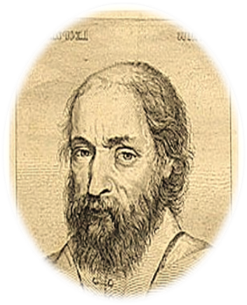  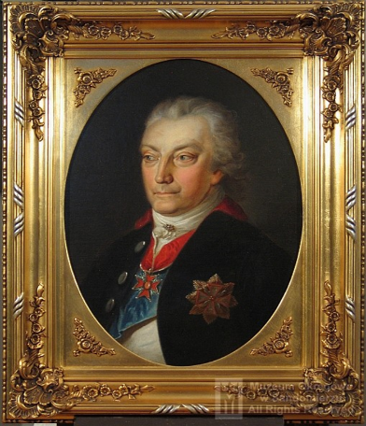  Concert will take place on 12th December Year of our Lord 1550 at 19:00 at the royal castle in Cracow.  Welcome!
BUILDING SERVICES  Benedict from Sandomierz  Architect and bricklayer  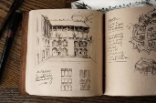  Expertises in modernization works  Telephone: Tel. 12 654 193 | 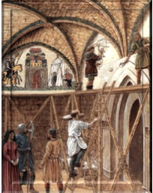
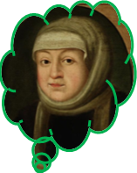
Job opportunity !!
I am looking for people willing to help with the cultivation of new species of vegetables. Savoy cabbage and dill will soon appear in Poland, thanks to the arrival of the Italian queen Bona Sforza. Their cultivation would be a kind of experiment on a national scale . If all goes well this will be saved it on the pages of our history . For this reason we need a patient, hardworking and conscientious person. If you have those features immediately come to the castle, maybe you will be helping the queen in the cultivation of new vegetables.
Ola Popiołek

Nawojka – the first female student

I stayed in center of Krakow along with 2 other students, Jacek and Jakub, but some people called him Andrzej. I have no idea why. On this day was celebrated Ester Monday, so there were many jokers. A lot of people celebrated openly, repeatedly pof water to such an extent than they were all wet. |  | 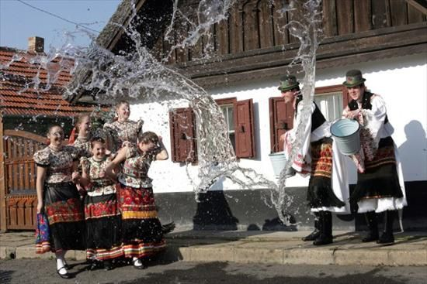
 | A group of kids saw that I was completely dry, so they started to run after me with buckets. I really liked this holiday so joined in the fun, with Jacek. But Jakub preferred to stand aside and watch the water fight. I decided to pour a solid bucket of water on him, but he run away and told me to leave. I didn't listen to him. I went up to him , he was behaving very strangely. I decided to encourage him to celebration. It turned out than Jakub was a woman, large number of people noticed this. After this incident Nawojka, that means Jakub was kicked out of the Academy and had to appear before the court of bishops. I decided to help her and advise something. Together we tried to look for a way to avoid the penalty which was burning at the stake. Nawojka was very nice and I started to think about her more often.
I decided to invite her for dinner in the evening, she agreed. After the evening I knew something between us sparks, so meetings were held more frequently. But the problem continued to exist. I realy liked Nawojka. Jacek sudenly came up with an idea. He came up with the idea that Nawojka should go to a monastery. I didn't like this idea as it would mean the end of common meetings with Nawojka. Nawojka stood before the court and promised than she will go to the Monastery. The court agreed. Then I was happy but also sad. Nawojka was also not completely satisfised. We had to part with a heavy heart, and I had a promise than I would never try to find her. Nawojka moved out and walked toward the monastery, and I was left with sorrow and grief in my heart because I lost a very close person to me
Jakub Moskalewicz

CROSSWORD – the vertical entry is the second word to a sentence about Poland!
1
2
3
4
5
6
7

1. name of the Polish queen , wife of the king Sigismund
2. Polish writer promoting Polish language
3. Polish poet famous for traveling and studying in Italy
4. The first woman studying at the Jagiellonian University
5. Polish king who gave his name to the most famous bell in Poland
6. the oldest Polish University
7. the Polish scientist who discovered that the Earth turns around the Sun
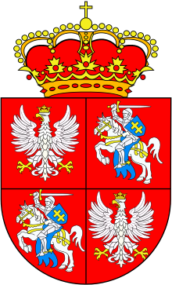
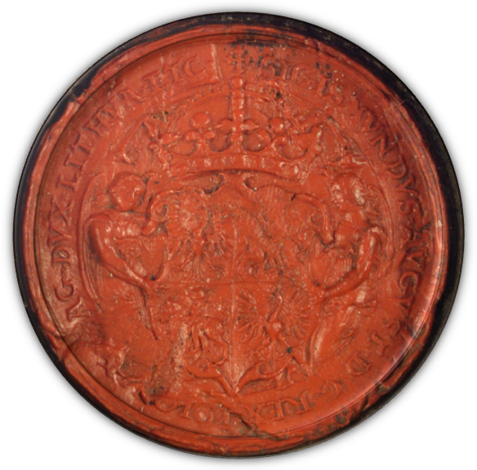

Emblem of Polish Lithuanian Commonwealth Stamp of the king Zygmunt August from 1553
