FAMILY COMPANY FROM PODLASIE USES THE KNOWLEDGE OF THE ANCIENT TIMES?

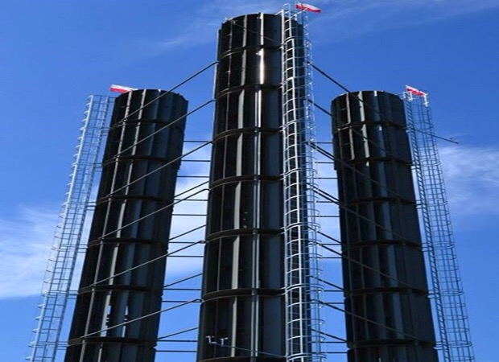
Vertical wind turbines it’s an inventory from Podlasie, made in a family company- Piskorzów. As Mr. SylwesterSalach explains, the technology used by their company, isn’t something new. Vertical axis was known from ancient times. New is here, that we let the wind on the circuit, we use kinetic energy changing in to rotary energy. Another new innovative feature is modularity, which enables you to build any size segments passing energy to the generator on the bottom. It can be a revolution. Thanks to the creation of any size objects, they can be used on the buildings roofs and on the decks of ships.Though more expensive than traditional solutions, vertical wind turbines are up to 50% efficient than before.They can be build in two months times, and relatively small height allows you to avoid formalities.
Agnieszka Banik I TC

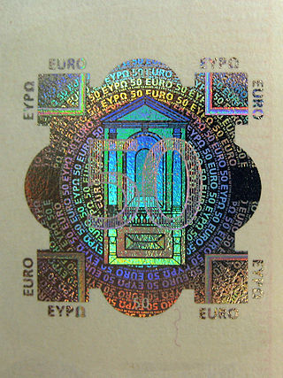
We do not have to worry about money

A hologram is a special form of protection. Itis a sign on anothersign in colouror transparent. It is aprotectionagainstdocumentsforgery. Hologram was invented by a Polishphysicist –Mieczysław Wolfke.

Alicja Wałek I TC
BUMPER THAT REDUCES THE IMPACT BY 90%?

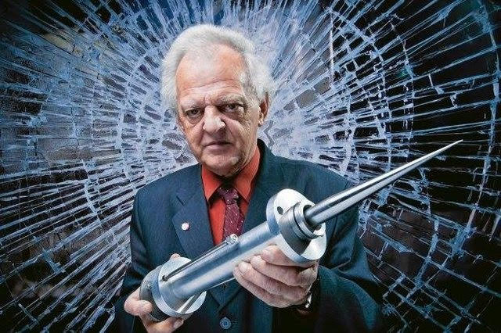
Łągiewka's bumper is a shock absorber which protects physical object against effects of collisions. Inventor of this method is Lucjan Łągiewka. This technology allows reducing the effects of collisions even about 90%. This mechanism reduces forces and energy which work in struck object. Łągiewka developed his bumper in the 90s but so far none practical realization of this inventionexists.

Karolina Chmura I TC
Bulletproof vest
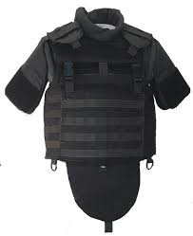
The first bulletproof vest in the world has been created by Poles, precisely Jan Szczepanik and Casimir Zeglen. Szczepanik reached a conclusion that a vest that has to stop bullets should be made of the strongest at that time fabric- silk. The fabric, arranged in suitable strands, has been strengthened with metal plates. This is how theoretically a bulletproof vest had originated. Jan Szczepanik was so confident of ist effectiveness that he tried it on himself- dressed in his invention he allowed to be given a gunshot. As you might guess- nothing happened. Polish vest quite soon found a practical use. In 1902 bombing assassination attempt on King Alfonso XIII of Spain failed, because the monarch was sitting in the carriage lined with a bulletproof fabric invented already by the Poles.Of course, today’s bulletproof vest differs from that of 1897. However, the Poles were the first to come up with this idea and produced the first copy.

Ernest Jarosławski I TC
Aleksandra Knap I TB
LRV

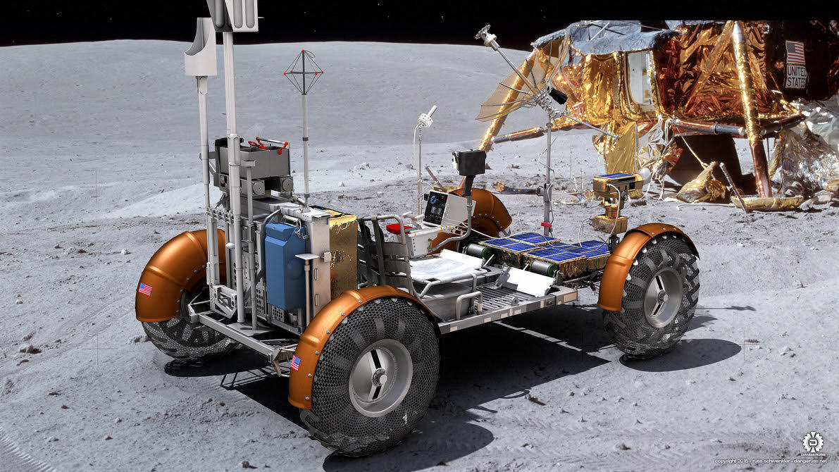
Polish invention - LUNAR ROVIN VEHICLE
Although Poland isn't the power of the automotive industry, our national ideas were always treated with appreciation. In history of space exploration professor Mieczysław Bekker became famous. He was engineer of Polish origin. He worked in the USA and he invented and made a suspension system for LUNAR ROVIN VEHICLE, for the company General Motors. So far it is the only vehicle which helps humans moving on the Moon. Mieczysław Bekker was also directing a team, which built a lunar car. It served for transportation of tools, scientific and communications equipment, and lunar soil samples. It was used during the last three lunar Apollo flights.
Iza Duszkiewicz I TC

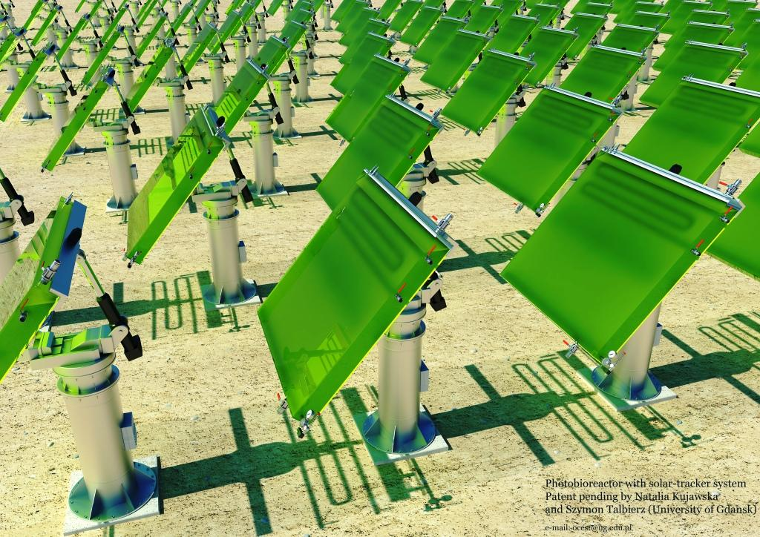
Photobioreactor

Photobioreactor system solar tracker for the production of biofuels third generation - the invention was developed by Natalia Kujawska and Simon Talbierz. It is an invention that allows you to run economically efficient cultivation of microalgae, rich in lipids, which then produce biofuel. Soon, thanks to the invention, we will be able to produce biofuel at any latitude 100 times more efficiently and faster than doing it now with the help of canola or maize.

Korycka Karolina I TC
A BULLETPROOF VEST FILLED WITH LIQUID

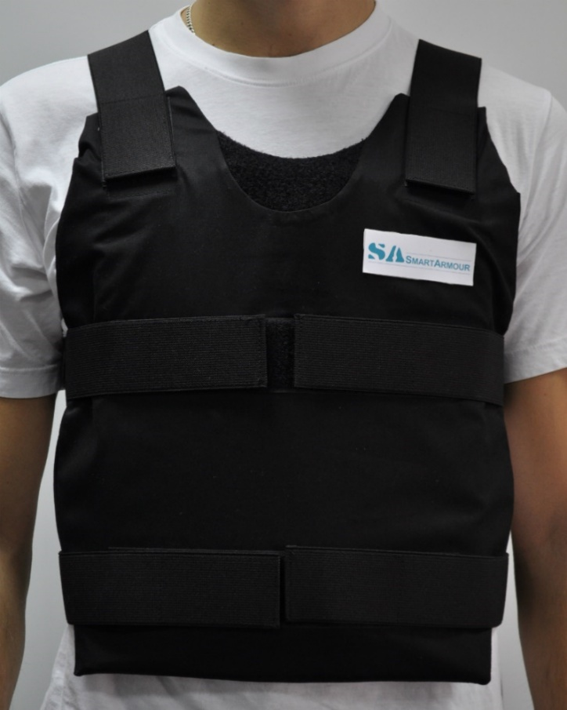
With the help of today’s bulletproof vests it is difficult to protect hands, legs or neck. The material for this bulletproofs vest is very hard and 30-40 layers are used to make one bulletproof vest. Scientists from Polish Institute of Security Technology MORATEX found a way to solve this problem. They invented liquid which becomes hard when it is hit. In effect this liquid protects against the bullet penetration. When you hit this liquid very hard, it becomes very hard. So in effect we can use this liquid to make bulletproof vests and we can use fewer layers of the material. New bulletproof vests are lighter and more flexible what allows making bulletproof suits which can’t block your movements.

Justyna Dudek I TC
THE CREATIVE CITIZEN OF MIELEC CONQUERS THE WORLD
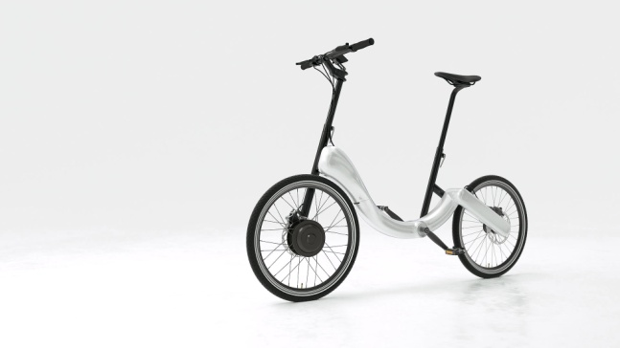
Marcin Piątkowski was 23 when he stood at the biggest Apple Store in Europe and pretended that he was showing his newest IBike to the audience. They were delighted. Although his bike still didn't exist, he sold one hundred of them! JIVR doesn't have a chain but he has a gearing hidden in the frame. Despite the aluminum-carbon contruction and slenderness it is heavier than you can expect because it's equipped with an engine with a battery. While riding a JIVR – even if - for a meeting in which shouldn't appear just after city gallop, you can accelerate to 25km/h. If the battery discharges,you could ride with the traditional method. In a destination of the travel you can fold the bike (because the urban vehicle has to be colapsible) and after you need only 90 minutes to recharge the battery. Actually it's not a bike... rather a vehicle for these who could ride a bike but they don't because of various reasons. JIVR can communicate with the city's infrastructure.
Natalia Balczyk, Patrycja Gera I TA
THE END OF EGYPTIAN CLIMBING ON BIKE CYCLE

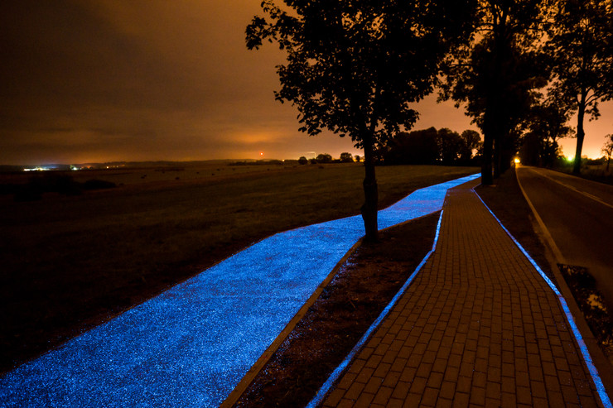
Blue bicycle path that glows in the dark was established near Lidzbark Warminski, on the trail leading to Lake Wielochowski. The author of the surface is a TPA laboratory in Pruszkow.
Surfaceshining bike path includes the so-called. phosphors. These are special synthetic substances, which "are loaded" by means of daylight, and at night they emit accumulated energy. During the day the cycling path is blue.
The idea here to create the optimal color scheme of the nearby lake and nature, and, mainly, for the safety of all traffic participants.

Patryk Golec I TC
What does music and a paper clip have in common?

A paper clip is a piece a bent wire, generally used to keep sheets of paper together. First patents for clips appeared in second half of the nineteen century. Józef Hofmann was inventor of the office clip. He was a composer and a pianist. The inspiration for Hofmann was a bent form of music notes. His most popular form clip “Gem” has never been patented, but it was produced probably in 1890 by “The Gem Manufacturing Company”. A device that bent clip “Gem” was patented in 1899 by William’s Middlebrook.

Katarzyna Ćwięka ITB
A POLE DISCOVERED AS A CHEAP PRODUCTION OF
PHOTOVOLTAIC MATERIAL
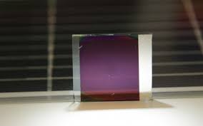
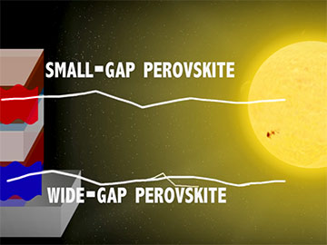
Perowskity is an invention of graphene. Pole Olga Malinkiewicz has discovered how to cheaply produce this photovoltaic material. It will be soon possible to obtain cheap energy from the sun. This polish woman is the author of one of those ideas. Malinkewicz proposes that crystals, which produce energy should be hidden in ink, and it can be printed on each surface. Perowskity is a mineral existing in the nature, but it can be also produced. In the sun water sit would replace the popular silicon, which ultimately results in more expensive than the perovskite. What is more interesting in this method is the fact that the material can be spread on any surface. It may be plastic or paper and maintain high cell efficiency. It is not possible to apply silicon to flexible materials. If the perovskity material would be sufficiently durable, it would depend only on the imagination of people how they would deal with mass production. It could be houses, cars, skyscraper windows or clothing. Layer only 200-300 nm thick.

Łukasz Stala, I TA,Marcelina Domoń ITc
Artificial bone
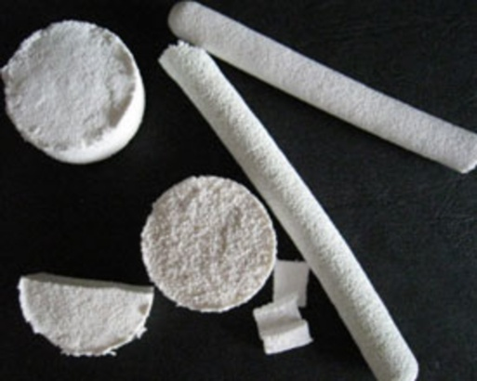
Artificial bone - bio material similar to natural human bones. It was developed by biochemists from Medical University in Lublin and the Academy of Mining and Metallurgy in Krakow. Work on the creation of the material lasted two years. A team of scientists was led by professor Grażyna Ginalska. A synthetic bone is a white, firm substance with hard and elastic structure, similar to construction natural bones of a human being. It can be soped with antibiotics and it avoids contagion in the implantation place. The substance doesn't have any side effects, doesn't cause allergic reactions, speeds up the healing of wounds, perfectly fits in the living tissue and bone cells combine to produce also the blood vessels. One of the components of the artificial bone is hydroxyapatite, a mineral occurring in the nature among others in the bones of human, animal and in the corals. Artificial bone is used for refilling after injuries and cancer of the bone, as well as inflammation after tooth removals and periodontists.
Faustyna Szkutnik, I TB
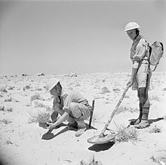
Polish people in the 2nd World War.
A mine detector was constructed during 2nd world war by the Polish lieutenants Józef Kosecki i Andrzej Garboś who served in Polish Military Forces.
It is composed of headphones, a bamboo stick with the plate in the end and a measuring camera in the backpack. In the plate there were two reels which made the electromagnetic field . When it detects metal it signals by whistling. A mines weeper moved the plate upon ground and found thanks to the sound localization of mines placed in the ground . First trials of the prototype were executed in Bari Town in Scotland on the 5th March 1942

Doroż Marcin,Dawid Maciejak, Magdalena Mydlarz I TB
B-Droid

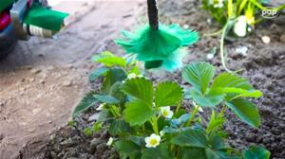
B-Droid is the first pollinating robot in the world. The appliance was developed at Warsaw University of Technology and was tested on strawberry and garlic fields. It can move between flower beds on its own, find flowers and carry pollen from one flower to another. B-Droid consists of two small video cameras, which are able to distinguish flowers and enable orientation in space, and two computers. One of them is located on the “bee” and transfers data to central computer, which controls the appliance. B-Droid’s movements are not controlled by a human–I t is self-reliant in its work. B-Droid, which is a driving robot, moves over the crops and by making movements whole its broom carries pollen from one flower to another.
Weronika Irla, Aleksandra Hamala

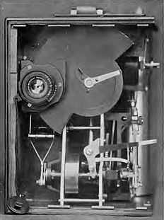
Handheld film camera?
The Aeroskop is the first handheld film camera in the world with automatic image stabilization. It was a type of compressed air camera for making films, constructed in 1908 by the Polish inventor Kazimierz Prószynski. The tool was closed in a wooden case with a handle attached to the top to carry. The camera was placed in a wooden casing with a film strip roll installed. His weight was about 6 kg.The camera has contributed to the development of early documentary, natural and documentary films. The designer shot the coronation of King George V in 1911 in London.

Dominik Bigos I TB

Unusual invention from 2013

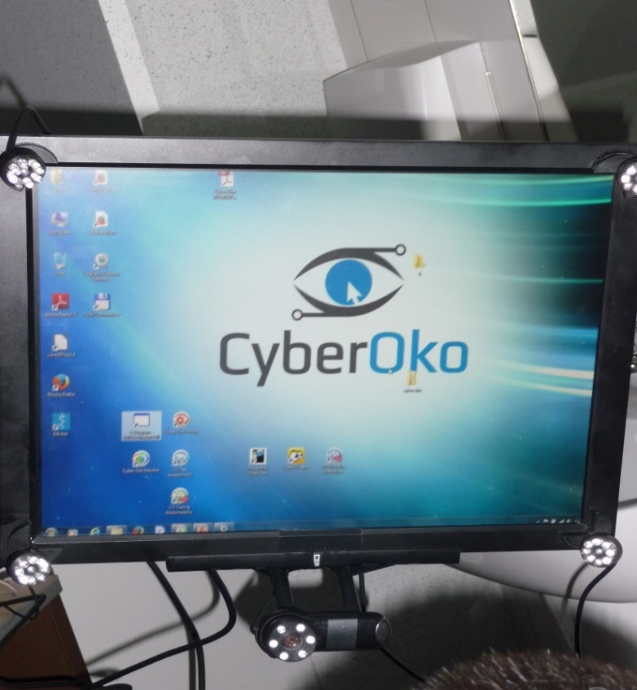
Cyber eye is an appliance to contact a person in state of her minimal awareness. We use it in medicine to communicate with patients. This system is the only way thanks to which a patient can get in touch with the outside world. Invention was rewarded as the best scientifically technical achievement in 2013. This invention was created by scientists of PolitechnikaGdańska (Gdańsk University of Technology) and now it is used in 6 centers in Poland.

