GOODBYE, BARCELONA!
By Alvaro Martinez García
After 16 awesome days in Barcelona, we have to say goodbye. The 1992 Summer Olympics Games are officially over since yesterday, 9th August. They have brought a lot of surprises for Spain and all the other countries around the world.
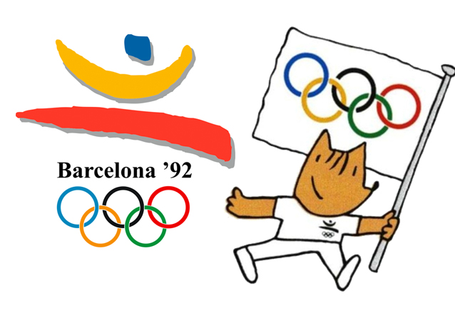
They started the 25th of July. They could have had the best Olympic opening ceremony with the song “Barcelona” of Freddie Mercury. Unfortunately, the famous singer from Queen died last year of AIDS. Despite this setback, they made an awesome performance, especially with the Olympic flame. It was lit with a flaming arrow, shot by Paralympic archer Antonio Rebollo. That shot “entered” (it didn’t enter but with a specific angle of the camera, it looked like that) and lit the Olympic Cauldron. After this opening ceremony, Olympic Games officially started with 9364 sportsmen and sportswomen from 169 countries. Curiously, the best country in this Summer Olympics was the Unified Team made of 12 out of 15 former Soviet republics. Estonia, Latvia and Lithuania competed individually.
These Olympic Games have been the best for our country. We’ve won a total of 22 medals (13 gold medals, 7 silver medals and 2 bronze medals) and set some Olympic and World Records. For example, the cyclist José Manuel Moreno with his gold medal and World Record in 1km Time Trial. We had two surprises too: the goal of the football player Kiko at minute 90 which set the score to 3-2 and made us won the match and the gold medal of Fermín Cacho at 1500m who passed his rival in the last 300m and crossed the finish line raising his hands with hundreds of people shouting his name.
Athletics had more surprises for all of us. American athlete Gail Devers won in 100m women after recovering from an illness in which she could have lost her feet. It was needed a photo-finish to know who won in that race (Gail Devers won with a difference of 0.06 seconds). One of the big surprises in athletics was in 400m men. British athlete Derek Redmond was one of the favourites but he injured his Achilles’ tendon in the middle of a race. He wanted to end even though everyone (even his father who jumped over the fence to stop him) tried to stop him. He crossed the finish line helped by his father and with tears falling from his eyes.
In basketball, the FIBA (International Basketball Federation) accepted the NBA players to be selected for the USA basketball team in the Olympic Games. This team nicknamed as “Dream Team” had famous players like Michael Jordan, Magic Johnson and Larry Bird among others. They won the gold medal with an average difference of 44 points and an average of 117 points scored per match.
Yesterday, the closing ceremony lasted almost 2 hours and ended with the song “Gitana Hechicera” and thousands of athletes on the stage while they were warned to get down because it could be dangerous.

