Dear European Union
By Clara de la Rosa
This entity will be always prospering and thanks to it we are one of the first political powers in the world.
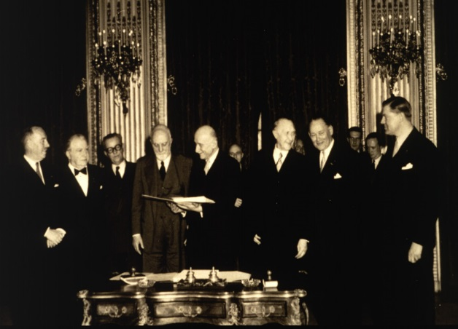
Forty-five years have passed since the fundation of the European Coal and Steel Community here, in Paris. Thanks to this event, our dear European Union is and will be the most important geopolitical entity in the whole world. Thirty-eight years ago the union of three European Communities took place: the European Economic Community in Rome, the European Atomic Energy Community and the European Coal and Steel Community. This union created an economic cooperation among six important countries of Europe: Italy, Germany, The Netherlands, Belgium, Luxembourg and, of course, our beautiful country, France. Thanks to these countries the European Union was created and we have to be really grateful.
European Coal and Steel Community (ECSC) Paris
Years later, other countries not that important, like United Kingdom, Spain or Portugal, strated to enter in our union. Nowadays countries that want to be part of this great entity continue entering and we are becoming more and more powerful together. Thanks to it our economy is also increasing and improving with the years so we won’t have any crisis never again, what is awesome. And we can’t forget the Euro, the coin which has helped a lot to the economy and to the commerce between the countries that form the entity. Also we have got to stop the continue conflicts that took us to the First and Second World War between some of the European countries, including our. This was the fundamental idea to create this big and great union.
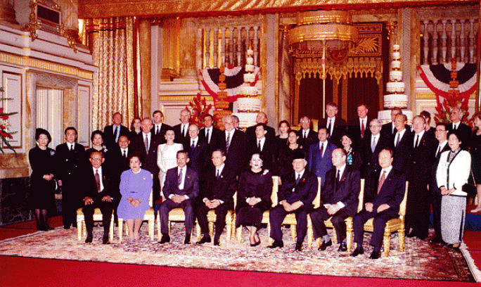
Last year some events took place to help the improvement and the prosperity of Europe: France assumend the presidency of the council because of its several helps and sacrifices for the welfare of Europe and its citizens, in January also three new countries entered in the European Union: Austria, Finland and Sweden , Romania and Slovakia requested to enter in June and in July Spain assumend the presidency of the council of the European Union after France, what a big disappointment…
This year Italy started with the presidency in January, which, honestly, did a good job but it will be difficult to overcome the presidency of France. The Czech Republic and Slovenia requested the membership to the European Union. In March we celebrated the ASEM Summit for the first time in Bangkok (Thailand). The President of the Council, the President of the European Commission, and the Secretary-General of the Association of Southeast Asian Nations attended to this meeting for improving comunication.
Asian-Europe meeting (ASEM Summit) Bangkok
Currently we are under the presidency of Ireland since July. Recently a transatlantic summit has been celebrated between Europe and United States in Washington and some days ago Denmark, Finland and Sweden signed the Schengen agreement.
We will continue informing about the new updates and events that occur in our European Union knowing that it’s really important for us because of all the things that could be changed in our government. We hope to continue being part of this Union as lons as possible and to get benefits from it.

