Mielec, 6th September 2017 Magnetometer- Do It Yourself
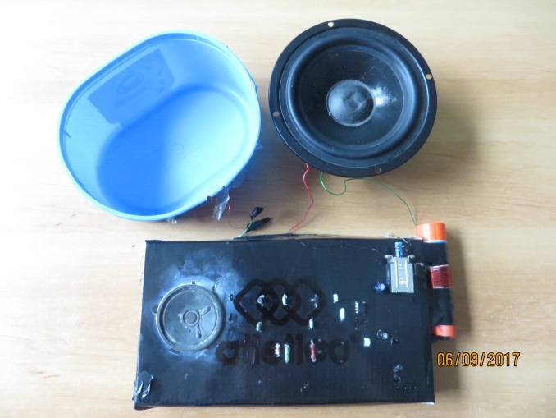

To make a magnetometer you need:
-Two transistors BC 547
-capacitors 3,3 nF and 2,2 nF and 10nF
-resistors 6,8 kΩ and 10kΩ and 220kΩ
-an integrated circuit LM 386
- a capacitor 10mF
-a loudspeaker
-a battery 9V
-a copper wire 3mm
-a card board and a plastic cup
-a glue tube
-a soldering iron
-a switch

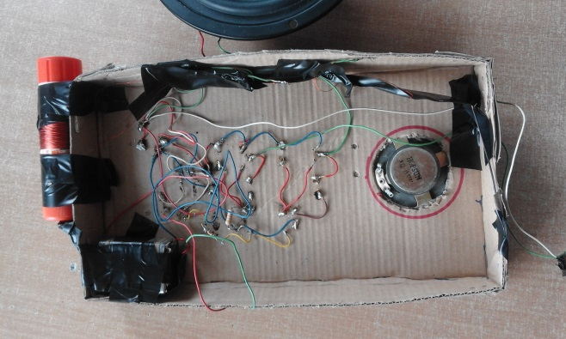
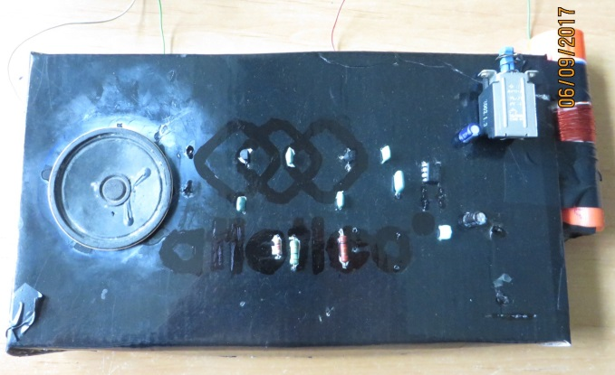
Step by step:
- Join the transistor BC 547 by a soldering iron and a copper wire with capacitor 3,3 nF, and next lead the wire to the capacitor 2,2 nF.

- Next join the capacitor 2,2 nF to the resistor 6,8 kΩ, and connect the second transistor BC 547 to the resistor.

- Connect two transistors to the capacitor 10kΩ, join with the resistor 220kΩ.

- Connect the capacitor 220kΩ to the capacitor 10nF which was joined with the integrated circuit LM 386.

- Connect the capacitor 10mF to the integrated circuit. Then connect the loudspeaker.

- Join the switch with the battery 9V.

- Connect all the elements with the copper wire and soldering iron and fix them on a cardboard box.

- Wind 10 coils of copper wire onto the plastic box and connect to one of transistors.

- Wind 60 scrolls of copper wire on the glue tube and pin to the second generator.

- The magnetometer is ready :D!

You can see our presentation here:
https://prezi.com/hmymy805ekjt/how-to-construct-a-magnetometer/?utm_campaign=share&utm_medium=copy

Made by: Justyna Dudek
Translation: Dominik Bigos

