PLANNING FORM
Disciplines: Technology and Mathematics

Title: Sistene Chapel

Teachers: Janja Maltar, Alina Dziurgot, Maria Pietras, Ian Kell, Ivana Pintac

School: The Bridge School

Class: A Vocational class in Construction

Planning of the thematic unit:
- Methodology:
- check up vocabulary
- resources ( on line) catalogues for paints with genuine costs, decide on room to be decorated, do we use the classroom? Do we use a fictional room from a floorplan, do we use photos or do students photograph their own rooms and extrapolate.
(student discussion……let them choose the colour)
- Key words paintbrush, colours, surface area, volume, estimate, length, width, shade, height, step ladders, ceiling, extension, walls, windows, gloss, emulsion, doors, wood, window frame, measure, tape measure, style, stencil, classroom
- Calculation of the surface in English

- laboratorial teaching method
- Cooperative learning
- Objectives: Planning to paint a room, calculating quantity of paint, choosing colours,

For example:
- Reinforcing weak students
- Using students’ calculating skills in English
- Knowledge, skills and abilities to be developed:
- KNOWLEDGE – how to calculate the area
- SKILLS - use of English in a technological process
- ABILITIES – mathematical competency , linguistic competency, team work
- Instruments, materials, resources:
For example:
- Notes from the technology lesson in a second language,
- Internet,
- measuring instruments (rangefinder – dalmierz),
- calculator

- Descriptions of activities/stages of thematic unit:
- Translate the words into second language with dictionaries or Match the English words to the second language.
- Students explain the way to measure the surface, in the second language
- Explanation of task with gaps and multiple choice. How to calculate the surface of the classroom to be painted:
Measure the 1.………, the 2 ………, and the 3 ……… of the four 4 ……… of the classroom. Measure the lengths and heights of the four 5………. and doors. Find the size of all the 6 ……………….. Exclude their surfaces from the surface of the whole 7……….. Add to the walls the missing surface of the 8………………….. Multiply the 9………………. and the ………….. of the 10………………..We don’t add the surface of the floor.

- A wall B length C volume
- A ceiling B height C shade
- A measure B colour C width
- A walls B ceilings, C ladders
- A doors B windows C walls
- A windows B doors C walls
- A classroom B swimming pool C school
- A floor B window C ceiling
- A length and width B width and breadth C Height and depth
- A Ceiling B Wall C Floor

- Insert the English names: length width, surface, window, door, ceiling, height
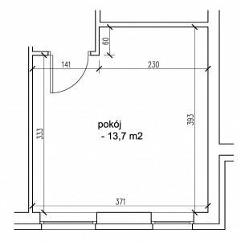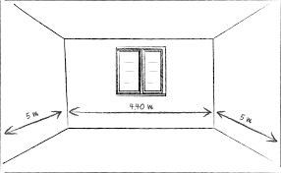
- Let students physically measure the length width and height of the classroom
To exclude doors, windows, electrical points etc. with a laser rangefinder
Use this data to calculate the surface area of each wall and the total surface area of the room using their notes from technology of construction lesson

- Choose 10 colors (refer to catalog……what do the words mean? Make sentences with those colours. Brief discussion. Extend Vocabulary. https://www.crownpaints.co.uk/colours/greens
- calculate the amount of the paint using a prepared guideline based on type of paint and how many coats – using the notes from technology lesson in the second language

- Evaluation: Evaluation grids for the teams and individual students.

- Extension work
- deciding timeline

