

|  |  |  |
| --- | --- | --- |
| **POLISH WEEKLY** | No 1/1970  A.D.1970 | |
| ***Table of contents:***  *- a great opening of Space Flights Planetarium in Olsztyn*  *-obituary*  *-Edward Gierek – speech to the citizens*  *-Karol Wojtyła is the Pope*  *-Polsh troops take part in the invasion on the Czechoslovakia*  *-everyday life in the 1970s*  *-Child Health Centre*  *- football match Poland-Brasil*  *-winter guide*  *-the concert of Budka Suflera in Sopot* | |  |

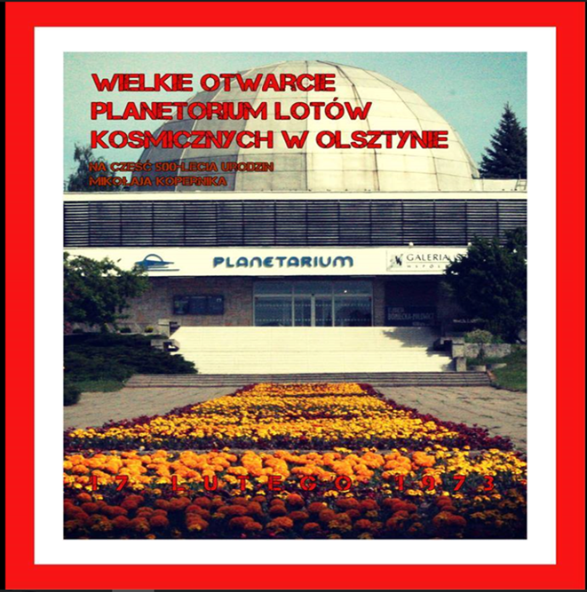

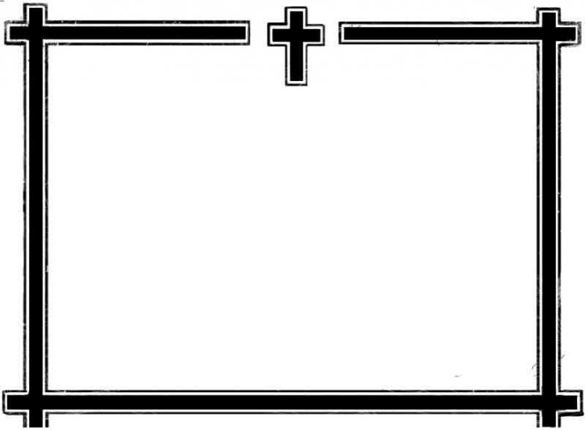

**Bartek Krukurka I TB**

On 17th December 1970

died at the age of 18, shot in the riots by soldiers of the National Army

a Gdańsk shipyard worker,

the beloved son,

a right man

**Zbigniew Godlewski**

(Jan Wiśniewski)

The funeral will be held in the chapel on

the cemetery in Gdansk-Oliwa in the night of 18th December 1970.

Then the body will be placed in the tomb.

Mourning

Family and Friends

**Weronika Irla I T**

**Edward Gierek gives a speech to the citizens**

**Dear Ladies and Gentlemen!  
We have an opportunity to be on the top in the world. We should work hard. We will build new schools, roads, streets and railways. Building it will help us to develop our country. If we work hard we will have good life. The power lies in the strength of the hands. Believe me. We are made of the same fabric. This is our plan.We will win this game. What do you think about it? Will you help me?!**

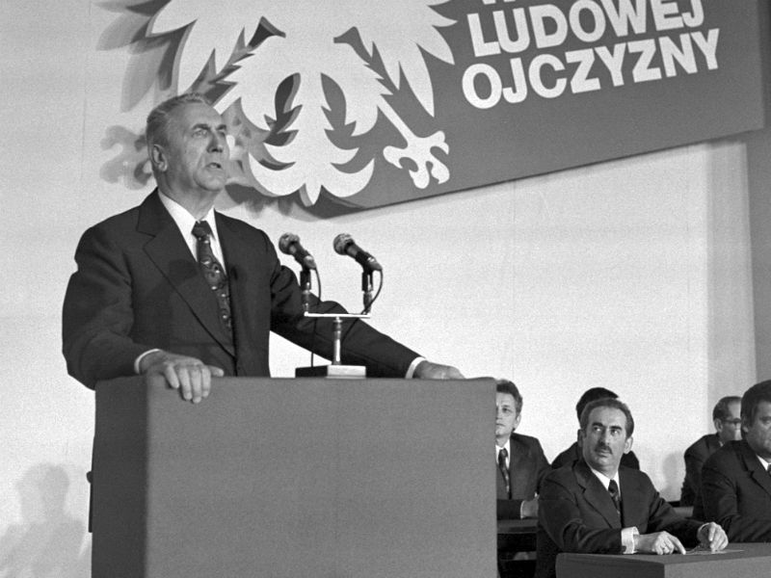

Bartek Krukurka I TB

***Monday ,16.10.1978***

The day like every day. It happened today, after almost five centuries.

One dream came true today .. I can't describe my feelings... let's start from the beginning.

It was a common day but everyone was waiting for the election of the new pope. It`s hard to believe , but I waited impatiently for this day. I was excited and a little restless . I hoped that Pole will be the new pope .My whole family wanted it too. At about 7 p.m we waited for an announcement who the new pope was. It was 4:30 p.m. the voting was over. No one knew who was the pope. Deep down I wanted it was our compatriot but I thought it was rather impossible. All the world thought that this pope will be Italian. So I stopped believing it would be different. It was 5 p.m. I waited for the information who was the new Pope. I sat alone in the room. It was 6 p.m. the transmission on TV from St. Peter`s Square. My heart was beating faster and faster. It was 6:18 p.m. I saw white smoke over the Sistine Chapel. It was a sign –We have a new pope! The crowd shouted- “HABEMUS PAPAM! “ Minutes went by…it was 6:44 p.m. Cardinal Pericle Felici spoke the traditional formula –“ I bring you good tidings of great joy- we have a new pope !Most Reverend Lord and most worthy of the Holy Roman Church , Cardinal Karol Wojtyła , who took himself name John Paul II. I didn`t know what was going on. I started to watch tv. I was shocked. A smile appeared on my face. I was jumping with happiness. No one had expected that the new Pope will be a man from Poland. It was 7:20 p.m. … Our new Pope came out on the basilica balcony to greet the astonished Rome and the whole world. Dreams come true ! I was smiling all the time. No one could destroy it. Our pope was the youngest of the popes who was selected from ages. Whole Poland was going crazy with pride.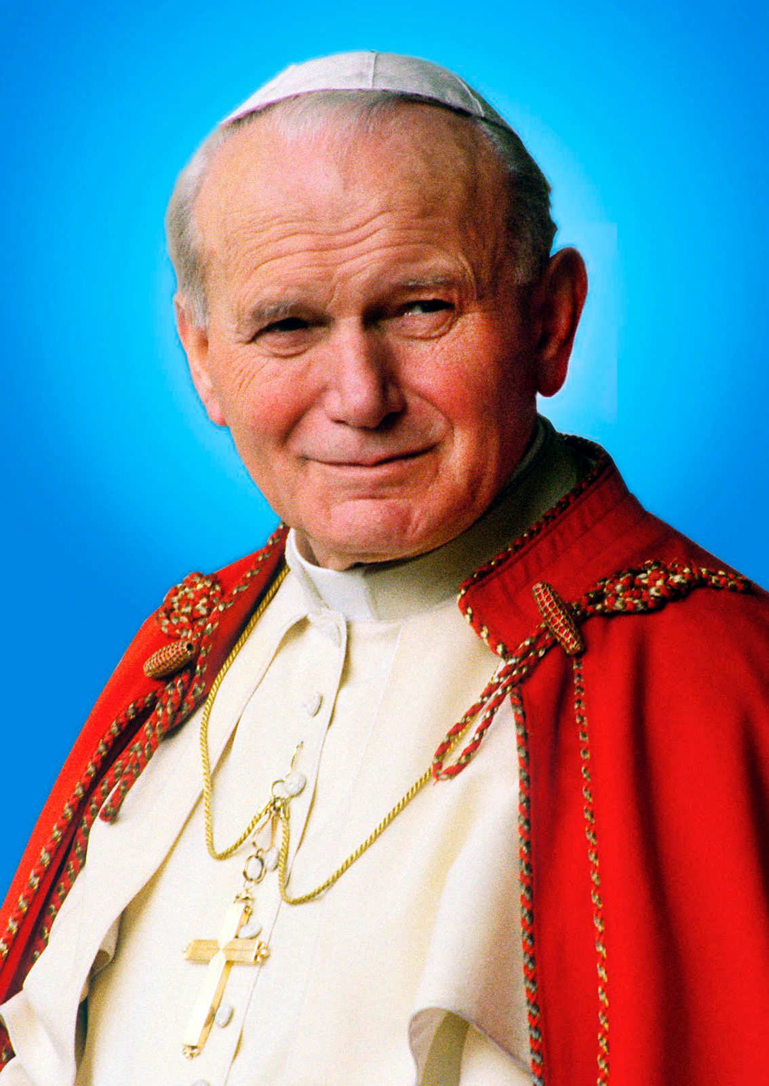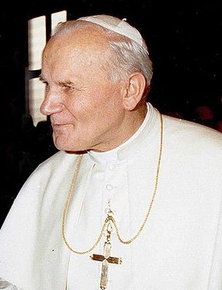

**Aleksandra Knap I TB**



I think that will be next day of uncertainty but I'm wrong. When I arrive home from school I turn on the TV to check the result of the choice of the new Pope. Unfortunately, no choice. I'm waiting and I praying to have a good Pope.

When it is six o'clock, I turn on TV again. I'm irritated . How long ?? When?? I was so interested!

In chimney appears the white smoke. It is eighteen past six. That is this moment.

WOW! The Pope is Polish - Karol Wojtyła, who took the name John Paul II.

I was speechless by surprise. I was crying out of happiness. Wonderful!

**Michał Szczepanek I TB**

*Grandpa tells his grandson.*

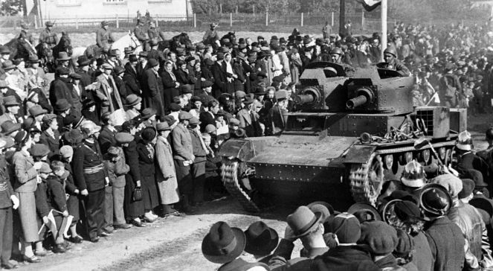

The Polish army forces in invasion on Czechoslovakia.

## Grandson:

Grandpa, what was that invasion all about?

## Grandpa:

Invasion was an armed raid of enemy’s army on the territory of another country.

In 1968 the Polish forces entered Czechoslovakia.

At night 20th August 1968 the armies of the Soviet Union, Poland, Hungary, Bulgaria and German Democratic Republic entered the Czechoslovakia’s territory.

There were 200.000-250.000 soldiers and 4200 tanks taking part in the invasion.

In a couple of hours the forces of the Warsaw Treaty took control of Czechoslovakia.

In total the armies taking part in the intervention caused deaths of 90 people.

More than 800 people got injured.

In 1969 an April 17th the 1st secretary of the Czech Communist party Alexander Dubcek was made give up his political post, he was succeeded by Gustav Husak, the supporter of ,,normalization’’.

## Grandpa:

I’ ve told what I remember. Maybe it’s not clear for you, but I hope it ‘ll be useful for you.

## Grandson:

Thank you very much grandpa.

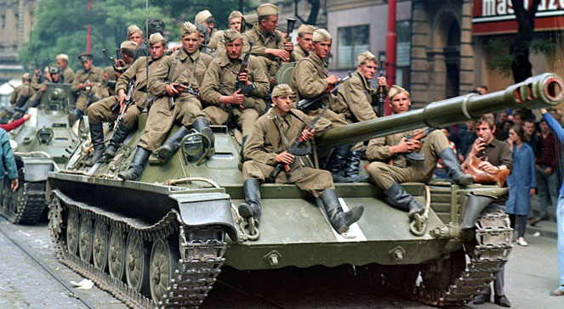**Sabina Krawiec and Gabriela Kulpa I TB**



**Everyday life in 1970s**

-Hi grandma . How are you?

-I’m ok, and you?

- I’d like you to tell me how was it to live in 1970s in that time?

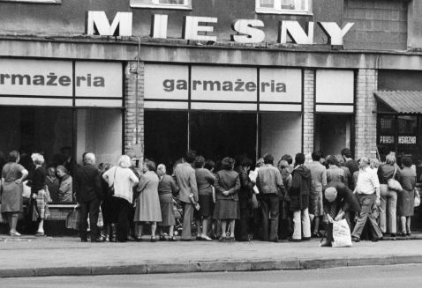-I really like to think about these years. There was almost nothing in shops except vinegar. Than special “ration stamps” were introduced and thanks to them it was possible to buy different products. For the first ones  you could buy: sugar, flour, meat. People were queuing for hours to buy something. And we also used to change each other in long queues. Sometimes when we wanted to get soap and when  it wasn’t in a shop  we took for example toothpaste.

-Really? So you didn’t have a toothpaste? What about other shops?

-There were shops called “Pewex”. In these shops you could pay only in dollars. Only rich people used to buy products in such kind of shops. Everything there looked like in American films.

-Where did the people take dollars from?

-There were people who had families in America.

-So there were not many people doing shopping in these shops, right?

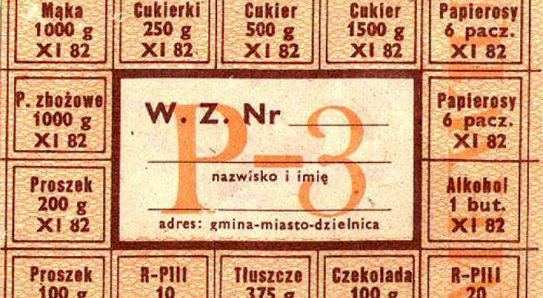- Yes, it’s true. If someone had clothes from “ Pewex” people were envious  and they used to say that this person was very trendy. There were also milk-bars.

-Why milk ones?

-As there were a lot of milk products. It was almost not possible to eat  any meat dishes.

-What about computers, phones or TVs?

-It was just one or two TVs in a village and you could watch only two channels on it. All the people living in this village were meeting in one house to watch something.

-That’s so weird. It’s good that everything is different now. I’m very happy you told me all about it.

-The pleasure was mine. It was great to turn back to that time.

**Natalia Niedbała I TB**



**CHILD HEALTH CENTRE**

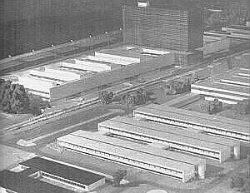

**Monument-Hospital - Child Health Centre. Layout made by dedicated and accomplished project...**

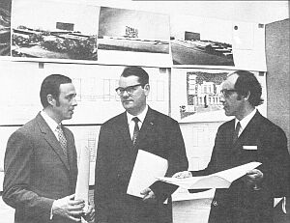

**... sponsored by: engineer. architect Jacek Bolechowski,**

**engineer architect Andrew Bołtuć and engineer designer Andrzej Zielinski**

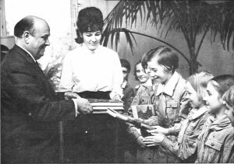

**One of the first deposits is made by scouts - students of the Music School in Lublin.The money is given to the Chairperson of the Social Committee for Construction of Monument-Hospital - Child Health Centre Minister Janusz Wieczorek.**

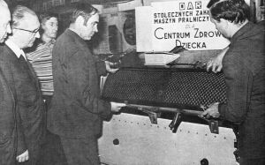

**One of the first gifts was a laundry machine.**

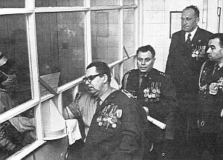

**Warsaw social environment called “Sons of the Regiment“ starts Blood Bank Centre.**

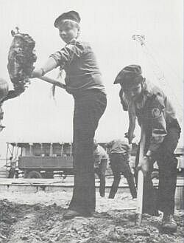

**Scouts help**

**in the excavation at the construction site of the for Child Health Centre.**

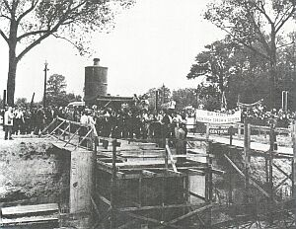

**And finally, in the afternoon on June 3 with the participation of thousands of people from all over Poland, the Chairman of the State Council Professor Henryk Jabłoński shows the documents saying about beginning of work of The Child Health Centre.**



**Aleksandra Knap I TB**

***Football championship   
Poland – Brasil – 1974***

**Brazilians start the second half but the Poles are catching the ball. Beautiful passing  from Maszczyk to Grzegorz Lato. Lato is running, passing the Brazilian defender and GOOOAAALLLL. Grzegorz Lato scored his 7th goal  in the 76th  minute of the match. Poland leads 1-0 with Brazil.**

**The end!! Poland is the winner!!! And this is Poland that is in the third place in the World Championship!**

**We say goodbye to you and thank you for your attention. Jacek Ciszewski commented to you from the Munich stadium.**

**Sabina Taraszka I TB**

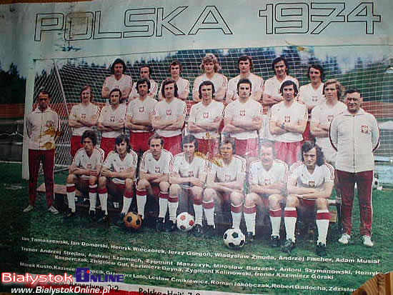

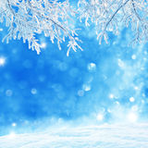WINTER GUIDE



**- how to deal with a winter of the century**

1. It is required to afford dry, clean and warm clothes. It is advisable to wear several thin layers, especially protecting face.
2. Never let your limbs be chilled, be in a constant motion to avoid frostbite!
3. If there is no warm bedding or jacket, you can always rip it up and stuff it with either fluff or wool.
4. Remember about warm food and drinks.
5. Maintain appropriate temperature in rooms and heat them.
6. Try to not to stay for too long when it is very cold outside.
7. Take care of appropriate tires, fuel and car electrical installation (battery).
8. Clear roads, pavements, vehicles and roofs of excessive snow.
9. Remember to not too overheat your body.

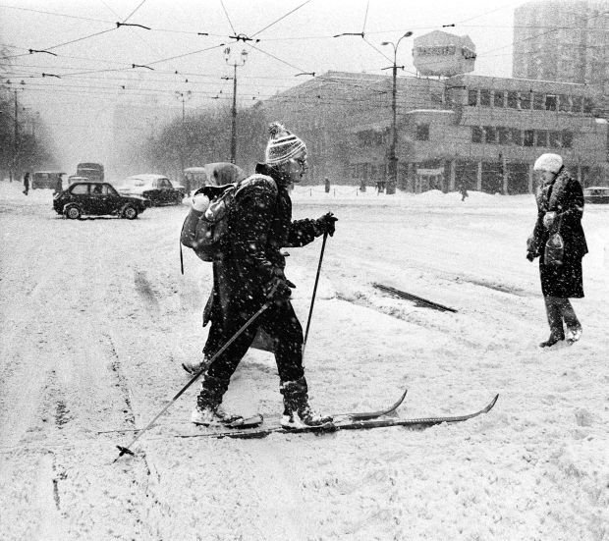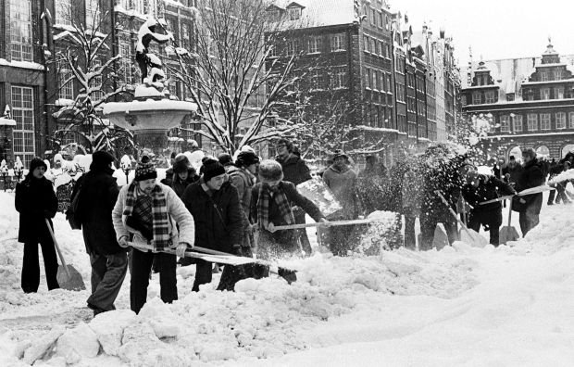**WINTER OF THE CENTURY**

**Weronika Czepiel I TB**

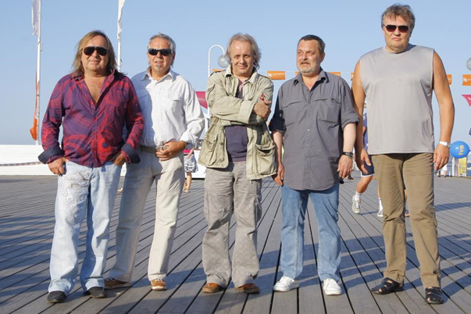

Since the beginning of  the band "Budka Suflera"it has presented many concerts, over 300 of them a year!

I would like to write you about one of them entitled "Budka Suflera in the Opera House, Live From Sopot '74". It took place on August 14, 1974, at the Forest Opera in Sopot. On the debut show appeared Krzysztof Cugowski (as leader), Romuald Lipko (keyboard instruments), Mieczysław Jurecki (guitar and bass), Marek Raduli (guitar, solo guitar), Tomasz Zeliszewski (drums), Zdzisław Janiak (guitar and rhythm guitar) And guest artists Stanisław Zybowski (guitar), Urszula (vocals) and Felicjan Andrzejczak (vocals). There have been presented fourteen hit songs, such as "Dream of the Valley", "Jolka, Jolka Remember", "Shadow of the Great Mountain", "From Long Expeditions", "Lead Time" and others: "All my hustle", "Genius Blues, "" The Road to Goodbye, "" It's not like that, "" Ragtime, "" Silence like this, "" Your radio, "and" It's such a lonely house. "

The band's fans were delighted! They heard their favourite songs! Everyone was having a great time-the crowd was having fun, the people’s hands were up!

The vocalists gave a few words to the fans. They thanked for the opportunity to appear in such a beautiful city on the big stage with such an entertaining and kind audience.

The atmosphere was really great. All the people were having fun not only the young ones but older people as well. With time, instead of rock  songs, artists started to play calm songs like "Jolka Jolka remember". People lifted hands up holding lights in them.

These were unforgettable moments.

The whole show lasted over an hour. The atmosphere was amazing. There was a feeling of love and warmth floating in the air, as if the world had stopped for a moment and all the evil had gone away.

 I am convinced that this concert will remain for a long time the memory of all the fans.

The band's concert was for everyone who wanted to hear it, and for  those who love rock!

**Dominik Bigos I TB**