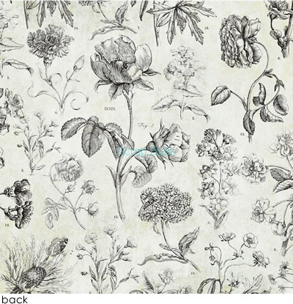
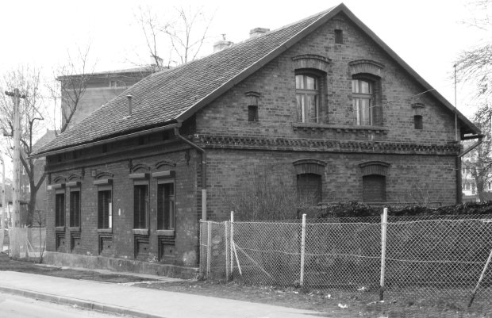
POLAND
WEEKLY
TABLE OF CONTENTS:
- Ode to youth
- Diary from Santo Domingo
- Invasion to Soplicowo
- Relations from F. Chopin’s concert
- Recipe for bigos
- How to make delicious coffee
- Letters from Peter
- 19th century fashion

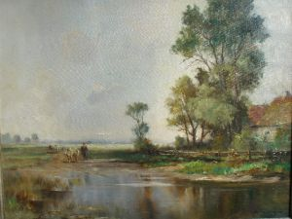
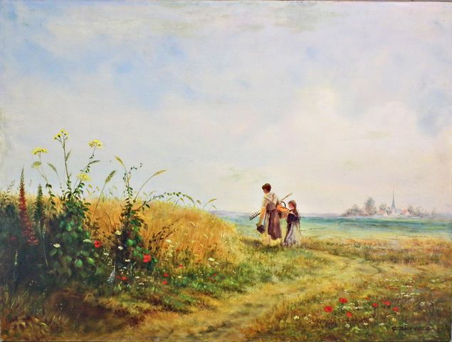

,,ode to youth’’, what is about?
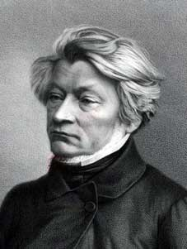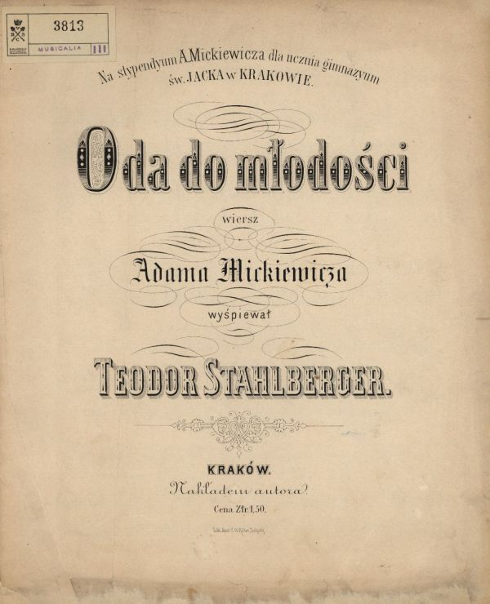

The poem of Adam Mickiewicz ‘’ ode to youth’’ is an ode, as indicated by the title.
Ode is a kind of a song with verses of laudatory or thankful character.

Mickiewicz selected this typically neoclassical genre, the ode, and by selecting this form, he got really close to the age of enlightenment. The poet directs his poem to the recipient specified in the name of the poem. The poem depicts the conservatives from the age of Enlightenment. Conservatives are opposed to the generation of young Romantics. Lyrical subject is encouraging to break all the barriers that limit the human beings, and to discover new places and values.
By means of contrast the poem shows two different worlds. They’re fighting together for domination. One of them is ‘the old world’, created by people of enlightenment. Mickiewicz is suggesting that the people of the old world are selfish and because of them the world is empty. The second world is full of young people, romantic ideas and energy. This is the reality where the old people don’t see any values. These people don’t have any ideas for the future. They live in the past. These Old people don’t fit to a new, changing world. The lyrical subject doesn’t want that world, he wants to run away from this old world. He knows that world in young hands will be better, it will be based on brotherhood, love and friendship. The world of the young is full of dreams and plans for the future. Youth is a power, which can do miracles.

The poem was really popular, a lot of people read about it in newspapers, it got well-known during the uprisings time.

Alicja Wałek

IT’S WHAT WE’RE BEEN WAITING FOR!
It’s happened! Young people have a voice. Old to rest. Old reality leaves. We big farewell to the dead generation, sluggish people who don’t have feelings and elation. Welcome the new young generation which means the new reality. These new people are having a higher goals! They are ready for join actions and sacrifices. People who will overcome weakness and will fight for themselves! Even at the cost of their lives! they can take the challenge and exceed existing horizons. The new reality is a great force which hasn’t been so far. Just: YOUNG FINALLY HAVE A VOICE!!!
Adam Mickiewicz „Ode to youth” (fragments in Polish)

Bez serc, bez ducha, to szkieletów ludy;
Młodości! dodaj mi skrzydła!
Niech nad martwym wzlecę światem
W rajską dziedzinę ułudy:
Kędy zapał tworzy cudy,
Nowości potrząsa kwiatem
I obleka w nadziei złote malowidła.
Młodości! ty nad poziomy
Wylatuj, a okiem słońca
Ludzkości całe ogromy
Przeniknij z końca do końca.
Młodości! tobie nektar żywota
Natenczas słodki, gdy z innymi dzielę:

Serca niebieskie poi wesele,
Kiedy je razem nić powiąże złota.
Razem, młodzi przyjaciele!...
W szczęściu wszystkiego są wszystkich cele;
Jednością silni, rozumni szałem,
Razem, młodzi przyjaciele!...
Hej! ramię do ramienia! spólnymi łańcuchy
Opaszmy ziemskie kolisko!
Zestrzelmy myśli w jedno ognisko
I w jedno ognisko duchy!...

Wiktoria Kolecka

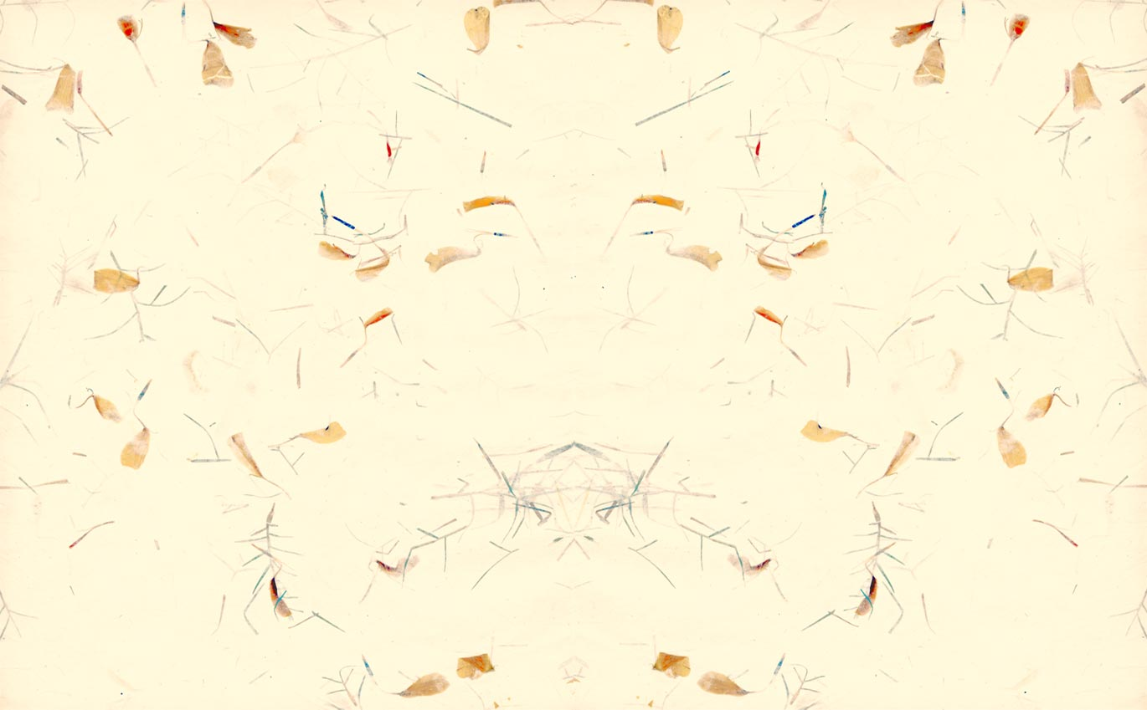

3rd May 1802 DIARY
I am waiting for a letter from my wife Maria. I miss her and my children. I don’t remember my children’s names. Our army is flowing on the ship today. Nobody of us is knowing where.
Somewhere on the ocean
Every day is looking the same. Captain gives us new works every day. I often help in the kitchen. I met legionnaire John. He has 3 children but doesn’t them.
on the ship there is missing water and food. A lots of soldiers have been sick for three days. I hope that I will survive till the end of the journey.
I miss four my family, my wife, my children and my country. I joined the legions to fight for the Polish independence. Now I'm on board, I do not know where, do not know where I sail, I do not know if I survive.
Another day of the trip
We talk, we remember, watching pictures of our families. We are no is in our change longer only the Polish Legions only 118th half-brigade of the French. gen. Leclerc.
...
We're already on the land. We put up tents. We isolate the sick. We are surrounded by beautiful mountains, the sea, coconuts and citrus groves. Many soldiers fell ill with yellow fever. We do not have doctors. No one can help them. ... Just some of them died.
In the following days we get combat missions. Every day we are fighting with the tribes and rebellious slaves in the area. Slaves have a chance to beat us.
Today General Donat Rochambeau. Leads us he is cruel. He orders us to kill the hostages. I'm in the battalion, which Polish officer commands. I'm in the middle of the worst fighting. I do not know whether I’ll survive.
... This is our last hour. I am writing from a makeshift shelter. We are being attacked from all sides, we can’t escape.
This is the last note, we will write in the notebook. I'm dying, I miss my homeland and my family. God save them.
Justyna Dudek

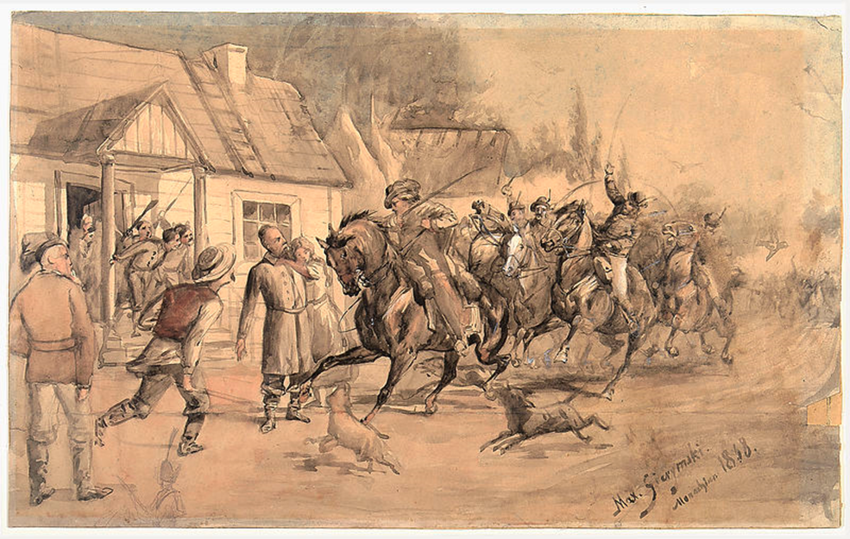
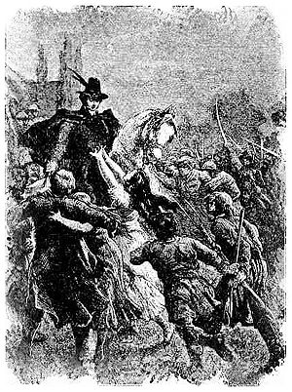

As we have previously informed the situation in Soplicowo was a long time very strained and its main cause was a dispute between the Count and Soplica of Castle Horeszków.
But yesterday, in the morning there was a breakthrough moment exactly Count’sinvasion onSoplica’s manor house.
According to witnesses Count along with his soldiers invaded the sleepy manor house and locked its residents in house arrest.
We look forward to action developments in Soplicowo, and the course of further action will be reported in next issues. Patryk Golec

Yesterday invasion to Soplicowo went ahead.

So, it has happened!

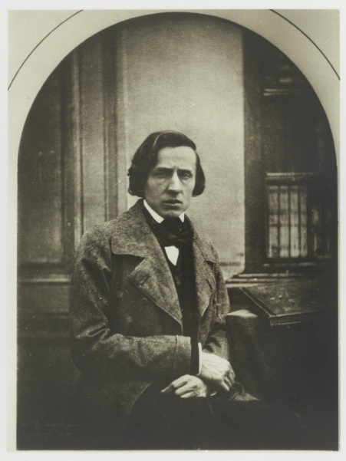
Relation from the Fryderyk Chopin's concert

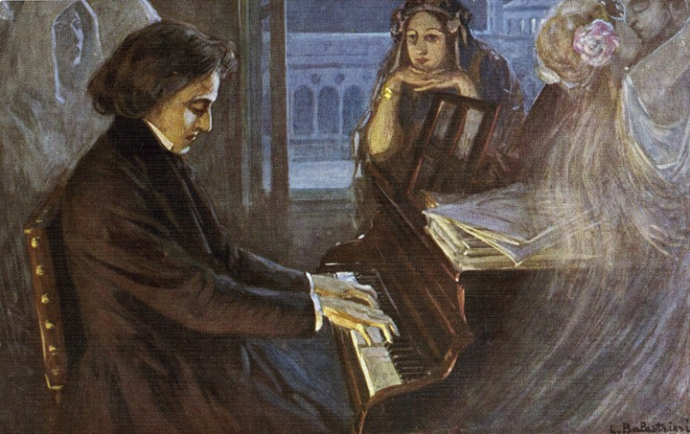

At 24 February 1818 in the Radziwiłł's palace concert of a young composer Fryderyk Chopin took place. Many listeners came for this event. Maybe his name says you not much but this extremely talented boy has possibility to do a great career. I can tell this after I listened to his piano play. It's amazing that at the age of eight Chopin shows so much talent. During the concert I noticed that young man had a huge expression and technical practice. I was impressed and speechless. At some point I looked around the hall and I noticed people staring at Chopin. I think that they were very worried and moved. I saw a woman who was standing straight to the performer and she was wiping a tear running down her cheek. It was something extraordinary. I realised that this artist has a beautiful gift to shrugging people by his play. Suddenly all talks calmed, there was only the piano. Then just someone said that „this child will replace Mozart”. There were a very important words for me because I think that Fryderyk Chopin has a huge talent and he will reach a huge success and his ability to influence human emotions will make that no one will not pass next to his play indifferently.
Karolina Chmura
BIGOS AS AN OLD POLISH DINNER
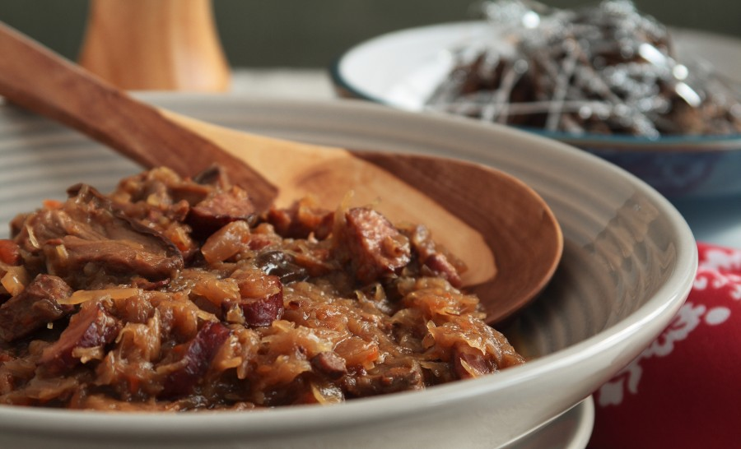
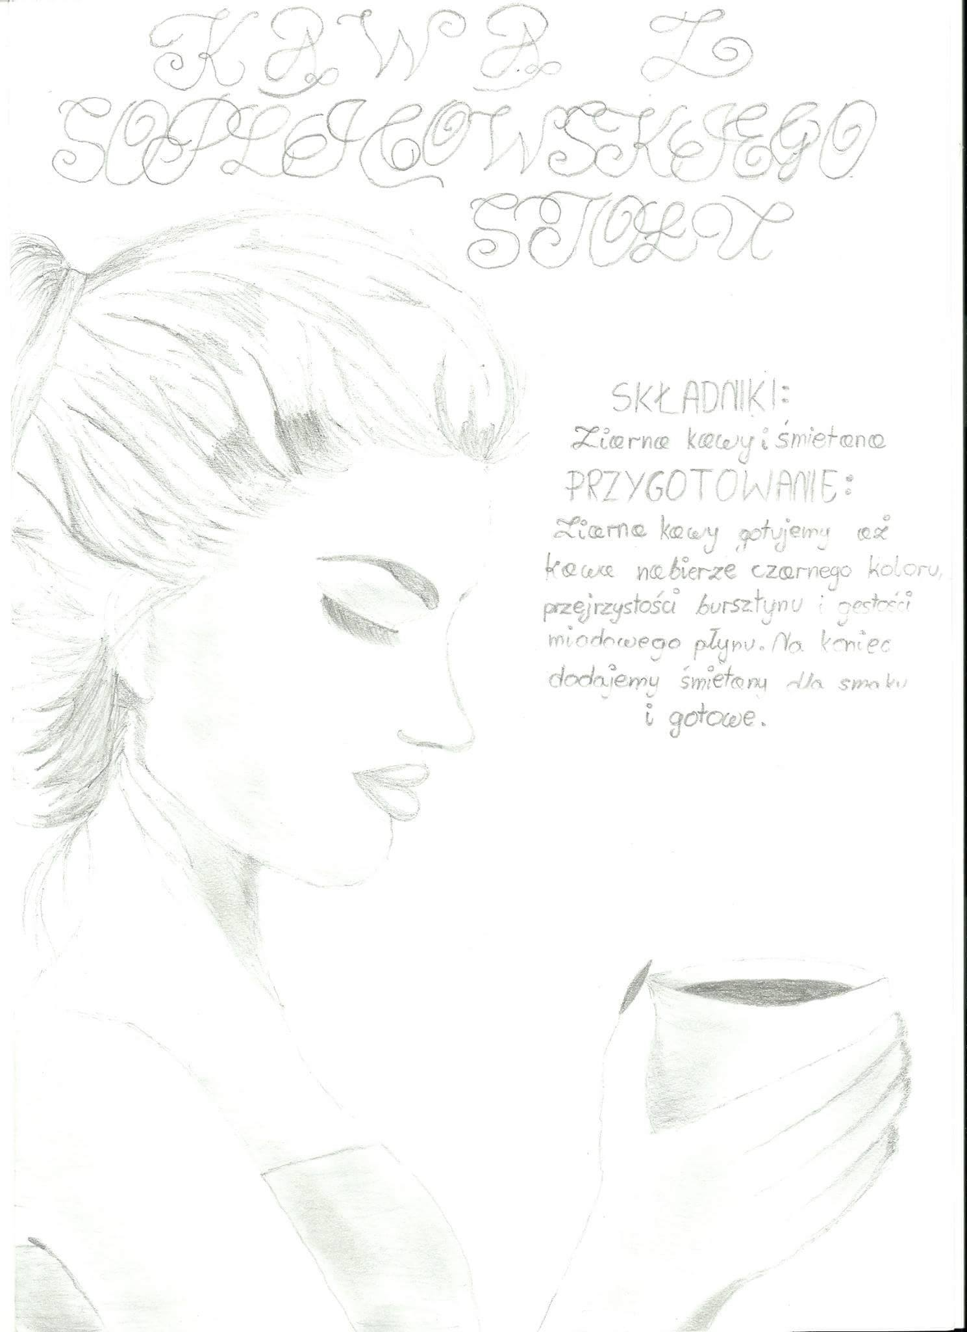
Bigos has such a charm, that the moretimes it is heated, the more tasty it is!!
INGRIDIENTS:
- 1.5 kg sour cabbage
- 1 kg pork
- 0,5 kg cooked ham
- 0.5 kg sausages
- 12 buletus which are dry
- 10 plums which are dry, too
- Bit of spices
- 2 onions
- Spoon of honey
- Red wine
Coffee from Soplician table.

Components:
Coffee beans and cream.
Preparations:
Cook coffee beans until the coffee will be black, transparent like an amber and thick like honey. At the end, add cream to a better taste and it’s ready.

Izabela Opala
LETTERS FROM PETER

My beloved wife!

I haven’t seen you in such a long time. My heart aches and longs for you my wonderful Katherine. You don’t have to worry about me anymore because I’m coming home soon. Tell our children that I love them very much and that I can’t wait to see and hug them again. You can’t even imagine the things that I have seen here. I see those horrific pictures every time I close my eyes. It has gotten to the point where I have to tell someone about all that has happened. Do you remember when you were crying because of Napoleon’s order I had to live? We didn’t even know where or why we were going to. No one had expected such an incredible view of the island. The sun warmed my face, and seagulls were circling above us. After four months of hard journey, we reached land. We were overjoyed with the sight of marvelous beaches, and mounds of fresh coconuts, and of course, the tremendous vodka of Ratafia. I wanted you to see this. Unfortunately, in the first days of march, three legions of battalion 113 half-brigade were split up and we were thrown into the war. We dealt with stopping riots between colonists and slaves. We didn’t know that the swamps of the island contained a terrible disease. My friends started being pestered with nausea, chills and even yellowness of the skin in some cases. After a while, those infected began to throw up blood and the sight of this was simply disgusting. It turned out that the local disease was known as yellow fever. I was frightened with the fact that this disease might happened to me as well. The plague came from the numerous species of reptiles, amphibians, and ticks that inhabited the island. But the ants caused the most problems. The ants found ways to slip into our clothing and destroyed every single meal. But not only the terrible conditions in which we lived in caused me to hate the island. I barely escaped with my life when natives attacked the building I was staying in. I thought I would die and I would never see you again. Somehow, me and my friends managed to escape. When the natives finally noticed that our people related to them more closely than the French, they stopped using cruel and unjust torture measures with their prisoners. They began to repay us with better and more humane treatment. My love, I have to go because I am very tired. I’d like to have a bit of sleep and rest after all of the horrors I’ve experienced on this island. Don’t worry my sweet, I’ll be at home in no time.
Kisses
Your Peter

Wiktoria Rydza
19th century fashion

