Short-Term Joint Staff Training Event Newsletter

On Monday the 25th February 2019, after a 12 hour journey from Spain, the Principal and Coordinator of 3rd Gymnasio of Naoussa picked us up from the airport in Thessaloniki to take us to their beautiful town.

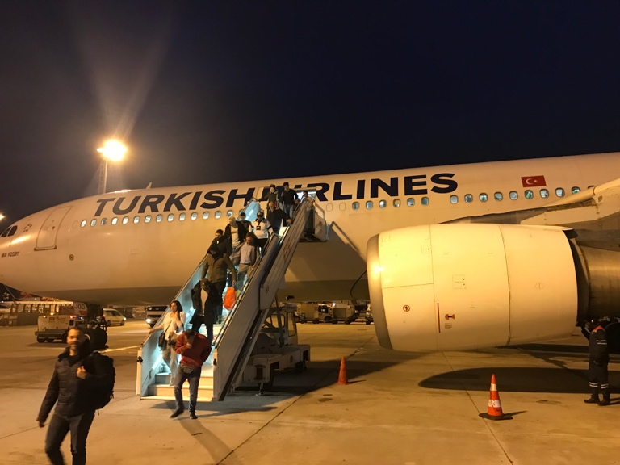

Naoussa is located in the north-western part of Greece near Macedonia, with an area of 300 km2, an elevation of 300m, and a population of 21,000 inhabitants. Historically an industrial centre, many of the factories closed in the 20th century and caused widespread unemployment.

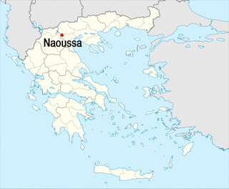

Driving to Saint Nicholas Park, we had an amazing view of the town at night. We finally got the local Delaggio Hotel at the heart of the city centre where we stayed during our trip. Impeccable rooms and very helpful staff made our stay very comfortable.

Early the next morning we met the members of the Italian team from D’Alessandro Vocinno school in San Nicandro Garganico in Italy. Giovanna (the school’s coordinator), Anna, Lucia and Concetta were extremely helpful, very cooperative, and great team colleagues.
We then went to Naoussa Town Hall where we met the Mayor and exchanged information about our countries, industry, and education sectors and measurements to tackle early school leaving and unemployment. We met Katrina, a mum from the school, who kindly took us to the Greek school. There we met all the pupils, staff and Nikos the former school Principal. Pupil motivation and enthusiasm for meeting us was fantastic.

This is when the hard work began. At the Greek school we first had a coordinator meeting to evaluate the progress of the project and to organize many aspects of the next pupil exchange to Greece and this term project celebrations. Many aspects about Twinspace were also discussed. As a result of the meeting we produced meeting minutes, a checklist to ensure the good progress of the project and an evaluation form.
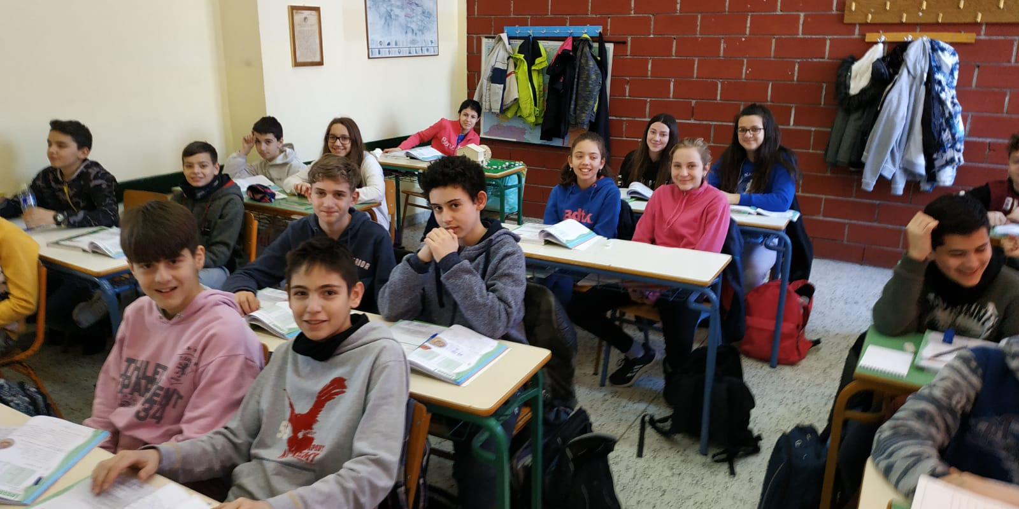

Following the meeting, teachers undertook a training event based on 2 key-competences: Entrepreneurship and Cultural and Social Awareness. After understanding the two key-competences, teachers focused on possible ways to include them in their lessons. The Greek team produced 4 lessons plans as an output that will be used during the pupils exchange to Greece.
Next it was time then to meet the families. Many parents arrived and made the effort to speak in English to welcome us. They have prepared an amazing welcoming lunch at the local Special Needs Schools and have brought large amounts of delicious and traditional Greek local food. Amongst our favourite was Kolokythopita (Zucchini pie), filled red peppers, vinaigrette and Greek traditional salads, steamed local vegetables, a variety of meats in a sauce, and traditional desserts such us syrup pastries and pies. Kourabiedes an almond pie and a mousse made with local grapes. We were really overwhelmed by the generosity and attention of all the families who organized the meal.
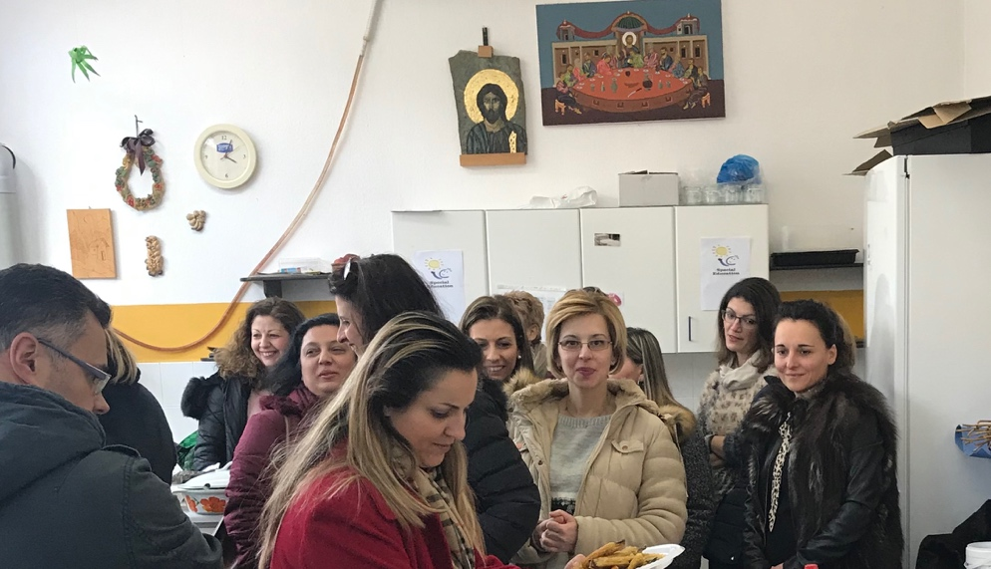

After eating we took a tour of the town and visited the main square, the impressive waterfalls from the river Arapitsa, and the statue of a heroic woman with her child.

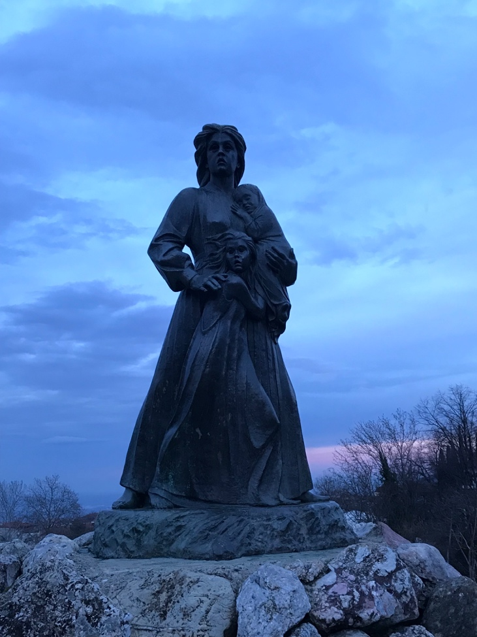

We saw the preparation for the Boules or local festival celebrated just before Lent in which locals wear their traditional costumes with faces illustrating the defiance to the Turkish occupation during the Ottoman Empire. We also walked passed a few local clubs dedicated to reading or dancing before finally visiting the local Library. There we had the privilege to see ancient books from the time of Aristoteles that have been kept and are now available online. We finished by dancing the local syrtaki with locals attending traditional dance lessons. We finished the day with dinner including a beautifully light Moussaka from one of the finest restaurants in town.

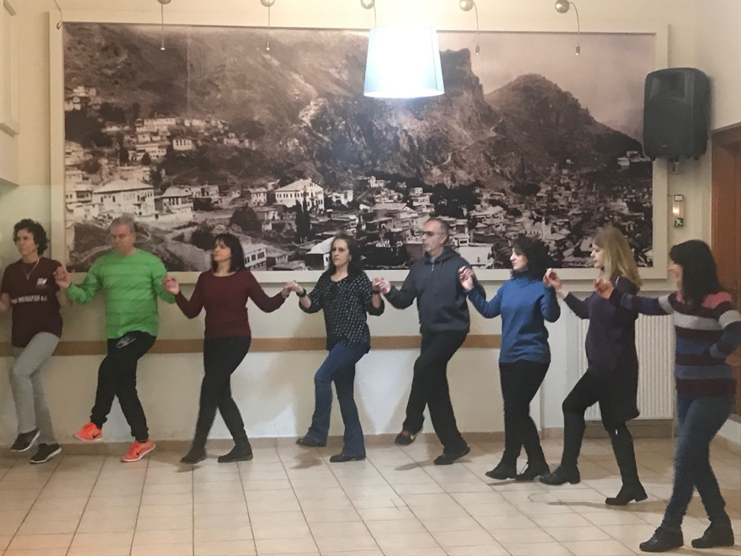

Day two was dedicated to cultural exchange visits to enrich our knowledge of European culture. We visited Thessaloniki with the support of a tourist guide. Walking from the walls of the city down to the baths, visiting the White Tower, the Roman Agora showing the different levels of the city, Saint Demetrios Church, Galerious Roundabout and the Archaeological museum. We finished the visit to this lively city with a sight of the sea and Aristoteles Square. Thessaloniki was without a doubt an amazing city to visit - we really enjoyed its history and cultural legacy.

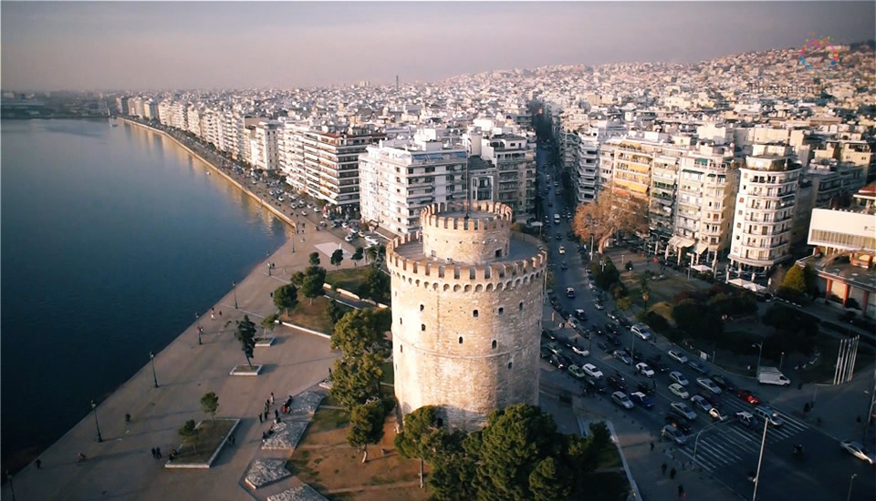
Back in Naoussa it was time to listen, see, and enjoy the street festival in preparation for the Boules. Local musicians played traditional music using trumpets and drums. We were welcomed to join in local dances with locals.
For our final day, we visited Vergina and its museum of Macedonian Tombs to learn about the school of Aristoteles in Esvoria. Thanks to the help of Anna, an archaeologist, professional tour guide, and mum of the school, we were able to learn all the details about that time and the impact of those rituals and methodology nowadays.
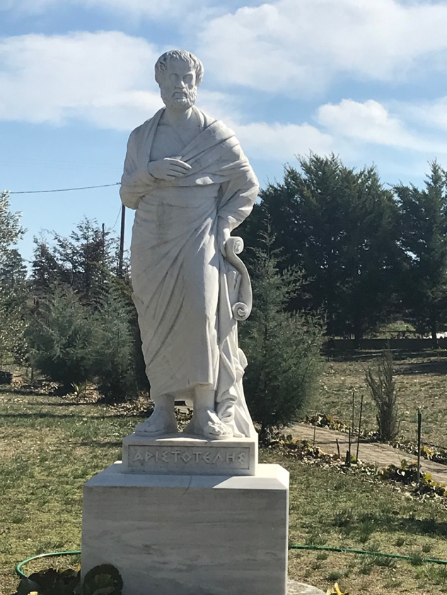

We then enjoyed a traditional barbeque in Saint Nicholas Park with traditional music and dance thanks to the generosity of one father from the school who manages the restaurant. Afterwards, we visited a local business that produces up to one thousand of the local red wine “Xinomavro”. From this, we learned how entrepreneurship can be used to run a successful local business. It was then time for dinner in the main square of the town and listening to the local concert.
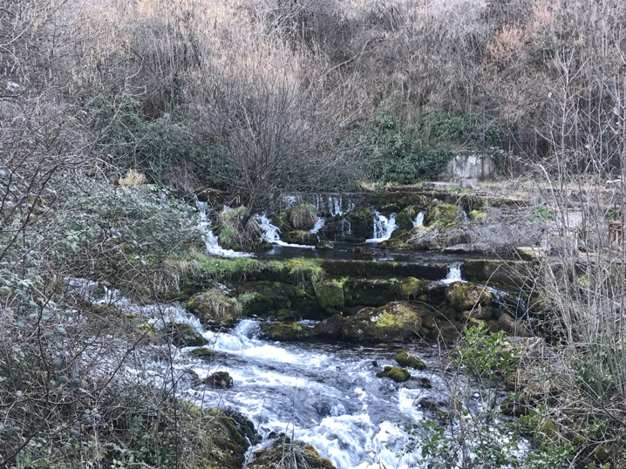
Overall, an amazing three days that made us fall in love with Naoussa, its culture, history and people. We thank the Principal of the school Yiannis and the Erasmus+ coordinator for all their attention and generosity. We want to offer our congratulations to them for a perfect organization of the mobility and thank them for how they looked after us. Enharisto!
We now are ready and really motivated to get back to work with our pupils in preparation for our next pupilsexchange to the town.
We love Naoussa!

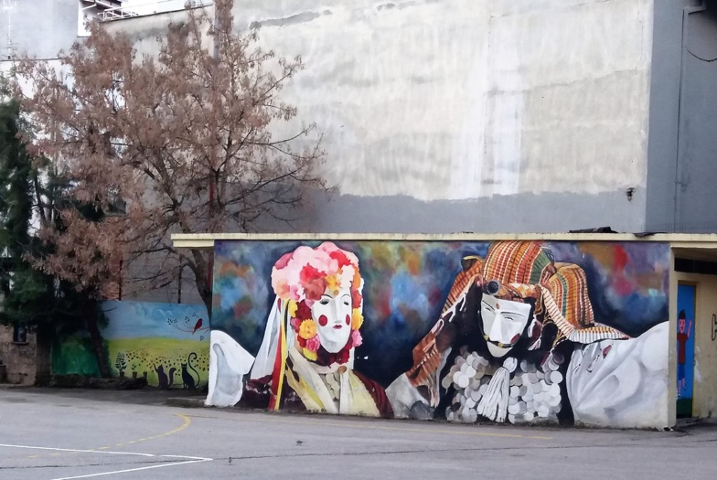

https://en.wikipedia.org/wiki/Naousa,_Imathia
https://www.naoussa.gr/en/city/theplace.htm

