$π$NUMBER DAY CELEBRATION

14th March is $π$ number day. This date is written as 3.14 in English speaking countries, as $π$ = 3.14159265…

Target group: First year pupils (11-12 years old)
Methodology: Collaborative work

TASK: What’s the value of $π$ ?
Bearing in mind that $π$ is the ratio of a circle’s circumference to its diameter.

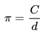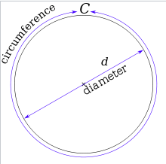

Pupils will need to find the value of $π$ measuring the diameter of different circumferences.

1. Find objects with a round or cylinder shape in school.
2. Using wool or rope to measure its diameter.
3. Tape the wool or rope to the object and, using the other side, go round the object.
4. Use a pencil to draw a mark where the two ends of the rope/wool meet.
5. Now measure the wool or rope.
6. Fill in the following table:

Object | Circumference | Diameter | $π$ = C/d

7. A representative from each group will have to orally explain the process, result and conclusions from the task.

8. The task could be competitive, for example, giving a prize to the group that is able to measure the most objects in the least amount of time.

