Lesson
Sustainable Developement Goal 3

1 - Look on the internet and answer: What is SDGs number 3?
Write a short definition here : ____________________________________________________________________________________________________________________________________________________________________________________________________________________________________________________________________________

2 - Now look at this document and pair it with the definitions below
A target is the persons or facts concerned

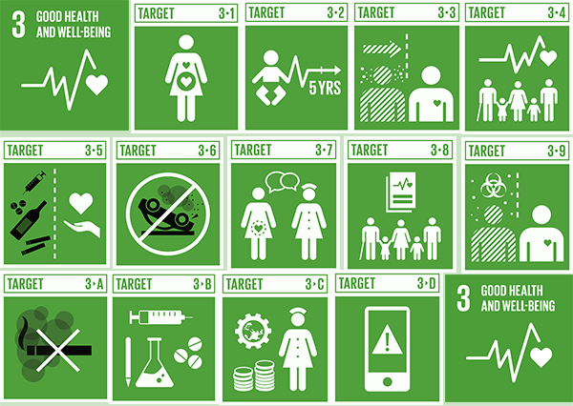

- To strengthen the prevention and treatment of substance abuse, including narcotic drug abuse and harmful use of alcohol.
Target N° 3______________
- To reduce the global maternal mortality
Target N° 3______________
- To reduce by one third premature mortality from noncommunicable diseases through prevention and treatment, and promote mental health and well-being.
Target N° 3______________
- To end the epidemics of AIDS, tuberculosis, malaria and neglected tropical diseases, and combat hepatitis, waterborne diseases and other communicable diseases.
Target N° 3______________
- To achieve universal health coverage, including financial risk protection, access to quality essential health-care services, and access to safe, effective, quality and affordable essential medicines and vaccines for all.
Target N° 3______________
- To prevent deaths of newborns and children under 5 years of age.
Target N° 3______________
- To cut by two the number of global deaths and injuries from road traffic accidents.
Target N° 3______________
- To ensure universal access to sexual and reproductive health-care services, including for family planning, information and education, and the integration of reproductive health into national strategies and programmes.
Target N° 3______________
- To reduce the number of deaths and illnesses from hazardous chemicals and air, water and soil pollution and contamination.
Target N° 3______________
Means of implementation for the targets
“Implementation” is to turn ideas into actions

Universal health coverage
Target N° 3______________

Health financing and workforce
Target N° 3______________

Medicines and vaccines
Target N° 3______________
Tobacco control
Target N° 3______________

Emergency preparedness
Target N° 3______________

3 - Write 3 sentences to explain the target you picked up - use must/ should/ Can or Cannot start by “Countries all over the world “
____________________________________________________________________________________________________________________________________________________________________________________________________________________________________________________________________________________________________________________________________________________

4 - Can you read these numbers?

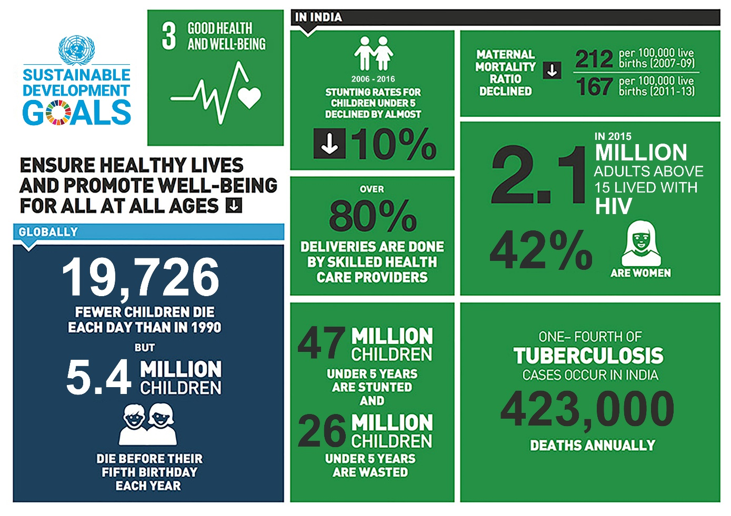
Per cent %
Dot .
Twenty twenty one 2021
One hundred 100
One thousand 1000
One million 1 000 000
Explain in French what you understand

5 – What is the impact of COVID 19 in SDG 3?
Search the internet for two arguments
_

_

6 -FINAL TASK
Present the target you have picked up with 3 sentences minimum // you can add free photos-videos or infographics
This work will be posted on the Twinspace and you will have a mark

Answers
Definition :Targets of Sustainable Development Goal 3 to ensure healthy lives and promote well-being for all at all ages
3.1. Maternal mortality
By 2030, reduce the global maternal mortality ratio to less than 70 per 100 000 live births.
3.2. Neonatal and child mortality
By 2030, end preventable deaths of newborns and children under 5 years of age, with all countries aiming to reduce neonatal mortality to at least as low as 12 per 1000 live births and under-5 mortality to at least as low as 25 per 1000 live births.
3.3. Infectious diseases
By 2030, end the epidemics of AIDS, tuberculosis, malaria and neglected tropical diseases, and combat hepatitis, waterborne diseases and other communicable diseases.
3.4. Noncommunicable diseases
By 2030, reduce by one third premature mortality from noncommunicable diseases through prevention and treatment, and promote mental health and well-being.
3.5. Substance abuse
Strengthen the prevention and treatment of substance abuse, including narcotic drug abuse and harmful use of alcohol.
3.6. Road traffic
By 2020, halve the number of global deaths and injuries from road traffic accidents.
3.7. Sexual and reproductive health
By 2030, ensure universal access to sexual and reproductive health-care services, including for family planning, information and education, and the integration of reproductive health into national strategies and programmes.
3.8. Universal health coverage
Achieve universal health coverage, including financial risk protection, access to quality essential health-care services, and access to safe, effective, quality and affordable essential medicines and vaccines for all.
3.9. Environmental health
By 2030, substantially reduce the number of deaths and illnesses from hazardous chemicals and air, water and soil pollution and contamination.

Goal 3 – Means of implementation for the targets
3.a. Tobacco control
Strengthen the implementation of the WHO Framework Convention on Tobacco Control in all countries, as appropriate.
3.b. Medicines and vaccines
Support the research and development of vaccines and medicines for the communicable and noncommunicable diseases that primarily affect developing countries. Provide access to affordable essential medicines and vaccines in accordance with the Doha Declaration on TRIPS and Public Health, which affirms the right of developing countries to the fullest use of the provisions in the Agreement on Trade-Related Aspects of Intellectual Property Rights (TRIPS agreement) regarding flexibilities to protect public health and, in particular, provide access to medicines for all.
3.c. Health financing and workforce
Substantially increase health financing and the recruitment, development, training and retention of the health workforce in developing countries, especially in least developed countries and small island developing States.
3.d. Emergency preparedness
Strengthen the capacity of all countries, in particular developing countries, for early warning, risk reduction and management of national and global health risks.
Target 3.8. Universal health coverage
This target can be seen as an overarching one that supports the achievement of the other targets. It is derived from the Millennium Development Goals, the new targets and the means of implementation.

