Erasmus+ 2017-2019: ‘Tracing our European spirit’
Journal
PASCAL Greek School Lemesos

Day 1 – Sunday 23rd of September
- What I liked most about “Vouni” was:
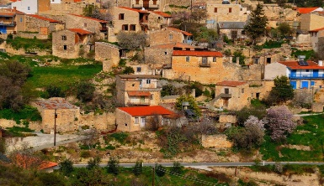
_____________________________________________________________________________________________________________________________________________________________________________________________________________________________________________________________________________________________________________________________________________________________________________________________________________

- List and describe one of the traditional games played at the village.

- _____________________________________________________________________________
- ________________________________________________________________________
- ________________________________________________________________________
- ________________________________________________________________________
- ________________________________________________________________________
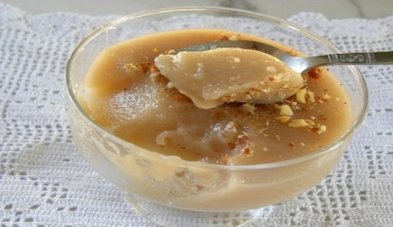

- What I thought about “palouze” was:
_____________________________________________________________________________________________________________________________________________________________________________________________________________________________________________________________________________________________________________________________________________________________________________________________________________

Day 2 - Monday 24th of September
- Find the environmental graffiti in the school yard, take a picture and say some words about it.
_____________________________________________________________________________________________________________________________________________________________________________________________________________________________________________________________________________________________________________________________________________________________________________________________________________

- What you liked the most about “PASCAL Greek School Lemesos”?

_____________________________________________________________________________________
_____________________________________________________________________________________________________________________________________________________________________________________________________________________________________________________________________________________________________________________________________________________________________________________________________________

- What you found most interesting from the presentations?

_____________________________________________________________________________________
_____________________________________________________________________________________________________________________________________________________________________________________________________________________________________________________________________________________________________________________________________________________________________________________________________________
_____________________________________________________________________________________

- What activity you found most interesting at the Medieval Art Workshop?
_____________________________________________________________________________________
_________________________________________________________________________________________________________________________________________________________________________________________________________________________________________________
_____________________________________________________________________________________
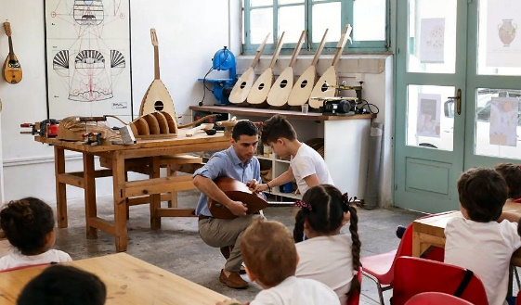

- Take a photo of a piece of art that you liked at the Medieval Art Workshop. Say some words about it.
________________________________________________________________________________________________________________________________________________________________________________________________________________________________________________________________________________________________________________________

- Take a selfie outside the Medieval Castle of Limassol. I found it beautiful because:

________________________________________________________________________________________________________________________________________________________________________________________________________________________________________________________________________________________________________________________
_____________________________________________________________________________________

Day 3 - Tuesday 25th of September

- What I liked most about the Traditional Cypriot Wedding (at “Kostas Kaimakliotis” Folkore Museum) was:
_____________________________________________________________________________________________________________________________________________________________________________________________________________________________________________________________________________________________________________________________________________________________________________________________________________

- What is another name for “Hala Sultan Tekke”?
_____________________________________________________________________________________________________________________________________________________________________________________________________________________________________________________________________________________________________________________________________________________________________________________________________________
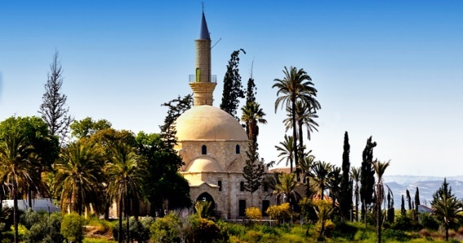

- Who is “Saint Lazarus” church named after?

_____________________________________________________________________________________________________________________________________________________________________________________________________________________________________________________________________________________________________________________________________________________________________________________________________________

- Where is the Medieval Castle of Larnaka located?

_____________________________________________________________________________________________________________________________________________________________________________________________________________________________________________________________________________________________________________________________________________________________________________________________________________

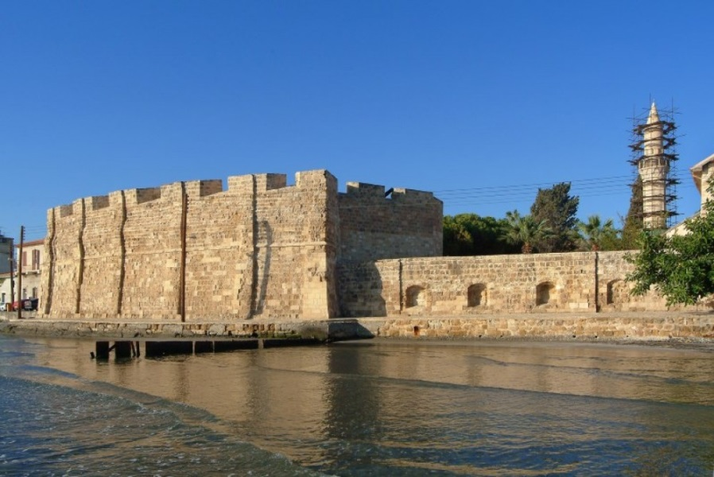

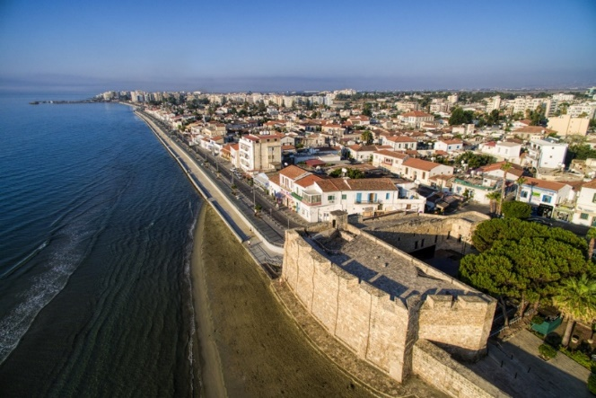

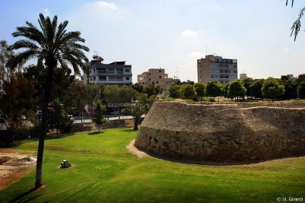
Day 4 - Wednesday 26th of September

- Take a selfie by the Venetian Walls. Describe the experience.

________________________________________________________________________________________________________________________________________________________________________________________________________________________________________________________________________________________________________________________
______________________________________________________________________________

- What can you see from the “Shacolas Tower Museum & Observatory”?
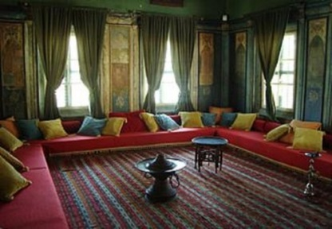
_____________________________________________________________________________________________________________________________________________________________________________________________________________________________________________________________________________________________________________________________________________________________________________________________________________

- Some words about the House of Hadjigeorgakis Kornesios.

_____________________________________________________________________________________________________________________________________________________________________________________________________________________________________________________________________________________________________________________________________________________________________________________________________________

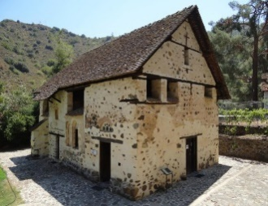
Day 5 - Thursday 27th of September

- Write some words about the history and architecture of “Agios Nikolaos tis Stegis”.
_____________________________________________________________________________________________________________________________________________________________________________________________________________________________________________________________________________________________________________________________________________________________________________________________________________
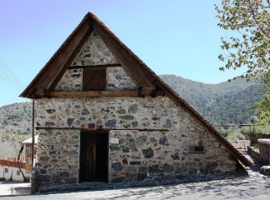
- What is unique about the church of “Archangelos Michael” in Pedoulas?
________________________________________________________________________________________________________________________________________________________________________________________________________________________________________________________________________________________________________________________
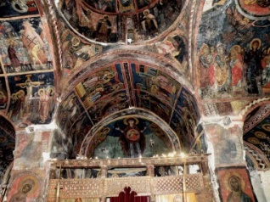
- Write some words about the history and architecture of “St. John Lampadistis” Monastery.
______________________________________________________________________________________________________________________________________________________________________________________________________________________________________________________________________________________________________________________________________________________________________________________________________

Day 6 – Friday 28th of September

- The activity I enjoyed the most:
__________________________________________________________________________________________________________________________________________________________________________________________________________________________________________________________________________________________________________________________________________________________________________________________________________________________________________________________________________________________________

- The restaurant I enjoyed the most:
__________________________________________________________________________________________________________________________________________________________________________________________________________________________________________________________________________________________________________________________________________________________________________________________________________________________________________________________________________________________________

- The best experience/memory from my journey:
__________________________________________________________________________________________________________________________________________________________________________________________________________________________________________________________________________________________________________________________________________________________________________________________________________________________________________________________________________________________________

