Erasmus+ “Tracing our European spirit”
Sitia October 15th to 20th

Journal
1. General high School of Sitia

i. Find a graffiti inside the school, take a picture and say some words about it.

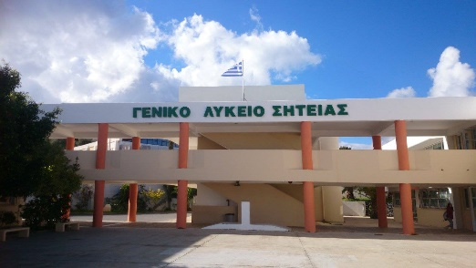

ii. What I liked most in the General High School of Sitia?

2. Presentations of countries and myths

i. What I found most interesting from each country’s presentation.

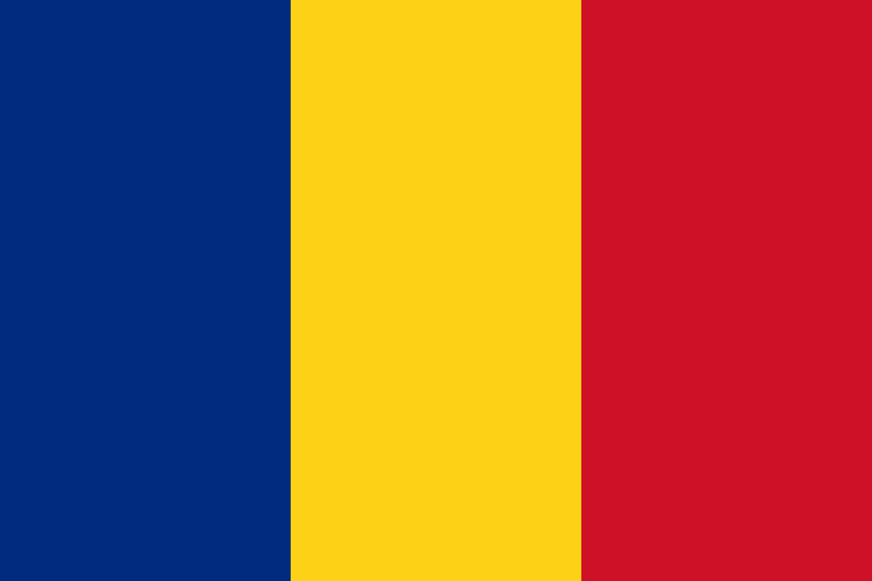

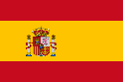

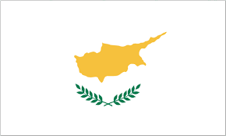

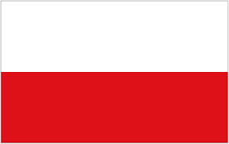

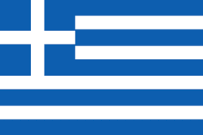

ii. Which country’s myth I liked most.

3. Archeological Museum of Sitia

i. What do I have learned about “Kouros of Palaikastro”
.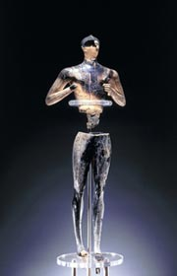

ii.Take a selfie with the exhibit that you liked most.

4. Roussolakos archaeological site

i. Some words about the myth of Zeus.
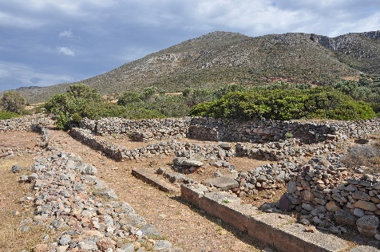

ii. What do I learned about the Minoan Peak Sanctuary.

5. Vai palm forest

- Take a selfie from the view point
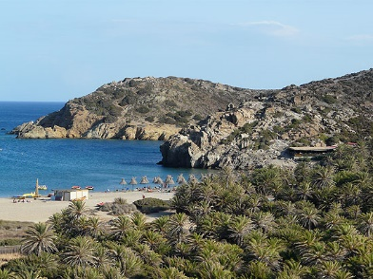

6. Toplou Monastery

i. Take a photo of the Magnesian referendum plaque.
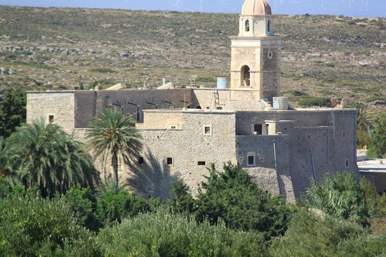
ii. What was the main point of this referendum.

7. Translate in your language the following words:

- καλημέρα (kalimera)

- Ευρώπη (Eyropi)

- Κρήτη (Kriti)

- Μυθολογία (mythologia)

- Δημοκρατία (Dimokratia)

8. Mochlos

i. Some words about Minoan naval tradition.
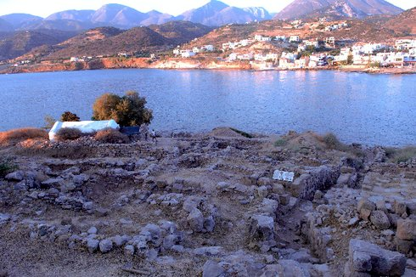

ii. Take a photo of St. Nicolas Isl. in Mochlos.

9. Zakros Minoan Palace

i. The main point on a Minoan palace (take a selfie with a friend of you)

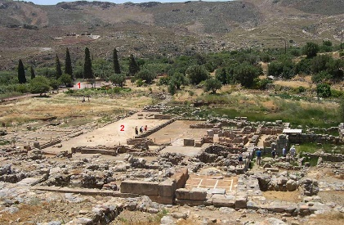

ii. Say some words about Zakros Minoan Palace

iii. Take a photo in the “Death Gorge”

10. Birth of Democracy and Greek Drama

i. Name the three greatest tragic poets of ancient times.
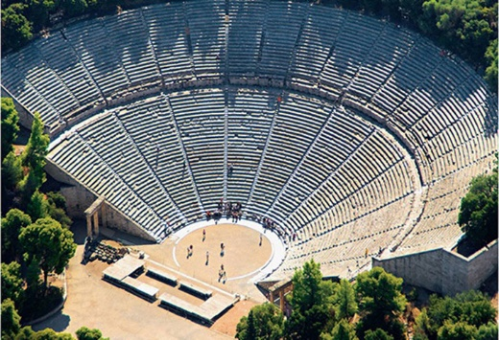

ii. What does mean the terms: Αξιοκρατία (Axiokratia), Ισονομία (Isonomia), Ισηγορία (Isigoria).
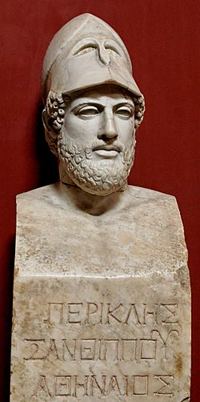

Impressions
-Archaeological site I found most exciting:

-Cretan/Greek tradition I liked most:

- The most delicious food I tried:

- The best moment of my journey:

