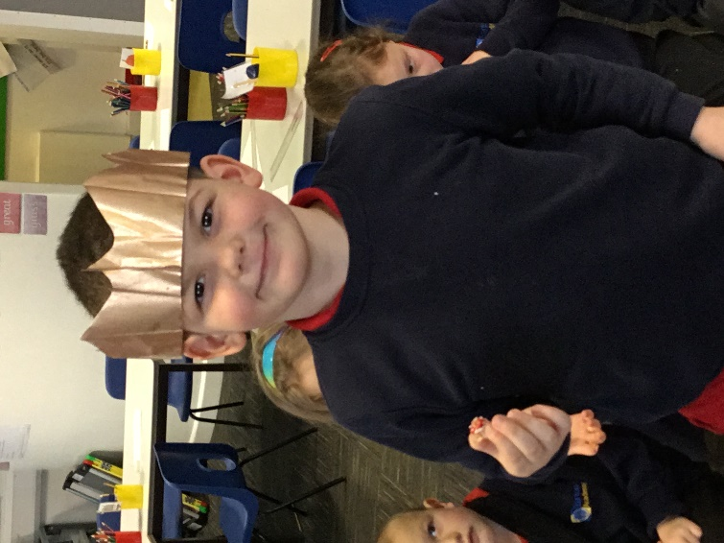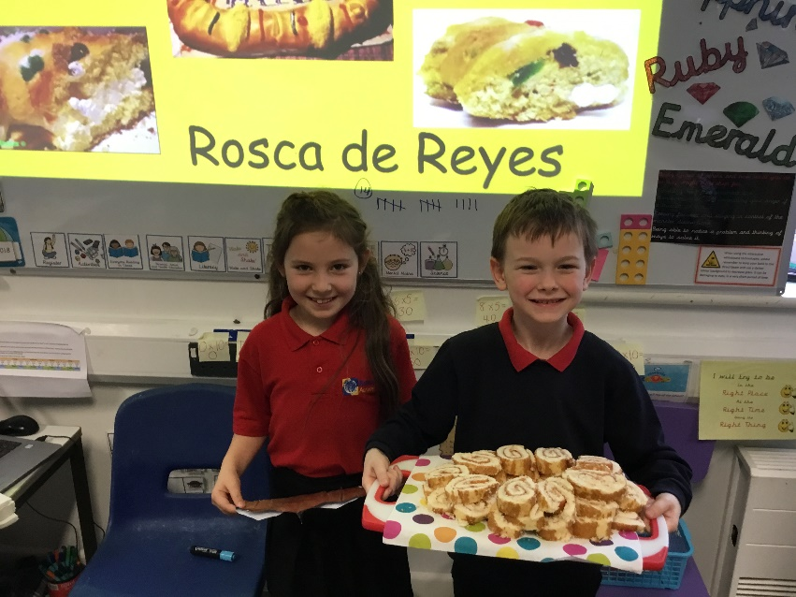

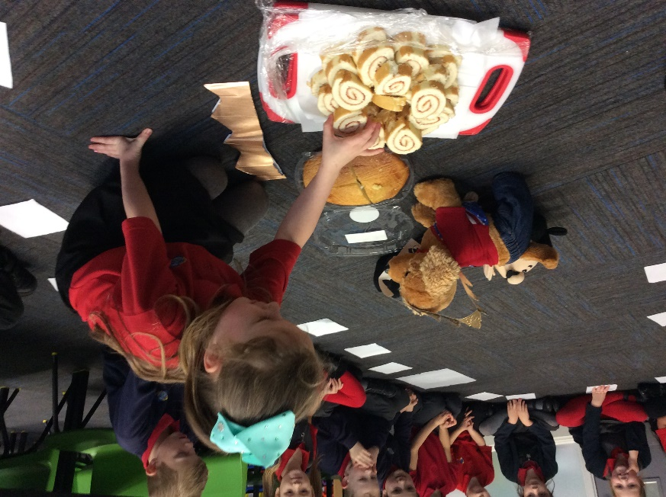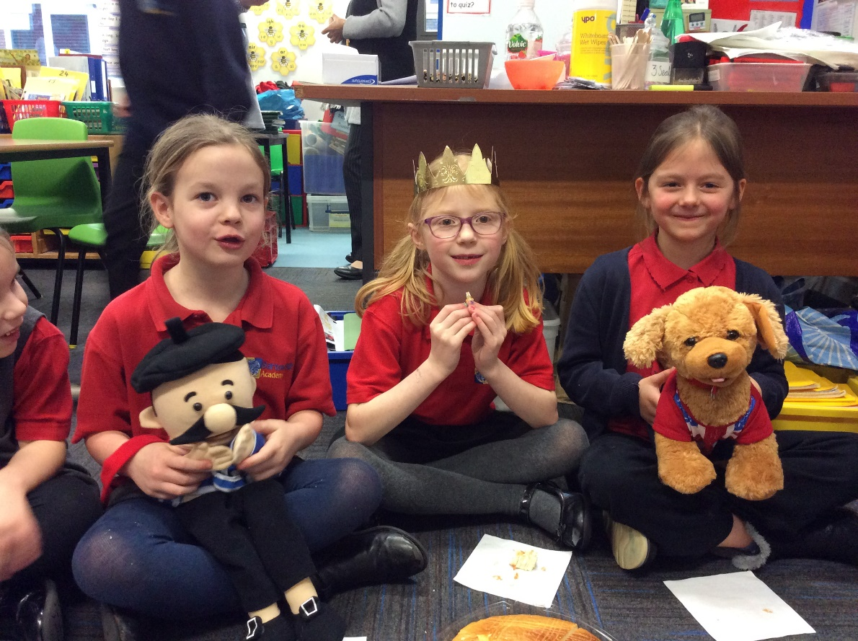

Barton Hill Academy celebrating the Spanish Festival ‘Roscon de Reyes’ and ‘La Galette des Rois’.

Epiphanie 2018