**Hello! My name is Mr Owl and I want to ask you a few questions!**

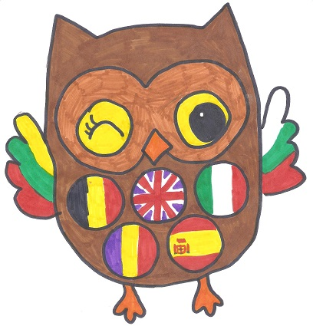

**Do you know these flags?**

|  |  |  |  |  |  |  |
| --- | --- | --- | --- | --- | --- | --- |
|  |  |  |  |  |  |  |
|  |  |  |  |  |  |  |
| **1** | **2** | **3** | **4** | **5** | **6** | **7** |

**Put the number on the map !**

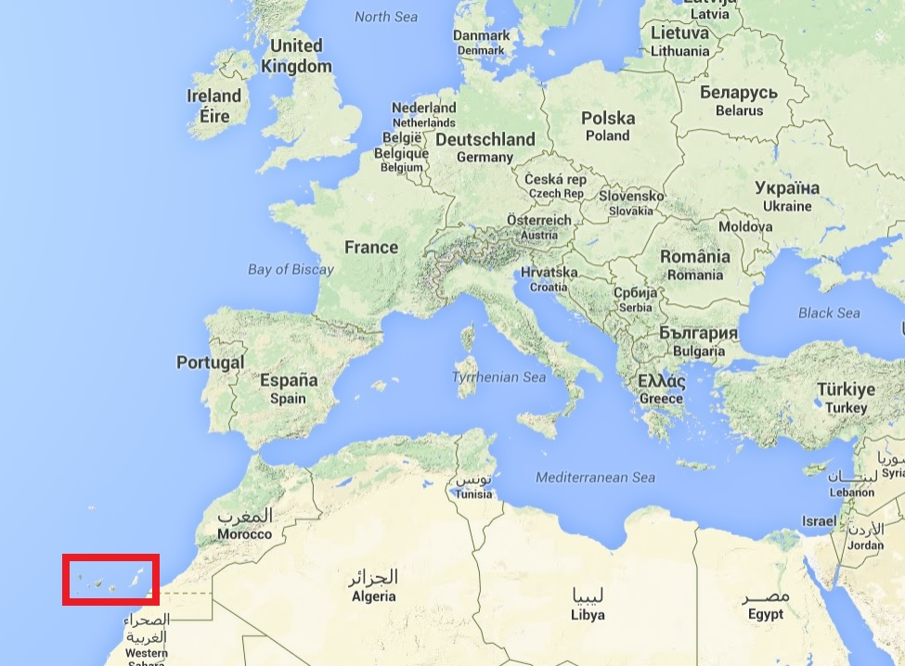

**Do you know the capital cities of these countries ?**

**Write your answer if you know ☺**

|  |  |  |  |
| --- | --- | --- | --- |
| United kingdom |  |  | Bucharest |
| Belgium |  |  | London |
| Romania |  |  | Brussels |
| Lithuania |  |  | Madrid |
| Tenerife (Spain) |  |  | Vilnius |
| Bulgaria |  |  | Roma |
| Italy |  |  | Sofia |

**Do you know what currency our partners use?**

**Connect the money with their countries ☺**

|  |  |  |  |
| --- | --- | --- | --- |
| United kingdom |  |  |  |
| Belgium |  |  |  |
| Romania |  |  |  |
| Lithuania |  |  |  |
| Tenerife |  |  |  |
| Bulgaria |  |  |  |
| Italy |  |  |  |



**Do you know a famous person of theses countries ?**

**Connect these photos with their countries ☺**

|  |  |  |
| --- | --- | --- |
| Lithuania |  | * David Beckham |
| Belgium |  | * Tintin |
| United Knigdom |  | * Nadia Comaneci, gymnast |
| Italy |  | * Arvydas Sabonis, a basketball player |
| Romania |  | * Spain Cesar Manrique |
| Bulgaria |  | * VASIL LEVSKI – HISTORIK HERO |
| Spain |  | * Pinocchio |

**Do you know a famous building of theses countries ?**



**Connect these photos with their countries ☺**

|  |  |  |  |
| --- | --- | --- | --- |
| Romania |  |  | Big Ben  in London |
| Belgium |  |  | Atomium in Brussels |
| United kingdom |  |  | The Bran Castle (Count Dracula’s Castle) |
| Tenerife |  |  | Gedimino pilis/ Gediminas' Tower in Vilnius |
| Lithuania |  |  | Spain (Auditorium in Santa cruz de Tenerife) |
| Italy |  |  | Cathedral Aleksander Nevski |
| Bulgaria |  |  | Pisa Tower |

**Do you know a traditional dish/food in any of these countries?**

**Connect these dishes with their countries ☺**

|  |  |  |  |
| --- | --- | --- | --- |
| Belgium |  |  |  |
| United kingdom |  |  |  |
| Lithuania |  |  |  |
| Tenrife |  |  |  |
| Romania |  |  |  |
| Italy |  |  |  |
| Bulgaria |  |  |  |

**Do you know how to say hello – goodbye – thank you?**

|  |  |  |  |
| --- | --- | --- | --- |
|  | Hello | Goodbye | Thank you |
| in English |  |  |  |
| in French |  |  |  |
| in Italian |  |  |  |
| in Spanish |  |  |  |
| in Bulgarian |  |  |  |
| in Romanian |  |  |  |
| in Lithuanian |  |  |  |

**And finally … Do you feel part of Europe?**

|  |  |
| --- | --- |
| Yes 🞏 | No 🞏 |

Thank you for helping me. Bye for now ...

Mr Owl !

