Hello! My name is Mr Owl and I want to ask you a few questions!
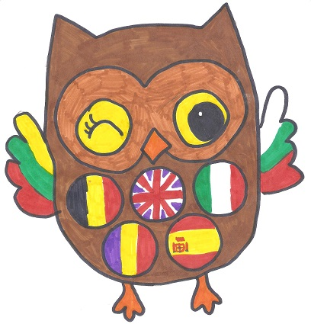

Do you know these flags?
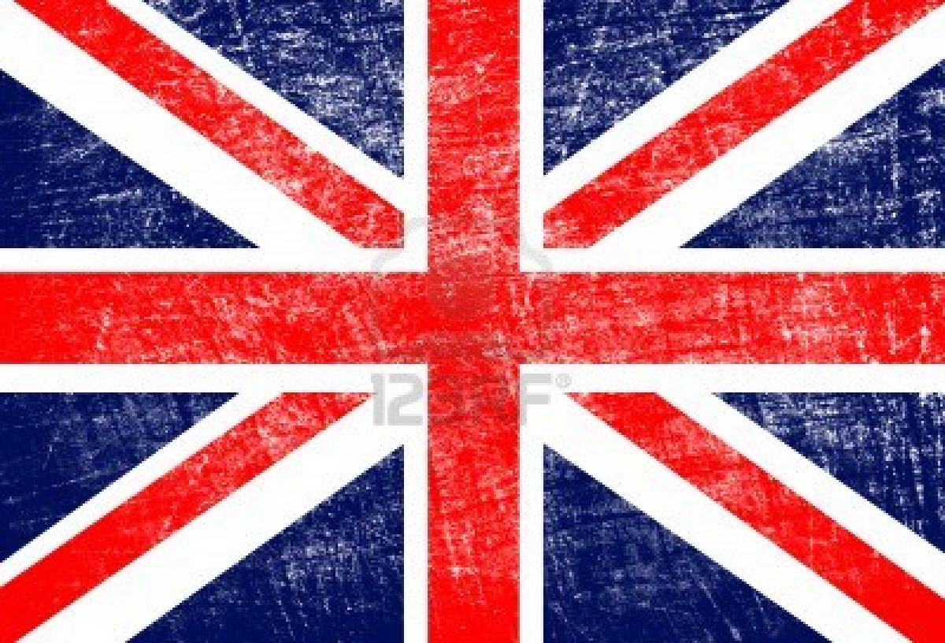 | 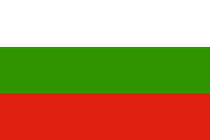 | 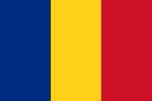 | 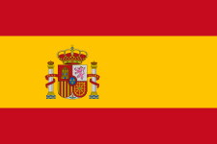 | 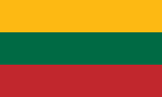 | 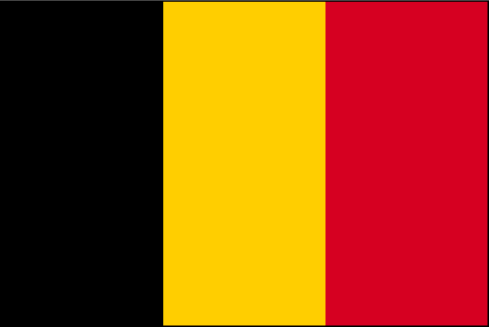 | 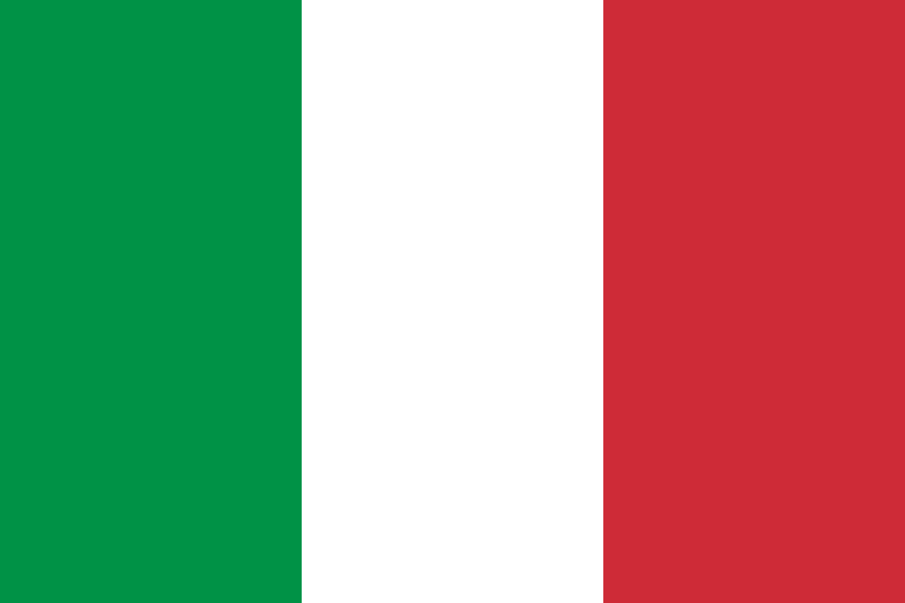
1 | 2 | 3 | 4 | 5 | 6 | 7
Put the number on the map !
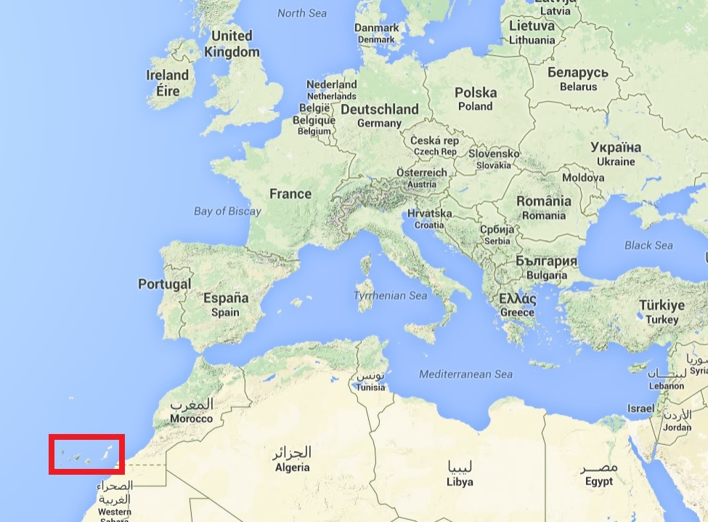

Do you know the capital cities of these countries ?
Write your answer if you know
United Kingdom | Bulgaria
Belgium | Spain
Romania | Italy
Lithuania

Do you know what currency our partners use?
Write your answer if you know
United Kingdom | Bulgaria
Belgium | Spain
Romania | Italy
Lithuania

Do you know how to say hello – goodbye – thank you?
 | Hello | Goodbye | Thank you
in English
in French
in Italian
in Spanish
in Bulgarian
in Romanian
in Lithuanian

Do you know a famous person of theses countries ?
Write your answer if you know
United Kingdom | Bulgaria
Belgium | Spain
Romania | Italy
Lithuania

Do you know a famous building of theses countries ?
Write your answer if you know
United Kingdom | Bulgaria
Belgium | Spain
Romania | Italy
Lithuania

Do you know a traditional dish/food in any of these countries?
Write the answer if you know
United Kingdom | Bulgaria
Belgium | Spain
Romania | Italy
Lithuania

And finally … Do you feel part of Europe?
Yes | No

Thank you for helping me. Bye for now ...
Mr Owl !

