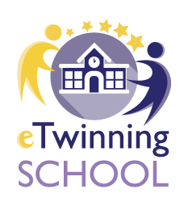
Meet and Code 2020
Scoala Gimnaziala “Inv. Radu Ion “, Vadu-Parului, Romania
Online event : Proud of Being European with Scratch

- Feedback , impresii
- Scratch 1 - Stefania
- Scratch 2 - Stefan, Bogdan , Ana G, Eliza
- Scratch -Antonio
- Scratch -Alex
- Scratch Antonio

Prof. Emilia Alexe

