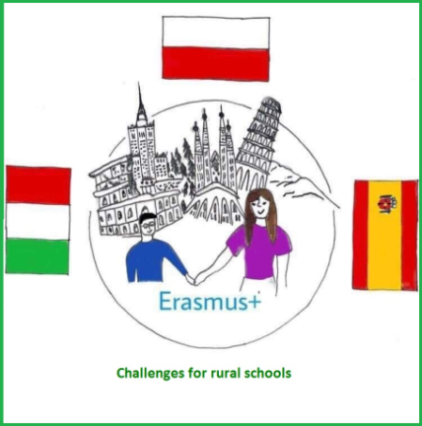

**Challenges   
for rural schools**

**The project of Erasmus+**

**Welcome to our fourth newsletter**Here you will find some information about the project work during the pandemic time.

**PARTNER SCHOOLS**

ISTITUTO COMPRENSIVO

Villaputzu, Italy

IES DON JUAN MANUEL

Cifuentes, Spain

ZESPÓŁ SZKÓŁ NR1 IM. MIKOŁAJA KOPERNIKA

Iłowo-Osada, Poland

IMPORTANT MESSAGE

The coronavirus pandemic has prevented us from implementing the project according to our plans.

We were therefore allowed to extend the project for one year more.   
So the project finishes on 31 August 2021. Hopefully we can manage to realise all we had planned.