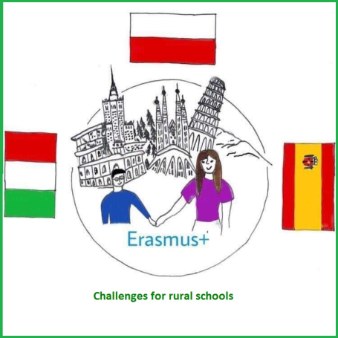

**THE LAST NEWSLETTER**

**Challenges   
for rural schools**

**The project of Erasmus+**

News

This is the last newsletter we would like to share. This August we finish our fantastic project. We all learnt a lot and had great fun.

We would like to share some results of the questionnaires we asked teachers, students and parents to fill in. All the results are on twin space. [Twinspace (etwinning.net)](https://twinspace.etwinning.net/72748/home)



**PARTNER SCHOOLS**

ISTITUTO COMPRENSIVO Villaputzu, Italy

IES DON JUAN MANUEL

Cifuentes, Spain

ZESPÓŁ SZKÓŁ NR1 IM. MIKOŁAJA KOPERNIKA

Iłowo-Osada, Poland

[](https://www.facebook.com/primaryschoolilowoosada/)