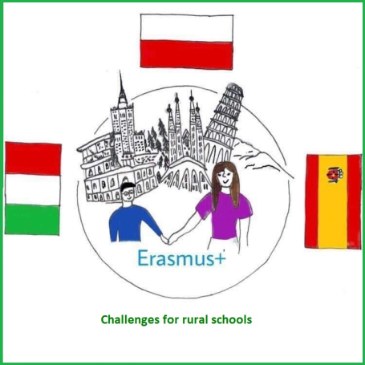
What is the project about?
Read the summary
VIRTUAL MOBILITY

Challenges
for rural schools

The project of Erasmus+

PARTNER SCHOOLS
ISTITUTO COMPRENSIVO Villaputzu, Italy

IES DON JUAN MANUEL
Cifuentes, Spain

ZESPÓŁ SZKÓŁ NR1 IM. MIKOŁAJA KOPERNIKA
Iłowo-Osada, Poland

From 7 to 11 June, "virtual mobility" to Sardinia took place. For five days, students from Italy hosted students from Polish and Spain online.
On the first day, they showed us around their school and held workshops on the preparation of a traditional Italian sweet snack.
On the second day, they showed us around their village and we solved quizzes to test our attentive listening.
On the third day, we talked about famous people from our countries. Every school chose three people and then we voted who we would like to know better. Than students from other countries asked questions about the chosen people.
On the fourth day, we summarized the work in our three-year project and prepared spaghetti.
On the last day of our meeting, we performed geometric and integration tasks and said goodbye to our friends from other countries.

There are some photos:
