The Czech Republic, the Netherlands, Romania ( Geography and Civics CLIL )
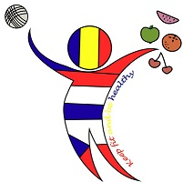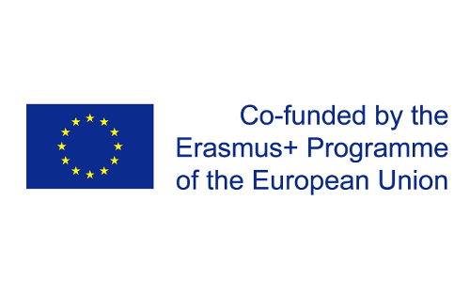

The map of the Czech Republic:
https://eprehledy.cz/online-mapa-ceske-republiky.php

The flag of the Czech Republic: 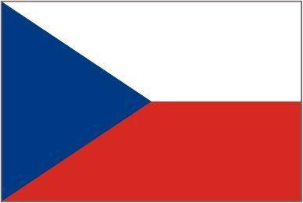
The national emblem: 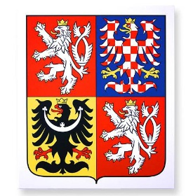

The capital city: PRAGUE 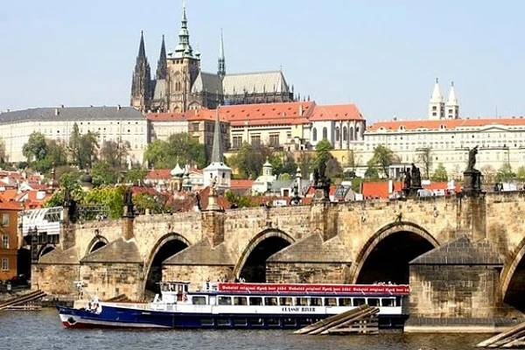

The map of the Netherlands:
https://img.obrazky.cz/?url=74fd0869882d5b01&size=3
The flag of the Netherlands:
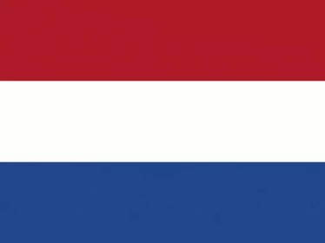

The coat of arms:
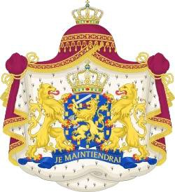

The capital city: AMSTERDAM 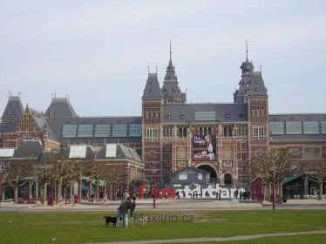
The map of Romania:
https://img.obrazky.cz/?url=3ff02386d7320293&size=2
The flag of Romania:
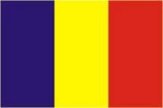
The coat of arms: 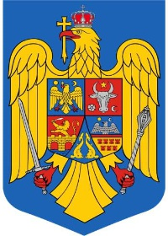

The capital city : BUCHAREST
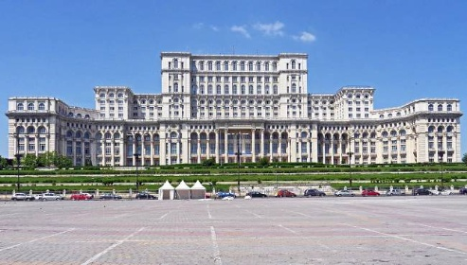

Play Kahoot game:
https://create.kahoot.it/details/the-czech-republic-romania-and-the-netherlands/3afc207e-3490-4753-b6ca-5b66c06131a7

Sources:
https://www.obrazky.cz/?q=praha&url=https%3A%2F%2Fwww.parniky-praha.eu%2Fdarkove-poukazy%2F_img%2Fpoukazky-4.jpg&imageId=774718337d54d384&data=lgLEEEsmY3YKXfVEiGwT_rWvUhDEMGuHaM6UfDx7tfLwRL3j_BT1M7v-xnYfBKZAk4N4bACONTU48B1Wj68MiP-MgkU-Gs5cetJAxAIOLJPEApRWxAKyJ8QC4rA%3Dhttps://www.obrazky.cz/?q=st%C3%A1tn%C3%AD+znak&url=https%3A%2F%2Fsk.alerion.cz%2Fsites%2Fdefault%2Ffiles%2Fzakaznici%2F%255Bnid%255D%2Fvelky_statni_znak_cr_plastovy.jpg&imageId=5d8412aa979f9b05&data=lgLEEGdJPF3jR863V4IIJeAv8J_EMGhR9bLLKjuKuoVi_o4bl8O1WTJe80jnD8JhDlXfs76OH3pEok0mZuiMRdYcqIC63c5cetOJxAJ2V5PEAieBxALrlsQCt6U%3D
https://img.obrazky.cz/?url=7004fd30cafc23a0&size=3
https://img.obrazky.cz/?url=40d7c5d0c80bf8d6&shttps://img.obrazky.cz/?url=b100309c63ff5d1c&size=2ize=2
https://img.obrazky.cz/?url=6cb12eef07ecbc81&size=2
https://img.obrazky.cz/?url=10a6013cb2962c44&size=2

This material was made by Mgr. Zuzana Jedličková, ZŠ Liberec, Broumovská as an outcome of Erasmus+ project called „Keep fit and be healthy“ in 2019.

