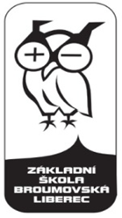

KEEP FIT AND BE HEALTHY

Famous Czech sportspersons (CLIL)

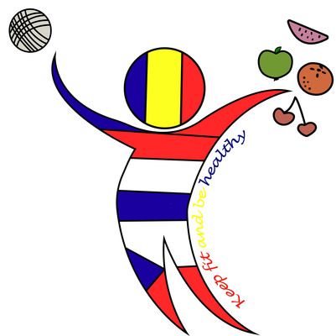
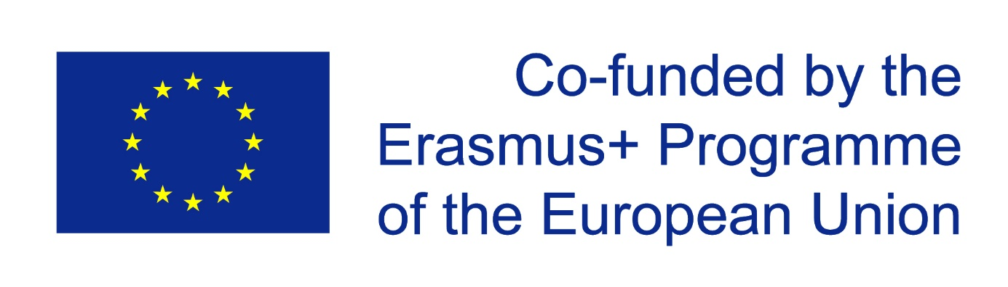
ESTER LEDECKÁ

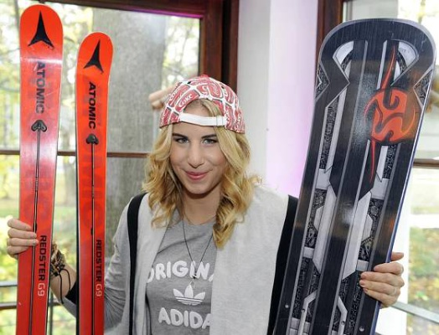

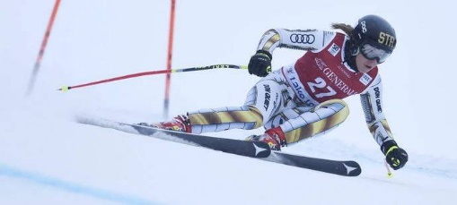

Ester Ledecká (* March 23, 1995 Prague) is a Czech snowboarder and Alpine skier. At the Winter Olympics in 2018 in Pyongyang, she won two gold medals when she first won super G in alpine skiing and a week later dominated the parallel giant slalom on the snowboard. As the first athlete in Olympic history, she won two disciplines with different equipment in one Winter Olympics. After Afise Rezcovová she became the second Olympian, who won the gold medal in two different sports, and the first woman to have done it in one Winter Olympics. She is also the first Czech Alpine skier to win Olympic gold and the first Olympic champion in history, starting in ski and snowboard disciplines. In snowboarding she is also a world champion in parallel and giant parallel slalom.
Interesting facts:
She didn’t go to primary and secondary school – her parents educated her at home. She only took her exams once a year. Her father Janek Ledecký is a famous Czech musician, composer and singer. Her grandfather Jan Klapáč is an ice hockey world champion (1972).

Answer the questions:
- How old is she?
- Which sports does she compete in?
- What medals did she win in the Winter Olympics in Pyongyang?
ZUZANA HEJNOVÁ
Zuzana Hejnová is a Czech athlete, whose specialization is running 400m hurdles . She is a bronze medalist from London 2012 and a double world champion from the World Championship 2013 in Moscow and 2015 in Beijing.
She is a multiple winner of the Diamond League meetings and in 2013, she has entered 13 races on 400 metres track without being defeated. She became the best athlete of Europe in 2013 inTallinn, Estonia.
She was born in 1986 in Liberec and her mum Alena Hejnová works as a primary teacher in our school. Zuzana sometimes visits our school and meets our students. In cooperation with her parents she established an athletic club for kids in our school.

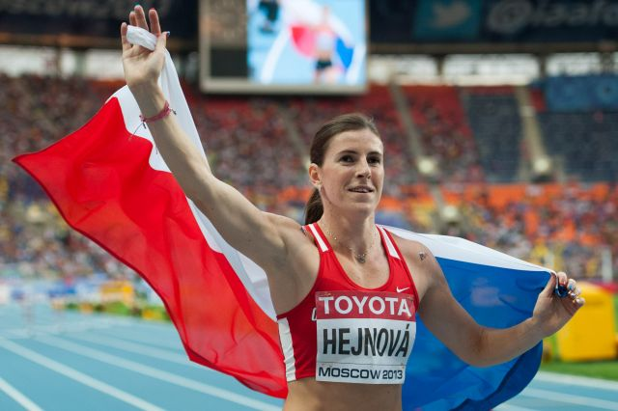

Answer the questions:
- How old is she?
- What medal did she win in the Olympics in London?
- When did it happen?
- How many times did she become the world champion?
- What does the word hurdles mean?

VĚRA ČÁSLAVSKÁ
Věra Čáslavská (May 3, 1942 Prague - August 30, 2016) [1] was a famous Czech gymnast, a coach and a prominent sports official, a seven-time Olympic champion, a four-time World Champion, eleven-time European Champion and a four-time Athlete of the Year of Czechoslovakia. After the Velvet Revolution, she worked as a chairwoman of the Czechoslovak Olympic Committee in 1990-1996, and in 1995-2001 she also became a member of the International Olympic Committee. She was one of two gymnasts in history, who managed to win gold medals in two Summer Olympics. She also won the World Championship in 1966 and European championships in1965 and 1967. For over forty years, she has already held a record in absolute number of individual gold medals in gymnastics. Between 1964 and 1968 he wasn‘t defeated in any big race.
Interesting facts:
She won 3 gold Olympic medals in Tokyo 1964.
She won 4 gold and 2 silver Olympic medals in Mexico 1968.
She worked as an adviser for the president of the Czech Republic Václav Havel.
In 2015 she called for solidarity with refugees from war affected countries.

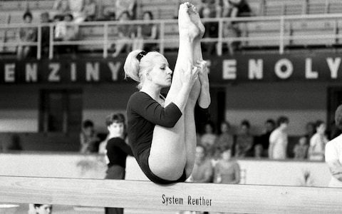
Answer the questions:
- How old was she when she won gold medals in Mexico?
- How old was she when she died?
Find the verbs in past simple:_________________________________________________
Find the sentence in present perfect:________________________________________
- Věra Čáslavská was a famous
A/ athlete
B/ snowboarder
C/ skier
D/ gymnast
- Zuzana Hejnová uses
A/ skies
B/ hurdles
C/ skates
D/ snowboard
- In Pyongyang Ester Ledecká won
A/ three gold medals
B/ four gold medals
C/ two gold medals in skiing
D/ two gold medals in two disciplines
- In Mexico Věra Čáslavská won
A/ four gold and two silver medals
B/ four gold medals
C/three gold and three silver medals
D/ none medal
- Věra Čáslavská was engaged in
A/ pop-music
B/ cycling
C/ politics
D/ ice hockey
- Ester Ledecká has won in
A/ parallel slalom and snowboardcross
B/ super G and parallel slalom
C/ slalom and snowboardcross
- Write play, do or go
______ skiing, ______ table tennis, ______ athletics, _____ running,
______ ice hockey, _______ snowboarding, _______ gymnastics,
______ judo, ________football, _______ horse-riding

Resources:

https://www.obrazky.cz/?q=ester+ledecka#utm_content=lista&utm_term=ester%20ledecka&utm_medium=link&utm_source=search.seznam.cz&id=c857fbcc6e521e24

https://www.obrazky.cz/?q=ester+ledecka#utm_content=lista&utm_term=ester%20ledecka&utm_medium=link&utm_source=search.seznam.cz&id=0863b14b74aceb1c

https://www.obrazky.cz/?q=zuzana+hejnov%C3%A1#utm_content=lista&utm_term=zuzana%20hejnov%C3%A1&utm_medium=link&utm_source=search.seznam.cz&id=63eb7fe5e58194eb

https://www.obrazky.cz/?q=v%C4%9Bra+%C4%8D%C3%A1slavsk%C3%A1#utm_content=lista&utm_term=v%C4%9Bra%20%C4%8D%C3%A1slavsk%C3%A1&utm_medium=link&utm_source=search.seznam.cz&id=c81a4dbab90ce1ce

