E FOR ENVIRONMENT PROJECT REPORT
Our project, E for Environment, started in March 2021 and ended in September 2021. Our project started with the participation of 6 schools from 3 countries. Initially, 1 school from France, 1 from Portugal and 4 from Turkey participated in our project. In the following stages, after our partner in Portugal left the project, another participant from Turkey joined our project. We continued our project as 1 school from France and 5 schools from Turkey.
During the planning phase of the project, we created our project to last for five weeks. However, due to the worldwide pandemic, our schools were closed to face-to-face education on different dates, both in France and in Turkey. For this reason, each participant implemented the activities in our project during the periods when their schools were open.
6th, 7th and 9th grade students participated in our project. A total of 60 students, 10 from each school, took part in our project.
The main purpose of our project was to identify environmental problems of students living in different regions and to find solutions to these problems by communicating with their other friends.
First of all, the participants were informed about how to use Web 2.0 tools at the orientation meeting. The logos and posters to be used for our project were designed by the students with the help of the CANVA website. In order to ensure democratic participation, the logo and posters of the project were selected by voting among the designs made. Participants were then grouped and matched with participants from the other school. Thus, the communication phase was started.
All communications of the participants were made via e-mail, as it caused less harm to the environment. This method was both fast and economical. The prepared letters were uploaded to the project's Twinspace[1] page. Students read the letters of the partners they were matched with from other schools and suggested solutions to their problems. Their partners followed the same process for other schools. Then, each participating school uploaded their solution proposals to the common PADLET page. In this way, a common solution proposal pool was created. After all schools completed their solution proposals, each school implemented the most appropriate solution proposal for its own problem in its school. This practice showed us that environmental problems are actually universal. It was seen by the participants that solving problems could be more effective if they worked together. Students protected nature by using the Cooperative Learning method.
During the dissemination phase of the project, the practices of each school in the project were turned into an e-book[3]. End-of-project surveys were conducted with the participants to get their views on the end of the project. Obtained results were made into a report.

PROJECT PARTNERS
Akköprü Secondary School (VAN)  Ege Tolgay ALTINAY  (Project Host) | Fatih Secondary School (ERZURUM)  Burak SOLAK  (Project Host) | 100. Yıl Secondary School (KONYA)  Aycan KARAMAN  (Project Partner)
Namık Kemal Secondary School (ESKİŞEHİR)  Nilgün GÜNERİ  (Project Partner) | Collège Immaculée (DAMVILLE)  Cecile KIENTZ  (Project Partner) | Mustafa Kemal Secondary School (VAN)  Cennet GÜLDALI  (Project Partner)

FIRST MEETING
1) First, all the partners of the project attended the introductory meeting.
2) At the meeting, the aim and method of the project was conveyed to the participating partners.
3) Task distribution was made with the participants.
4) Communication channels were created.
ROLES OF PARTNERS
Creating project pages (Twinspace) | Aycan KARAMAN  Ege Tolgay ALTINAY
Creating and tracking the project facebook group | Burak SOLAK
Creating Project’s Trailer Video | Aycan KARAMAN
Creating and following the Instagram page of the project | Nilgün GÜNERİ
Project logo and poster voting questionnaire | Cecile KIENTZ
Creating the project Web-site and its contents | Ege Tolgay ALTINAY
Creating an e-book | Cecile KIENTZ  Nilgün GÜNERİ
Creating a pre-evaluation questionnaire | CENNET GÜLDALI
Creating end-of-project evaluation questionnairre | Burak SOLAK
Creating the digital board | Cennet GÜLDALI

PROJECT START-UP TASKS
As a result of the task distribution, the initial tasks of the project were carried out as follows:
1) Project introduction video (in English) was prepared.
2) The teachers in the project introduced themselves, their school and their city on Twinspace.
3) Project map was created in Twinspace.
4) Parent permission documents were prepared. Documents signed by parents have been uploaded to Twinspace.
5) Teacher and student pre-tests were created for our project. Our teachers and students participated in our surveys. Our survey results were shared on Twinspace.
6) Whatsapp group was created to facilitate communication between partners in our project.
7) Facebook page and project website were created for the dissemination of the project.
8) Students and parents were informed about the project through online meeting applications.
9) A teacher meeting was held on Zoom for the promotion of the eTwinning platform and the distribution of tasks.
10) Students made posters, logos and slogans for the project. Poster and logo competitions were organized. The results were shared with partners at Twinspace and Whatsapp.
11) The project was promoted on school websites and social media.
12) Student teams were formed and tasks were shared.
13) Students were added to the Twinspace and the Twinspace was introduced to them.

POSTER AND LOGO DESIGNS
The logos and posters to be used for our project were designed by the students with the help of the CANVA website. In order to ensure democratic participation, the logo and posters of the project were selected by voting among the designs made.
Logo voting results are: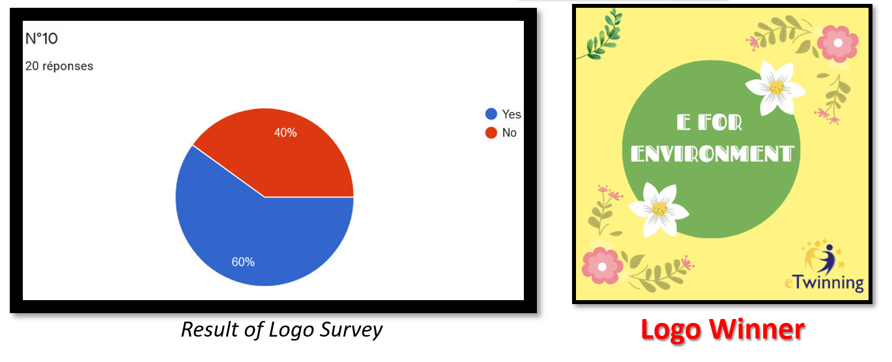
Poster voting results are:
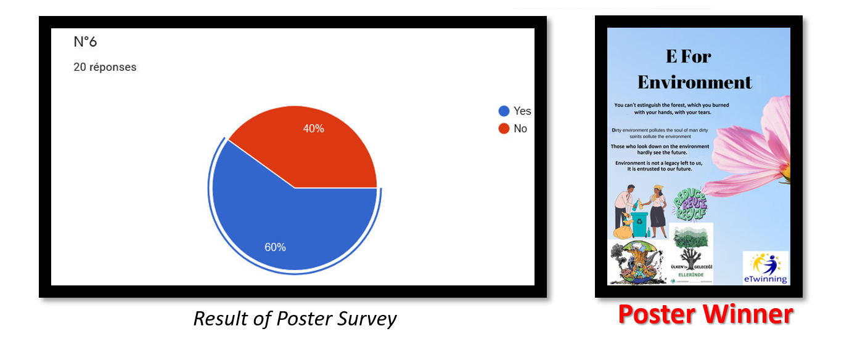

MATCHINGS OF E-MAIL PARTNERS
Akköprü Secondary School/VAN
Pair 1: Avşin-Ceyda with Alice-Rose(France)
Pair 2: Fırat-Bilal with Yaprak-Rümeysa (Mustafa Kemal Secondary School / VAN)
Pair 3: Sevanur-Nisanur with Ayşenur-Yağmur(Fatih Secondary School / ERZURUM)
Pair 4: Zeynep-Nisanur with Beyzanur-Hakan(Namık Kemal Secondary School / ESKİŞEHİR)
Pair 5: Eylül-Meryem with Nazlı-Burçin(100. Yıl Secondary School / KONYA)
Collège Immaculée, Mesnils sur Iton, FRANCE
Pair 1: Avsin and Ceyda (Akkopru) with Alice Tree and Rose Tree
Pair 2: Azad-Rojin(Mustafa Kemal Sec. Sch.) with Mattéo Wildlife and Nathan Wildlife
Pair 3: Hayrettin-Hilal(Erzurum) with Marine Flower and Océane Flower
Pair 4: Fatmanur-Ecrin(Eskisehir) with Eugénie Sea
Pair 5: Tuana- Selin(Konya) with Juliette Sea
Fatih Secondary School/ ERZURUM
Pair 1: Hayrettin-Hilal with Marine and Oceane(France)
Pair 2: Ayşenur-Yağmur with Sevanur-Nisanur(Van-Akköprü)
Pair 3: Çağrı-Suna with Yusuf Enes- Emre(Konya 100. Yıl Secondary School)
Pair 4: Abdulkadir-Nurevşan with Eren-Ceren(Eskişehir)
Pair 5: Taha-Kadir with Berat-Naz(Van-Mustafa Kemal Secondary School)
Mustafa Kemal Secondary School/VAN
Pair 1: Azad-Rojin with Matteo Wildlife-Nathan Wildlife(France)
Pair 2: Yaprak-Rümeysa with Fırat-Bilal (Akköprü Secondary School)
Pair 3: Berat-Naz with Taha-Kadir (Fatih Secondary School)
Pair 4: Hayrunnisa with Cemre-Elif(Eskişehir)
Pair 5: Nehir with Resul-Mustafa(Konya)
Namık Kemal Secondary School /ESKİŞEHİR
Pair 1: Cemre-Elif with Hayrunnisa(Mustafa Kemal Secondary School)
Pair 2: Beyzanur-Hakan with Zeynep-Nisanur(Akköprü Secondary School)
Pair 3: Fatmanur-Ecrin with Eugénie Sea(Collège Immaculée)
Pair 4: Damla-ZeynepEla with Ilker-Metehan(100.yıl Secondary School)
Pair 5: Eren-Ceren with Abdulkadir-Nurevşan(Fatih Secondary School)
100. Yıl Secondary School/KONYA
Pair 1: Tuana-Selin with Juliette Sea(Collége Immaculée)
Pair 2: Ilker-Metehan with Damla-Zeynep Ela(Namık Kemal Secondary School)
Pair 3: Resul-Mustafa with Nehir(Mustafa Kemal Secondary School)
Pair 4: YusufEnes-Emre with Çağrı-Suna(Fatih Secondary School)
Pair 5: Nazlı-Burçin with Eylül-Meryem(Akköprü Secondary School)
PROJECT AIMS
Objectives: At the end of this project, students;
• Identifies the environmental problems in the regions of the participating schools.
• They can share the environmental problems they have experienced with other students living in different regions in English and offer solutions to other problems.
• Reaches common consciousness about nature problems.
• Understands the importance of digital methods that are the least harmful to the environment as a communication method.
• Uses electronic communication tools efficiently.
• It can bring together the solution proposals it has developed as a digital book.
• Implements the solutions in the school in line with the possibilities..

PROJECT ACTIVITIES:
ACTIVITY 1: SENDING E-MAILS TO PENPALS:
All participating schools formed internal working groups to send the letters. In the meeting held with the students, environmental problems in their schools were determined by brainstorming and listing methods. In the letters they sent, the participating students shared the environmental problems identified at the meeting with the other students they matched with and asked them to propose solutions. The written letters have been uploaded to the TwinSpace portal.
ACTIVITY 2: ENTERING SOLUTION PROPOSALS:
After the participants read the letters they received, they made a list of environmental problems mentioned by other schools. The participants came together and created common solutions to the problems raised. The solution proposals created were uploaded to the PADLET[2] page that all schools use in common..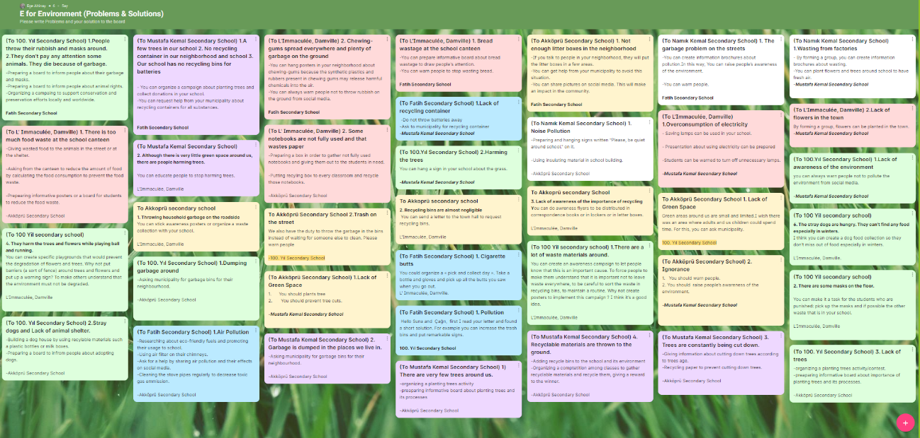
ACTIVITY 3: IMPLEMENTATION:
Öğrenciler diğer okullarca kendilerine sunulan çözüm önerilerini bir araya getirdiler. Sorunu en iyi çözebilecek olan çözüm önerisini gerçekleştirmek için uygulama aşamasına geçtiler. Uygulama aşamasında okullar şu etkinlikleri yaptı:
MUSTAFA KEMAL SECONDARY SCHOOL / VAN:  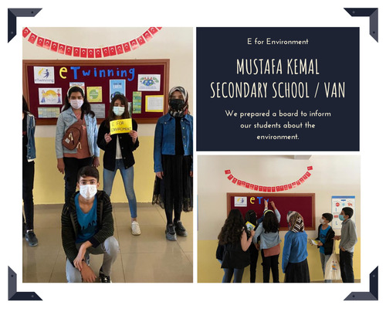  We have prepared a board to inform our students about the environment. We have informed our other students to use environmentally friendly products and to save our planet. | AKKÖPRÜ SECONDARY SCHOOL / VAN: 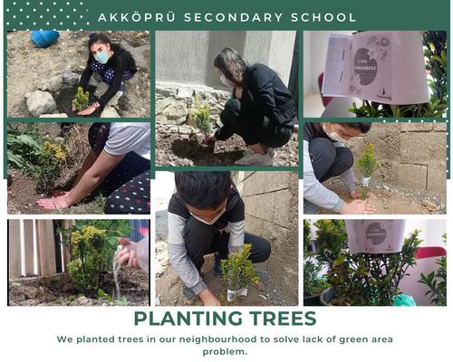  We planted trees in our neighborhood to make up for the lack of green space.
FATIH SECONDARY SCHOOL / ERZURUM:  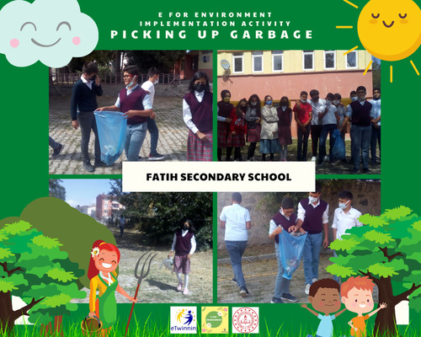  We collected all the garbage we found in our school yard and in our neighborhood. | L'Immaculée College / DAMVILLE, FRANCE:  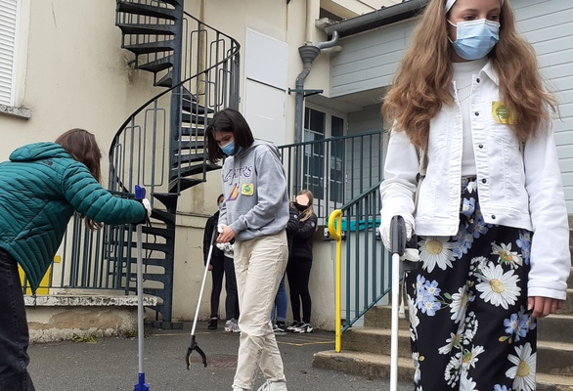  We collected all the garbage we found in the playground. Some other students came and helped us!

WEB 2.0 TOOLS
One of our goals in our project was to develop students' technological skills and 21st century skills. For this purpose, it is aimed that students use WEB 2.0 tools actively. Teachers as well as students researched and tried to learn new WEB 2.0 tools. This also improved the informatics skills of teachers.
TEACHERS’ USE OF WEB 2.0
- All of the teachers guided the students on WEB 2.0 tools.
- All of the teachers offered them some options to use for the material to be prepared.
- All the teachers helped the students in the difficulties experienced during the use of the selected tool.
- The teachers responsible for the surveys (Ege, Burak, Aycan and Cecile) prepared surveys with survey tools such as GOOGLE FORMS.
- Posters containing project rules and reminder texts were prepared with CANVA by the founders.
- They prepared various videos such as school promotion videos with WEB 2.0 tools such as RENDERFOREST and MOVIE MAKER.
STUDENTS’ USE OF WEB 2.0
- Students used CANVA to create their logos/posters.
- The participants came together and created common solutions to the problems raised. The solution proposals created were uploaded to the PADLET page that all schools use in common.
- Students answered questionnaires about GOOGLE FORMS.
COLLABORATIVE LEARNING
The e for Environment eTwinning project is based on a collaborative learning approach to solving environmental problems. In the collaborative approach, group members depend on each other to perform tasks that they would not otherwise be able to complete individually, as in our project, students in mixed groups receive support from each other to accomplish tasks using Web 2.0 Tools. Groups are heterogeneous as students in groups come from a variety of countries and cultures. They also differ in terms of age groups, gender and language proficiency levels. In addition, there are 3-4 students in each group because it is important that students can participate in the activities equally. The collaborative approach proposes the idea that students learn best when they learn in a group.
In addition, group learning allows students to become more social.
Accordingly, in our project, our students have the chance to socialize more in groups.
They have become more self-confident individuals. Under the guidance of mentor teachers, students actively take responsibility for their own learning and that of their groupmates.
E.g; High school students participating in the project gained different perspectives to secondary school students.
This is also an example of Tutor Assisted Learning. This is how they develop a sense of positive commitment, which is crucial for collaborative learning.

The Zone of ​​Proximal Development (ZPD) expresses the difference between what a student can do without help and what he can achieve with support and encouragement from a teacher or an expert adult. Students have supported each other in this development area throughout this project.
In addition to the learning experience, the students were also active in other aspects of the project such as designing the logo/poster, voting for the competitions in the project, and sharing their ideas on Twinspace. Examples of Cooperative Learning in our project can be listed as follows;
- At the beginning of the project, they used e-mail to introduce themselves and get to know each other. This gave students a chance to meet new people and socialize more before starting the activities.
- Students used Padlet to collect their solution proposals in a common pool within the project. In this way, all participating students created a common learning wall.
PROJECT PRODUCTS
- e-Book:
Students and project partner teachers photographed all phases of the project. These stages, photographed later, were turned into a common product, an e-book. By creating a digital product at the end of the project, the participants avoided the use of paper. The e-book included the writings of teachers and students who participated in the project. In this way, participants from all levels contributed to the project.

- e-Certificate:
All students who participated in the project were entitled to receive an electronic certificate. Certificates were shared on the digital media TwinSpace page and in WhatsApp groups. With the digital participation certificate, the use of paper has been prevented.

SURVEY RESULTS:
1) Student Survey Results: ^{[4]} 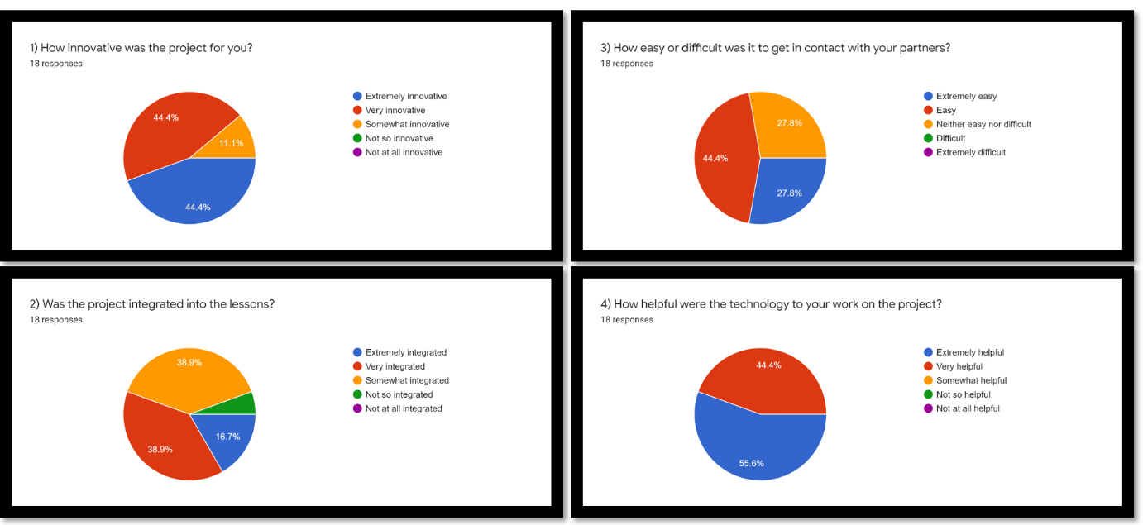
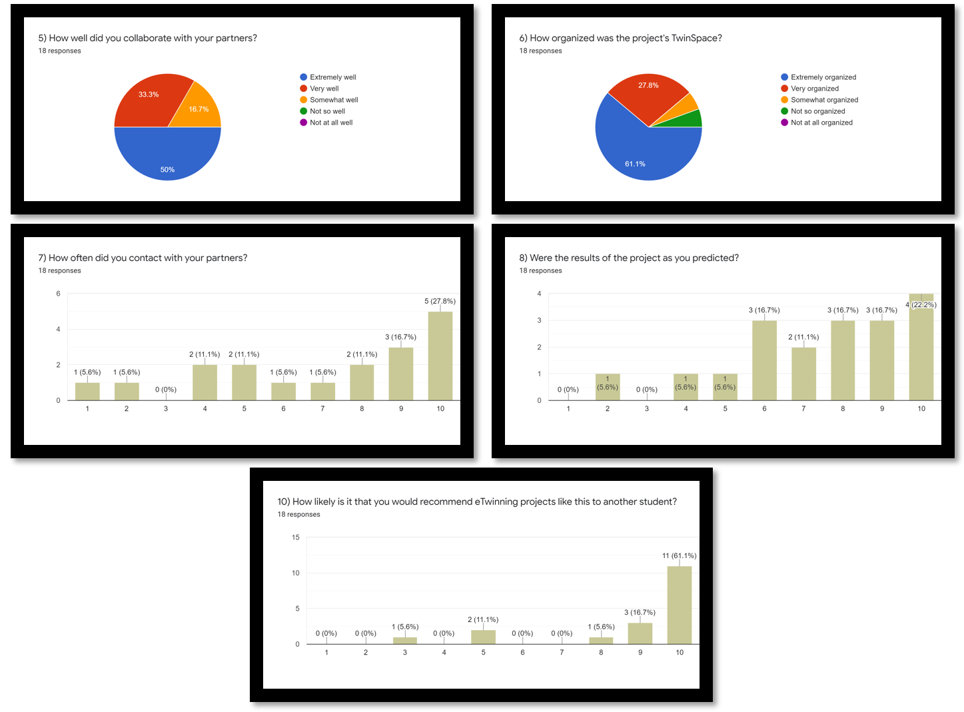
2) Teacher Survey Results: ^{[5]} 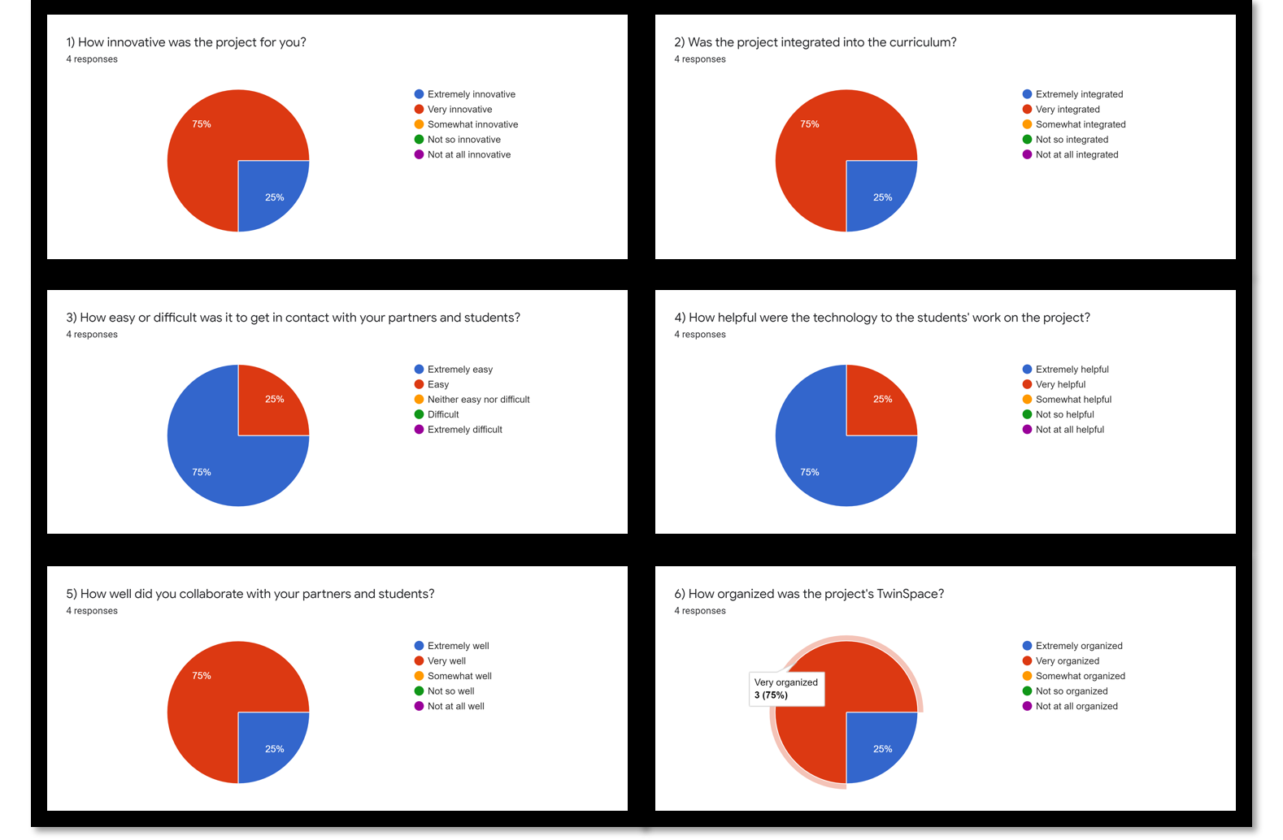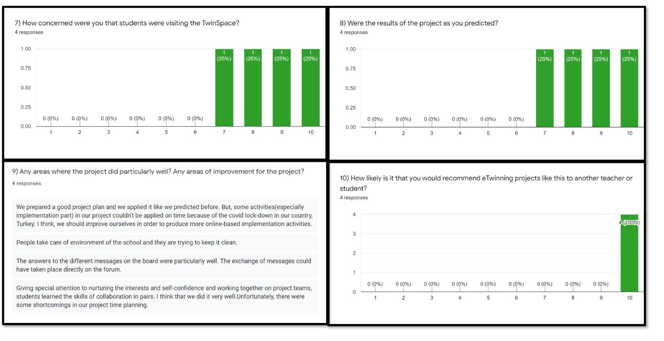

Sources:
- TwinSpace: https://twinspace.etwinning.net/170548/home
- E for Environment Padlet: https://padlet.com/egealtinay/eforenvironment
- e-Book: https://madmagz.com/fr/magazine/1902783#/page/1
- Student Survey Results: https://docs.google.com/forms/d/1dbnaykLQki-aW2oVDIxwmrX6gqBepLZB88jVfLmiOsg/edit?ts=60d32370#responses
- Teacher Survey Results: https://docs.google.com/forms/d/1qA7FXEdv2O_QCylJZsT_oQ_JlZMQozwJ4S9vMJcSvCI/edit?ts=60d32359#responses

