Hungarian Stereotypes explained by other nationalities
- If a Hungarian passes through a revolving door right after you he will come out before you
- Two Hungarians can have three different and often contradictory opinions
- Hungarian women are beautiful
- Hungarians tend to eat rich dishes, full of fat
- Hungarians complain a lot and they are rather pessimistic when expressing an opinion
- Hungarians do not make a toast with beer
- Most Hungarians think we are the descendants of Huns
- Hungary is a horse riding nation
These stereotypes are explained by other nationaities.
If a Hungarian passes through a revolving door right after you he will come out before you
This is not very pleasing is it? This means some of my fellow citizens tend to show a pushy, intrusive behavior, especially when abroad. It also means though that people from this country will always find a way to get by often not paying too much attention to good manners and certain unwritten rules. Well at least it has a good side. I personally think it applies to other post-communist countries although to various degrees.
Two Hungarians can have three different and often contradictory opinions
Very true. This stems from the fact that Hungarians are very self-centered people who do not cooperate easily. It probably has historical reasons. During centuries of wars, living under occupation, and uprisings against occupations people learned not to trust too much in others even when they are fellow citizens. So the mental attitude above can be the residual effect of our history.
Hungarian women are beautiful
I agree, but it is just an opinion. When having lived in America for a while I started to think the same thing about women around me, and they had nothing to do with Hungarians. So yes, when hearing this from someone I tend to think, I am happy you have good memories from my country.
Hungarians tend to eat rich dishes, full of fat
Well yes, traditional Hungarian cuisine is like that, but we happily try to integrate new things as well. For instance the best burger I have ever eaten was at Teddy’s Fab, in Deerfield, IL, making me forget about the often stated opinion that hamburger is just a junk food. Well that was definitely not true.
Hungarians complain a lot and they are rather pessimistic when expressing an opinion
True and I attribute it also to history. Hopefully it will change in the future. I have to add though, that while this is the norm there are huge variations on a personal basis.
Hungarians do not make a toast with beer
After the revolution and war against the Habsburg Empire, which started in 1848 and fell in 1849, generals of the Hungarian army (most of them deserted from the Austrian army when learned there was an uprising in Hungary) were executed. Austrian army leaders celebrated their victory and made a toast with beer. For 150 years after that no Hungarian was supposed to toast with beer. And although the 150 years has already passed it still feels unusual for us to make a toast with beer.
Hungary is a horse riding nation
We like horses and like horse riding as well as all related sports. In eastern Hungary on the great plain, tourists are entertained by professional horsemen who can perform a few really exceptional stunts (riding two horses simultaneously while standing on them with one leg on each).

Other stereotypes
1. HUNGARIANS ARE RESOURCEFUL This stereotype is based on the belief that Hungarians always manage to find the “loopholes” (kiskapu) for avoiding certain problems. This loophole tends not to comply with official rules. Indeed, Hungarians have had to endure many decades (or, in the case of the Turks, centuries) of oppression which made them particularly apt at finding inventive solutions to make the most of their circumstances.
2. HUNGARIANS EAT VAST AMOUNTS OF PAPRIKA AND FAT It is not hard to get at the root of this preconception – Hungarian cuisine is indeed full of fatty, spicy food with paprika, and a lot of restaurants targeting tourists tend to reinforce this idea. But today, modern Hungarian cuisine is characterised by a much wider and more health-conscious range of foods.
3. HUNGARIANS ARE ALWAYS COLD Some foreigners have observed that the heating in our homes and workplaces is usually kept at a higher temperature than in the United States. Some have also said that we tend to complain more about the cold than the heat. But a quick look at social media will quickly debunk this theory – no matter what the weather is like, someone will be complaining about it.
4. EVERY HUNGARIAN OWNS A HORSE It was probably a bunch of visitors in the 19th-century who started this stereotype. Although Hungary was indeed a horse-keeping nation for a long time, it is obviously no longer the case. Regardless, you can see more horses in the countryside than in other countries.
5. HUNGARIAN MEN ALL HAVE A MOUSTACHE This misconception can also be attributed to the fashion journals of the beginning of the 20th century. Moustaches are no longer as fashionable as in those days, or at least in different forms.
6. HUNGARIANS ALWAYS COMPLAIN Although Hungary is certainly characterised by a certain pessimism and a cynical worldview, this generalisation may be a bit of an overstatement. The characteristically dry Hungarian sense of humour certainly makes this pessimism more tolerable and entertaining. Ask a Hungarian “how are you?”, and while this question is often merely a nicety in English-speaking cultures, a Hungarian will be quick to share with you her most recent grievances.
7. HUNGARIANS ARGUE A LOT Hungarians are a proud and passionate people who stick to their opinion and will defend their position in any situation where they are personally involved.
Stereotypes explained by us, Hungarians
There are plenty of ingrained stereotypes about us, Hungarians, for example a man is not a man without mustache or that real people of Pest drink coffee at Gerbeaud every day.
Which is not true at all. By definition, the stereotypes are schemes that help with fast and efficient data processing, and yes, they have a basis in reality. But we usually use them too generously, so they are also applied in situations where they are not really supposed to. For example, for us Hungarians the following:
Hungarian is an equestrian nation.
... Once it was. 1000 years ago. When our ancestors came to the Carpathian Basin, they haven’t had any Wizzair or Ryanair flight, so they had no choice. But today's average urban Hungarian hasn’t seen a horse in person, maybe not all their lives. (And many of them had only see chicken in a processed state, but don’t get into it right now.) The stereotype is only established in one thing: we are quite proud of our former equestrian traditions, and because of this, there are many tradition preserving groups and riding stables located throughout the country.

The Hungarian dishes are inedible fatty and always has paprika in it.
We cannot really deny this one. Fish soup, goulash soup, stuffed cabbage, roast sausage … fat and paprika is essential for everything.
Strange foods.
Those food that doesn’t have the first two additive are simply perverse: just think about TúróRudi, this chocolate coated cottage cheese stick (don’t deny it, no one else understands or like this food, except Hungarians) or the poppy seed pasta, from which the French have the jitters. Because poppy is not only a never-used food raw material in many European countries, but also illegal, since drugs can be produced from it. We, however, don’t waste poppy seed for such purposes, because:
We drink.
Everything. Wine, beer, pálinka. In particular wine and pálinka is what all rural households are cooking according to the stereotype. And the truth is: there is something in it. There are much, much more official wine regions than would be justified on the basis of the country's territory, and under a regulation in force since a few years, every individual can cook pálinka at home. And the top of everything, there is the concept of "pálinka tree" that can be said for all unidentified fruit trees during harvest.

The girls are beautiful and easy to get them.
We barely ever protest about the first part, although there are many overweight or let’s say, not model-looking people, just as everywhere in the welfare societies. As for the fastness: this stereotype is widespread mainly due to the Hungarian porn industry, and only half-true: we are certainly easier to get than a faithful Muslim living in chador, but still! A “Hi baby” is not enough for us!
Paunchy and big-mustached men.
In contrast to the beautiful Hungarian girls, the Hungarian men are not typical pretty boys. The beer belly (true) and the mustache (thankfully no longer true) are essential accessories of every Hungarian man in the caricatures. As well as the bad dressing. If you’ve never seen a real low-end sweatshirt, visit any optional countryside wedding and/or pigsticking.
Wedding parties and pig slaughtering.
Maybe we should mention this after the food-stereotypes, but we have two main terms of the year: winter, when pigstickings are, and summer, when nuptials. The two differ only in the framework of the story: pigsticking is a ritual killing of a poor animal using a lot of alcohol, while the second one is a party woven around the consumption of these meat products. Of course, we must obtain a marriageable couple, but it’s clear that no one is there for their sake.
Hungarian language is the second most difficult after Chinese.
We can say again: partially true. We don’t have as many tenses as the Englishmen, Frenchmen or Spaniards, but we have inflective language, with word order not strictly bound. So it’s enough to miss a suffix or mix up a world, and we find ourselves in the middle of a totally pointless sentence. But we are also aware of this, so we're very helpful and creative to decode every Hungarian attempt. But really: feel free to try, we love to listen!
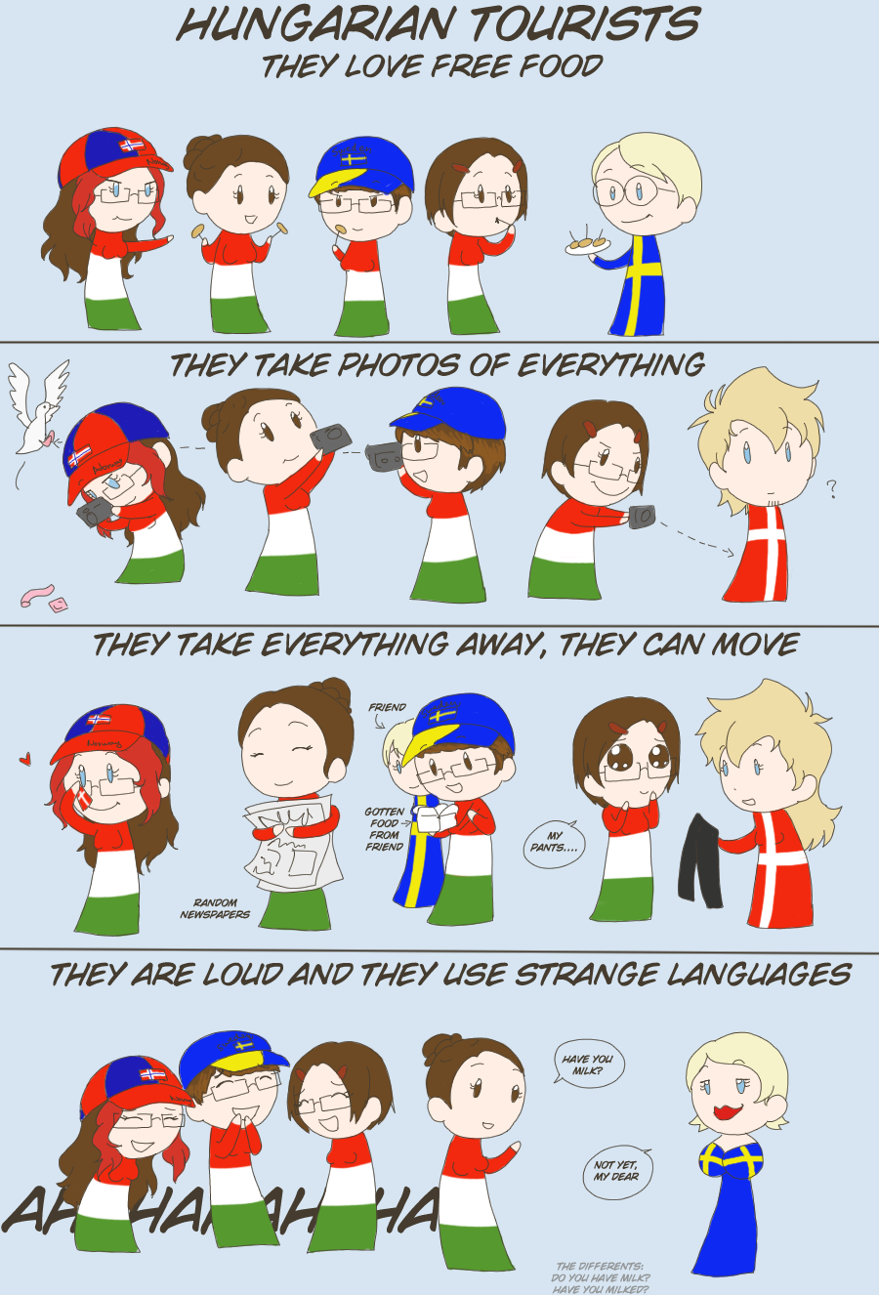
The Gypsy music is the real Hungarian music.
It's just as exaggerated idea as Liszt's Hungarian Rhapsody is the real Hungarian music. In fact, it’s not true that every Hungarian hospitality units, even the lowest have their own gypsy musicians, and an average Hungarian young people do not party for the beat of Hungarian Dances in the disco. But both are Hungaricums and parts of the Hungarian cultural heritage.
The Hungarians always complain.
About our government, the European Union, the taxes, the unbearable relatives, our health, and everything in general. This is particularly true in the older age group, so do not accidentally ask those who seems to be 50 years or older, "How do you do" if you don’t have an hour for the response and appropriate mental strength to pretend compassion. Oh, and this is not enough! You must bid: “This must be terrible. Not as much as…” If you don’t bid, you're not compassionate enough.
All Hungarians have a summer house on the shore of Lake Balaton.
No. Unfortunately. But all Hungarians have a friend who has a holiday home on the shore, so the problem is solved.
