Subject: Language, History
Title: Portfolio of Polish historical events.
Theme: a comprehensive study about some Polish historical events.
Class: I.A & II.A
Number of participants: 20
The purpose of the subject: To comprehend an overall view of the History of Poland and important historical figures.
Skillsets to develop: cognitive skills, to highlight essential information, investigative writing, teamwork
The nature of this class:
Get ready for our visit to Poland C2

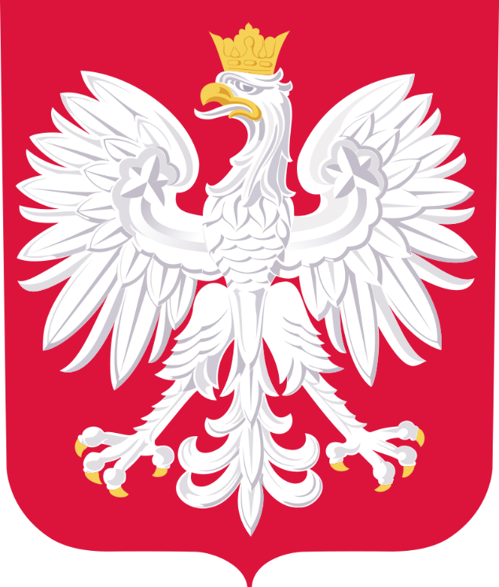
Do you known the legend of the three brothers called Lech, Czech and Rus ?
Could you tell it?

Lech, Czech and Rus (refers to a founding myth of three Slavic peoples: the Poles (or Lechites), the Czechs, and the Rus' people. The three legendary brothers appear together in the Wielkopolska Chronicle, compiled in the early 14th century. The legend states that the brothers, on a hunting trip, followed different prey and thus travelled (and settled) in different directions; Lech in the north, Czech in the west, and Rus in the East. There are multiple versions of the legend, including several regional variants in Poland and the Czech Republic that mention only one or two of the brothers.
In the Polish version of the legend, three brothers went hunting together but each of them followed a different prey and eventually they all traveled in different directions. Rus went to the east, Čech headed to the west to settle on the Říp Mountain rising up from the Bohemian hilly countryside, while Lech traveled north. There, while hunting, he followed his arrow and suddenly found himself face-to-face with a fierce, white eagle guarding its nest from intruders. Seeing the eagle against the red of the setting sun, Lech took this as a good omen and decided to settle there. He named his settlement Gniezno (Polish gniazdo - 'nest') in commemoration and adopted the White Eagle as his coat-of-arms. The white eagle remains a symbol of Poland to this day, and the colors of the eagle and the setting sun are depicted in Poland's coat of arms, as well as its flag, with a white stripe on top for the eagle, and a red stripe on the bottom for the sunset.

According to Wielkopolska Chronicle (13th century), Slavs are descendants of Javan, the son of Japheth, the son of Noah. He had three sons - Lech (the oldest), Rus, and Čech (the youngest), who decided to settle west, north, and east

Is it related to the coat of arms of Poland?
According to legend, the White Eagle emblem originated when Poland's legendary founder Lech saw a white eagle's nest. When he looked at the bird, a ray of sunshine from the red setting sun fell on its wings, so they appeared tipped with gold, the rest of the eagle was pure white. He was delighted and decided to settle there and placed the eagle on his emblem. He also named the place Gniezdno (currently Gniezno) from the Polish word gniazdo ("nest").

What are the colours of the Polish flag?
Poland’s national flag consists of two, equally-sized rectangular strips, the upper one being white and the lower one being red.
White is used to substitute silver. It represents the element of water, as well as purity and immaculately.
Red is the symbol of fire and blood and, in spiritual interpretation, courage and valor.

When Poland gained independence after World War I, it was finally able to make the red and white flag fully legal.

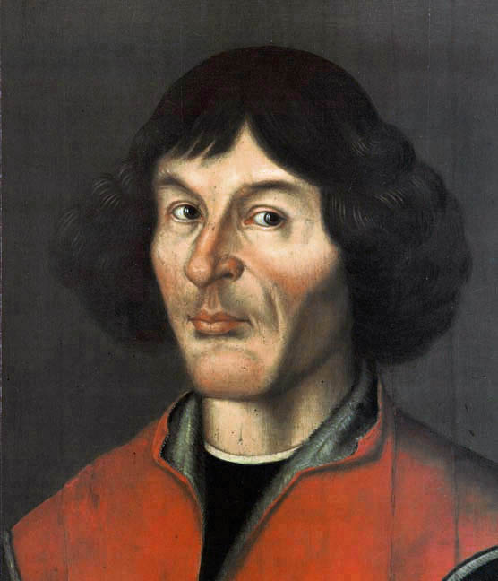

Who has written the play about the revolutions of the celestial spheres?
Nicolas Copernico
was a Renaissance-era mathematician and astronomer who formulated a model of the universe that placed the Sun rather than the Earth at the center of the universe, likely independently of Aristarchus of Samos, who had formulated such a model some eighteen centuries earlier.
The publication of Copernicus' model in his book De revolutionibus orbium coelestium (On the Revolutions of the Celestial Spheres), just before his death in 1543, was a major event in the history of science, triggering the Copernican Revolution and making an important contribution to the Scientific Revolution.
Copernicus was born and died in Royal Prussia, a region that had been part of the Kingdom of Poland since 1466. A polyglot and polymath, he obtained a doctorate in canon law and was also a mathematician, astronomer, physician, classics scholar, translator, governor, diplomat, and economist. In 1517 he derived a quantity theory of money – a key concept in economics – and in 1519 he formulated an economics principle that later came to be called Gresham's law.[9]

What did the main character advocate in this play?
What are the main ideas of this character´s theory?

The Heliocentric System

The Earth-centered Universe of Aristotle and Ptolemy held sway on Western thinking for almost 2000 years. Then, in the 16th century a "new" (but remember Aristarchus) idea was proposed by the Polish astronomer Nicolai Copernicus (1473-1543).

The Heliocentric System
In a book called On the Revolutions of the Heavenly Bodies (that was published as Copernicus lay on his deathbed), Copernicus proposed that the Sun, not the Earth, was the center of the Solar System. Such a model is called a heliocentric system. The ordering of the planets known to Copernicus in this new system is illustrated in the following figure, which we recognize as the modern ordering of those planets.

Why he did not publish his work until the year of his death?
In 1530, Copernicus published his paper "De Revolutionibus," which laid an outline of his belief that the Earth rotates around the sun. Of course, Copernicus waited until he was dying to publish this so he could escape the sure punishment from the Catholic Church. It took the encouragement of George Rheticus, a 25-year-old German mathematics professor, to persuade Copernicus to publish his work. It wasn't just that the Church would punish him, but Copernicus was a perfectionist. He didn't want to publish something that he wasn't positive was true. He had been circulating summaries of his work among his friends, but he waited until 1543 (the year he died) to print the full work: On the Revolutions of the Heavenly Orbs.

Where did they find the character's corpse?
He died on the 24th of May 1543 in Frombork ,Poland.
Copernicus was buried in an unmarked grave in Frombork Cathedral, the church where he worked.
In 2006 a skull, missing the lower jaw, had been found buried near an altar where the astronomer had been known to pray daily. The archaeologists thought this might be him. The skull was from a 70-year-old male (which matched the approximate age for Copernicus when he died in 1543) and a forensic reconstruction looked like an older version of the astronomer’s portraits . But to confirm that they had indeed found their man, the archaeologists needed to perform a DNA test. The problem? Copernicus had no children and though his uncle was known to be buried in the same cathedral, no one knew where.
Now comes news that the archaeologists found a few hairs in a book Copernicus owned. The archaeologists brought in a geneticist who compared the DNA from the hairs to that found in some bones that accompanied the skull--a vertebra, a tooth and a femur bone.
The DNA in two out of four hairs matched the bones.

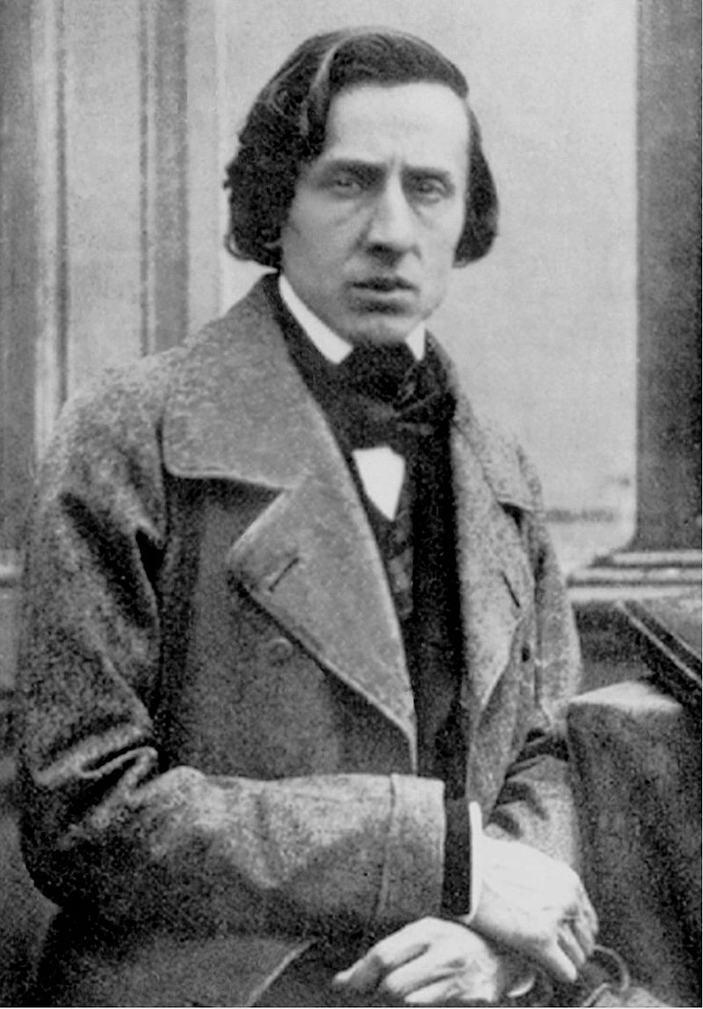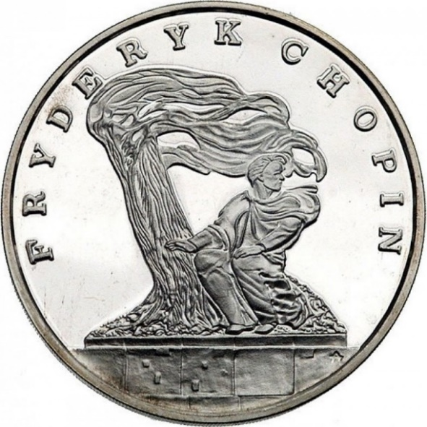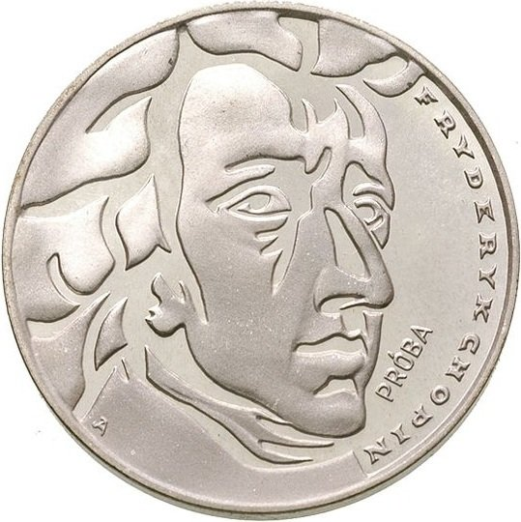
Who said “it is useless to go back over what has been and is not already”?
Frédéric François (1 March 1810 – 17 October 1849) was a Polish composer and virtuoso pianist of the Romantic era who wrote primarily for the solo piano.
He gained and has maintained renown worldwide as a leading musician of his era, whose "poetic genius was based on a professional technique that was without equal in his generation.
Chopin was born in what was then the Duchy of Warsaw and grew up in Warsaw, which in 1815 became part of Congress Poland. A child prodigy, he completed his musical education and composed his earlier works in Warsaw before leaving Poland at the age of 20

What instrument was self-taught?
The piano
At what age did he compose his first work?
When he was 17.
It quickly became apparent that he was a child prodigy. By the age of seven Fryderyk had begun giving public concerts, and in 1817 he composed two polonaises

What were his academic grades at the lyceum
Chopin graduated cum laude on the 7th of July 1826

With whom did he share an apartment in Paris?
With important writers like: Victor Hugo, Honoré de Balzac y Heinrich Heine,

What romantic characteristics can we find in the character?

Many Romanticism movement symbols: misterious man, to be exiled, tormented inpiration, his early death.
His romantic musical nationalist theme, manifested in the adoption and stylization of forms of folk music of Poland such as stone and mazurka, vindicating the patriotic feeling, precisely in times of Russian oppression.

Where is Chopin´s heart located?
During his final days, famed Polish composer Frédéric Chopin, with fawning Parisian women fainting all around him, he made the gruesome request that his heart be taken from his corpse and sent back to his home country, knowing full well that his body would never leave Paris.
Chopin’s eldest sister, Ludwika Jędrzejewicz, complied with his request, taking the heart to the Holy Cross Church in Warsaw where it was buried beneath a small monument.

