Group them and…

Do not worry. You can import a coin like the one above from your spanish partner. ( I have sent them a copy of the templates via email )
Tip
How to import a file into Tinkerkad.
1.-
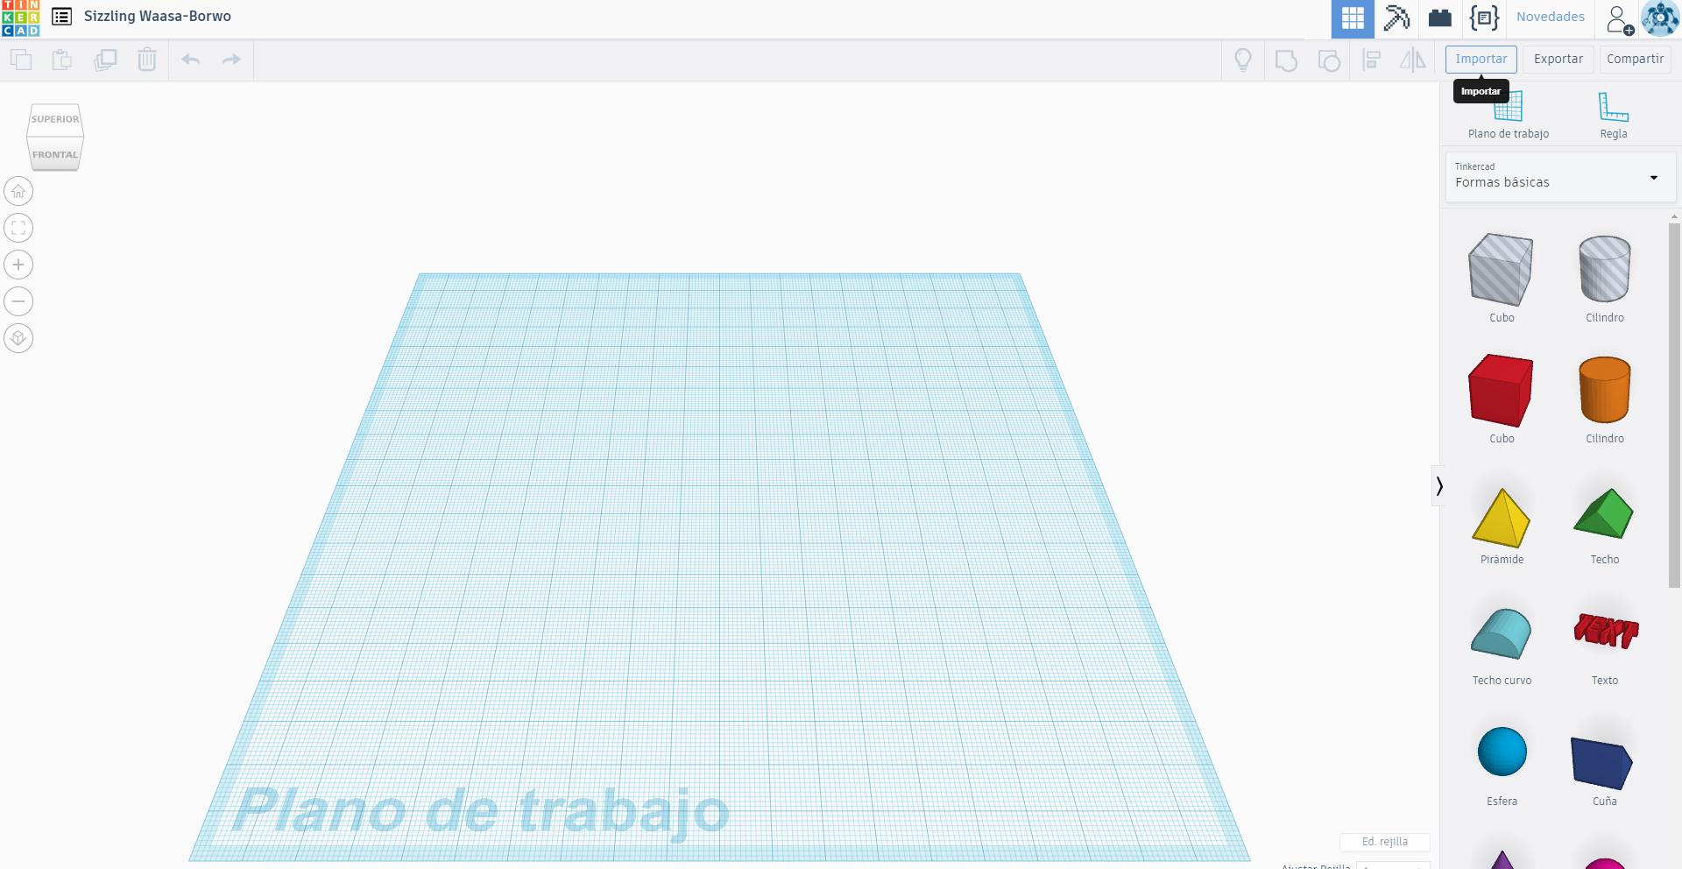

2.-
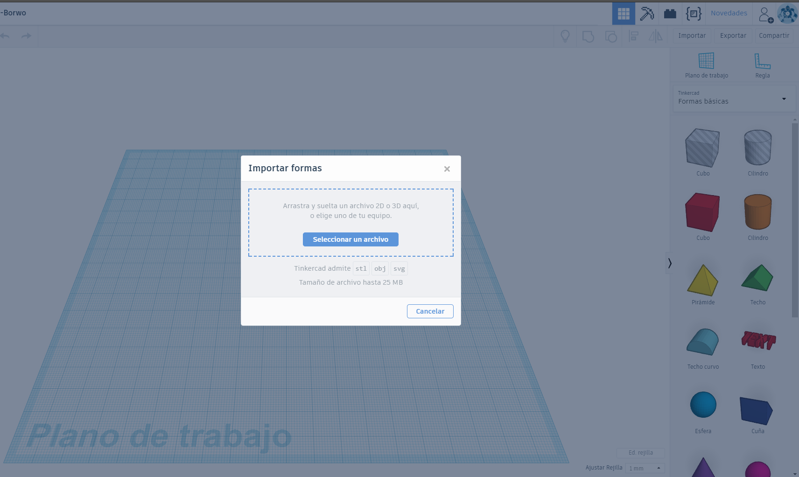
3.-
That´s all
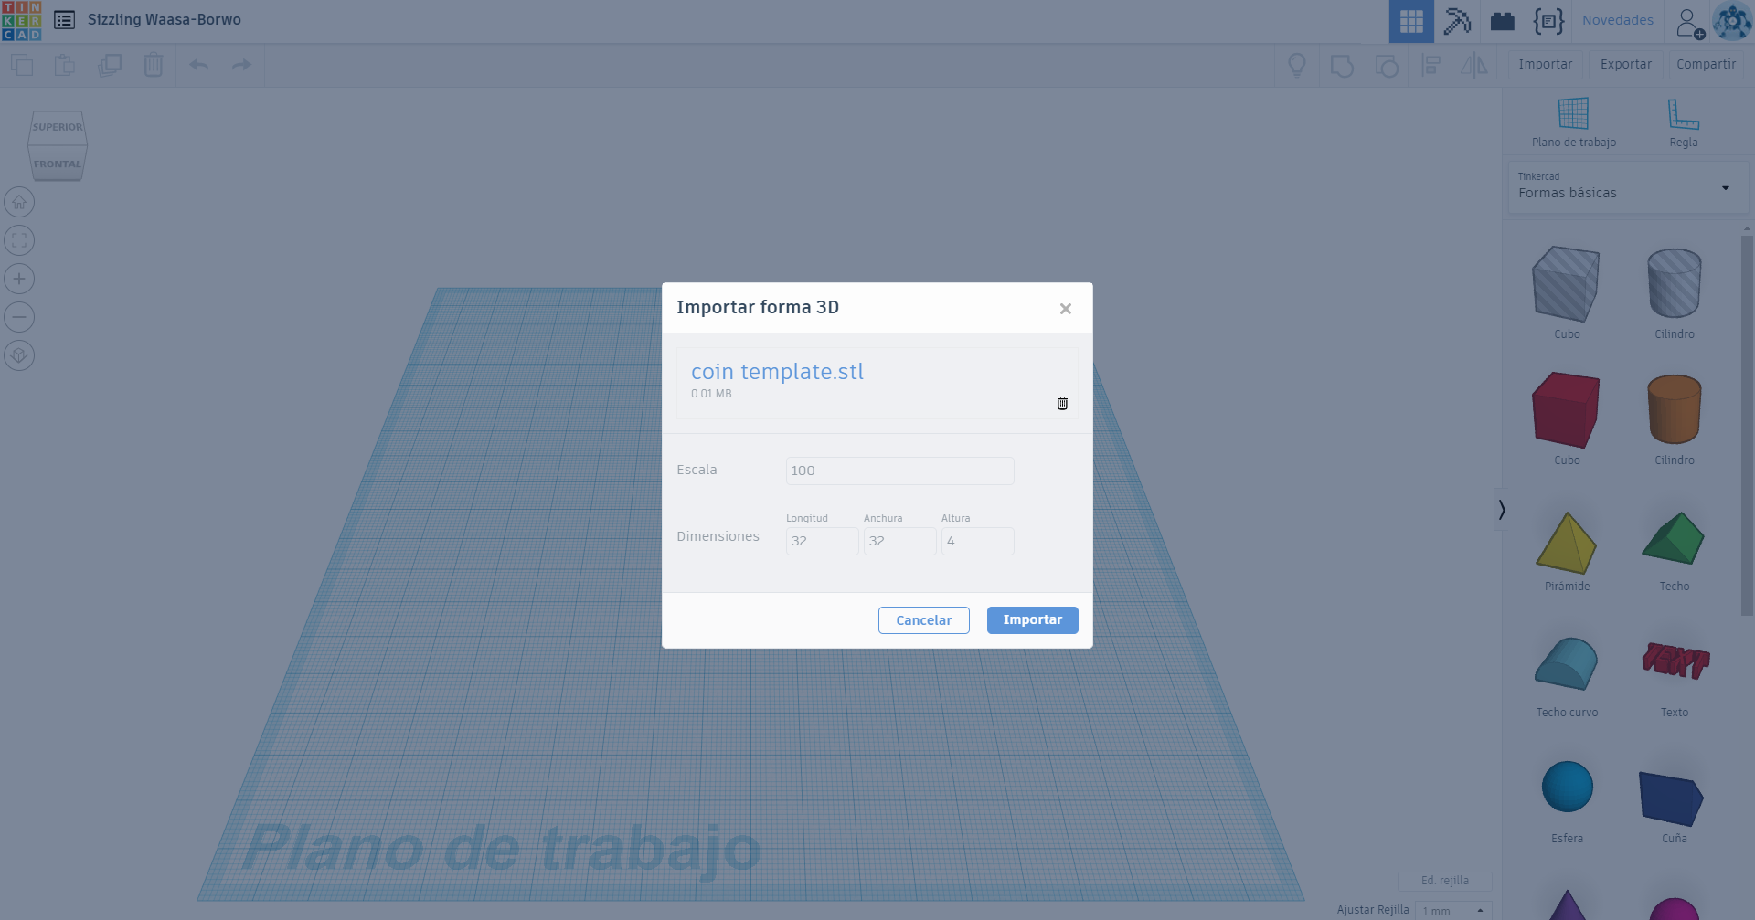
4.-
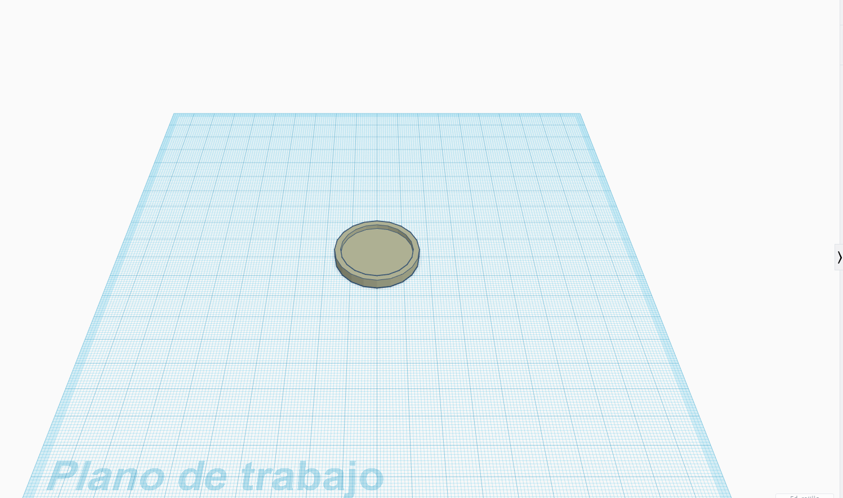

How to add text and images to our coin ( easily )
How to add text
Press and drag TEXT
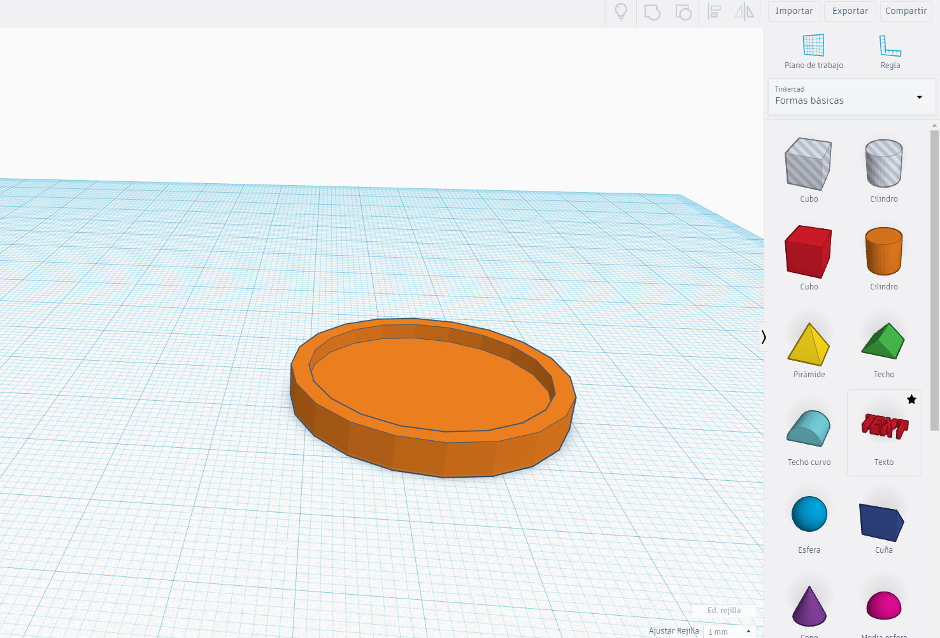

To edit the text, click and type here
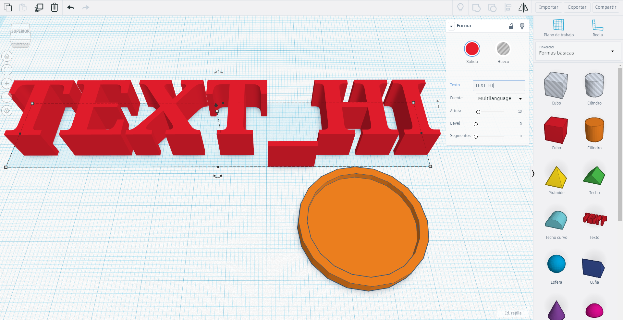

How to turn a 2D image into a 3D Model
Properties of the image. Black on white figures. ( silhouettes )
e.g
- Go to https://image.online-convert.com/
- Convert to .svg for Romania and Poland

